Preliminary ESP regressions

Abigail Tyrell

13 Jul 2021

# Black sea bass

Stock region: Mid

EPU: MAB, All, all, NE

# 1 Introduction

These are preliminary regressions that compare Mid Black sea bass catch, abundance, recruitment, and F to various indicators in the MAB, All, all, NE Environmental Protection Units (EPUs) taken from the ecodata package. The indicators are lagged by 1 years.

# 2 Regression analysis

All regressions are simple linear correlations assessed at the p < 0.5 level. Please note, due to the large number of indicators tested, a certain amount of statistically significant results are expected even if there are no underlying mechanistic connections. These correlations do not necessarily imply causation.

## 2.1 Trends with time

##### Figures

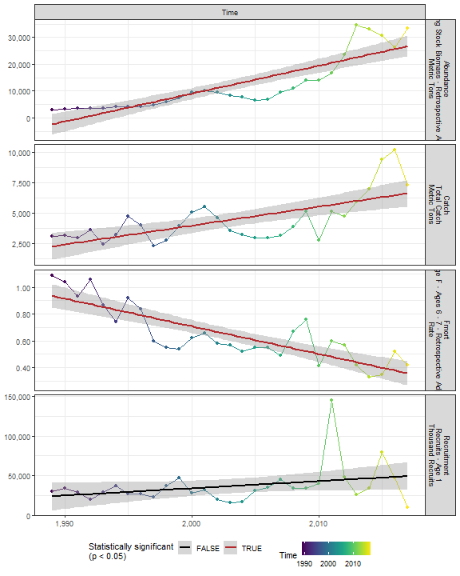

##### Regression statistics

Table 2.1: Catch vs Time

|  |  |  |  |  |
| --- | --- | --- | --- | --- |
|  | Estimate | Std. Error | t value | Pr(>|t|) |
| (Intercept) | -307118.84 | 66180.85 | -4.64 | 0 |
| Val | 155.53 | 33.04 | 4.71 | 0 |

|  |  |
| --- | --- |
| Name | Value |
| F-statistic | 22.16 |
| df | 1, 27 |
| R2 | 0.45 |
| R2-adj | 0.43 |

Table 2.1: Fmort vs Time

|  |  |  |  |  |
| --- | --- | --- | --- | --- |
|  | Estimate | Std. Error | t value | Pr(>|t|) |
| (Intercept) | 41.95 | 5.33 | 7.87 | 0 |
| Val | -0.02 | 0.00 | -7.75 | 0 |

|  |  |
| --- | --- |
| Name | Value |
| F-statistic | 60.1 |
| df | 1, 27 |
| R2 | 0.69 |
| R2-adj | 0.68 |

Table 2.1: Abundance vs Time

|  |  |  |  |  |
| --- | --- | --- | --- | --- |
|  | Estimate | Std. Error | t value | Pr(>|t|) |
| (Intercept) | -2070955 | 231857.79 | -8.93 | 0 |
| Val | 1040 | 115.75 | 8.98 | 0 |

|  |  |
| --- | --- |
| Name | Value |
| F-statistic | 80.72 |
| df | 1, 27 |
| R2 | 0.75 |
| R2-adj | 0.74 |

## 2.2 Physical indicators

### 2.2.1 Temperature-related

#### 2.2.1.1 Cold pool index

##### Figures

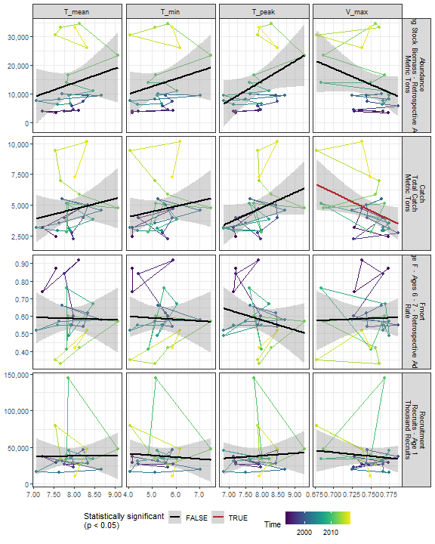

##### Regression statistics

Table 2.2: Catch vs V_max

|  |  |  |  |  |
| --- | --- | --- | --- | --- |
|  | Estimate | Std. Error | t value | Pr(>|t|) |
| (Intercept) | 26413.32 | 9926.97 | 2.66 | 0.01 |
| Val | -29157.48 | 13268.12 | -2.20 | 0.04 |

|  |  |
| --- | --- |
| Name | Value |
| F-statistic | 4.83 |
| df | 1, 23 |
| R2 | 0.17 |
| R2-adj | 0.14 |

#### 2.2.1.2 Warm core rings

##### Figures

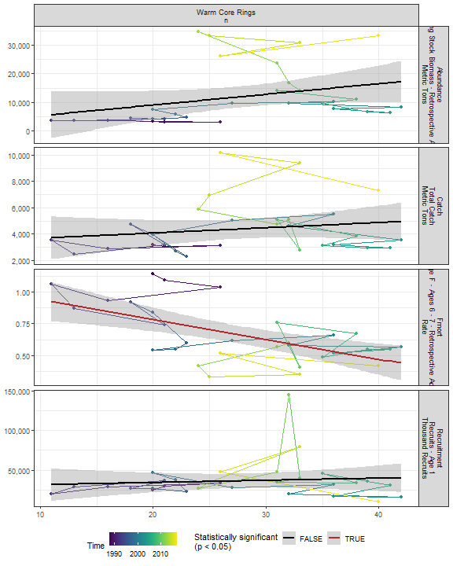

##### Regression statistics

Table 2.3: Fmort vs Warm Core Rings n

|  |  |  |  |  |
| --- | --- | --- | --- | --- |
|  | Estimate | Std. Error | t value | Pr(>|t|) |
| (Intercept) | 1.10 | 0.12 | 9.45 | 0 |
| Val | -0.02 | 0.00 | -3.90 | 0 |

|  |  |
| --- | --- |
| Name | Value |
| F-statistic | 15.19 |
| df | 1, 28 |
| R2 | 0.35 |
| R2-adj | 0.33 |

#### 2.2.1.3 Marine heatwave index

##### Figures

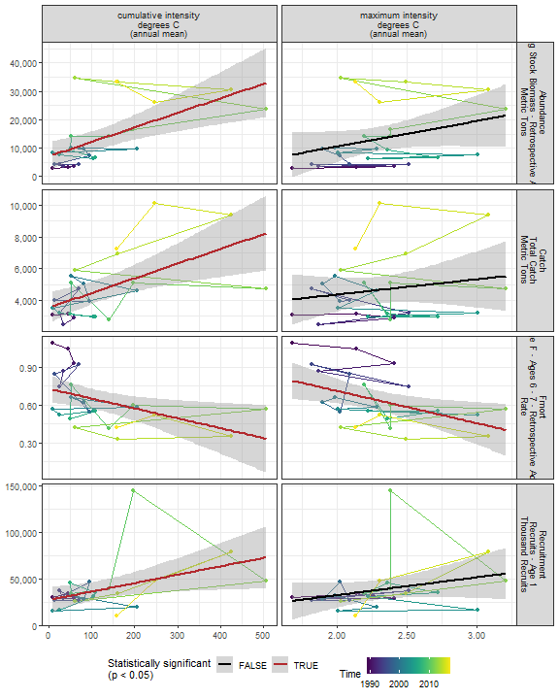

##### Regression statistics

Table 2.4: Catch vs cumulative intensity degrees C (annual mean)

|  |  |  |  |  |
| --- | --- | --- | --- | --- |
|  | Estimate | Std. Error | t value | Pr(>|t|) |
| (Intercept) | 3531.16 | 476.48 | 7.41 | 0 |
| Val | 9.30 | 2.82 | 3.30 | 0 |

|  |  |
| --- | --- |
| Name | Value |
| F-statistic | 10.89 |
| df | 1, 23 |
| R2 | 0.32 |
| R2-adj | 0.29 |

Table 2.4: Fmort vs cumulative intensity degrees C (annual mean)

|  |  |  |  |  |
| --- | --- | --- | --- | --- |
|  | Estimate | Std. Error | t value | Pr(>|t|) |
| (Intercept) | 0.73 | 0.05 | 13.69 | 0.00 |
| Val | 0.00 | 0.00 | -2.49 | 0.02 |

|  |  |
| --- | --- |
| Name | Value |
| F-statistic | 6.19 |
| df | 1, 23 |
| R2 | 0.21 |
| R2-adj | 0.18 |

Table 2.4: Fmort vs maximum intensity degrees C (annual mean)

|  |  |  |  |  |
| --- | --- | --- | --- | --- |
|  | Estimate | Std. Error | t value | Pr(>|t|) |
| (Intercept) | 1.22 | 0.23 | 5.29 | 0.00 |
| Val | -0.26 | 0.10 | -2.57 | 0.02 |

|  |  |
| --- | --- |
| Name | Value |
| F-statistic | 6.6 |
| df | 1, 23 |
| R2 | 0.22 |
| R2-adj | 0.19 |

Table 2.4: Recruitment vs cumulative intensity degrees C (annual mean)

|  |  |  |  |  |
| --- | --- | --- | --- | --- |
|  | Estimate | Std. Error | t value | Pr(>|t|) |
| (Intercept) | 27233.93 | 6711.26 | 4.06 | 0.00 |
| Val | 90.00 | 39.71 | 2.27 | 0.03 |

|  |  |
| --- | --- |
| Name | Value |
| F-statistic | 5.14 |
| df | 1, 23 |
| R2 | 0.18 |
| R2-adj | 0.15 |

Table 2.4: Abundance vs cumulative intensity degrees C (annual mean)

|  |  |  |  |  |
| --- | --- | --- | --- | --- |
|  | Estimate | Std. Error | t value | Pr(>|t|) |
| (Intercept) | 7099.18 | 2439.91 | 2.91 | 0.01 |
| Val | 51.19 | 14.44 | 3.55 | 0.00 |

|  |  |
| --- | --- |
| Name | Value |
| F-statistic | 12.58 |
| df | 1, 23 |
| R2 | 0.35 |
| R2-adj | 0.33 |

#### 2.2.1.4 Marine heatwave index in the stock region

##### Figures

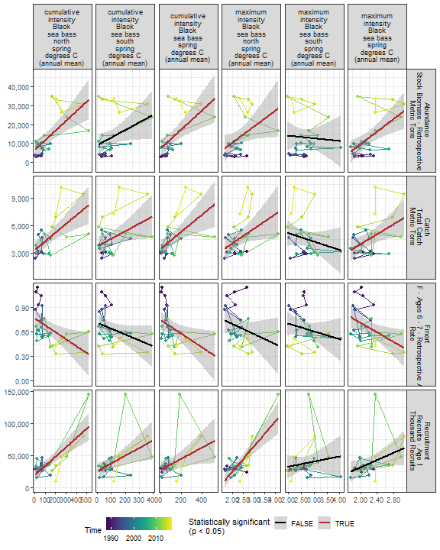

##### Regression statistics

Table 2.5: Catch vs cumulative intensity Black sea bass north spring degrees C (annual mean)

|  |  |  |  |  |
| --- | --- | --- | --- | --- |
|  | Estimate | Std. Error | t value | Pr(>|t|) |
| (Intercept) | 3393.30 | 452.22 | 7.50 | 0 |
| Val | 9.41 | 2.42 | 3.88 | 0 |

|  |  |
| --- | --- |
| Name | Value |
| F-statistic | 15.06 |
| df | 1, 23 |
| R2 | 0.4 |
| R2-adj | 0.37 |

Table 2.5: Catch vs cumulative intensity Black sea bass spring degrees C (annual mean)

|  |  |  |  |  |
| --- | --- | --- | --- | --- |
|  | Estimate | Std. Error | t value | Pr(>|t|) |
| (Intercept) | 3517.14 | 464.99 | 7.56 | 0 |
| Val | 9.19 | 2.82 | 3.26 | 0 |

|  |  |
| --- | --- |
| Name | Value |
| F-statistic | 10.61 |
| df | 1, 24 |
| R2 | 0.31 |
| R2-adj | 0.28 |

Table 2.5: Catch vs maximum intensity Black sea bass north spring degrees C (annual mean)

|  |  |  |  |  |
| --- | --- | --- | --- | --- |
|  | Estimate | Std. Error | t value | Pr(>|t|) |
| (Intercept) | 970.3 | 1759.31 | 0.55 | 0.59 |
| Val | 1565.9 | 736.95 | 2.12 | 0.04 |

|  |  |
| --- | --- |
| Name | Value |
| F-statistic | 4.51 |
| df | 1, 23 |
| R2 | 0.16 |
| R2-adj | 0.13 |

Table 2.5: Catch vs maximum intensity Black sea bass spring degrees C (annual mean)

|  |  |  |  |  |
| --- | --- | --- | --- | --- |
|  | Estimate | Std. Error | t value | Pr(>|t|) |
| (Intercept) | -1373.48 | 2317.31 | -0.59 | 0.56 |
| Val | 2693.75 | 1038.73 | 2.59 | 0.02 |

|  |  |
| --- | --- |
| Name | Value |
| F-statistic | 6.73 |
| df | 1, 24 |
| R2 | 0.22 |
| R2-adj | 0.19 |

Table 2.5: Catch vs cumulative intensity Black sea bass south spring degrees C (annual mean)

|  |  |  |  |  |
| --- | --- | --- | --- | --- |
|  | Estimate | Std. Error | t value | Pr(>|t|) |
| (Intercept) | 3778.64 | 521.68 | 7.24 | 0.00 |
| Val | 8.13 | 3.71 | 2.19 | 0.04 |

|  |  |
| --- | --- |
| Name | Value |
| F-statistic | 4.8 |
| df | 1, 24 |
| R2 | 0.17 |
| R2-adj | 0.13 |

Table 2.5: Fmort vs cumulative intensity Black sea bass north spring degrees C (annual mean)

|  |  |  |  |  |
| --- | --- | --- | --- | --- |
|  | Estimate | Std. Error | t value | Pr(>|t|) |
| (Intercept) | 0.76 | 0.06 | 13.54 | 0.00 |
| Val | 0.00 | 0.00 | -2.80 | 0.01 |

|  |  |
| --- | --- |
| Name | Value |
| F-statistic | 7.86 |
| df | 1, 23 |
| R2 | 0.25 |
| R2-adj | 0.22 |

Table 2.5: Fmort vs cumulative intensity Black sea bass spring degrees C (annual mean)

|  |  |  |  |  |
| --- | --- | --- | --- | --- |
|  | Estimate | Std. Error | t value | Pr(>|t|) |
| (Intercept) | 0.74 | 0.06 | 13.26 | 0.00 |
| Val | 0.00 | 0.00 | -2.43 | 0.02 |

|  |  |
| --- | --- |
| Name | Value |
| F-statistic | 5.92 |
| df | 1, 24 |
| R2 | 0.2 |
| R2-adj | 0.16 |

Table 2.5: Fmort vs maximum intensity Black sea bass spring degrees C (annual mean)

|  |  |  |  |  |
| --- | --- | --- | --- | --- |
|  | Estimate | Std. Error | t value | Pr(>|t|) |
| (Intercept) | 1.28 | 0.26 | 4.89 | 0.00 |
| Val | -0.29 | 0.12 | -2.45 | 0.02 |

|  |  |
| --- | --- |
| Name | Value |
| F-statistic | 5.99 |
| df | 1, 24 |
| R2 | 0.2 |
| R2-adj | 0.17 |

Table 2.5: Recruitment vs cumulative intensity Black sea bass north spring degrees C (annual mean)

|  |  |  |  |  |
| --- | --- | --- | --- | --- |
|  | Estimate | Std. Error | t value | Pr(>|t|) |
| (Intercept) | 19533.81 | 4757.20 | 4.11 | 0 |
| Val | 144.81 | 25.51 | 5.68 | 0 |

|  |  |
| --- | --- |
| Name | Value |
| F-statistic | 32.23 |
| df | 1, 23 |
| R2 | 0.58 |
| R2-adj | 0.57 |

Table 2.5: Recruitment vs cumulative intensity Black sea bass spring degrees C (annual mean)

|  |  |  |  |  |
| --- | --- | --- | --- | --- |
|  | Estimate | Std. Error | t value | Pr(>|t|) |
| (Intercept) | 27820.83 | 6495.98 | 4.28 | 0.00 |
| Val | 85.57 | 39.42 | 2.17 | 0.04 |

|  |  |
| --- | --- |
| Name | Value |
| F-statistic | 4.71 |
| df | 1, 24 |
| R2 | 0.16 |
| R2-adj | 0.13 |

Table 2.5: Recruitment vs maximum intensity Black sea bass north spring degrees C (annual mean)

|  |  |  |  |  |
| --- | --- | --- | --- | --- |
|  | Estimate | Std. Error | t value | Pr(>|t|) |
| (Intercept) | -51052.16 | 15150.57 | -3.37 | 0 |
| Val | 38383.92 | 6346.39 | 6.05 | 0 |

|  |  |
| --- | --- |
| Name | Value |
| F-statistic | 36.58 |
| df | 1, 23 |
| R2 | 0.61 |
| R2-adj | 0.6 |

Table 2.5: Recruitment vs cumulative intensity Black sea bass south spring degrees C (annual mean)

|  |  |  |  |  |
| --- | --- | --- | --- | --- |
|  | Estimate | Std. Error | t value | Pr(>|t|) |
| (Intercept) | 25641.19 | 6456.20 | 3.97 | 0.00 |
| Val | 119.82 | 45.92 | 2.61 | 0.02 |

|  |  |
| --- | --- |
| Name | Value |
| F-statistic | 6.81 |
| df | 1, 24 |
| R2 | 0.22 |
| R2-adj | 0.19 |

Table 2.5: Abundance vs cumulative intensity Black sea bass north spring degrees C (annual mean)

|  |  |  |  |  |
| --- | --- | --- | --- | --- |
|  | Estimate | Std. Error | t value | Pr(>|t|) |
| (Intercept) | 6541.15 | 2306.36 | 2.84 | 0.01 |
| Val | 51.17 | 12.37 | 4.14 | 0.00 |

|  |  |
| --- | --- |
| Name | Value |
| F-statistic | 17.12 |
| df | 1, 23 |
| R2 | 0.43 |
| R2-adj | 0.4 |

Table 2.5: Abundance vs cumulative intensity Black sea bass spring degrees C (annual mean)

|  |  |  |  |  |
| --- | --- | --- | --- | --- |
|  | Estimate | Std. Error | t value | Pr(>|t|) |
| (Intercept) | 7292.25 | 2371.75 | 3.07 | 0.01 |
| Val | 50.10 | 14.39 | 3.48 | 0.00 |

|  |  |
| --- | --- |
| Name | Value |
| F-statistic | 12.12 |
| df | 1, 24 |
| R2 | 0.34 |
| R2-adj | 0.31 |

Table 2.5: Abundance vs maximum intensity Black sea bass north spring degrees C (annual mean)

|  |  |  |  |  |
| --- | --- | --- | --- | --- |
|  | Estimate | Std. Error | t value | Pr(>|t|) |
| (Intercept) | -6193.83 | 9183.81 | -0.67 | 0.51 |
| Val | 8325.70 | 3846.98 | 2.16 | 0.04 |

|  |  |
| --- | --- |
| Name | Value |
| F-statistic | 4.68 |
| df | 1, 23 |
| R2 | 0.17 |
| R2-adj | 0.13 |

Table 2.5: Abundance vs maximum intensity Black sea bass spring degrees C (annual mean)

|  |  |  |  |  |
| --- | --- | --- | --- | --- |
|  | Estimate | Std. Error | t value | Pr(>|t|) |
| (Intercept) | -23548.62 | 11386.61 | -2.07 | 0.05 |
| Val | 16581.45 | 5104.04 | 3.25 | 0.00 |

|  |  |
| --- | --- |
| Name | Value |
| F-statistic | 10.55 |
| df | 1, 24 |
| R2 | 0.31 |
| R2-adj | 0.28 |

#### 2.2.1.5 GLORYS bottom temperature

##### Figures

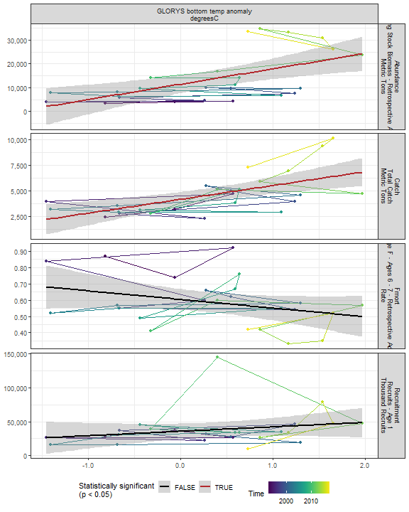

##### Regression statistics

Table 2.6: Catch vs GLORYS bottom temp anomaly degreesC

|  |  |  |  |  |
| --- | --- | --- | --- | --- |
|  | Estimate | Std. Error | t value | Pr(>|t|) |
| (Intercept) | 4161.68 | 348.97 | 11.93 | 0 |
| Val | 1359.11 | 355.03 | 3.83 | 0 |

|  |  |
| --- | --- |
| Name | Value |
| F-statistic | 14.65 |
| df | 1, 23 |
| R2 | 0.39 |
| R2-adj | 0.36 |

Table 2.6: Abundance vs GLORYS bottom temp anomaly degreesC

|  |  |  |  |  |
| --- | --- | --- | --- | --- |
|  | Estimate | Std. Error | t value | Pr(>|t|) |
| (Intercept) | 11455.96 | 1815.64 | 6.31 | 0 |
| Val | 6429.92 | 1847.18 | 3.48 | 0 |

|  |  |
| --- | --- |
| Name | Value |
| F-statistic | 12.12 |
| df | 1, 23 |
| R2 | 0.35 |
| R2-adj | 0.32 |

#### 2.2.1.6 Long-term sea surface temperature

##### Figures

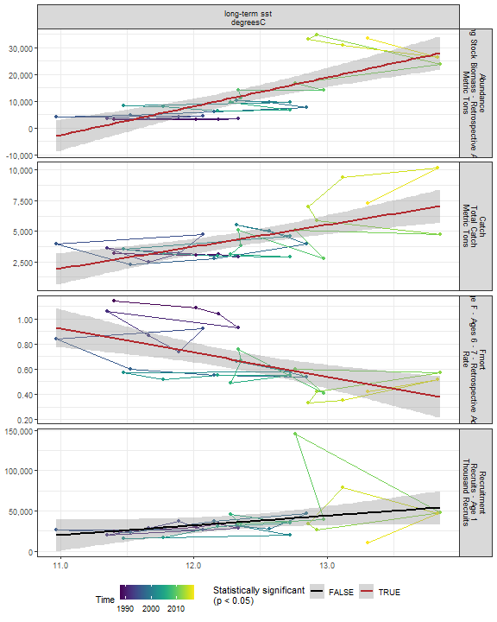

##### Regression statistics

Table 2.7: Catch vs long-term sst degreesC

|  |  |  |  |  |
| --- | --- | --- | --- | --- |
|  | Estimate | Std. Error | t value | Pr(>|t|) |
| (Intercept) | -17672.95 | 4983.39 | -3.55 | 0 |
| Val | 1784.02 | 402.62 | 4.43 | 0 |

|  |  |
| --- | --- |
| Name | Value |
| F-statistic | 19.63 |
| df | 1, 28 |
| R2 | 0.41 |
| R2-adj | 0.39 |

Table 2.7: Fmort vs long-term sst degreesC

|  |  |  |  |  |
| --- | --- | --- | --- | --- |
|  | Estimate | Std. Error | t value | Pr(>|t|) |
| (Intercept) | 3.04 | 0.61 | 5.02 | 0 |
| Val | -0.19 | 0.05 | -3.93 | 0 |

|  |  |
| --- | --- |
| Name | Value |
| F-statistic | 15.47 |
| df | 1, 28 |
| R2 | 0.36 |
| R2-adj | 0.33 |

Table 2.7: Abundance vs long-term sst degreesC

|  |  |  |  |  |
| --- | --- | --- | --- | --- |
|  | Estimate | Std. Error | t value | Pr(>|t|) |
| (Intercept) | -120713.25 | 22838.28 | -5.29 | 0 |
| Val | 10728.69 | 1845.17 | 5.81 | 0 |

|  |  |
| --- | --- |
| Name | Value |
| F-statistic | 33.81 |
| df | 1, 28 |
| R2 | 0.55 |
| R2-adj | 0.53 |

#### 2.2.1.7 Sea surface temperature anomaly in EPU

##### Figures

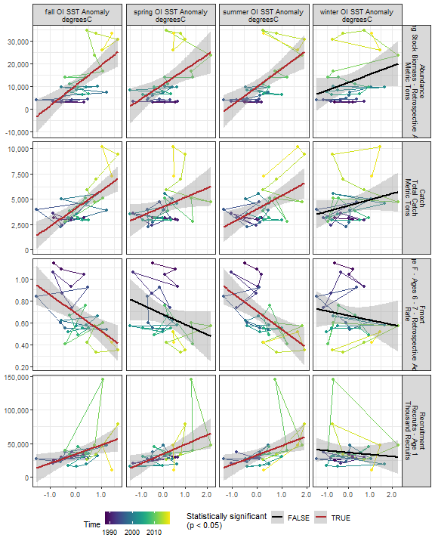

##### Regression statistics

Table 2.8: Catch vs spring OI SST Anomaly degreesC

|  |  |  |  |  |
| --- | --- | --- | --- | --- |
|  | Estimate | Std. Error | t value | Pr(>|t|) |
| (Intercept) | 4254.40 | 340.77 | 12.48 | 0.00 |
| Val | 921.04 | 431.08 | 2.14 | 0.04 |

|  |  |
| --- | --- |
| Name | Value |
| F-statistic | 4.57 |
| df | 1, 28 |
| R2 | 0.14 |
| R2-adj | 0.11 |

Table 2.8: Catch vs summer OI SST Anomaly degreesC

|  |  |  |  |  |
| --- | --- | --- | --- | --- |
|  | Estimate | Std. Error | t value | Pr(>|t|) |
| (Intercept) | 4024.02 | 327.25 | 12.30 | 0 |
| Val | 1335.11 | 411.21 | 3.25 | 0 |

|  |  |
| --- | --- |
| Name | Value |
| F-statistic | 10.54 |
| df | 1, 28 |
| R2 | 0.27 |
| R2-adj | 0.25 |

Table 2.8: Catch vs fall OI SST Anomaly degreesC

|  |  |  |  |  |
| --- | --- | --- | --- | --- |
|  | Estimate | Std. Error | t value | Pr(>|t|) |
| (Intercept) | 4102.56 | 272.43 | 15.06 | 0 |
| Val | 1768.91 | 363.06 | 4.87 | 0 |

|  |  |
| --- | --- |
| Name | Value |
| F-statistic | 23.74 |
| df | 1, 28 |
| R2 | 0.46 |
| R2-adj | 0.44 |

Table 2.8: Fmort vs summer OI SST Anomaly degreesC

|  |  |  |  |  |
| --- | --- | --- | --- | --- |
|  | Estimate | Std. Error | t value | Pr(>|t|) |
| (Intercept) | 0.71 | 0.04 | 19.30 | 0 |
| Val | -0.17 | 0.05 | -3.65 | 0 |

|  |  |
| --- | --- |
| Name | Value |
| F-statistic | 13.31 |
| df | 1, 28 |
| R2 | 0.32 |
| R2-adj | 0.3 |

Table 2.8: Fmort vs fall OI SST Anomaly degreesC

|  |  |  |  |  |
| --- | --- | --- | --- | --- |
|  | Estimate | Std. Error | t value | Pr(>|t|) |
| (Intercept) | 0.69 | 0.04 | 19.17 | 0 |
| Val | -0.17 | 0.05 | -3.46 | 0 |

|  |  |
| --- | --- |
| Name | Value |
| F-statistic | 11.99 |
| df | 1, 28 |
| R2 | 0.3 |
| R2-adj | 0.27 |

Table 2.8: Recruitment vs spring OI SST Anomaly degreesC

|  |  |  |  |  |
| --- | --- | --- | --- | --- |
|  | Estimate | Std. Error | t value | Pr(>|t|) |
| (Intercept) | 34286.32 | 4041.73 | 8.48 | 0.00 |
| Val | 14170.01 | 5112.84 | 2.77 | 0.01 |

|  |  |
| --- | --- |
| Name | Value |
| F-statistic | 7.68 |
| df | 1, 28 |
| R2 | 0.22 |
| R2-adj | 0.19 |

Table 2.8: Recruitment vs summer OI SST Anomaly degreesC

|  |  |  |  |  |
| --- | --- | --- | --- | --- |
|  | Estimate | Std. Error | t value | Pr(>|t|) |
| (Intercept) | 32436.50 | 4270.62 | 7.60 | 0.00 |
| Val | 14077.54 | 5366.41 | 2.62 | 0.01 |

|  |  |
| --- | --- |
| Name | Value |
| F-statistic | 6.88 |
| df | 1, 28 |
| R2 | 0.2 |
| R2-adj | 0.17 |

Table 2.8: Recruitment vs fall OI SST Anomaly degreesC

|  |  |  |  |  |
| --- | --- | --- | --- | --- |
|  | Estimate | Std. Error | t value | Pr(>|t|) |
| (Intercept) | 34016.90 | 4163.72 | 8.17 | 0.00 |
| Val | 13750.39 | 5548.74 | 2.48 | 0.02 |

|  |  |
| --- | --- |
| Name | Value |
| F-statistic | 6.14 |
| df | 1, 28 |
| R2 | 0.18 |
| R2-adj | 0.15 |

Table 2.8: Abundance vs spring OI SST Anomaly degreesC

|  |  |  |  |  |
| --- | --- | --- | --- | --- |
|  | Estimate | Std. Error | t value | Pr(>|t|) |
| (Intercept) | 11031.30 | 1656.73 | 6.66 | 0 |
| Val | 6475.66 | 2095.78 | 3.09 | 0 |

|  |  |
| --- | --- |
| Name | Value |
| F-statistic | 9.55 |
| df | 1, 28 |
| R2 | 0.25 |
| R2-adj | 0.23 |

Table 2.8: Abundance vs summer OI SST Anomaly degreesC

|  |  |  |  |  |
| --- | --- | --- | --- | --- |
|  | Estimate | Std. Error | t value | Pr(>|t|) |
| (Intercept) | 9749.72 | 1591.95 | 6.12 | 0 |
| Val | 8097.17 | 2000.43 | 4.05 | 0 |

|  |  |
| --- | --- |
| Name | Value |
| F-statistic | 16.38 |
| df | 1, 28 |
| R2 | 0.37 |
| R2-adj | 0.35 |

Table 2.8: Abundance vs fall OI SST Anomaly degreesC

|  |  |  |  |  |
| --- | --- | --- | --- | --- |
|  | Estimate | Std. Error | t value | Pr(>|t|) |
| (Intercept) | 10486.21 | 1447.99 | 7.24 | 0 |
| Val | 9033.07 | 1929.65 | 4.68 | 0 |

|  |  |
| --- | --- |
| Name | Value |
| F-statistic | 21.91 |
| df | 1, 28 |
| R2 | 0.44 |
| R2-adj | 0.42 |

#### 2.2.1.8 Sea surface temperature anomaly in stock region

##### Figures

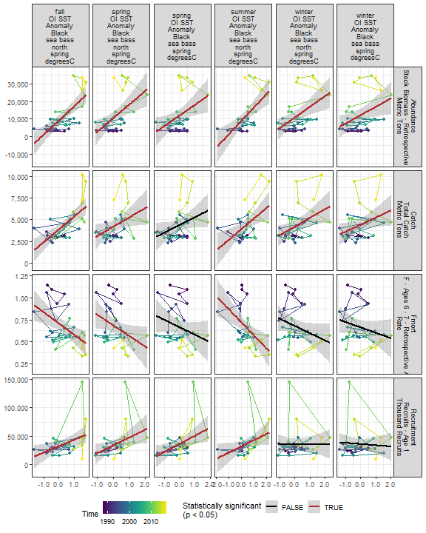

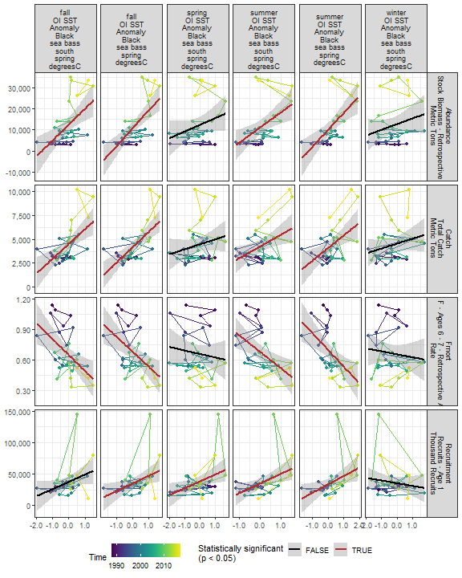

##### Regression statistics

Table 2.9: Catch vs winter OI SST Anomaly Black sea bass north spring degreesC

|  |  |  |  |  |
| --- | --- | --- | --- | --- |
|  | Estimate | Std. Error | t value | Pr(>|t|) |
| (Intercept) | 4220.93 | 329.30 | 12.82 | 0.00 |
| Val | 996.60 | 376.37 | 2.65 | 0.01 |

|  |  |
| --- | --- |
| Name | Value |
| F-statistic | 7.01 |
| df | 1, 28 |
| R2 | 0.2 |
| R2-adj | 0.17 |

Table 2.9: Catch vs spring OI SST Anomaly Black sea bass north spring degreesC

|  |  |  |  |  |
| --- | --- | --- | --- | --- |
|  | Estimate | Std. Error | t value | Pr(>|t|) |
| (Intercept) | 4193.23 | 344.62 | 12.17 | 0.00 |
| Val | 1077.95 | 489.61 | 2.20 | 0.04 |

|  |  |
| --- | --- |
| Name | Value |
| F-statistic | 4.85 |
| df | 1, 28 |
| R2 | 0.15 |
| R2-adj | 0.12 |

Table 2.9: Catch vs summer OI SST Anomaly Black sea bass north spring degreesC

|  |  |  |  |  |
| --- | --- | --- | --- | --- |
|  | Estimate | Std. Error | t value | Pr(>|t|) |
| (Intercept) | 3910.94 | 341.86 | 11.44 | 0 |
| Val | 1222.94 | 380.95 | 3.21 | 0 |

|  |  |
| --- | --- |
| Name | Value |
| F-statistic | 10.31 |
| df | 1, 28 |
| R2 | 0.27 |
| R2-adj | 0.24 |

Table 2.9: Catch vs fall OI SST Anomaly Black sea bass north spring degreesC

|  |  |  |  |  |
| --- | --- | --- | --- | --- |
|  | Estimate | Std. Error | t value | Pr(>|t|) |
| (Intercept) | 3878.66 | 278.87 | 13.91 | 0 |
| Val | 1478.44 | 290.61 | 5.09 | 0 |

|  |  |
| --- | --- |
| Name | Value |
| F-statistic | 25.88 |
| df | 1, 28 |
| R2 | 0.48 |
| R2-adj | 0.46 |

Table 2.9: Catch vs winter OI SST Anomaly Black sea bass spring degreesC

|  |  |  |  |  |
| --- | --- | --- | --- | --- |
|  | Estimate | Std. Error | t value | Pr(>|t|) |
| (Intercept) | 4432.93 | 338.07 | 13.11 | 0.00 |
| Val | 814.37 | 387.52 | 2.10 | 0.04 |

|  |  |
| --- | --- |
| Name | Value |
| F-statistic | 4.42 |
| df | 1, 28 |
| R2 | 0.14 |
| R2-adj | 0.11 |

Table 2.9: Catch vs summer OI SST Anomaly Black sea bass spring degreesC

|  |  |  |  |  |
| --- | --- | --- | --- | --- |
|  | Estimate | Std. Error | t value | Pr(>|t|) |
| (Intercept) | 4082.91 | 324.21 | 12.59 | 0 |
| Val | 1336.58 | 421.48 | 3.17 | 0 |

|  |  |
| --- | --- |
| Name | Value |
| F-statistic | 10.06 |
| df | 1, 28 |
| R2 | 0.26 |
| R2-adj | 0.24 |

Table 2.9: Catch vs fall OI SST Anomaly Black sea bass spring degreesC

|  |  |  |  |  |
| --- | --- | --- | --- | --- |
|  | Estimate | Std. Error | t value | Pr(>|t|) |
| (Intercept) | 4171.76 | 268.74 | 15.52 | 0 |
| Val | 1631.79 | 331.92 | 4.92 | 0 |

|  |  |
| --- | --- |
| Name | Value |
| F-statistic | 24.17 |
| df | 1, 28 |
| R2 | 0.46 |
| R2-adj | 0.44 |

Table 2.9: Catch vs summer OI SST Anomaly Black sea bass south spring degreesC

|  |  |  |  |  |
| --- | --- | --- | --- | --- |
|  | Estimate | Std. Error | t value | Pr(>|t|) |
| (Intercept) | 4248.50 | 326.81 | 13.00 | 0.00 |
| Val | 1223.85 | 456.96 | 2.68 | 0.01 |

|  |  |
| --- | --- |
| Name | Value |
| F-statistic | 7.17 |
| df | 1, 28 |
| R2 | 0.2 |
| R2-adj | 0.18 |

Table 2.9: Catch vs fall OI SST Anomaly Black sea bass south spring degreesC

|  |  |  |  |  |
| --- | --- | --- | --- | --- |
|  | Estimate | Std. Error | t value | Pr(>|t|) |
| (Intercept) | 4522.69 | 294.35 | 15.37 | 0 |
| Val | 1551.00 | 397.93 | 3.90 | 0 |

|  |  |
| --- | --- |
| Name | Value |
| F-statistic | 15.19 |
| df | 1, 28 |
| R2 | 0.35 |
| R2-adj | 0.33 |

Table 2.9: Fmort vs spring OI SST Anomaly Black sea bass north spring degreesC

|  |  |  |  |  |
| --- | --- | --- | --- | --- |
|  | Estimate | Std. Error | t value | Pr(>|t|) |
| (Intercept) | 0.68 | 0.04 | 17.03 | 0.00 |
| Val | -0.12 | 0.06 | -2.13 | 0.04 |

|  |  |
| --- | --- |
| Name | Value |
| F-statistic | 4.54 |
| df | 1, 28 |
| R2 | 0.14 |
| R2-adj | 0.11 |

Table 2.9: Fmort vs summer OI SST Anomaly Black sea bass north spring degreesC

|  |  |  |  |  |
| --- | --- | --- | --- | --- |
|  | Estimate | Std. Error | t value | Pr(>|t|) |
| (Intercept) | 0.72 | 0.04 | 18.45 | 0 |
| Val | -0.15 | 0.04 | -3.40 | 0 |

|  |  |
| --- | --- |
| Name | Value |
| F-statistic | 11.58 |
| df | 1, 28 |
| R2 | 0.29 |
| R2-adj | 0.27 |

Table 2.9: Fmort vs fall OI SST Anomaly Black sea bass north spring degreesC

|  |  |  |  |  |
| --- | --- | --- | --- | --- |
|  | Estimate | Std. Error | t value | Pr(>|t|) |
| (Intercept) | 0.71 | 0.04 | 18.41 | 0 |
| Val | -0.13 | 0.04 | -3.21 | 0 |

|  |  |
| --- | --- |
| Name | Value |
| F-statistic | 10.29 |
| df | 1, 28 |
| R2 | 0.27 |
| R2-adj | 0.24 |

Table 2.9: Fmort vs summer OI SST Anomaly Black sea bass spring degreesC

|  |  |  |  |  |
| --- | --- | --- | --- | --- |
|  | Estimate | Std. Error | t value | Pr(>|t|) |
| (Intercept) | 0.70 | 0.04 | 19.14 | 0 |
| Val | -0.17 | 0.05 | -3.50 | 0 |

|  |  |
| --- | --- |
| Name | Value |
| F-statistic | 12.27 |
| df | 1, 28 |
| R2 | 0.3 |
| R2-adj | 0.28 |

Table 2.9: Fmort vs fall OI SST Anomaly Black sea bass spring degreesC

|  |  |  |  |  |
| --- | --- | --- | --- | --- |
|  | Estimate | Std. Error | t value | Pr(>|t|) |
| (Intercept) | 0.68 | 0.04 | 19.01 | 0 |
| Val | -0.15 | 0.04 | -3.37 | 0 |

|  |  |
| --- | --- |
| Name | Value |
| F-statistic | 11.38 |
| df | 1, 28 |
| R2 | 0.29 |
| R2-adj | 0.26 |

Table 2.9: Fmort vs summer OI SST Anomaly Black sea bass south spring degreesC

|  |  |  |  |  |
| --- | --- | --- | --- | --- |
|  | Estimate | Std. Error | t value | Pr(>|t|) |
| (Intercept) | 0.68 | 0.04 | 18.62 | 0 |
| Val | -0.16 | 0.05 | -3.14 | 0 |

|  |  |
| --- | --- |
| Name | Value |
| F-statistic | 9.89 |
| df | 1, 28 |
| R2 | 0.26 |
| R2-adj | 0.23 |

Table 2.9: Fmort vs fall OI SST Anomaly Black sea bass south spring degreesC

|  |  |  |  |  |
| --- | --- | --- | --- | --- |
|  | Estimate | Std. Error | t value | Pr(>|t|) |
| (Intercept) | 0.65 | 0.04 | 17.88 | 0 |
| Val | -0.16 | 0.05 | -3.21 | 0 |

|  |  |
| --- | --- |
| Name | Value |
| F-statistic | 10.28 |
| df | 1, 28 |
| R2 | 0.27 |
| R2-adj | 0.24 |

Table 2.9: Recruitment vs spring OI SST Anomaly Black sea bass north spring degreesC

|  |  |  |  |  |
| --- | --- | --- | --- | --- |
|  | Estimate | Std. Error | t value | Pr(>|t|) |
| (Intercept) | 33797.03 | 4249.69 | 7.95 | 0.00 |
| Val | 13891.34 | 6037.64 | 2.30 | 0.03 |

|  |  |
| --- | --- |
| Name | Value |
| F-statistic | 5.29 |
| df | 1, 28 |
| R2 | 0.16 |
| R2-adj | 0.13 |

Table 2.9: Recruitment vs summer OI SST Anomaly Black sea bass north spring degreesC

|  |  |  |  |  |
| --- | --- | --- | --- | --- |
|  | Estimate | Std. Error | t value | Pr(>|t|) |
| (Intercept) | 32034.91 | 4613.49 | 6.94 | 0.00 |
| Val | 10806.71 | 5141.06 | 2.10 | 0.04 |

|  |  |
| --- | --- |
| Name | Value |
| F-statistic | 4.42 |
| df | 1, 28 |
| R2 | 0.14 |
| R2-adj | 0.11 |

Table 2.9: Recruitment vs fall OI SST Anomaly Black sea bass north spring degreesC

|  |  |  |  |  |
| --- | --- | --- | --- | --- |
|  | Estimate | Std. Error | t value | Pr(>|t|) |
| (Intercept) | 32349.11 | 4345.78 | 7.44 | 0.00 |
| Val | 11275.53 | 4528.66 | 2.49 | 0.02 |

|  |  |
| --- | --- |
| Name | Value |
| F-statistic | 6.2 |
| df | 1, 28 |
| R2 | 0.18 |
| R2-adj | 0.15 |

Table 2.9: Recruitment vs summer OI SST Anomaly Black sea bass spring degreesC

|  |  |  |  |  |
| --- | --- | --- | --- | --- |
|  | Estimate | Std. Error | t value | Pr(>|t|) |
| (Intercept) | 33172.41 | 4258.14 | 7.79 | 0.00 |
| Val | 13565.26 | 5535.65 | 2.45 | 0.02 |

|  |  |
| --- | --- |
| Name | Value |
| F-statistic | 6.01 |
| df | 1, 28 |
| R2 | 0.18 |
| R2-adj | 0.15 |

Table 2.9: Recruitment vs fall OI SST Anomaly Black sea bass spring degreesC

|  |  |  |  |  |
| --- | --- | --- | --- | --- |
|  | Estimate | Std. Error | t value | Pr(>|t|) |
| (Intercept) | 34594.19 | 4142.49 | 8.35 | 0.00 |
| Val | 12366.61 | 5116.36 | 2.42 | 0.02 |

|  |  |
| --- | --- |
| Name | Value |
| F-statistic | 5.84 |
| df | 1, 28 |
| R2 | 0.17 |
| R2-adj | 0.14 |

Table 2.9: Recruitment vs summer OI SST Anomaly Black sea bass south spring degreesC

|  |  |  |  |  |
| --- | --- | --- | --- | --- |
|  | Estimate | Std. Error | t value | Pr(>|t|) |
| (Intercept) | 34549.71 | 4044.79 | 8.54 | 0.00 |
| Val | 15377.46 | 5655.54 | 2.72 | 0.01 |

|  |  |
| --- | --- |
| Name | Value |
| F-statistic | 7.39 |
| df | 1, 28 |
| R2 | 0.21 |
| R2-adj | 0.18 |

Table 2.9: Recruitment vs spring OI SST Anomaly Black sea bass spring degreesC

|  |  |  |  |  |
| --- | --- | --- | --- | --- |
|  | Estimate | Std. Error | t value | Pr(>|t|) |
| (Intercept) | 36426.60 | 4056.56 | 8.98 | 0.00 |
| Val | 14241.22 | 5589.02 | 2.55 | 0.02 |

|  |  |
| --- | --- |
| Name | Value |
| F-statistic | 6.49 |
| df | 1, 28 |
| R2 | 0.19 |
| R2-adj | 0.16 |

Table 2.9: Recruitment vs spring OI SST Anomaly Black sea bass south spring degreesC

|  |  |  |  |  |
| --- | --- | --- | --- | --- |
|  | Estimate | Std. Error | t value | Pr(>|t|) |
| (Intercept) | 37887.22 | 4154.16 | 9.12 | 0.00 |
| Val | 11087.06 | 4566.36 | 2.43 | 0.02 |

|  |  |
| --- | --- |
| Name | Value |
| F-statistic | 5.9 |
| df | 1, 28 |
| R2 | 0.17 |
| R2-adj | 0.14 |

Table 2.9: Abundance vs winter OI SST Anomaly Black sea bass north spring degreesC

|  |  |  |  |  |
| --- | --- | --- | --- | --- |
|  | Estimate | Std. Error | t value | Pr(>|t|) |
| (Intercept) | 10946.14 | 1643.54 | 6.66 | 0 |
| Val | 6029.63 | 1878.48 | 3.21 | 0 |

|  |  |
| --- | --- |
| Name | Value |
| F-statistic | 10.3 |
| df | 1, 28 |
| R2 | 0.27 |
| R2-adj | 0.24 |

Table 2.9: Abundance vs spring OI SST Anomaly Black sea bass north spring degreesC

|  |  |  |  |  |
| --- | --- | --- | --- | --- |
|  | Estimate | Std. Error | t value | Pr(>|t|) |
| (Intercept) | 10569.59 | 1652.06 | 6.40 | 0 |
| Val | 7767.60 | 2347.13 | 3.31 | 0 |

|  |  |
| --- | --- |
| Name | Value |
| F-statistic | 10.95 |
| df | 1, 28 |
| R2 | 0.28 |
| R2-adj | 0.26 |

Table 2.9: Abundance vs summer OI SST Anomaly Black sea bass north spring degreesC

|  |  |  |  |  |
| --- | --- | --- | --- | --- |
|  | Estimate | Std. Error | t value | Pr(>|t|) |
| (Intercept) | 9007.10 | 1646.33 | 5.47 | 0 |
| Val | 7566.88 | 1834.59 | 4.12 | 0 |

|  |  |
| --- | --- |
| Name | Value |
| F-statistic | 17.01 |
| df | 1, 28 |
| R2 | 0.38 |
| R2-adj | 0.36 |

Table 2.9: Abundance vs fall OI SST Anomaly Black sea bass north spring degreesC

|  |  |  |  |  |
| --- | --- | --- | --- | --- |
|  | Estimate | Std. Error | t value | Pr(>|t|) |
| (Intercept) | 9171.39 | 1393.28 | 6.58 | 0 |
| Val | 8061.41 | 1451.92 | 5.55 | 0 |

|  |  |
| --- | --- |
| Name | Value |
| F-statistic | 30.83 |
| df | 1, 28 |
| R2 | 0.52 |
| R2-adj | 0.51 |

Table 2.9: Abundance vs winter OI SST Anomaly Black sea bass spring degreesC

|  |  |  |  |  |
| --- | --- | --- | --- | --- |
|  | Estimate | Std. Error | t value | Pr(>|t|) |
| (Intercept) | 12214.97 | 1731.01 | 7.06 | 0.00 |
| Val | 4735.67 | 1984.22 | 2.39 | 0.02 |

|  |  |
| --- | --- |
| Name | Value |
| F-statistic | 5.7 |
| df | 1, 28 |
| R2 | 0.17 |
| R2-adj | 0.14 |

Table 2.9: Abundance vs summer OI SST Anomaly Black sea bass spring degreesC

|  |  |  |  |  |
| --- | --- | --- | --- | --- |
|  | Estimate | Std. Error | t value | Pr(>|t|) |
| (Intercept) | 10109.86 | 1584.16 | 6.38 | 0 |
| Val | 8092.40 | 2059.44 | 3.93 | 0 |

|  |  |
| --- | --- |
| Name | Value |
| F-statistic | 15.44 |
| df | 1, 28 |
| R2 | 0.36 |
| R2-adj | 0.33 |

Table 2.9: Abundance vs fall OI SST Anomaly Black sea bass spring degreesC

|  |  |  |  |  |
| --- | --- | --- | --- | --- |
|  | Estimate | Std. Error | t value | Pr(>|t|) |
| (Intercept) | 10810.60 | 1396.10 | 7.74 | 0 |
| Val | 8566.44 | 1724.32 | 4.97 | 0 |

|  |  |
| --- | --- |
| Name | Value |
| F-statistic | 24.68 |
| df | 1, 28 |
| R2 | 0.47 |
| R2-adj | 0.45 |

Table 2.9: Abundance vs summer OI SST Anomaly Black sea bass south spring degreesC

|  |  |  |  |  |
| --- | --- | --- | --- | --- |
|  | Estimate | Std. Error | t value | Pr(>|t|) |
| (Intercept) | 11143.13 | 1653.12 | 6.74 | 0 |
| Val | 7110.62 | 2311.45 | 3.08 | 0 |

|  |  |
| --- | --- |
| Name | Value |
| F-statistic | 9.46 |
| df | 1, 28 |
| R2 | 0.25 |
| R2-adj | 0.23 |

Table 2.9: Abundance vs fall OI SST Anomaly Black sea bass south spring degreesC

|  |  |  |  |  |
| --- | --- | --- | --- | --- |
|  | Estimate | Std. Error | t value | Pr(>|t|) |
| (Intercept) | 12592.69 | 1593.45 | 7.90 | 0 |
| Val | 7513.83 | 2154.17 | 3.49 | 0 |

|  |  |
| --- | --- |
| Name | Value |
| F-statistic | 12.17 |
| df | 1, 28 |
| R2 | 0.3 |
| R2-adj | 0.28 |

Table 2.9: Abundance vs spring OI SST Anomaly Black sea bass spring degreesC

|  |  |  |  |  |
| --- | --- | --- | --- | --- |
|  | Estimate | Std. Error | t value | Pr(>|t|) |
| (Intercept) | 11999.68 | 1701.92 | 7.05 | 0.00 |
| Val | 6045.67 | 2344.87 | 2.58 | 0.02 |

|  |  |
| --- | --- |
| Name | Value |
| F-statistic | 6.65 |
| df | 1, 28 |
| R2 | 0.19 |
| R2-adj | 0.16 |

### 2.2.2 Stratification

##### Figures

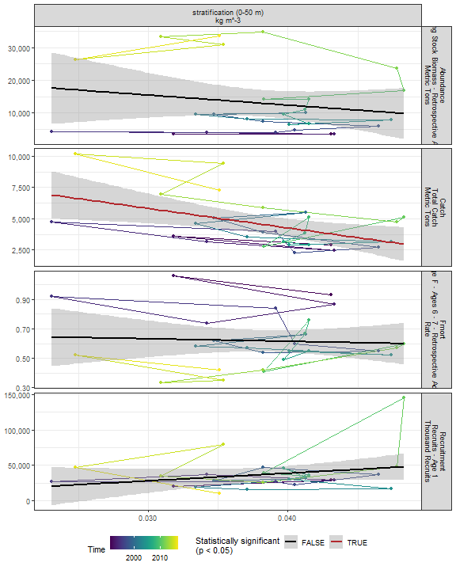

##### Regression statistics

Table 2.10: Catch vs stratification (0-50 m) kg m^-3

|  |  |  |  |  |
| --- | --- | --- | --- | --- |
|  | Estimate | Std. Error | t value | Pr(>|t|) |
| (Intercept) | 10497.99 | 2181.53 | 4.81 | 0.00 |
| Val | -155908.94 | 56111.74 | -2.78 | 0.01 |

|  |  |
| --- | --- |
| Name | Value |
| F-statistic | 7.72 |
| df | 1, 25 |
| R2 | 0.24 |
| R2-adj | 0.21 |

### 2.2.3 Wind

#### 2.2.3.1 Winter wind speed

##### Figures

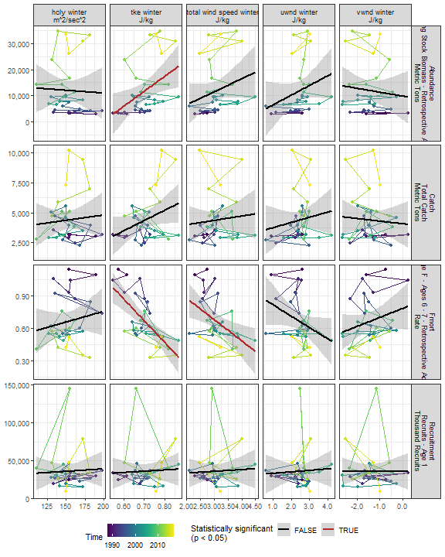

##### Regression statistics

Table 2.11: Fmort vs tke winter J/kg

|  |  |  |  |  |
| --- | --- | --- | --- | --- |
|  | Estimate | Std. Error | t value | Pr(>|t|) |
| (Intercept) | 2.06 | 0.28 | 7.41 | 0 |
| Val | -1.98 | 0.39 | -5.05 | 0 |

|  |  |
| --- | --- |
| Name | Value |
| F-statistic | 25.46 |
| df | 1, 28 |
| R2 | 0.48 |
| R2-adj | 0.46 |

Table 2.11: Fmort vs total wind speed winter J/kg

|  |  |  |  |  |
| --- | --- | --- | --- | --- |
|  | Estimate | Std. Error | t value | Pr(>|t|) |
| (Intercept) | 1.27 | 0.21 | 5.93 | 0.00 |
| Val | -0.20 | 0.07 | -2.87 | 0.01 |

|  |  |
| --- | --- |
| Name | Value |
| F-statistic | 8.23 |
| df | 1, 28 |
| R2 | 0.23 |
| R2-adj | 0.2 |

Table 2.11: Abundance vs tke winter J/kg

|  |  |  |  |  |
| --- | --- | --- | --- | --- |
|  | Estimate | Std. Error | t value | Pr(>|t|) |
| (Intercept) | -28194.90 | 15487.66 | -1.82 | 0.08 |
| Val | 56959.11 | 21884.15 | 2.60 | 0.01 |

|  |  |
| --- | --- |
| Name | Value |
| F-statistic | 6.77 |
| df | 1, 28 |
| R2 | 0.19 |
| R2-adj | 0.17 |

#### 2.2.3.2 Spring wind speed

##### Figures

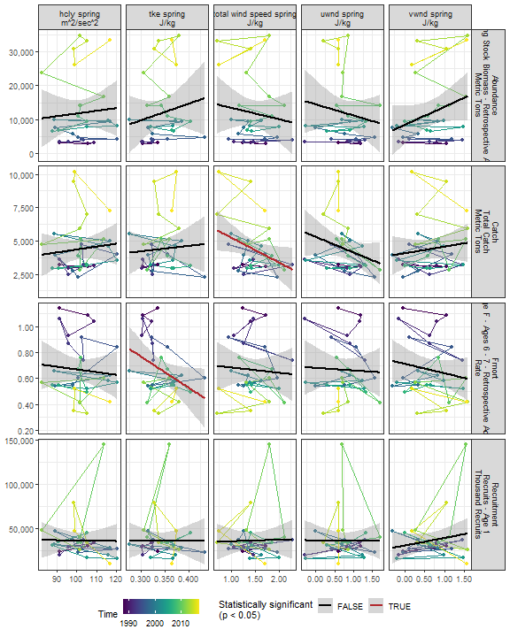

##### Regression statistics

Table 2.12: Catch vs total wind speed spring J/kg

|  |  |  |  |  |
| --- | --- | --- | --- | --- |
|  | Estimate | Std. Error | t value | Pr(>|t|) |
| (Intercept) | 7094.50 | 1329.36 | 5.34 | 0.00 |
| Val | -1863.44 | 880.92 | -2.12 | 0.04 |

|  |  |
| --- | --- |
| Name | Value |
| F-statistic | 4.47 |
| df | 1, 28 |
| R2 | 0.14 |
| R2-adj | 0.11 |

Table 2.12: Fmort vs tke spring J/kg

|  |  |  |  |  |
| --- | --- | --- | --- | --- |
|  | Estimate | Std. Error | t value | Pr(>|t|) |
| (Intercept) | 1.48 | 0.39 | 3.78 | 0.00 |
| Val | -2.39 | 1.14 | -2.10 | 0.04 |

|  |  |
| --- | --- |
| Name | Value |
| F-statistic | 4.41 |
| df | 1, 28 |
| R2 | 0.14 |
| R2-adj | 0.11 |

#### 2.2.3.3 Summer wind speed

##### Figures

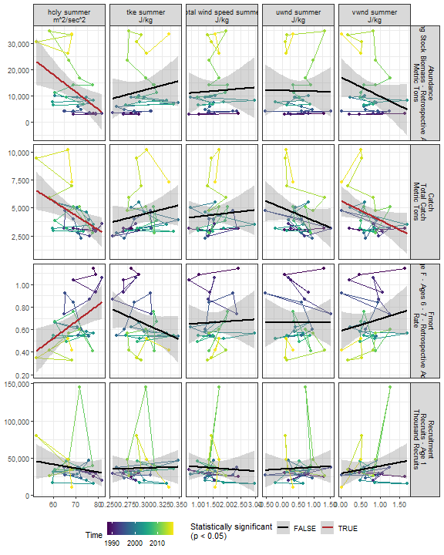

##### Regression statistics

Table 2.13: Catch vs hcly summer m2/sec2

|  |  |  |  |  |
| --- | --- | --- | --- | --- |
|  | Estimate | Std. Error | t value | Pr(>|t|) |
| (Intercept) | 13201.22 | 3175.90 | 4.16 | 0.00 |
| Val | -127.08 | 45.49 | -2.79 | 0.01 |

|  |  |
| --- | --- |
| Name | Value |
| F-statistic | 7.8 |
| df | 1, 28 |
| R2 | 0.22 |
| R2-adj | 0.19 |

Table 2.13: Catch vs vwnd summer J/kg

|  |  |  |  |  |
| --- | --- | --- | --- | --- |
|  | Estimate | Std. Error | t value | Pr(>|t|) |
| (Intercept) | 5599.38 | 686.23 | 8.16 | 0.00 |
| Val | -1703.64 | 830.36 | -2.05 | 0.05 |

|  |  |
| --- | --- |
| Name | Value |
| F-statistic | 4.21 |
| df | 1, 28 |
| R2 | 0.13 |
| R2-adj | 0.1 |

Table 2.13: Fmort vs hcly summer m2/sec2

|  |  |  |  |  |
| --- | --- | --- | --- | --- |
|  | Estimate | Std. Error | t value | Pr(>|t|) |
| (Intercept) | -0.37 | 0.37 | -1.00 | 0.32 |
| Val | 0.01 | 0.01 | 2.82 | 0.01 |

|  |  |
| --- | --- |
| Name | Value |
| F-statistic | 7.97 |
| df | 1, 28 |
| R2 | 0.22 |
| R2-adj | 0.19 |

Table 2.13: Abundance vs hcly summer m2/sec2

|  |  |  |  |  |
| --- | --- | --- | --- | --- |
|  | Estimate | Std. Error | t value | Pr(>|t|) |
| (Intercept) | 57832.49 | 16591.63 | 3.49 | 0.00 |
| Val | -661.64 | 237.63 | -2.78 | 0.01 |

|  |  |
| --- | --- |
| Name | Value |
| F-statistic | 7.75 |
| df | 1, 28 |
| R2 | 0.22 |
| R2-adj | 0.19 |

#### 2.2.3.4 Fall wind speed

##### Figures

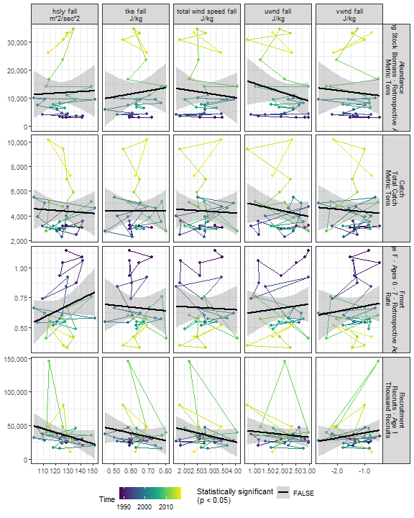

##### Regression statistics

[1] “No statistically significant data”

### 2.2.4 Gulf Stream Index

##### Figures

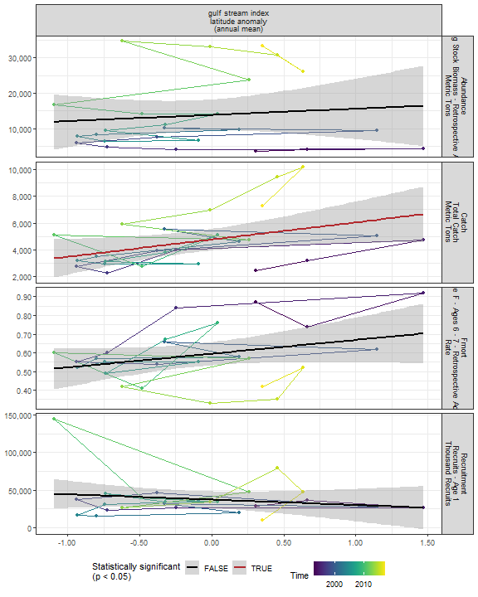

##### Regression statistics

Table 2.14: Catch vs gulf stream index latitude anomaly (annual mean)

|  |  |  |  |  |
| --- | --- | --- | --- | --- |
|  | Estimate | Std. Error | t value | Pr(>|t|) |
| (Intercept) | 4764.51 | 387.91 | 12.28 | 0.00 |
| Val | 1279.11 | 581.57 | 2.20 | 0.04 |

|  |  |
| --- | --- |
| Name | Value |
| F-statistic | 4.84 |
| df | 1, 23 |
| R2 | 0.17 |
| R2-adj | 0.14 |

### 2.2.5 North Atlantic Oscillation

##### Figures

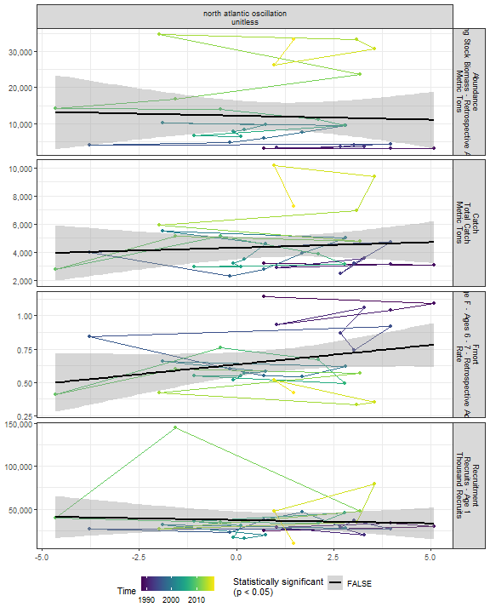

##### Regression statistics

[1] “No statistically significant data”

### 2.2.6 Species location

#### 2.2.6.1 Species distribution

##### Figures

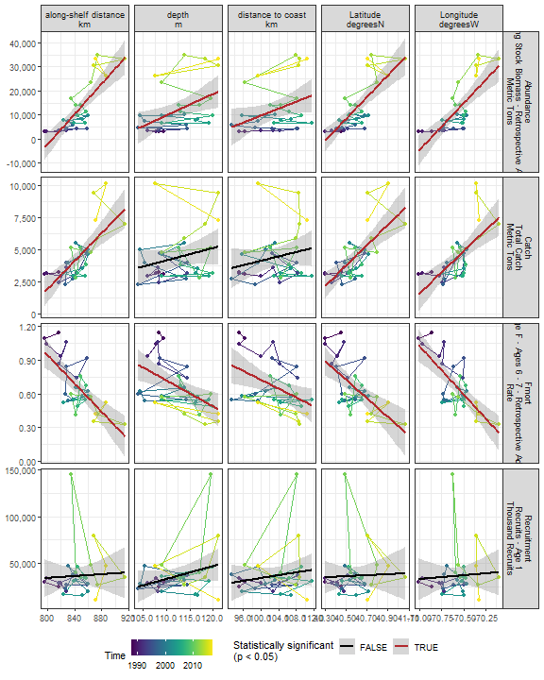

##### Regression statistics

Table 2.15: Catch vs Latitude degreesN

|  |  |  |  |  |
| --- | --- | --- | --- | --- |
|  | Estimate | Std. Error | t value | Pr(>|t|) |
| (Intercept) | -319031.69 | 61804.05 | -5.16 | 0 |
| Val | 7970.74 | 1523.23 | 5.23 | 0 |

|  |  |
| --- | --- |
| Name | Value |
| F-statistic | 27.38 |
| df | 1, 28 |
| R2 | 0.49 |
| R2-adj | 0.48 |

Table 2.15: Catch vs Longitude degreesW

|  |  |  |  |  |
| --- | --- | --- | --- | --- |
|  | Estimate | Std. Error | t value | Pr(>|t|) |
| (Intercept) | 466397.08 | 98581.22 | 4.73 | 0 |
| Val | 6546.14 | 1396.74 | 4.69 | 0 |

|  |  |
| --- | --- |
| Name | Value |
| F-statistic | 21.97 |
| df | 1, 28 |
| R2 | 0.44 |
| R2-adj | 0.42 |

Table 2.15: Catch vs along-shelf distance km

|  |  |  |  |  |
| --- | --- | --- | --- | --- |
|  | Estimate | Std. Error | t value | Pr(>|t|) |
| (Intercept) | -42302.73 | 8777.68 | -4.82 | 0 |
| Val | 55.25 | 10.39 | 5.32 | 0 |

|  |  |
| --- | --- |
| Name | Value |
| F-statistic | 28.3 |
| df | 1, 28 |
| R2 | 0.5 |
| R2-adj | 0.48 |

Table 2.15: Fmort vs Latitude degreesN

|  |  |  |  |  |
| --- | --- | --- | --- | --- |
|  | Estimate | Std. Error | t value | Pr(>|t|) |
| (Intercept) | 34.22 | 7.84 | 4.36 | 0 |
| Val | -0.83 | 0.19 | -4.28 | 0 |

|  |  |
| --- | --- |
| Name | Value |
| F-statistic | 18.31 |
| df | 1, 28 |
| R2 | 0.4 |
| R2-adj | 0.37 |

Table 2.15: Fmort vs Longitude degreesW

|  |  |  |  |  |
| --- | --- | --- | --- | --- |
|  | Estimate | Std. Error | t value | Pr(>|t|) |
| (Intercept) | -59.23 | 10.26 | -5.77 | 0 |
| Val | -0.85 | 0.15 | -5.84 | 0 |

|  |  |
| --- | --- |
| Name | Value |
| F-statistic | 34.06 |
| df | 1, 28 |
| R2 | 0.55 |
| R2-adj | 0.53 |

Table 2.15: Fmort vs along-shelf distance km

|  |  |  |  |  |
| --- | --- | --- | --- | --- |
|  | Estimate | Std. Error | t value | Pr(>|t|) |
| (Intercept) | 6.03 | 1.03 | 5.86 | 0 |
| Val | -0.01 | 0.00 | -5.22 | 0 |

|  |  |
| --- | --- |
| Name | Value |
| F-statistic | 27.24 |
| df | 1, 28 |
| R2 | 0.49 |
| R2-adj | 0.48 |

Table 2.15: Fmort vs depth m

|  |  |  |  |  |
| --- | --- | --- | --- | --- |
|  | Estimate | Std. Error | t value | Pr(>|t|) |
| (Intercept) | 3.25 | 0.78 | 4.17 | 0 |
| Val | -0.02 | 0.01 | -3.33 | 0 |

|  |  |
| --- | --- |
| Name | Value |
| F-statistic | 11.07 |
| df | 1, 28 |
| R2 | 0.28 |
| R2-adj | 0.26 |

Table 2.15: Fmort vs distance to coast km

|  |  |  |  |  |
| --- | --- | --- | --- | --- |
|  | Estimate | Std. Error | t value | Pr(>|t|) |
| (Intercept) | 2.69 | 0.76 | 3.56 | 0.00 |
| Val | -0.02 | 0.01 | -2.69 | 0.01 |

|  |  |
| --- | --- |
| Name | Value |
| F-statistic | 7.21 |
| df | 1, 28 |
| R2 | 0.2 |
| R2-adj | 0.18 |

Table 2.15: Abundance vs Latitude degreesN

|  |  |  |  |  |
| --- | --- | --- | --- | --- |
|  | Estimate | Std. Error | t value | Pr(>|t|) |
| (Intercept) | -1823618.58 | 292531.51 | -6.23 | 0 |
| Val | 45237.98 | 7209.74 | 6.27 | 0 |

|  |  |
| --- | --- |
| Name | Value |
| F-statistic | 39.37 |
| df | 1, 28 |
| R2 | 0.58 |
| R2-adj | 0.57 |

Table 2.15: Abundance vs Longitude degreesW

|  |  |  |  |  |
| --- | --- | --- | --- | --- |
|  | Estimate | Std. Error | t value | Pr(>|t|) |
| (Intercept) | 2727010.57 | 457526.1 | 5.96 | 0 |
| Val | 38469.23 | 6482.4 | 5.93 | 0 |

|  |  |
| --- | --- |
| Name | Value |
| F-statistic | 35.22 |
| df | 1, 28 |
| R2 | 0.56 |
| R2-adj | 0.54 |

Table 2.15: Abundance vs along-shelf distance km

|  |  |  |  |  |
| --- | --- | --- | --- | --- |
|  | Estimate | Std. Error | t value | Pr(>|t|) |
| (Intercept) | -256928.6 | 40489.81 | -6.35 | 0 |
| Val | 318.2 | 47.91 | 6.64 | 0 |

|  |  |
| --- | --- |
| Name | Value |
| F-statistic | 44.11 |
| df | 1, 28 |
| R2 | 0.61 |
| R2-adj | 0.6 |

Table 2.15: Abundance vs depth m

|  |  |  |  |  |
| --- | --- | --- | --- | --- |
|  | Estimate | Std. Error | t value | Pr(>|t|) |
| (Intercept) | -88012.35 | 36859.04 | -2.39 | 0.02 |
| Val | 888.82 | 327.65 | 2.71 | 0.01 |

|  |  |
| --- | --- |
| Name | Value |
| F-statistic | 7.36 |
| df | 1, 28 |
| R2 | 0.21 |
| R2-adj | 0.18 |

Table 2.15: Abundance vs distance to coast km

|  |  |  |  |  |
| --- | --- | --- | --- | --- |
|  | Estimate | Std. Error | t value | Pr(>|t|) |
| (Intercept) | -63089.82 | 35460.10 | -1.78 | 0.09 |
| Val | 727.37 | 343.65 | 2.12 | 0.04 |

|  |  |
| --- | --- |
| Name | Value |
| F-statistic | 4.48 |
| df | 1, 28 |
| R2 | 0.14 |
| R2-adj | 0.11 |

#### 2.2.6.2 Northern range

Northernmost survey observation in each year.

##### Figures

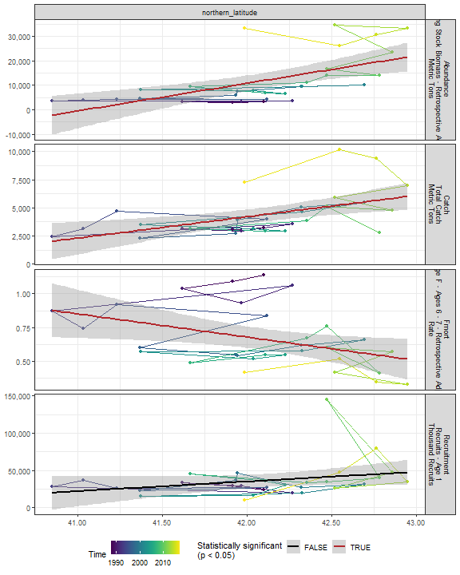

##### Regression statistics

Table 2.16: Catch vs northern_latitude

|  |  |  |  |  |
| --- | --- | --- | --- | --- |
|  | Estimate | Std. Error | t value | Pr(>|t|) |
| (Intercept) | -75719.07 | 24386.09 | -3.11 | 0 |
| Val | 1902.75 | 579.29 | 3.28 | 0 |

|  |  |
| --- | --- |
| Name | Value |
| F-statistic | 10.79 |
| df | 1, 28 |
| R2 | 0.28 |
| R2-adj | 0.25 |

Table 2.16: Fmort vs northern_latitude

|  |  |  |  |  |
| --- | --- | --- | --- | --- |
|  | Estimate | Std. Error | t value | Pr(>|t|) |
| (Intercept) | 7.90 | 3.04 | 2.60 | 0.01 |
| Val | -0.17 | 0.07 | -2.38 | 0.02 |

|  |  |
| --- | --- |
| Name | Value |
| F-statistic | 5.68 |
| df | 1, 28 |
| R2 | 0.17 |
| R2-adj | 0.14 |

Table 2.16: Abundance vs northern_latitude

|  |  |  |  |  |
| --- | --- | --- | --- | --- |
|  | Estimate | Std. Error | t value | Pr(>|t|) |
| (Intercept) | -464174.26 | 119818.27 | -3.87 | 0 |
| Val | 11309.31 | 2846.26 | 3.97 | 0 |

|  |  |
| --- | --- |
| Name | Value |
| F-statistic | 15.79 |
| df | 1, 28 |
| R2 | 0.36 |
| R2-adj | 0.34 |

#### 2.2.6.3 Southern range

Southernmost survey observation in each year.

##### Figures

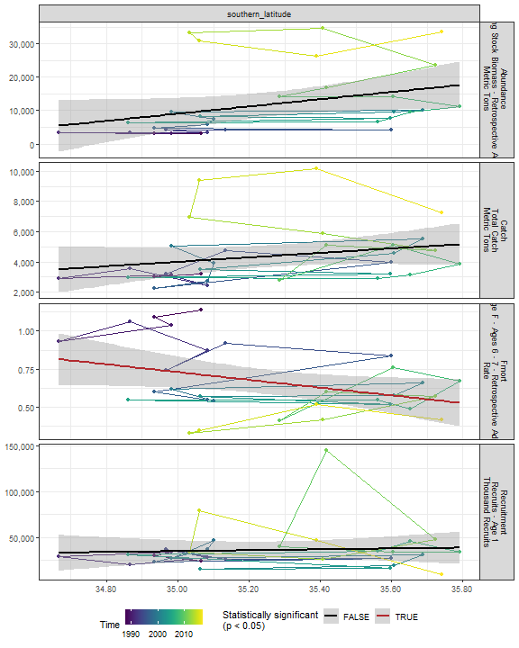

##### Regression statistics

Table 2.17: Fmort vs southern_latitude

|  |  |  |  |  |
| --- | --- | --- | --- | --- |
|  | Estimate | Std. Error | t value | Pr(>|t|) |
| (Intercept) | 9.63 | 4.31 | 2.24 | 0.03 |
| Val | -0.25 | 0.12 | -2.08 | 0.05 |

|  |  |
| --- | --- |
| Name | Value |
| F-statistic | 4.33 |
| df | 1, 28 |
| R2 | 0.13 |
| R2-adj | 0.1 |

## 2.3 Trophic indicators

### 2.3.1 Chlorophyll

#### 2.3.1.1 Annual chlorophyll

##### Figures

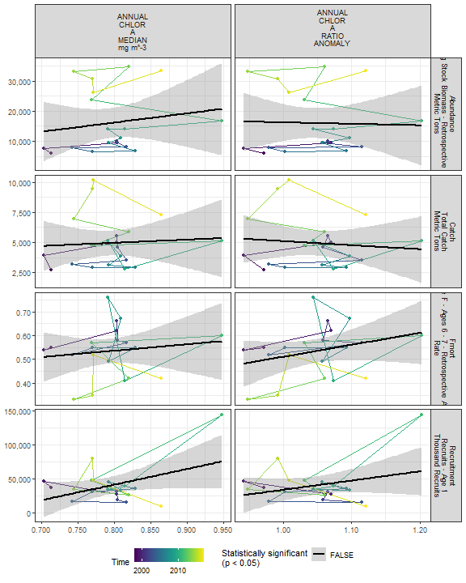

##### Regression statistics

[1] “No statistically significant data”

#### 2.3.1.2 Monthly chlorophyll

##### Figures

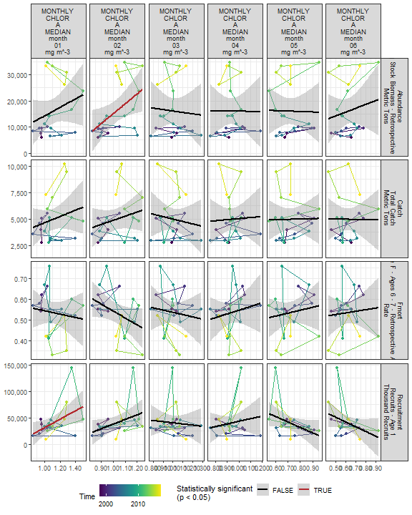

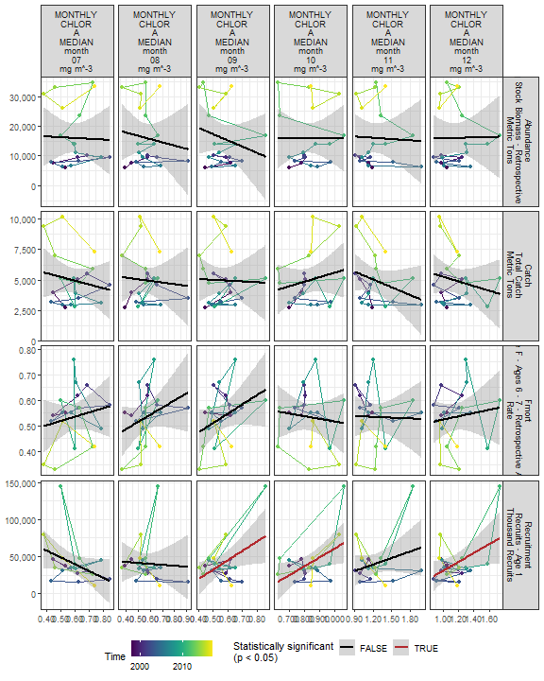

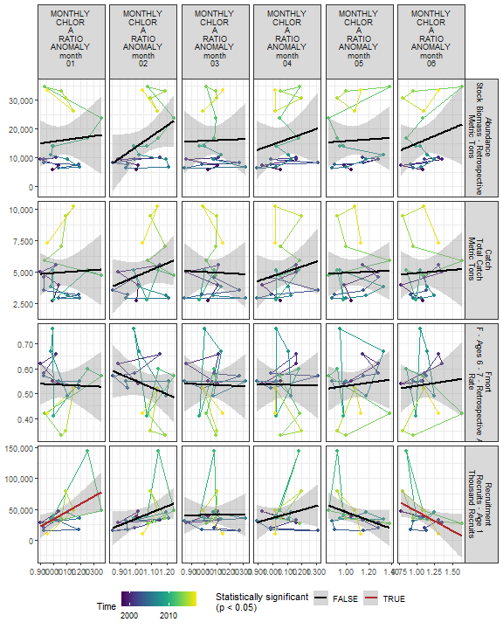

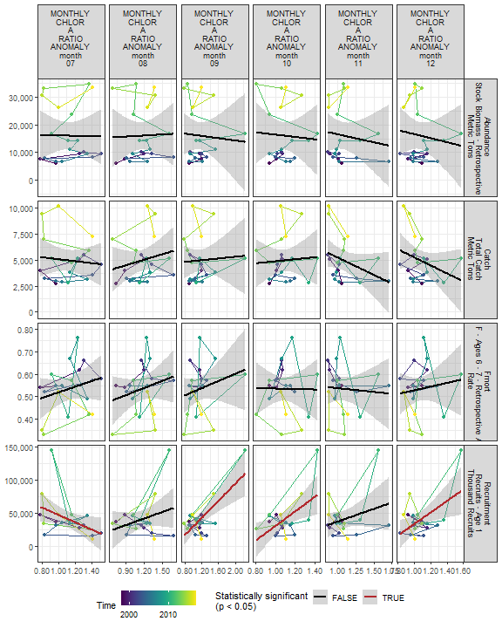

##### Regression statistics

Table 2.18: Recruitment vs MONTHLY CHLOR A MEDIAN month 01 mg m^-3

|  |  |  |  |  |
| --- | --- | --- | --- | --- |
|  | Estimate | Std. Error | t value | Pr(>|t|) |
| (Intercept) | -48790.65 | 38702.49 | -1.26 | 0.22 |
| Val | 80402.07 | 34557.96 | 2.33 | 0.03 |

|  |  |
| --- | --- |
| Name | Value |
| F-statistic | 5.41 |
| df | 1, 18 |
| R2 | 0.23 |
| R2-adj | 0.19 |

Table 2.18: Recruitment vs MONTHLY CHLOR A MEDIAN month 09 mg m^-3

|  |  |  |  |  |
| --- | --- | --- | --- | --- |
|  | Estimate | Std. Error | t value | Pr(>|t|) |
| (Intercept) | -30512.66 | 31671.11 | -0.96 | 0.35 |
| Val | 126046.99 | 55460.09 | 2.27 | 0.04 |

|  |  |
| --- | --- |
| Name | Value |
| F-statistic | 5.17 |
| df | 1, 18 |
| R2 | 0.22 |
| R2-adj | 0.18 |

Table 2.18: Recruitment vs MONTHLY CHLOR A MEDIAN month 10 mg m^-3

|  |  |  |  |  |
| --- | --- | --- | --- | --- |
|  | Estimate | Std. Error | t value | Pr(>|t|) |
| (Intercept) | -58972.92 | 41888.04 | -1.41 | 0.18 |
| Val | 119930.93 | 50155.28 | 2.39 | 0.03 |

|  |  |
| --- | --- |
| Name | Value |
| F-statistic | 5.72 |
| df | 1, 18 |
| R2 | 0.24 |
| R2-adj | 0.2 |

Table 2.18: Recruitment vs MONTHLY CHLOR A MEDIAN month 12 mg m^-3

|  |  |  |  |  |
| --- | --- | --- | --- | --- |
|  | Estimate | Std. Error | t value | Pr(>|t|) |
| (Intercept) | -28128.64 | 30791.43 | -0.91 | 0.37 |
| Val | 59258.27 | 26205.33 | 2.26 | 0.04 |

|  |  |
| --- | --- |
| Name | Value |
| F-statistic | 5.11 |
| df | 1, 18 |
| R2 | 0.22 |
| R2-adj | 0.18 |

Table 2.18: Recruitment vs MONTHLY CHLOR A RATIO ANOMALY month 01

|  |  |  |  |  |
| --- | --- | --- | --- | --- |
|  | Estimate | Std. Error | t value | Pr(>|t|) |
| (Intercept) | -90170.06 | 50340.00 | -1.79 | 0.09 |
| Val | 123507.66 | 47376.97 | 2.61 | 0.02 |

|  |  |
| --- | --- |
| Name | Value |
| F-statistic | 6.8 |
| df | 1, 18 |
| R2 | 0.27 |
| R2-adj | 0.23 |

Table 2.18: Recruitment vs MONTHLY CHLOR A RATIO ANOMALY month 06

|  |  |  |  |  |
| --- | --- | --- | --- | --- |
|  | Estimate | Std. Error | t value | Pr(>|t|) |
| (Intercept) | 109276.94 | 32531.12 | 3.36 | 0.00 |
| Val | -63170.24 | 29271.24 | -2.16 | 0.04 |

|  |  |
| --- | --- |
| Name | Value |
| F-statistic | 4.66 |
| df | 1, 18 |
| R2 | 0.21 |
| R2-adj | 0.16 |

Table 2.18: Recruitment vs MONTHLY CHLOR A RATIO ANOMALY month 07

|  |  |  |  |  |
| --- | --- | --- | --- | --- |
|  | Estimate | Std. Error | t value | Pr(>|t|) |
| (Intercept) | 102701.67 | 29988.97 | 3.42 | 0.00 |
| Val | -55743.14 | 26235.13 | -2.12 | 0.05 |

|  |  |
| --- | --- |
| Name | Value |
| F-statistic | 4.51 |
| df | 1, 18 |
| R2 | 0.2 |
| R2-adj | 0.16 |

Table 2.18: Recruitment vs MONTHLY CHLOR A RATIO ANOMALY month 09

|  |  |  |  |  |
| --- | --- | --- | --- | --- |
|  | Estimate | Std. Error | t value | Pr(>|t|) |
| (Intercept) | -34875.12 | 17389.82 | -2.01 | 0.06 |
| Val | 64984.61 | 14520.31 | 4.48 | 0.00 |

|  |  |
| --- | --- |
| Name | Value |
| F-statistic | 20.03 |
| df | 1, 18 |
| R2 | 0.53 |
| R2-adj | 0.5 |

Table 2.18: Recruitment vs MONTHLY CHLOR A RATIO ANOMALY month 10

|  |  |  |  |  |
| --- | --- | --- | --- | --- |
|  | Estimate | Std. Error | t value | Pr(>|t|) |
| (Intercept) | -81402.47 | 43485.60 | -1.87 | 0.08 |
| Val | 111729.38 | 39620.92 | 2.82 | 0.01 |

|  |  |
| --- | --- |
| Name | Value |
| F-statistic | 7.95 |
| df | 1, 18 |
| R2 | 0.31 |
| R2-adj | 0.27 |

Table 2.18: Recruitment vs MONTHLY CHLOR A RATIO ANOMALY month 12

|  |  |  |  |  |
| --- | --- | --- | --- | --- |
|  | Estimate | Std. Error | t value | Pr(>|t|) |
| (Intercept) | -54491.81 | 36267.56 | -1.50 | 0.15 |
| Val | 87765.73 | 33196.56 | 2.64 | 0.02 |

|  |  |
| --- | --- |
| Name | Value |
| F-statistic | 6.99 |
| df | 1, 18 |
| R2 | 0.28 |
| R2-adj | 0.24 |

Table 2.18: Abundance vs MONTHLY CHLOR A MEDIAN month 02 mg m^-3

|  |  |  |  |  |
| --- | --- | --- | --- | --- |
|  | Estimate | Std. Error | t value | Pr(>|t|) |
| (Intercept) | -22704.71 | 16485.44 | -1.38 | 0.19 |
| Val | 37823.24 | 15998.28 | 2.36 | 0.03 |

|  |  |
| --- | --- |
| Name | Value |
| F-statistic | 5.59 |
| df | 1, 18 |
| R2 | 0.24 |
| R2-adj | 0.19 |

#### 2.3.1.3 Weekly chlorophyll

##### Figures

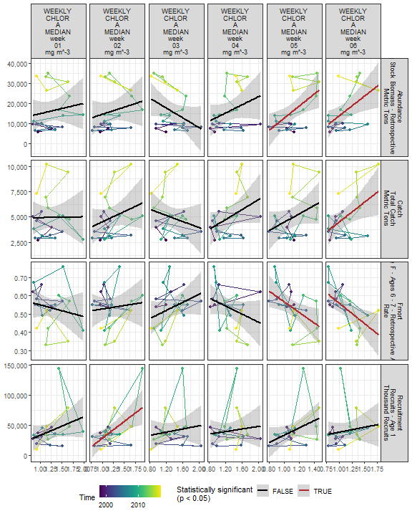

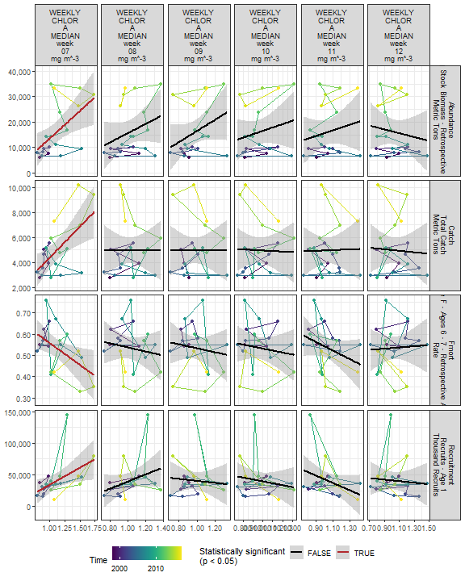

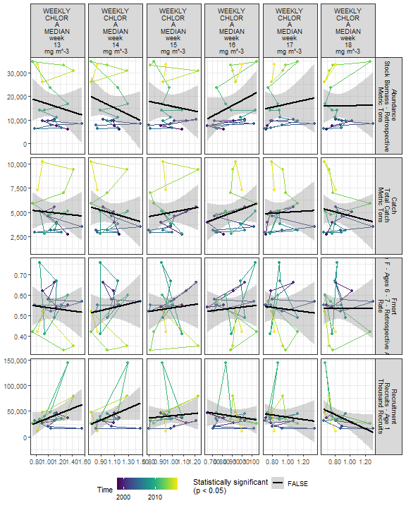

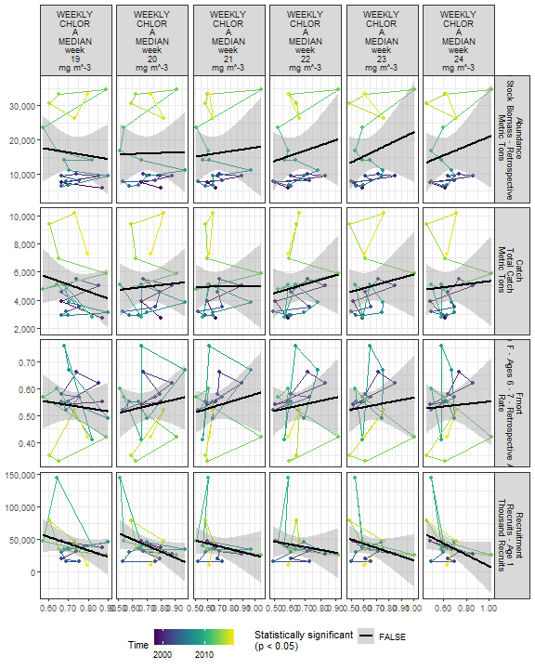

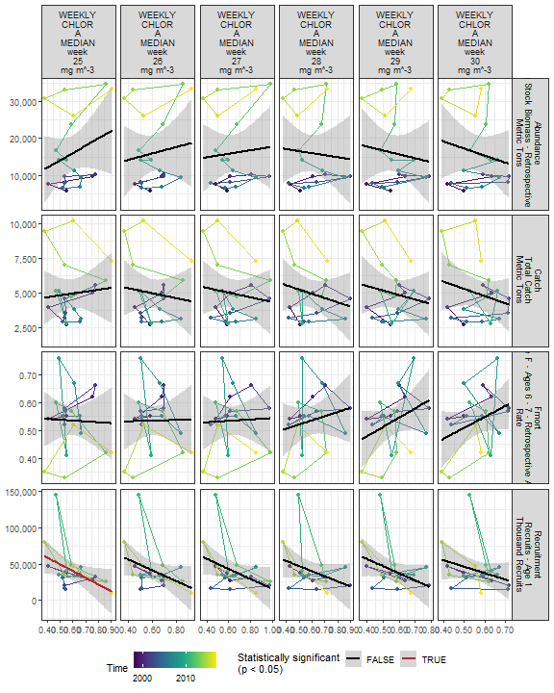

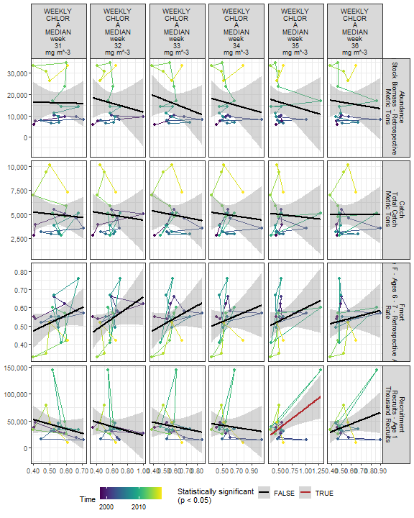

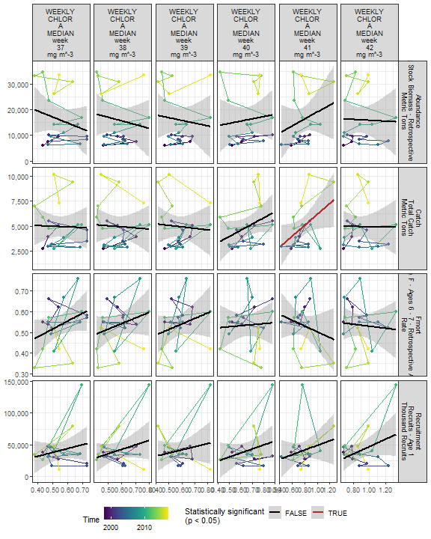

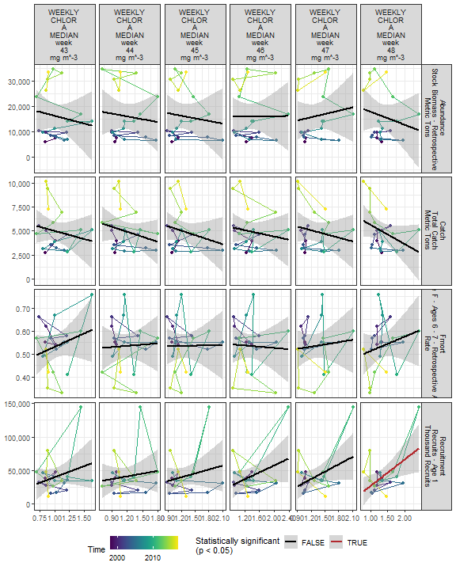

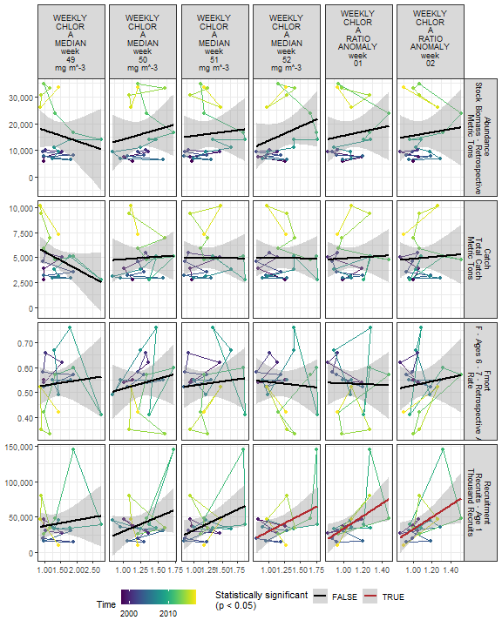

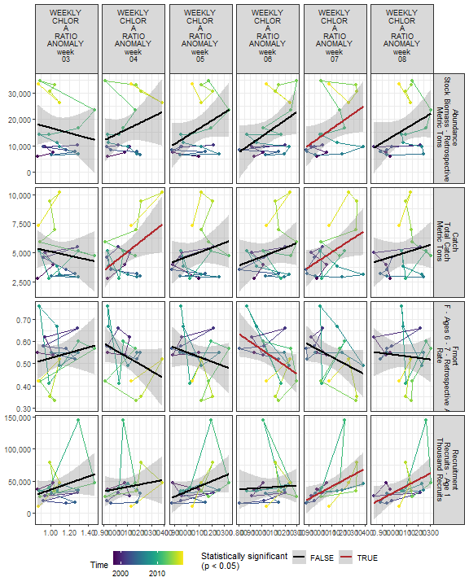

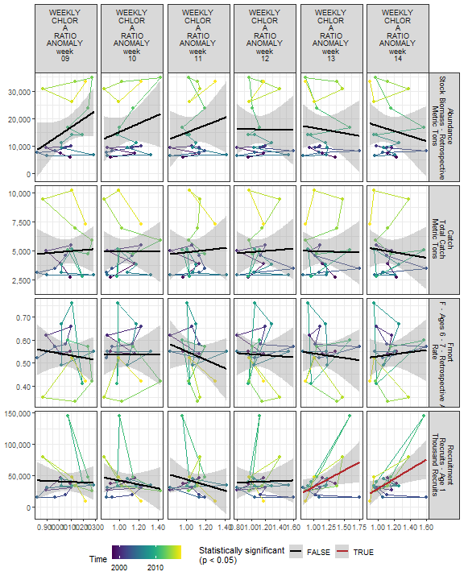

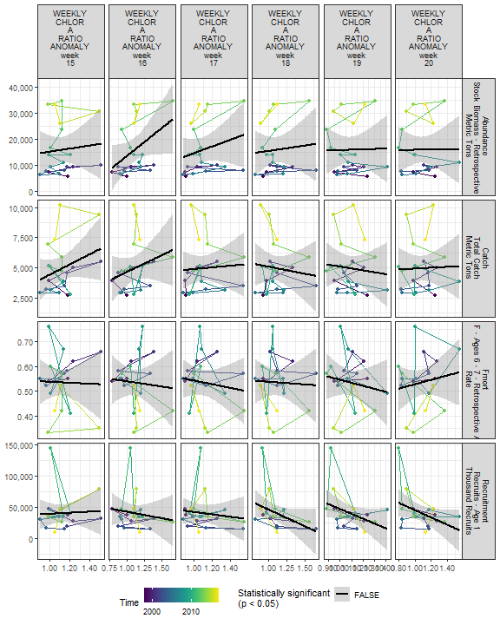

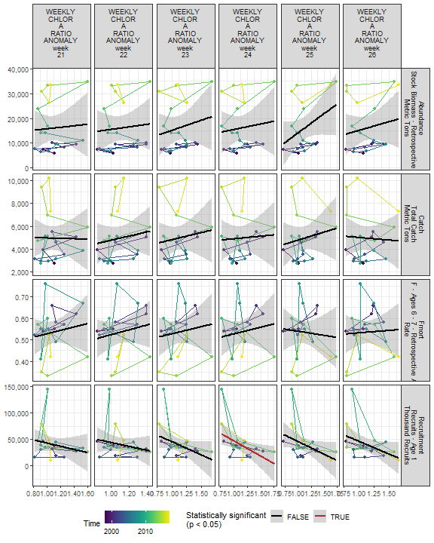

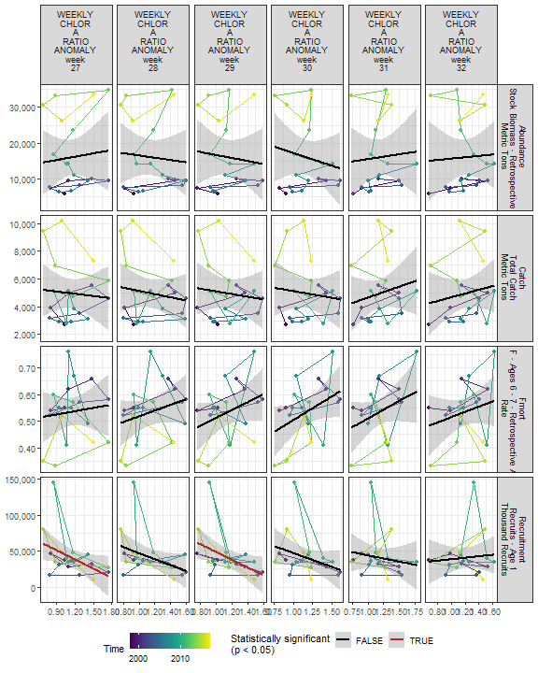

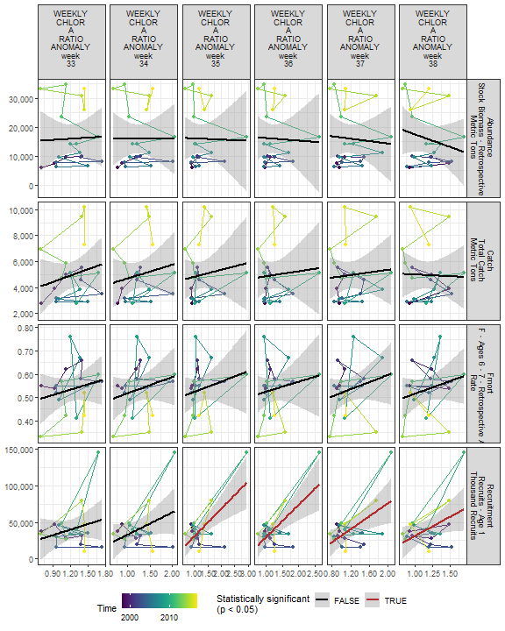

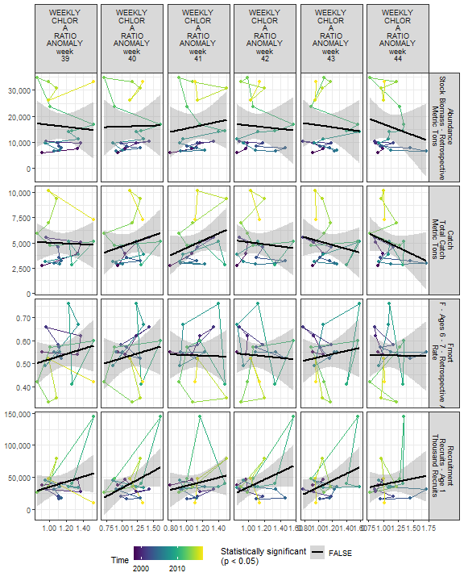

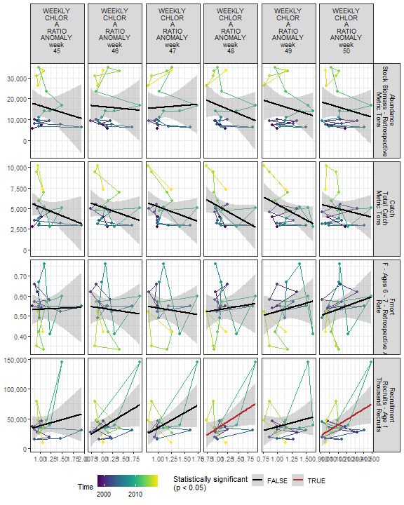

##### Regression statistics

Table 2.19: Catch vs WEEKLY CHLOR A MEDIAN week 06 mg m^-3

|  |  |  |  |  |
| --- | --- | --- | --- | --- |
|  | Estimate | Std. Error | t value | Pr(>|t|) |
| (Intercept) | 588.53 | 1803.58 | 0.33 | 0.75 |
| Val | 3917.01 | 1578.41 | 2.48 | 0.02 |

|  |  |
| --- | --- |
| Name | Value |
| F-statistic | 6.16 |
| df | 1, 18 |
| R2 | 0.25 |
| R2-adj | 0.21 |

Table 2.19: Catch vs WEEKLY CHLOR A MEDIAN week 07 mg m^-3

|  |  |  |  |  |
| --- | --- | --- | --- | --- |
|  | Estimate | Std. Error | t value | Pr(>|t|) |
| (Intercept) | -615.11 | 1706.27 | -0.36 | 0.72 |
| Val | 4992.47 | 1494.04 | 3.34 | 0.00 |

|  |  |
| --- | --- |
| Name | Value |
| F-statistic | 11.17 |
| df | 1, 18 |
| R2 | 0.38 |
| R2-adj | 0.35 |

Table 2.19: Catch vs WEEKLY CHLOR A MEDIAN week 41 mg m^-3

|  |  |  |  |  |
| --- | --- | --- | --- | --- |
|  | Estimate | Std. Error | t value | Pr(>|t|) |
| (Intercept) | 731.57 | 1968.36 | 0.37 | 0.71 |
| Val | 5445.80 | 2484.34 | 2.19 | 0.04 |

|  |  |
| --- | --- |
| Name | Value |
| F-statistic | 4.81 |
| df | 1, 18 |
| R2 | 0.21 |
| R2-adj | 0.17 |

Table 2.19: Catch vs WEEKLY CHLOR A RATIO ANOMALY week 04

|  |  |  |  |  |
| --- | --- | --- | --- | --- |
|  | Estimate | Std. Error | t value | Pr(>|t|) |
| (Intercept) | -3956.51 | 3870.24 | -1.02 | 0.32 |
| Val | 8215.32 | 3552.00 | 2.31 | 0.03 |

|  |  |
| --- | --- |
| Name | Value |
| F-statistic | 5.35 |
| df | 1, 18 |
| R2 | 0.23 |
| R2-adj | 0.19 |

Table 2.19: Catch vs WEEKLY CHLOR A RATIO ANOMALY week 07

|  |  |  |  |  |
| --- | --- | --- | --- | --- |
|  | Estimate | Std. Error | t value | Pr(>|t|) |
| (Intercept) | -1842.67 | 3163.63 | -0.58 | 0.57 |
| Val | 6226.28 | 2876.60 | 2.16 | 0.04 |

|  |  |
| --- | --- |
| Name | Value |
| F-statistic | 4.68 |
| df | 1, 18 |
| R2 | 0.21 |
| R2-adj | 0.16 |

Table 2.19: Fmort vs WEEKLY CHLOR A MEDIAN week 06 mg m^-3

|  |  |  |  |  |
| --- | --- | --- | --- | --- |
|  | Estimate | Std. Error | t value | Pr(>|t|) |
| (Intercept) | 0.78 | 0.09 | 9.00 | 0.00 |
| Val | -0.22 | 0.08 | -2.94 | 0.01 |

|  |  |
| --- | --- |
| Name | Value |
| F-statistic | 8.64 |
| df | 1, 18 |
| R2 | 0.32 |
| R2-adj | 0.29 |

Table 2.19: Fmort vs WEEKLY CHLOR A MEDIAN week 07 mg m^-3

|  |  |  |  |  |
| --- | --- | --- | --- | --- |
|  | Estimate | Std. Error | t value | Pr(>|t|) |
| (Intercept) | 0.76 | 0.09 | 8.05 | 0.00 |
| Val | -0.21 | 0.08 | -2.48 | 0.02 |

|  |  |
| --- | --- |
| Name | Value |
| F-statistic | 6.17 |
| df | 1, 18 |
| R2 | 0.26 |
| R2-adj | 0.21 |

Table 2.19: Fmort vs WEEKLY CHLOR A MEDIAN week 05 mg m^-3

|  |  |  |  |  |
| --- | --- | --- | --- | --- |
|  | Estimate | Std. Error | t value | Pr(>|t|) |
| (Intercept) | 0.86 | 0.13 | 6.55 | 0.00 |
| Val | -0.29 | 0.12 | -2.50 | 0.02 |

|  |  |
| --- | --- |
| Name | Value |
| F-statistic | 6.24 |
| df | 1, 18 |
| R2 | 0.26 |
| R2-adj | 0.22 |

Table 2.19: Fmort vs WEEKLY CHLOR A RATIO ANOMALY week 06

|  |  |  |  |  |
| --- | --- | --- | --- | --- |
|  | Estimate | Std. Error | t value | Pr(>|t|) |
| (Intercept) | 0.93 | 0.17 | 5.31 | 0.00 |
| Val | -0.36 | 0.16 | -2.27 | 0.04 |

|  |  |
| --- | --- |
| Name | Value |
| F-statistic | 5.14 |
| df | 1, 18 |
| R2 | 0.22 |
| R2-adj | 0.18 |

Table 2.19: Recruitment vs WEEKLY CHLOR A MEDIAN week 07 mg m^-3

|  |  |  |  |  |
| --- | --- | --- | --- | --- |
|  | Estimate | Std. Error | t value | Pr(>|t|) |
| (Intercept) | -19596.74 | 25485.61 | -0.77 | 0.45 |
| Val | 53779.76 | 22315.63 | 2.41 | 0.03 |

|  |  |
| --- | --- |
| Name | Value |
| F-statistic | 5.81 |
| df | 1, 18 |
| R2 | 0.24 |
| R2-adj | 0.2 |

Table 2.19: Recruitment vs WEEKLY CHLOR A RATIO ANOMALY week 07

|  |  |  |  |  |
| --- | --- | --- | --- | --- |
|  | Estimate | Std. Error | t value | Pr(>|t|) |
| (Intercept) | -61228.40 | 41400.34 | -1.48 | 0.16 |
| Val | 93151.28 | 37644.19 | 2.47 | 0.02 |

|  |  |
| --- | --- |
| Name | Value |
| F-statistic | 6.12 |
| df | 1, 18 |
| R2 | 0.25 |
| R2-adj | 0.21 |

Table 2.19: Recruitment vs WEEKLY CHLOR A MEDIAN week 02 mg m^-3

|  |  |  |  |  |
| --- | --- | --- | --- | --- |
|  | Estimate | Std. Error | t value | Pr(>|t|) |
| (Intercept) | -27732.83 | 22231.44 | -1.25 | 0.23 |
| Val | 56228.14 | 17857.90 | 3.15 | 0.01 |

|  |  |
| --- | --- |
| Name | Value |
| F-statistic | 9.91 |
| df | 1, 18 |
| R2 | 0.36 |
| R2-adj | 0.32 |

Table 2.19: Recruitment vs WEEKLY CHLOR A MEDIAN week 25 mg m^-3

|  |  |  |  |  |
| --- | --- | --- | --- | --- |
|  | Estimate | Std. Error | t value | Pr(>|t|) |
| (Intercept) | 95192.87 | 26716.81 | 3.56 | 0.00 |
| Val | -91840.38 | 43534.72 | -2.11 | 0.05 |

|  |  |
| --- | --- |
| Name | Value |
| F-statistic | 4.45 |
| df | 1, 18 |
| R2 | 0.2 |
| R2-adj | 0.15 |

Table 2.19: Recruitment vs WEEKLY CHLOR A MEDIAN week 35 mg m^-3

|  |  |  |  |  |
| --- | --- | --- | --- | --- |
|  | Estimate | Std. Error | t value | Pr(>|t|) |
| (Intercept) | -3048.75 | 15676.05 | -0.19 | 0.85 |
| Val | 76540.35 | 25998.58 | 2.94 | 0.01 |

|  |  |
| --- | --- |
| Name | Value |
| F-statistic | 8.67 |
| df | 1, 18 |
| R2 | 0.33 |
| R2-adj | 0.29 |

Table 2.19: Recruitment vs WEEKLY CHLOR A MEDIAN week 48 mg m^-3

|  |  |  |  |  |
| --- | --- | --- | --- | --- |
|  | Estimate | Std. Error | t value | Pr(>|t|) |
| (Intercept) | -12977.21 | 21044.81 | -0.62 | 0.55 |
| Val | 39673.24 | 15118.30 | 2.62 | 0.02 |

|  |  |
| --- | --- |
| Name | Value |
| F-statistic | 6.89 |
| df | 1, 18 |
| R2 | 0.28 |
| R2-adj | 0.24 |

Table 2.19: Recruitment vs WEEKLY CHLOR A MEDIAN week 52 mg m^-3

|  |  |  |  |  |
| --- | --- | --- | --- | --- |
|  | Estimate | Std. Error | t value | Pr(>|t|) |
| (Intercept) | -16049.99 | 26648.21 | -0.60 | 0.55 |
| Val | 45920.04 | 21201.89 | 2.17 | 0.04 |

|  |  |
| --- | --- |
| Name | Value |
| F-statistic | 4.69 |
| df | 1, 18 |
| R2 | 0.21 |
| R2-adj | 0.16 |

Table 2.19: Recruitment vs WEEKLY CHLOR A RATIO ANOMALY week 01

|  |  |  |  |  |
| --- | --- | --- | --- | --- |
|  | Estimate | Std. Error | t value | Pr(>|t|) |
| (Intercept) | -54296.60 | 36897.52 | -1.47 | 0.16 |
| Val | 87937.65 | 33918.95 | 2.59 | 0.02 |

|  |  |
| --- | --- |
| Name | Value |
| F-statistic | 6.72 |
| df | 1, 18 |
| R2 | 0.27 |
| R2-adj | 0.23 |

Table 2.19: Recruitment vs WEEKLY CHLOR A RATIO ANOMALY week 02

|  |  |  |  |  |
| --- | --- | --- | --- | --- |
|  | Estimate | Std. Error | t value | Pr(>|t|) |
| (Intercept) | -52963.81 | 41041.21 | -1.29 | 0.21 |
| Val | 85734.69 | 37372.09 | 2.29 | 0.03 |

|  |  |
| --- | --- |
| Name | Value |
| F-statistic | 5.26 |
| df | 1, 18 |
| R2 | 0.23 |
| R2-adj | 0.18 |

Table 2.19: Recruitment vs WEEKLY CHLOR A RATIO ANOMALY week 08

|  |  |  |  |  |
| --- | --- | --- | --- | --- |
|  | Estimate | Std. Error | t value | Pr(>|t|) |
| (Intercept) | -63958.29 | 47034.52 | -1.36 | 0.19 |
| Val | 96655.97 | 43292.02 | 2.23 | 0.04 |

|  |  |
| --- | --- |
| Name | Value |
| F-statistic | 4.98 |
| df | 1, 18 |
| R2 | 0.22 |
| R2-adj | 0.17 |

Table 2.19: Recruitment vs WEEKLY CHLOR A RATIO ANOMALY week 13

|  |  |  |  |  |
| --- | --- | --- | --- | --- |
|  | Estimate | Std. Error | t value | Pr(>|t|) |
| (Intercept) | -19576.81 | 28055.15 | -0.70 | 0.49 |
| Val | 52027.38 | 23860.13 | 2.18 | 0.04 |

|  |  |
| --- | --- |
| Name | Value |
| F-statistic | 4.75 |
| df | 1, 18 |
| R2 | 0.21 |
| R2-adj | 0.17 |

Table 2.19: Recruitment vs WEEKLY CHLOR A RATIO ANOMALY week 14

|  |  |  |  |  |
| --- | --- | --- | --- | --- |
|  | Estimate | Std. Error | t value | Pr(>|t|) |
| (Intercept) | -46787.02 | 33918.92 | -1.38 | 0.18 |
| Val | 76488.01 | 29397.33 | 2.60 | 0.02 |

|  |  |
| --- | --- |
| Name | Value |
| F-statistic | 6.77 |
| df | 1, 18 |
| R2 | 0.27 |
| R2-adj | 0.23 |

Table 2.19: Recruitment vs WEEKLY CHLOR A RATIO ANOMALY week 24

|  |  |  |  |  |
| --- | --- | --- | --- | --- |
|  | Estimate | Std. Error | t value | Pr(>|t|) |
| (Intercept) | 104687.88 | 26774.02 | 3.91 | 0.00 |
| Val | -57552.11 | 23354.98 | -2.46 | 0.02 |

|  |  |
| --- | --- |
| Name | Value |
| F-statistic | 6.07 |
| df | 1, 18 |
| R2 | 0.25 |
| R2-adj | 0.21 |

Table 2.19: Recruitment vs WEEKLY CHLOR A RATIO ANOMALY week 27

|  |  |  |  |  |
| --- | --- | --- | --- | --- |
|  | Estimate | Std. Error | t value | Pr(>|t|) |
| (Intercept) | 88801.97 | 23509.65 | 3.78 | 0.00 |
| Val | -42370.85 | 19851.28 | -2.13 | 0.05 |

|  |  |
| --- | --- |
| Name | Value |
| F-statistic | 4.56 |
| df | 1, 18 |
| R2 | 0.2 |
| R2-adj | 0.16 |

Table 2.19: Recruitment vs WEEKLY CHLOR A RATIO ANOMALY week 29

|  |  |  |  |  |
| --- | --- | --- | --- | --- |
|  | Estimate | Std. Error | t value | Pr(>|t|) |
| (Intercept) | 102832.28 | 27960.36 | 3.68 | 0.00 |
| Val | -54251.99 | 23701.27 | -2.29 | 0.03 |

|  |  |
| --- | --- |
| Name | Value |
| F-statistic | 5.24 |
| df | 1, 18 |
| R2 | 0.23 |
| R2-adj | 0.18 |

Table 2.19: Recruitment vs WEEKLY CHLOR A RATIO ANOMALY week 35

|  |  |  |  |  |
| --- | --- | --- | --- | --- |
|  | Estimate | Std. Error | t value | Pr(>|t|) |
| (Intercept) | -6669.01 | 13051.08 | -0.51 | 0.62 |
| Val | 37479.80 | 9669.90 | 3.88 | 0.00 |

|  |  |
| --- | --- |
| Name | Value |
| F-statistic | 15.02 |
| df | 1, 18 |
| R2 | 0.45 |
| R2-adj | 0.42 |

Table 2.19: Recruitment vs WEEKLY CHLOR A RATIO ANOMALY week 36

|  |  |  |  |  |
| --- | --- | --- | --- | --- |
|  | Estimate | Std. Error | t value | Pr(>|t|) |
| (Intercept) | -13460.27 | 15193.41 | -0.89 | 0.39 |
| Val | 43740.95 | 11696.90 | 3.74 | 0.00 |

|  |  |
| --- | --- |
| Name | Value |
| F-statistic | 13.98 |
| df | 1, 18 |
| R2 | 0.44 |
| R2-adj | 0.41 |

Table 2.19: Recruitment vs WEEKLY CHLOR A RATIO ANOMALY week 37

|  |  |  |  |  |
| --- | --- | --- | --- | --- |
|  | Estimate | Std. Error | t value | Pr(>|t|) |
| (Intercept) | -12481.04 | 18926.54 | -0.66 | 0.52 |
| Val | 44130.20 | 15170.33 | 2.91 | 0.01 |

|  |  |
| --- | --- |
| Name | Value |
| F-statistic | 8.46 |
| df | 1, 18 |
| R2 | 0.32 |
| R2-adj | 0.28 |

Table 2.19: Recruitment vs WEEKLY CHLOR A RATIO ANOMALY week 38

|  |  |  |  |  |
| --- | --- | --- | --- | --- |
|  | Estimate | Std. Error | t value | Pr(>|t|) |
| (Intercept) | -21561.79 | 29208.66 | -0.74 | 0.47 |
| Val | 52726.80 | 24407.87 | 2.16 | 0.04 |

|  |  |
| --- | --- |
| Name | Value |
| F-statistic | 4.67 |
| df | 1, 18 |
| R2 | 0.21 |
| R2-adj | 0.16 |

Table 2.19: Recruitment vs WEEKLY CHLOR A RATIO ANOMALY week 48

|  |  |  |  |  |
| --- | --- | --- | --- | --- |
|  | Estimate | Std. Error | t value | Pr(>|t|) |
| (Intercept) | -9451.90 | 23306.32 | -0.41 | 0.69 |
| Val | 43660.97 | 19818.22 | 2.20 | 0.04 |

|  |  |
| --- | --- |
| Name | Value |
| F-statistic | 4.85 |
| df | 1, 18 |
| R2 | 0.21 |
| R2-adj | 0.17 |

Table 2.19: Recruitment vs WEEKLY CHLOR A RATIO ANOMALY week 50

|  |  |  |  |  |
| --- | --- | --- | --- | --- |
|  | Estimate | Std. Error | t value | Pr(>|t|) |
| (Intercept) | -58065.72 | 41787.59 | -1.39 | 0.18 |
| Val | 88862.47 | 37412.52 | 2.38 | 0.03 |

|  |  |
| --- | --- |
| Name | Value |
| F-statistic | 5.64 |
| df | 1, 18 |
| R2 | 0.24 |
| R2-adj | 0.2 |

Table 2.19: Abundance vs WEEKLY CHLOR A MEDIAN week 06 mg m^-3

|  |  |  |  |  |
| --- | --- | --- | --- | --- |
|  | Estimate | Std. Error | t value | Pr(>|t|) |
| (Intercept) | -5794.66 | 8544.17 | -0.68 | 0.51 |
| Val | 19590.49 | 7477.46 | 2.62 | 0.02 |

|  |  |
| --- | --- |
| Name | Value |
| F-statistic | 6.86 |
| df | 1, 18 |
| R2 | 0.28 |
| R2-adj | 0.24 |

Table 2.19: Abundance vs WEEKLY CHLOR A MEDIAN week 07 mg m^-3

|  |  |  |  |  |
| --- | --- | --- | --- | --- |
|  | Estimate | Std. Error | t value | Pr(>|t|) |
| (Intercept) | -8245.92 | 8639.85 | -0.95 | 0.35 |
| Val | 21761.69 | 7565.20 | 2.88 | 0.01 |

|  |  |
| --- | --- |
| Name | Value |
| F-statistic | 8.27 |
| df | 1, 18 |
| R2 | 0.31 |
| R2-adj | 0.28 |

Table 2.19: Abundance vs WEEKLY CHLOR A RATIO ANOMALY week 07

|  |  |  |  |  |
| --- | --- | --- | --- | --- |
|  | Estimate | Std. Error | t value | Pr(>|t|) |
| (Intercept) | -16629.89 | 15204.40 | -1.09 | 0.29 |
| Val | 29924.40 | 13824.94 | 2.16 | 0.04 |

|  |  |
| --- | --- |
| Name | Value |
| F-statistic | 4.69 |
| df | 1, 18 |
| R2 | 0.21 |
| R2-adj | 0.16 |

Table 2.19: Abundance vs WEEKLY CHLOR A MEDIAN week 05 mg m^-3

|  |  |  |  |  |
| --- | --- | --- | --- | --- |
|  | Estimate | Std. Error | t value | Pr(>|t|) |
| (Intercept) | -17303.24 | 11994.95 | -1.44 | 0.17 |
| Val | 29988.50 | 10666.35 | 2.81 | 0.01 |

|  |  |
| --- | --- |
| Name | Value |
| F-statistic | 7.9 |
| df | 1, 18 |
| R2 | 0.31 |
| R2-adj | 0.27 |

### 2.3.2 Primary production

#### 2.3.2.1 Annual primary production

##### Figures

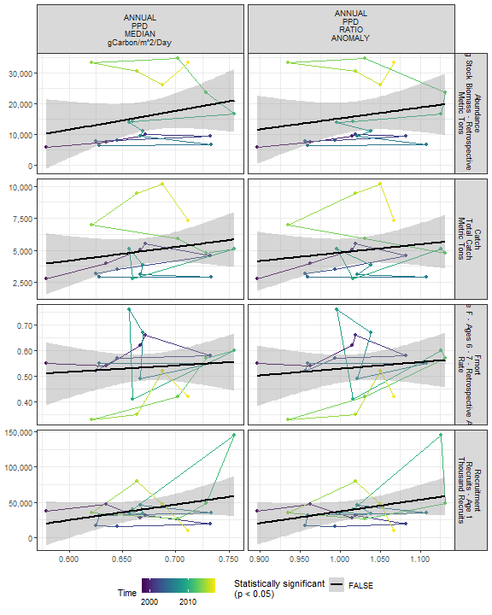

##### Regression statistics

[1] “No statistically significant data”

#### 2.3.2.2 Monthly primary production

##### Figures

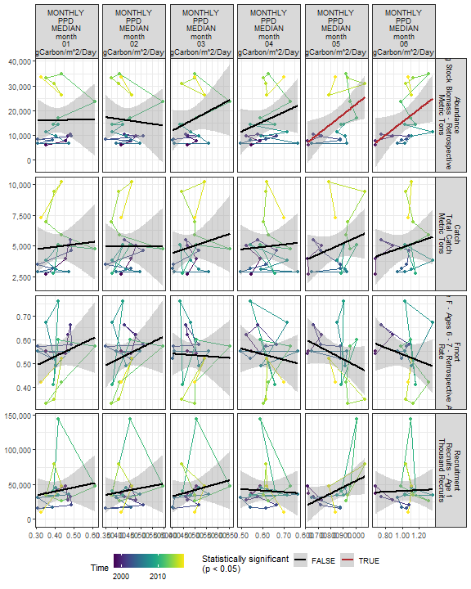

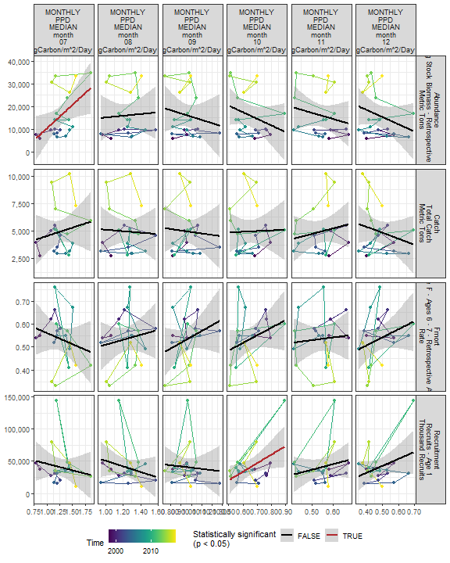

##### Regression statistics

Table 2.20: Recruitment vs MONTHLY PPD MEDIAN month 10 gCarbon/m^2/Day

|  |  |  |  |  |
| --- | --- | --- | --- | --- |
|  | Estimate | Std. Error | t value | Pr(>|t|) |
| (Intercept) | -45704.26 | 38081.70 | -1.20 | 0.25 |
| Val | 132077.99 | 57836.73 | 2.28 | 0.03 |

|  |  |
| --- | --- |
| Name | Value |
| F-statistic | 5.21 |
| df | 1, 18 |
| R2 | 0.22 |
| R2-adj | 0.18 |

Table 2.20: Abundance vs MONTHLY PPD MEDIAN month 05 gCarbon/m^2/Day

|  |  |  |  |  |
| --- | --- | --- | --- | --- |
|  | Estimate | Std. Error | t value | Pr(>|t|) |
| (Intercept) | -17608.65 | 13336.14 | -1.32 | 0.20 |
| Val | 40022.77 | 15714.22 | 2.55 | 0.02 |

|  |  |
| --- | --- |
| Name | Value |
| F-statistic | 6.49 |
| df | 1, 18 |
| R2 | 0.26 |
| R2-adj | 0.22 |

Table 2.20: Abundance vs MONTHLY PPD MEDIAN month 06 gCarbon/m^2/Day

|  |  |  |  |  |
| --- | --- | --- | --- | --- |
|  | Estimate | Std. Error | t value | Pr(>|t|) |
| (Intercept) | -11067.93 | 12670.99 | -0.87 | 0.39 |
| Val | 26307.39 | 12160.37 | 2.16 | 0.04 |

|  |  |
| --- | --- |
| Name | Value |
| F-statistic | 4.68 |
| df | 1, 18 |
| R2 | 0.21 |
| R2-adj | 0.16 |

Table 2.20: Abundance vs MONTHLY PPD MEDIAN month 07 gCarbon/m^2/Day

|  |  |  |  |  |
| --- | --- | --- | --- | --- |
|  | Estimate | Std. Error | t value | Pr(>|t|) |
| (Intercept) | -10241.49 | 11113.58 | -0.92 | 0.37 |
| Val | 20678.25 | 8618.41 | 2.40 | 0.03 |

|  |  |
| --- | --- |
| Name | Value |
| F-statistic | 5.76 |
| df | 1, 18 |
| R2 | 0.24 |
| R2-adj | 0.2 |

#### 2.3.2.3 Weekly primary production

##### Figures

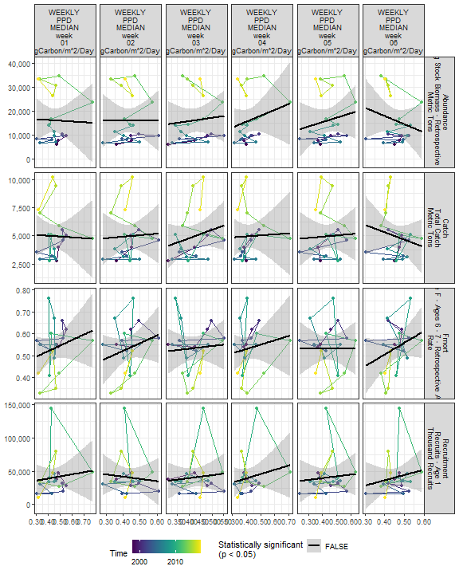

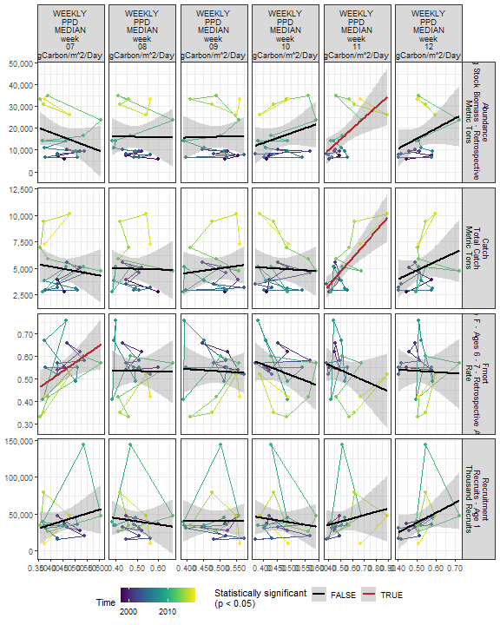

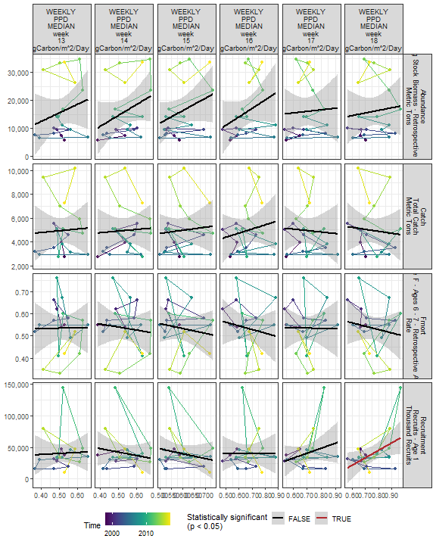

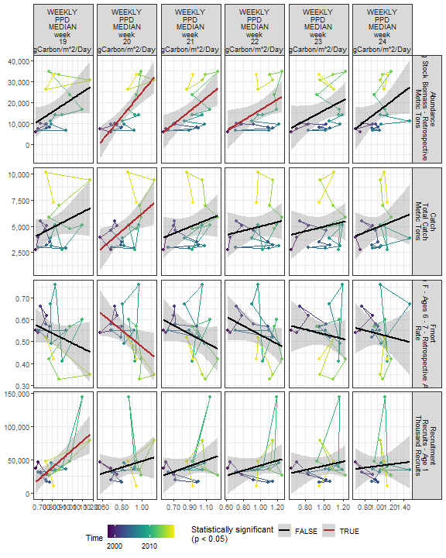

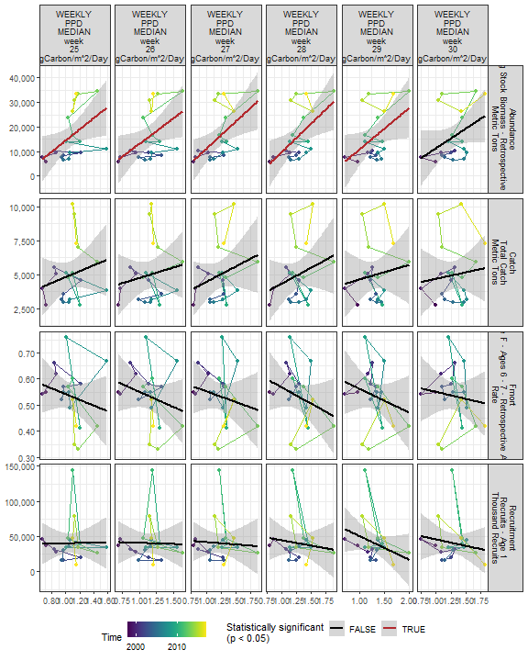

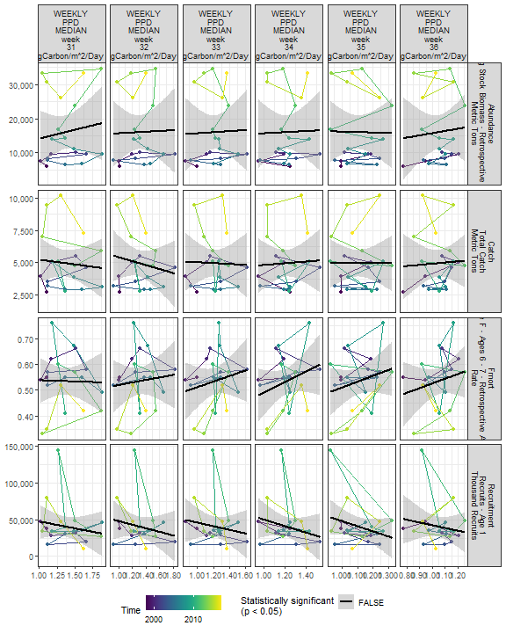

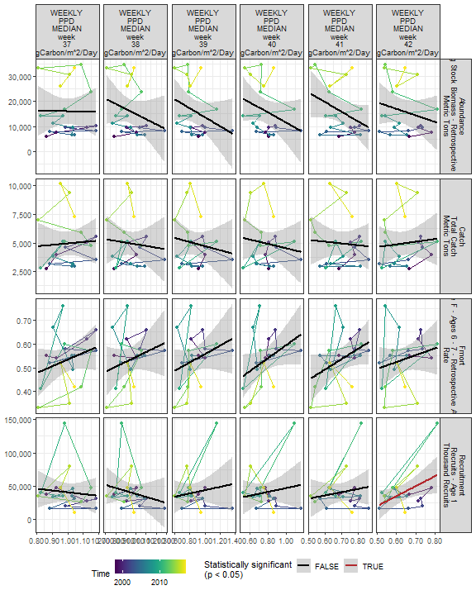

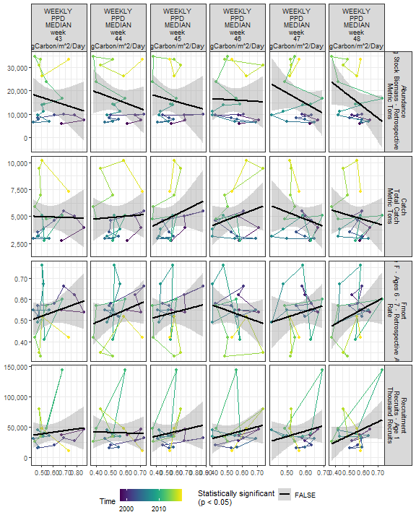

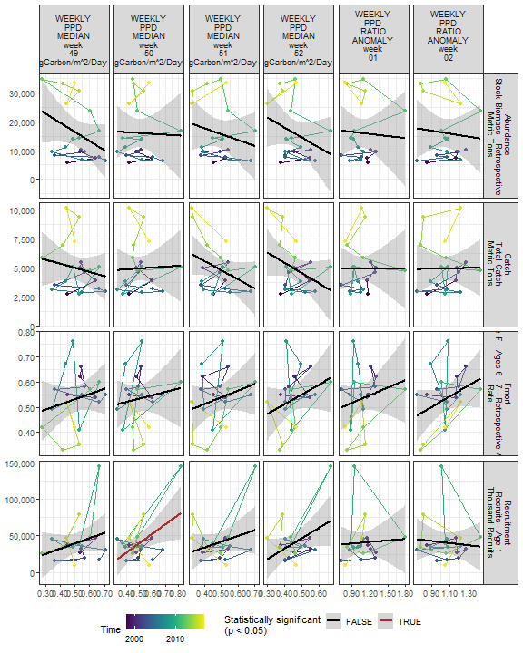

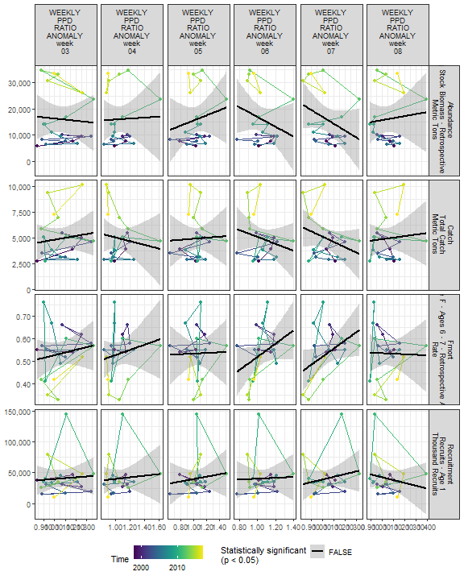

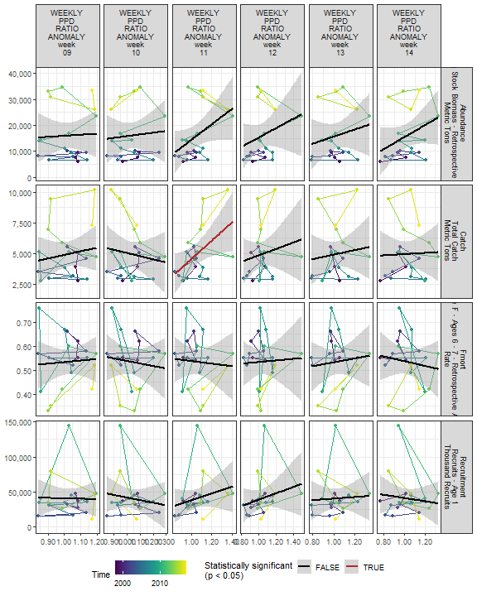

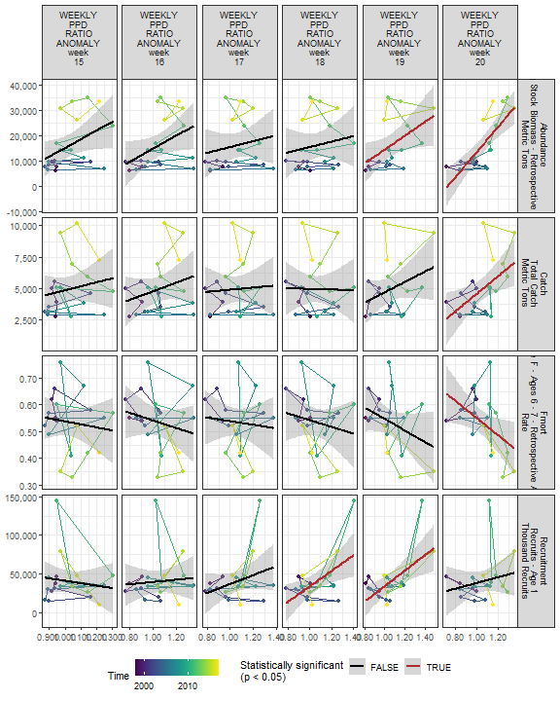

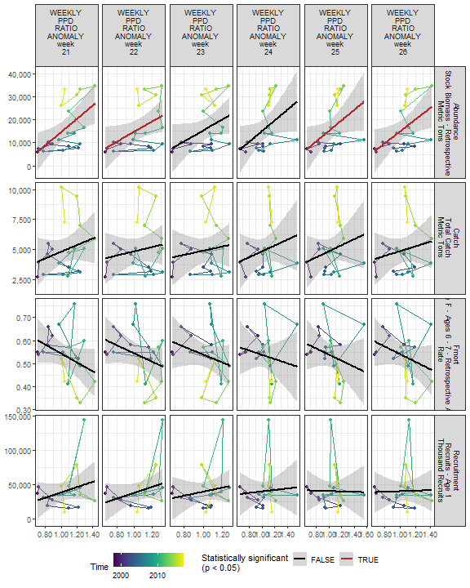

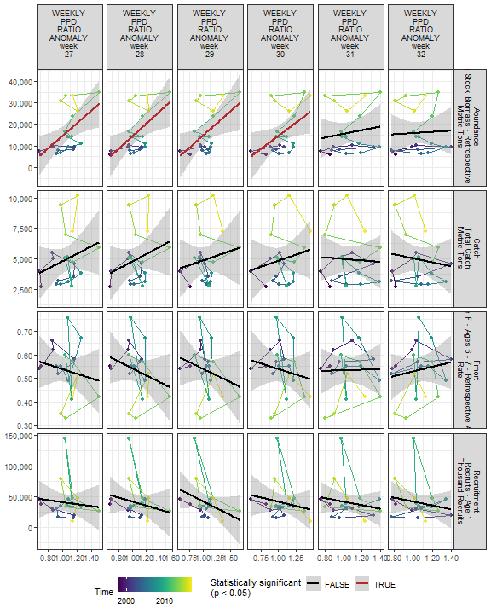

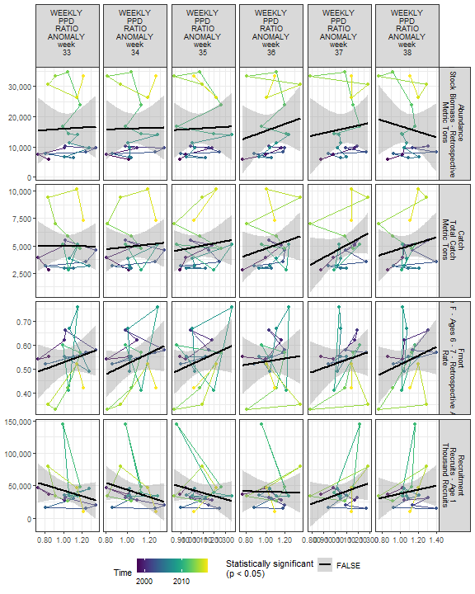

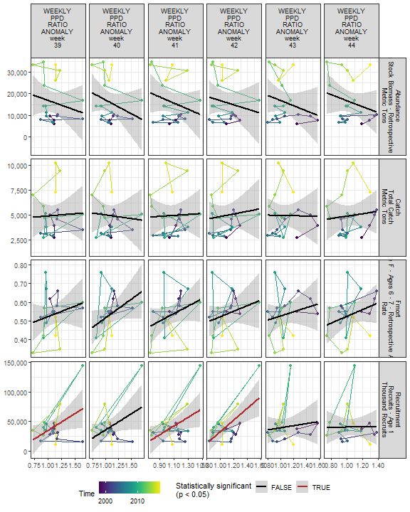

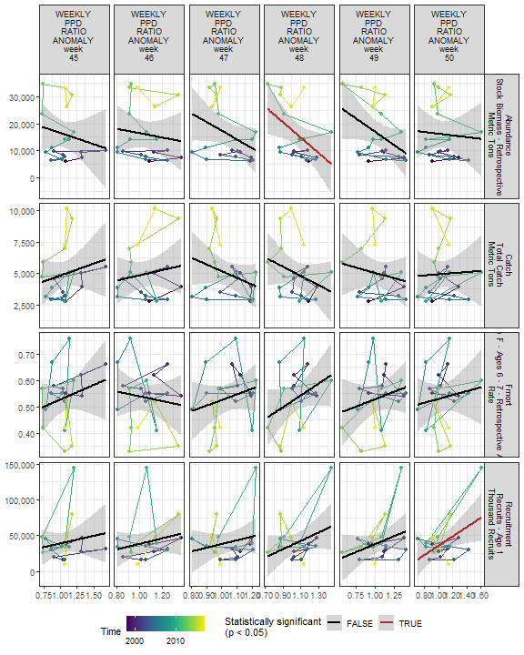

##### Regression statistics

Table 2.21: Catch vs WEEKLY PPD MEDIAN week 11 gCarbon/m^2/Day

|  |  |  |  |  |
| --- | --- | --- | --- | --- |
|  | Estimate | Std. Error | t value | Pr(>|t|) |
| (Intercept) | -1849.81 | 1475.36 | -1.25 | 0.23 |
| Val | 13016.91 | 2758.01 | 4.72 | 0.00 |

|  |  |
| --- | --- |
| Name | Value |
| F-statistic | 22.28 |
| df | 1, 18 |
| R2 | 0.55 |
| R2-adj | 0.53 |

Table 2.21: Catch vs WEEKLY PPD MEDIAN week 20 gCarbon/m^2/Day

|  |  |  |  |  |
| --- | --- | --- | --- | --- |
|  | Estimate | Std. Error | t value | Pr(>|t|) |
| (Intercept) | -1892.73 | 2742.74 | -0.69 | 0.50 |
| Val | 8093.23 | 3210.45 | 2.52 | 0.02 |

|  |  |
| --- | --- |
| Name | Value |
| F-statistic | 6.35 |
| df | 1, 18 |
| R2 | 0.26 |
| R2-adj | 0.22 |

Table 2.21: Catch vs WEEKLY PPD RATIO ANOMALY week 11

|  |  |  |  |  |
| --- | --- | --- | --- | --- |
|  | Estimate | Std. Error | t value | Pr(>|t|) |
| (Intercept) | -2809.18 | 3140.81 | -0.89 | 0.38 |
| Val | 7381.55 | 2964.82 | 2.49 | 0.02 |

|  |  |
| --- | --- |
| Name | Value |
| F-statistic | 6.2 |
| df | 1, 18 |
| R2 | 0.26 |
| R2-adj | 0.21 |

Table 2.21: Catch vs WEEKLY PPD RATIO ANOMALY week 20

|  |  |  |  |  |
| --- | --- | --- | --- | --- |
|  | Estimate | Std. Error | t value | Pr(>|t|) |
| (Intercept) | -2385.23 | 2802.36 | -0.85 | 0.41 |
| Val | 7001.02 | 2648.88 | 2.64 | 0.02 |

|  |  |
| --- | --- |
| Name | Value |
| F-statistic | 6.99 |
| df | 1, 18 |
| R2 | 0.28 |
| R2-adj | 0.24 |

Table 2.21: Fmort vs WEEKLY PPD MEDIAN week 20 gCarbon/m^2/Day

|  |  |  |  |  |
| --- | --- | --- | --- | --- |
|  | Estimate | Std. Error | t value | Pr(>|t|) |
| (Intercept) | 0.84 | 0.14 | 5.86 | 0.00 |
| Val | -0.37 | 0.17 | -2.17 | 0.04 |

|  |  |
| --- | --- |
| Name | Value |
| F-statistic | 4.7 |
| df | 1, 18 |
| R2 | 0.21 |
| R2-adj | 0.16 |

Table 2.21: Fmort vs WEEKLY PPD RATIO ANOMALY week 20

|  |  |  |  |  |
| --- | --- | --- | --- | --- |
|  | Estimate | Std. Error | t value | Pr(>|t|) |
| (Intercept) | 0.87 | 0.15 | 5.95 | 0.00 |
| Val | -0.32 | 0.14 | -2.33 | 0.03 |

|  |  |
| --- | --- |
| Name | Value |
| F-statistic | 5.42 |
| df | 1, 18 |
| R2 | 0.23 |
| R2-adj | 0.19 |

Table 2.21: Fmort vs WEEKLY PPD MEDIAN week 07 gCarbon/m^2/Day

|  |  |  |  |  |
| --- | --- | --- | --- | --- |
|  | Estimate | Std. Error | t value | Pr(>|t|) |
| (Intercept) | 0.19 | 0.14 | 1.35 | 0.19 |
| Val | 0.76 | 0.31 | 2.44 | 0.03 |

|  |  |
| --- | --- |
| Name | Value |
| F-statistic | 5.95 |
| df | 1, 18 |
| R2 | 0.25 |
| R2-adj | 0.21 |

Table 2.21: Recruitment vs WEEKLY PPD MEDIAN week 18 gCarbon/m^2/Day

|  |  |  |  |  |
| --- | --- | --- | --- | --- |
|  | Estimate | Std. Error | t value | Pr(>|t|) |
| (Intercept) | -50393.3 | 39720.05 | -1.27 | 0.22 |
| Val | 119790.4 | 51934.86 | 2.31 | 0.03 |

|  |  |
| --- | --- |
| Name | Value |
| F-statistic | 5.32 |
| df | 1, 18 |
| R2 | 0.23 |
| R2-adj | 0.19 |

Table 2.21: Recruitment vs WEEKLY PPD MEDIAN week 19 gCarbon/m^2/Day

|  |  |  |  |  |
| --- | --- | --- | --- | --- |
|  | Estimate | Std. Error | t value | Pr(>|t|) |
| (Intercept) | -69902.52 | 29944.80 | -2.33 | 0.03 |
| Val | 134742.01 | 36125.77 | 3.73 | 0.00 |

|  |  |
| --- | --- |
| Name | Value |
| F-statistic | 13.91 |
| df | 1, 18 |
| R2 | 0.44 |
| R2-adj | 0.4 |

Table 2.21: Recruitment vs WEEKLY PPD MEDIAN week 42 gCarbon/m^2/Day

|  |  |  |  |  |
| --- | --- | --- | --- | --- |
|  | Estimate | Std. Error | t value | Pr(>|t|) |
| (Intercept) | -55649.74 | 43734.26 | -1.27 | 0.22 |
| Val | 150527.95 | 68036.10 | 2.21 | 0.04 |

|  |  |
| --- | --- |
| Name | Value |
| F-statistic | 4.9 |
| df | 1, 18 |
| R2 | 0.21 |
| R2-adj | 0.17 |

Table 2.21: Recruitment vs WEEKLY PPD MEDIAN week 50 gCarbon/m^2/Day

|  |  |  |  |  |
| --- | --- | --- | --- | --- |
|  | Estimate | Std. Error | t value | Pr(>|t|) |
| (Intercept) | -23775.11 | 26040.93 | -0.91 | 0.37 |
| Val | 127746.83 | 50713.48 | 2.52 | 0.02 |

|  |  |
| --- | --- |
| Name | Value |
| F-statistic | 6.35 |
| df | 1, 18 |
| R2 | 0.26 |
| R2-adj | 0.22 |

Table 2.21: Recruitment vs WEEKLY PPD RATIO ANOMALY week 18

|  |  |  |  |  |
| --- | --- | --- | --- | --- |
|  | Estimate | Std. Error | t value | Pr(>|t|) |
| (Intercept) | -65224.73 | 38080.89 | -1.71 | 0.10 |
| Val | 99451.43 | 35531.06 | 2.80 | 0.01 |

|  |  |
| --- | --- |
| Name | Value |
| F-statistic | 7.83 |
| df | 1, 18 |
| R2 | 0.3 |
| R2-adj | 0.26 |

Table 2.21: Recruitment vs WEEKLY PPD RATIO ANOMALY week 19

|  |  |  |  |  |
| --- | --- | --- | --- | --- |
|  | Estimate | Std. Error | t value | Pr(>|t|) |
| (Intercept) | -66282.53 | 33330.32 | -1.99 | 0.06 |
| Val | 100821.87 | 31152.10 | 3.24 | 0.00 |

|  |  |
| --- | --- |
| Name | Value |
| F-statistic | 10.47 |
| df | 1, 18 |
| R2 | 0.37 |
| R2-adj | 0.33 |

Table 2.21: Recruitment vs WEEKLY PPD RATIO ANOMALY week 39

|  |  |  |  |  |
| --- | --- | --- | --- | --- |
|  | Estimate | Std. Error | t value | Pr(>|t|) |
| (Intercept) | -22366.53 | 29898.31 | -0.75 | 0.46 |
| Val | 57420.88 | 26882.18 | 2.14 | 0.05 |

|  |  |
| --- | --- |
| Name | Value |
| F-statistic | 4.56 |
| df | 1, 18 |
| R2 | 0.2 |
| R2-adj | 0.16 |

Table 2.21: Recruitment vs WEEKLY PPD RATIO ANOMALY week 41

|  |  |  |  |  |
| --- | --- | --- | --- | --- |
|  | Estimate | Std. Error | t value | Pr(>|t|) |
| (Intercept) | -39153.88 | 34758.43 | -1.13 | 0.27 |
| Val | 74191.79 | 32025.74 | 2.32 | 0.03 |

|  |  |
| --- | --- |
| Name | Value |
| F-statistic | 5.37 |
| df | 1, 18 |
| R2 | 0.23 |
| R2-adj | 0.19 |

Table 2.21: Recruitment vs WEEKLY PPD RATIO ANOMALY week 42

|  |  |  |  |  |
| --- | --- | --- | --- | --- |
|  | Estimate | Std. Error | t value | Pr(>|t|) |
| (Intercept) | -65945.93 | 30453.64 | -2.17 | 0.04 |
| Val | 98947.08 | 27980.35 | 3.54 | 0.00 |

|  |  |
| --- | --- |
| Name | Value |
| F-statistic | 12.51 |
| df | 1, 18 |
| R2 | 0.41 |
| R2-adj | 0.38 |

Table 2.21: Recruitment vs WEEKLY PPD RATIO ANOMALY week 50

|  |  |  |  |  |
| --- | --- | --- | --- | --- |
|  | Estimate | Std. Error | t value | Pr(>|t|) |
| (Intercept) | -28552.87 | 29581.28 | -0.97 | 0.35 |
| Val | 64700.81 | 27287.43 | 2.37 | 0.03 |

|  |  |
| --- | --- |
| Name | Value |
| F-statistic | 5.62 |
| df | 1, 18 |
| R2 | 0.24 |
| R2-adj | 0.2 |

Table 2.21: Abundance vs WEEKLY PPD MEDIAN week 11 gCarbon/m^2/Day

|  |  |  |  |  |
| --- | --- | --- | --- | --- |
|  | Estimate | Std. Error | t value | Pr(>|t|) |
| (Intercept) | -9856.42 | 8574.92 | -1.15 | 0.27 |
| Val | 49508.32 | 16029.77 | 3.09 | 0.01 |

|  |  |
| --- | --- |
| Name | Value |
| F-statistic | 9.54 |
| df | 1, 18 |
| R2 | 0.35 |
| R2-adj | 0.31 |

Table 2.21: Abundance vs WEEKLY PPD MEDIAN week 20 gCarbon/m^2/Day

|  |  |  |  |  |
| --- | --- | --- | --- | --- |
|  | Estimate | Std. Error | t value | Pr(>|t|) |
| (Intercept) | -32047.03 | 10195.00 | -3.14 | 0.01 |
| Val | 56875.54 | 11933.51 | 4.77 | 0.00 |

|  |  |
| --- | --- |
| Name | Value |
| F-statistic | 22.72 |
| df | 1, 18 |
| R2 | 0.56 |
| R2-adj | 0.53 |

Table 2.21: Abundance vs WEEKLY PPD RATIO ANOMALY week 20

|  |  |  |  |  |
| --- | --- | --- | --- | --- |
|  | Estimate | Std. Error | t value | Pr(>|t|) |
| (Intercept) | -36044.87 | 9905.41 | -3.64 | 0 |
| Val | 49713.07 | 9362.91 | 5.31 | 0 |

|  |  |
| --- | --- |
| Name | Value |
| F-statistic | 28.19 |
| df | 1, 18 |
| R2 | 0.61 |
| R2-adj | 0.59 |

Table 2.21: Abundance vs WEEKLY PPD RATIO ANOMALY week 19

|  |  |  |  |  |
| --- | --- | --- | --- | --- |
|  | Estimate | Std. Error | t value | Pr(>|t|) |
| (Intercept) | -13143.13 | 13214.38 | -0.99 | 0.33 |
| Val | 27551.47 | 12350.79 | 2.23 | 0.04 |

|  |  |
| --- | --- |
| Name | Value |
| F-statistic | 4.98 |
| df | 1, 18 |
| R2 | 0.22 |
| R2-adj | 0.17 |

Table 2.21: Abundance vs WEEKLY PPD MEDIAN week 21 gCarbon/m^2/Day

|  |  |  |  |  |
| --- | --- | --- | --- | --- |
|  | Estimate | Std. Error | t value | Pr(>|t|) |
| (Intercept) | -12518.53 | 9506.08 | -1.32 | 0.20 |
| Val | 31733.33 | 10374.19 | 3.06 | 0.01 |

|  |  |
| --- | --- |
| Name | Value |
| F-statistic | 9.36 |
| df | 1, 18 |
| R2 | 0.34 |
| R2-adj | 0.31 |

Table 2.21: Abundance vs WEEKLY PPD MEDIAN week 22 gCarbon/m^2/Day

|  |  |  |  |  |
| --- | --- | --- | --- | --- |
|  | Estimate | Std. Error | t value | Pr(>|t|) |
| (Intercept) | -8241.18 | 10686.31 | -0.77 | 0.45 |
| Val | 24630.86 | 10667.72 | 2.31 | 0.03 |

|  |  |
| --- | --- |
| Name | Value |
| F-statistic | 5.33 |
| df | 1, 18 |
| R2 | 0.23 |
| R2-adj | 0.19 |

Table 2.21: Abundance vs WEEKLY PPD MEDIAN week 25 gCarbon/m^2/Day

|  |  |  |  |  |
| --- | --- | --- | --- | --- |
|  | Estimate | Std. Error | t value | Pr(>|t|) |
| (Intercept) | -8105.09 | 10494.68 | -0.77 | 0.45 |
| Val | 22603.07 | 9662.50 | 2.34 | 0.03 |

|  |  |
| --- | --- |
| Name | Value |
| F-statistic | 5.47 |
| df | 1, 18 |
| R2 | 0.23 |
| R2-adj | 0.19 |

Table 2.21: Abundance vs WEEKLY PPD MEDIAN week 26 gCarbon/m^2/Day

|  |  |  |  |  |
| --- | --- | --- | --- | --- |
|  | Estimate | Std. Error | t value | Pr(>|t|) |
| (Intercept) | -7916.71 | 10776.02 | -0.73 | 0.47 |
| Val | 21001.70 | 9298.13 | 2.26 | 0.04 |

|  |  |
| --- | --- |
| Name | Value |
| F-statistic | 5.1 |
| df | 1, 18 |
| R2 | 0.22 |
| R2-adj | 0.18 |

Table 2.21: Abundance vs WEEKLY PPD MEDIAN week 27 gCarbon/m^2/Day

|  |  |  |  |  |
| --- | --- | --- | --- | --- |
|  | Estimate | Std. Error | t value | Pr(>|t|) |
| (Intercept) | -11332.29 | 9997.42 | -1.13 | 0.27 |
| Val | 22445.30 | 8059.12 | 2.79 | 0.01 |

|  |  |
| --- | --- |
| Name | Value |
| F-statistic | 7.76 |
| df | 1, 18 |
| R2 | 0.3 |
| R2-adj | 0.26 |

Table 2.21: Abundance vs WEEKLY PPD MEDIAN week 28 gCarbon/m^2/Day

|  |  |  |  |  |
| --- | --- | --- | --- | --- |
|  | Estimate | Std. Error | t value | Pr(>|t|) |
| (Intercept) | -13130.34 | 10793.95 | -1.22 | 0.24 |
| Val | 23090.46 | 8420.89 | 2.74 | 0.01 |

|  |  |
| --- | --- |
| Name | Value |
| F-statistic | 7.52 |
| df | 1, 18 |
| R2 | 0.29 |
| R2-adj | 0.26 |

Table 2.21: Abundance vs WEEKLY PPD MEDIAN week 29 gCarbon/m^2/Day

|  |  |  |  |  |
| --- | --- | --- | --- | --- |
|  | Estimate | Std. Error | t value | Pr(>|t|) |
| (Intercept) | -6052.85 | 10485.97 | -0.58 | 0.57 |
| Val | 16889.81 | 7880.14 | 2.14 | 0.05 |

|  |  |
| --- | --- |
| Name | Value |
| F-statistic | 4.59 |
| df | 1, 18 |
| R2 | 0.2 |
| R2-adj | 0.16 |

Table 2.21: Abundance vs WEEKLY PPD RATIO ANOMALY week 21

|  |  |  |  |  |
| --- | --- | --- | --- | --- |
|  | Estimate | Std. Error | t value | Pr(>|t|) |
| (Intercept) | -14035.71 | 10295.72 | -1.36 | 0.19 |
| Val | 28724.23 | 9682.56 | 2.97 | 0.01 |

|  |  |
| --- | --- |
| Name | Value |
| F-statistic | 8.8 |
| df | 1, 18 |
| R2 | 0.33 |
| R2-adj | 0.29 |

Table 2.21: Abundance vs WEEKLY PPD RATIO ANOMALY week 22

|  |  |  |  |  |
| --- | --- | --- | --- | --- |
|  | Estimate | Std. Error | t value | Pr(>|t|) |
| (Intercept) | -6900.40 | 10926.65 | -0.63 | 0.54 |
| Val | 21705.34 | 10177.77 | 2.13 | 0.05 |

|  |  |
| --- | --- |
| Name | Value |
| F-statistic | 4.55 |
| df | 1, 18 |
| R2 | 0.2 |
| R2-adj | 0.16 |

Table 2.21: Abundance vs WEEKLY PPD RATIO ANOMALY week 25

|  |  |  |  |  |
| --- | --- | --- | --- | --- |
|  | Estimate | Std. Error | t value | Pr(>|t|) |
| (Intercept) | -7558.32 | 11263.95 | -0.67 | 0.51 |
| Val | 22789.06 | 10719.64 | 2.13 | 0.05 |

|  |  |
| --- | --- |
| Name | Value |
| F-statistic | 4.52 |
| df | 1, 18 |
| R2 | 0.2 |
| R2-adj | 0.16 |

Table 2.21: Abundance vs WEEKLY PPD RATIO ANOMALY week 26

|  |  |  |  |  |
| --- | --- | --- | --- | --- |
|  | Estimate | Std. Error | t value | Pr(>|t|) |
| (Intercept) | -10703.02 | 11118.78 | -0.96 | 0.35 |
| Val | 25714.91 | 10538.77 | 2.44 | 0.03 |

|  |  |
| --- | --- |
| Name | Value |
| F-statistic | 5.95 |
| df | 1, 18 |
| R2 | 0.25 |
| R2-adj | 0.21 |

Table 2.21: Abundance vs WEEKLY PPD RATIO ANOMALY week 27

|  |  |  |  |  |
| --- | --- | --- | --- | --- |
|  | Estimate | Std. Error | t value | Pr(>|t|) |
| (Intercept) | -15031.11 | 11333.93 | -1.33 | 0.20 |
| Val | 29674.59 | 10685.14 | 2.78 | 0.01 |

|  |  |
| --- | --- |
| Name | Value |
| F-statistic | 7.71 |
| df | 1, 18 |
| R2 | 0.3 |
| R2-adj | 0.26 |

Table 2.21: Abundance vs WEEKLY PPD RATIO ANOMALY week 28

|  |  |  |  |  |
| --- | --- | --- | --- | --- |
|  | Estimate | Std. Error | t value | Pr(>|t|) |
| (Intercept) | -13966.50 | 10992.50 | -1.27 | 0.22 |
| Val | 28404.39 | 10262.02 | 2.77 | 0.01 |

|  |  |
| --- | --- |
| Name | Value |
| F-statistic | 7.66 |
| df | 1, 18 |
| R2 | 0.3 |
| R2-adj | 0.26 |

Table 2.21: Abundance vs WEEKLY PPD RATIO ANOMALY week 29

|  |  |  |  |  |
| --- | --- | --- | --- | --- |
|  | Estimate | Std. Error | t value | Pr(>|t|) |
| (Intercept) | -7284.30 | 9892.27 | -0.74 | 0.47 |
| Val | 22324.32 | 9292.23 | 2.40 | 0.03 |

|  |  |
| --- | --- |
| Name | Value |
| F-statistic | 5.77 |
| df | 1, 18 |
| R2 | 0.24 |
| R2-adj | 0.2 |

Table 2.21: Abundance vs WEEKLY PPD RATIO ANOMALY week 30

|  |  |  |  |  |
| --- | --- | --- | --- | --- |
|  | Estimate | Std. Error | t value | Pr(>|t|) |
| (Intercept) | -9945.69 | 11755.85 | -0.85 | 0.41 |
| Val | 24700.41 | 11029.11 | 2.24 | 0.04 |

|  |  |
| --- | --- |
| Name | Value |
| F-statistic | 5.02 |
| df | 1, 18 |
| R2 | 0.22 |
| R2-adj | 0.17 |

Table 2.21: Abundance vs WEEKLY PPD RATIO ANOMALY week 48

|  |  |  |  |  |
| --- | --- | --- | --- | --- |
|  | Estimate | Std. Error | t value | Pr(>|t|) |
| (Intercept) | 46152.49 | 12986.58 | 3.55 | 0.00 |
| Val | -28500.83 | 12105.55 | -2.35 | 0.03 |

|  |  |
| --- | --- |
| Name | Value |
| F-statistic | 5.54 |
| df | 1, 18 |
| R2 | 0.24 |
| R2-adj | 0.19 |

### 2.3.3 Zooplankton

#### 2.3.3.1 Spring zooplankton abundance by species

##### Figures

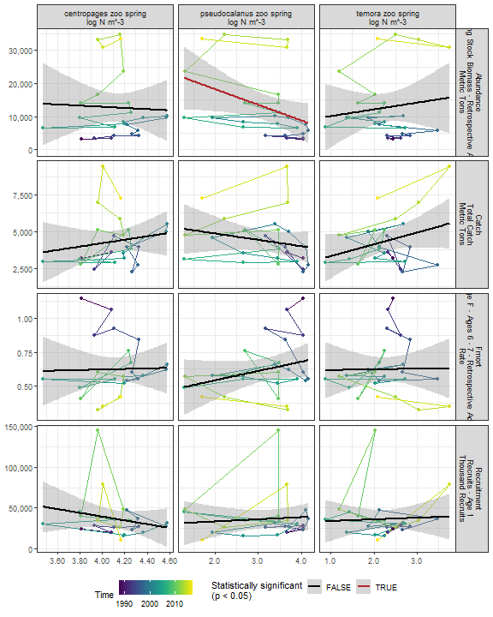

##### Regression statistics

Table 2.22: Abundance vs pseudocalanus zoo spring log N m^-3

|  |  |  |  |  |
| --- | --- | --- | --- | --- |
|  | Estimate | Std. Error | t value | Pr(>|t|) |
| (Intercept) | 27685.83 | 7254.53 | 3.82 | 0.00 |
| Val | -4728.25 | 2201.65 | -2.15 | 0.04 |

|  |  |
| --- | --- |
| Name | Value |
| F-statistic | 4.61 |
| df | 1, 23 |
| R2 | 0.17 |
| R2-adj | 0.13 |

#### 2.3.3.2 Fall zooplankton abundance by species

##### Figures

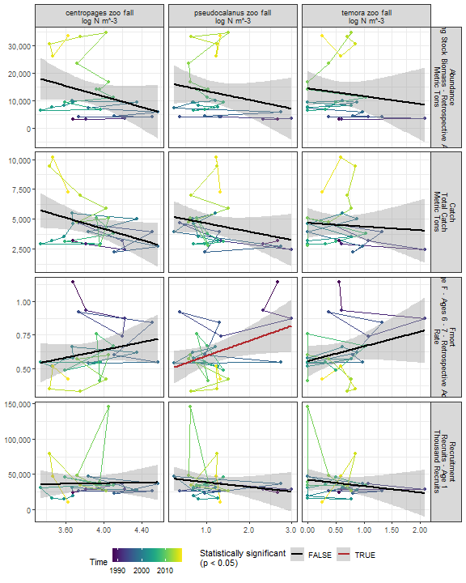

##### Regression statistics

Table 2.23: Fmort vs pseudocalanus zoo fall log N m^-3

|  |  |  |  |  |
| --- | --- | --- | --- | --- |
|  | Estimate | Std. Error | t value | Pr(>|t|) |
| (Intercept) | 0.49 | 0.07 | 7.10 | 0.00 |
| Val | 0.11 | 0.05 | 2.27 | 0.03 |

|  |  |
| --- | --- |
| Name | Value |
| F-statistic | 5.13 |
| df | 1, 25 |
| R2 | 0.17 |
| R2-adj | 0.14 |

#### 2.3.3.3 Zooplankton abundance by group

##### Figures

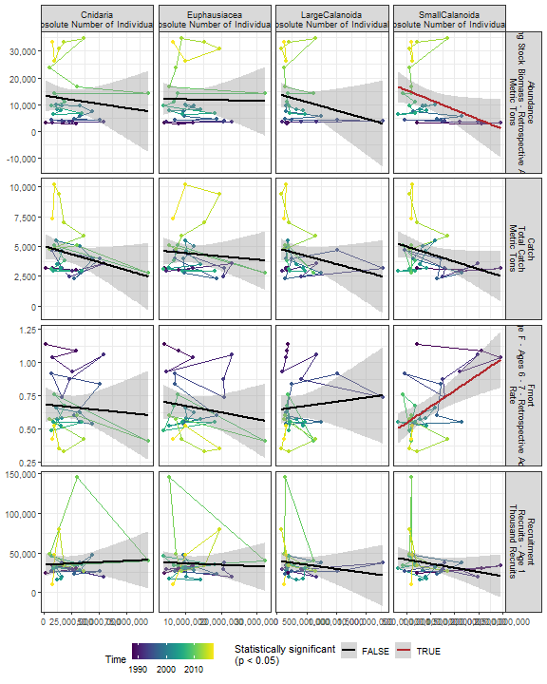

##### Regression statistics

Table 2.24: Fmort vs SmallCalanoida Absolute Number of Individuals

|  |  |  |  |  |
| --- | --- | --- | --- | --- |
|  | Estimate | Std. Error | t value | Pr(>|t|) |
| (Intercept) | 0.42 | 0.07 | 5.77 | 0 |
| Val | 0.00 | 0.00 | 3.68 | 0 |

|  |  |
| --- | --- |
| Name | Value |
| F-statistic | 13.51 |
| df | 1, 28 |
| R2 | 0.33 |
| R2-adj | 0.3 |

Table 2.24: Abundance vs SmallCalanoida Absolute Number of Individuals

|  |  |  |  |  |
| --- | --- | --- | --- | --- |
|  | Estimate | Std. Error | t value | Pr(>|t|) |
| (Intercept) | 18989.93 | 3735.35 | 5.08 | 0.00 |
| Val | 0.00 | 0.00 | -2.16 | 0.04 |

|  |  |
| --- | --- |
| Name | Value |
| F-statistic | 4.65 |
| df | 1, 28 |
| R2 | 0.14 |
| R2-adj | 0.11 |

#### 2.3.3.4 Abundance of Calanus CV and adults

##### Figures

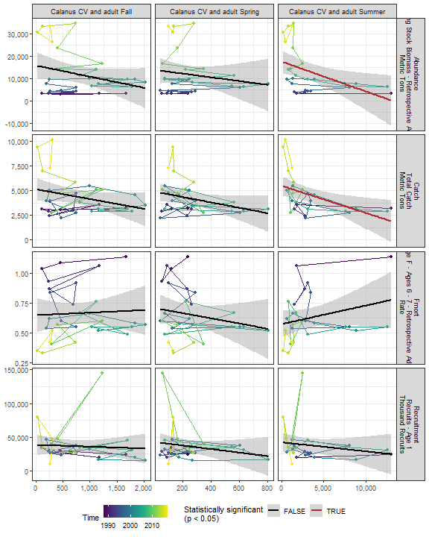

##### Regression statistics

Table 2.25: Catch vs Calanus CV and adult Summer

|  |  |  |  |  |
| --- | --- | --- | --- | --- |
|  | Estimate | Std. Error | t value | Pr(>|t|) |
| (Intercept) | 5487.59 | 490.63 | 11.18 | 0.00 |
| Val | -0.27 | 0.10 | -2.74 | 0.01 |

|  |  |
| --- | --- |
| Name | Value |
| F-statistic | 7.49 |
| df | 1, 24 |
| R2 | 0.24 |
| R2-adj | 0.21 |

Table 2.25: Abundance vs Calanus CV and adult Summer

|  |  |  |  |  |
| --- | --- | --- | --- | --- |
|  | Estimate | Std. Error | t value | Pr(>|t|) |
| (Intercept) | 17493.05 | 2569.88 | 6.81 | 0.00 |
| Val | -1.33 | 0.53 | -2.53 | 0.02 |

|  |  |
| --- | --- |
| Name | Value |
| F-statistic | 6.39 |
| df | 1, 24 |
| R2 | 0.21 |
| R2-adj | 0.18 |

#### 2.3.3.5 Zooplankton abundance anomaly

##### Figures

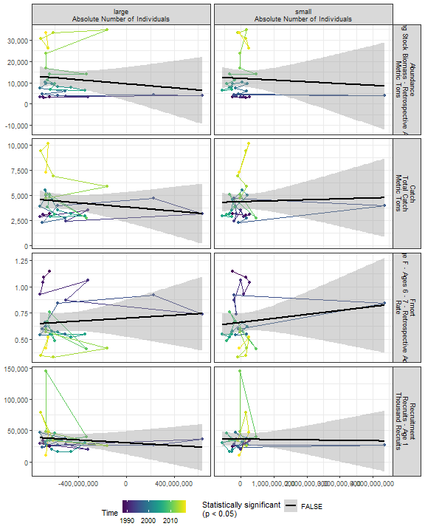

##### Regression statistics

[1] “No statistically significant data”

#### 2.3.3.6 Zooplankton diversity index

##### Figures

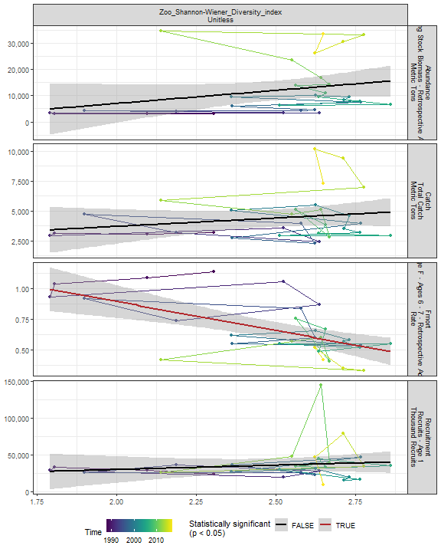

##### Regression statistics

Table 2.26: Fmort vs Zoo_Shannon-Wiener_Diversity_index Unitless

|  |  |  |  |  |
| --- | --- | --- | --- | --- |
|  | Estimate | Std. Error | t value | Pr(>|t|) |
| (Intercept) | 1.84 | 0.29 | 6.36 | 0 |
| Val | -0.47 | 0.12 | -4.10 | 0 |

|  |  |
| --- | --- |
| Name | Value |
| F-statistic | 16.78 |
| df | 1, 28 |
| R2 | 0.37 |
| R2-adj | 0.35 |

#### 2.3.3.7 Small/large copepod anomaly

##### Figures

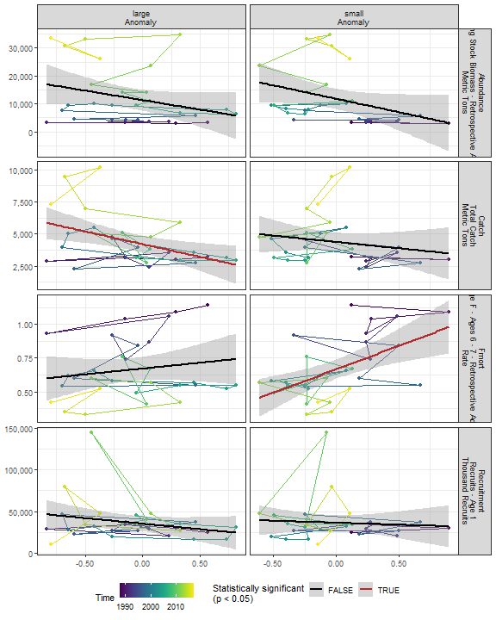

##### Regression statistics

Table 2.27: Catch vs large Anomaly

|  |  |  |  |  |
| --- | --- | --- | --- | --- |
|  | Estimate | Std. Error | t value | Pr(>|t|) |
| (Intercept) | 4198.72 | 327.22 | 12.83 | 0.00 |
| Val | -1975.31 | 712.08 | -2.77 | 0.01 |

|  |  |
| --- | --- |
| Name | Value |
| F-statistic | 7.7 |
| df | 1, 28 |
| R2 | 0.22 |
| R2-adj | 0.19 |

Table 2.27: Fmort vs small Anomaly

|  |  |  |  |  |
| --- | --- | --- | --- | --- |
|  | Estimate | Std. Error | t value | Pr(>|t|) |
| (Intercept) | 0.67 | 0.04 | 19.08 | 0 |
| Val | 0.35 | 0.10 | 3.53 | 0 |

|  |  |
| --- | --- |
| Name | Value |
| F-statistic | 12.45 |
| df | 1, 28 |
| R2 | 0.31 |
| R2-adj | 0.28 |

#### 2.3.3.8 Ichthyoplankton diversity

##### Figures

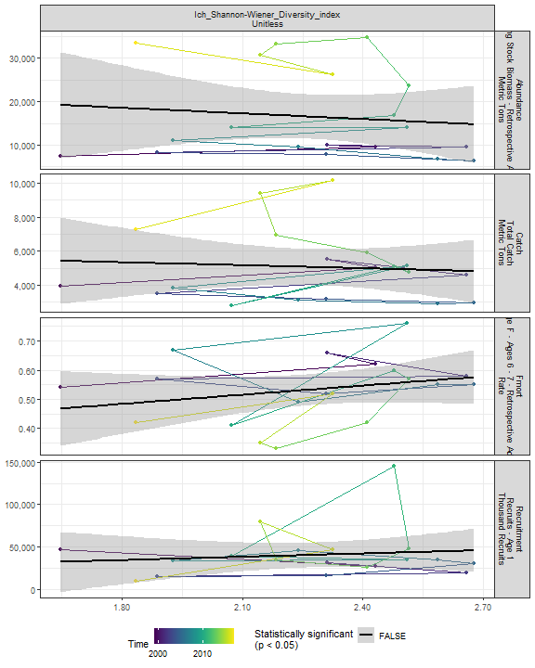

##### Regression statistics

[1] “No statistically significant data”

### 2.3.4 Forage fish abundance

##### Figures

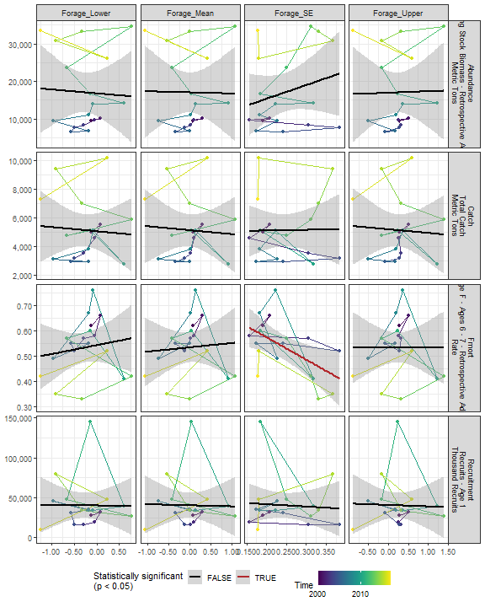

##### Regression statistics

Table 2.28: Fmort vs Forage_SE

|  |  |  |  |  |
| --- | --- | --- | --- | --- |
|  | Estimate | Std. Error | t value | Pr(>|t|) |
| (Intercept) | 0.75 | 0.08 | 9.06 | 0.00 |
| Val | -0.89 | 0.32 | -2.73 | 0.01 |

|  |  |
| --- | --- |
| Name | Value |
| F-statistic | 7.47 |
| df | 1, 16 |
| R2 | 0.32 |
| R2-adj | 0.28 |

## 2.4 Trophic indicators in the stock region

### 2.4.1 Chlorophyll in stock region

##### Figures

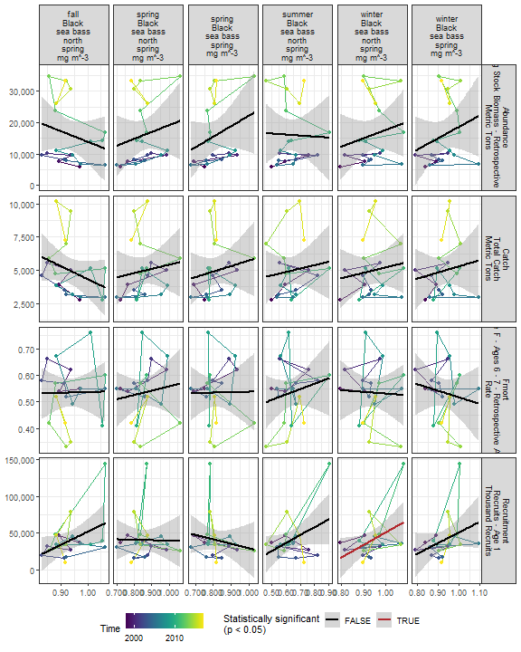

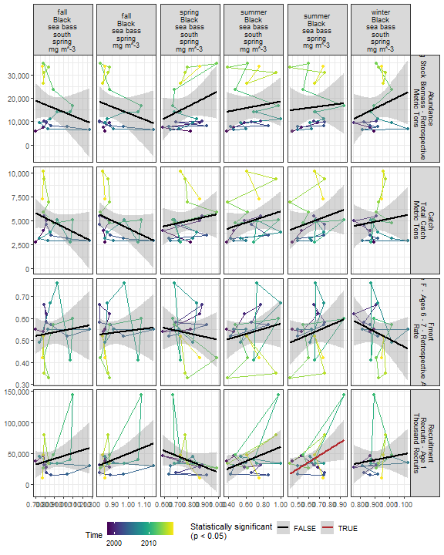

##### Regression statistics

Table 2.29: Recruitment vs winter Black sea bass north spring mg m^-3

|  |  |  |  |  |
| --- | --- | --- | --- | --- |
|  | Estimate | Std. Error | t value | Pr(>|t|) |
| (Intercept) | -121723.3 | 76505.86 | -1.59 | 0.13 |
| Val | 172812.0 | 81387.83 | 2.12 | 0.05 |

|  |  |
| --- | --- |
| Name | Value |
| F-statistic | 4.51 |
| df | 1, 18 |
| R2 | 0.2 |
| R2-adj | 0.16 |

Table 2.29: Recruitment vs summer Black sea bass spring mg m^-3

|  |  |  |  |  |
| --- | --- | --- | --- | --- |
|  | Estimate | Std. Error | t value | Pr(>|t|) |
| (Intercept) | -28544.2 | 31605.24 | -0.90 | 0.38 |
| Val | 107364.2 | 48477.41 | 2.21 | 0.04 |

|  |  |
| --- | --- |
| Name | Value |
| F-statistic | 4.91 |
| df | 1, 18 |
| R2 | 0.21 |
| R2-adj | 0.17 |

### 2.4.2 Primary production in stock region

##### Figures

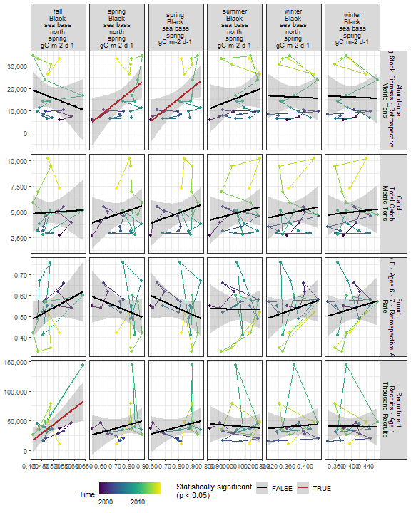

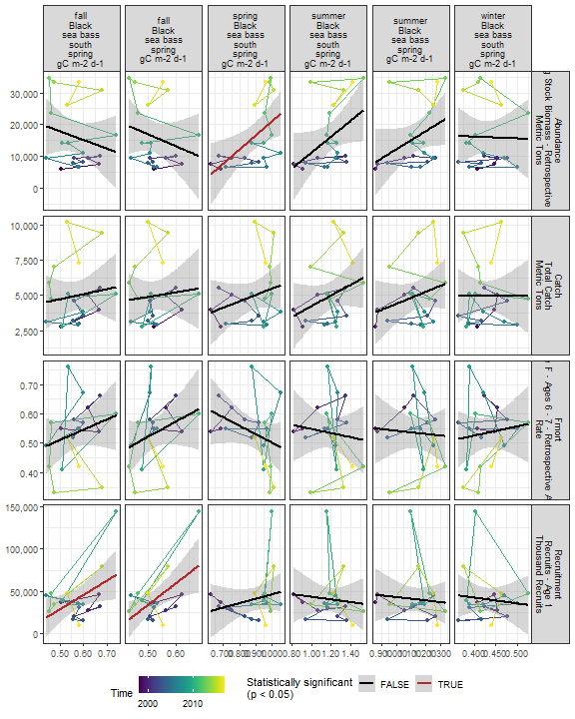

##### Regression statistics

Table 2.30: Recruitment vs fall Black sea bass north spring gC m-2 d-1

|  |  |  |  |  |
| --- | --- | --- | --- | --- |
|  | Estimate | Std. Error | t value | Pr(>|t|) |
| (Intercept) | -97574.38 | 48410.28 | -2.02 | 0.06 |
| Val | 280774.29 | 97995.79 | 2.87 | 0.01 |

|  |  |
| --- | --- |
| Name | Value |
| F-statistic | 8.21 |
| df | 1, 18 |
| R2 | 0.31 |
| R2-adj | 0.28 |

Table 2.30: Recruitment vs fall Black sea bass spring gC m-2 d-1

|  |  |  |  |  |
| --- | --- | --- | --- | --- |
|  | Estimate | Std. Error | t value | Pr(>|t|) |
| (Intercept) | -90945.67 | 47064.48 | -1.93 | 0.07 |
| Val | 250326.64 | 89190.66 | 2.81 | 0.01 |

|  |  |
| --- | --- |
| Name | Value |
| F-statistic | 7.88 |
| df | 1, 18 |
| R2 | 0.3 |
| R2-adj | 0.27 |

Table 2.30: Recruitment vs fall Black sea bass south spring gC m-2 d-1

|  |  |  |  |  |
| --- | --- | --- | --- | --- |
|  | Estimate | Std. Error | t value | Pr(>|t|) |
| (Intercept) | -56213.01 | 42101.47 | -1.34 | 0.20 |
| Val | 169708.37 | 73371.26 | 2.31 | 0.03 |

|  |  |
| --- | --- |
| Name | Value |
| F-statistic | 5.35 |
| df | 1, 18 |
| R2 | 0.23 |
| R2-adj | 0.19 |

Table 2.30: Abundance vs spring Black sea bass north spring gC m-2 d-1

|  |  |  |  |  |
| --- | --- | --- | --- | --- |
|  | Estimate | Std. Error | t value | Pr(>|t|) |
| (Intercept) | -21691.43 | 16068.51 | -1.35 | 0.19 |
| Val | 49572.17 | 20978.66 | 2.36 | 0.03 |

|  |  |
| --- | --- |
| Name | Value |
| F-statistic | 5.58 |
| df | 1, 18 |
| R2 | 0.24 |
| R2-adj | 0.19 |

Table 2.30: Abundance vs spring Black sea bass spring gC m-2 d-1

|  |  |  |  |  |
| --- | --- | --- | --- | --- |
|  | Estimate | Std. Error | t value | Pr(>|t|) |
| (Intercept) | -24312.65 | 15317.74 | -1.59 | 0.13 |
| Val | 49502.04 | 18664.82 | 2.65 | 0.02 |

|  |  |
| --- | --- |
| Name | Value |
| F-statistic | 7.03 |
| df | 1, 18 |
| R2 | 0.28 |
| R2-adj | 0.24 |

Table 2.30: Abundance vs spring Black sea bass south spring gC m-2 d-1

|  |  |  |  |  |
| --- | --- | --- | --- | --- |
|  | Estimate | Std. Error | t value | Pr(>|t|) |
| (Intercept) | -23052.27 | 14087.82 | -1.64 | 0.12 |
| Val | 44053.74 | 15750.33 | 2.80 | 0.01 |

|  |  |
| --- | --- |
| Name | Value |
| F-statistic | 7.82 |
| df | 1, 18 |
| R2 | 0.3 |
| R2-adj | 0.26 |

### 2.4.3 Zooplankton in the stock region

#### 2.4.3.1 Annual zooplankton abundance in the stock region

#### Ctyp 100m3 Annual

##### Figures

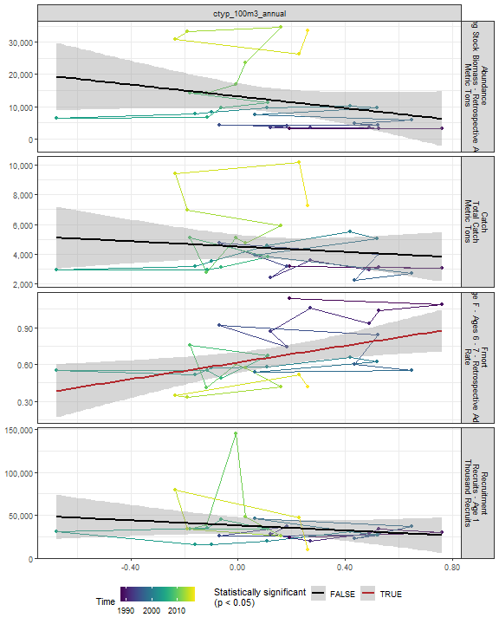

##### Regression statistics

Table 2.31: Fmort vs ctyp_100m3_annual

|  |  |  |  |  |
| --- | --- | --- | --- | --- |
|  | Estimate | Std. Error | t value | Pr(>|t|) |
| (Intercept) | 0.62 | 0.04 | 15.17 | 0.00 |
| Val | 0.34 | 0.12 | 2.82 | 0.01 |

|  |  |
| --- | --- |
| Name | Value |
| F-statistic | 7.98 |
| df | 1, 28 |
| R2 | 0.22 |
| R2-adj | 0.19 |

#### Calfin 100m3 Annual

##### Figures

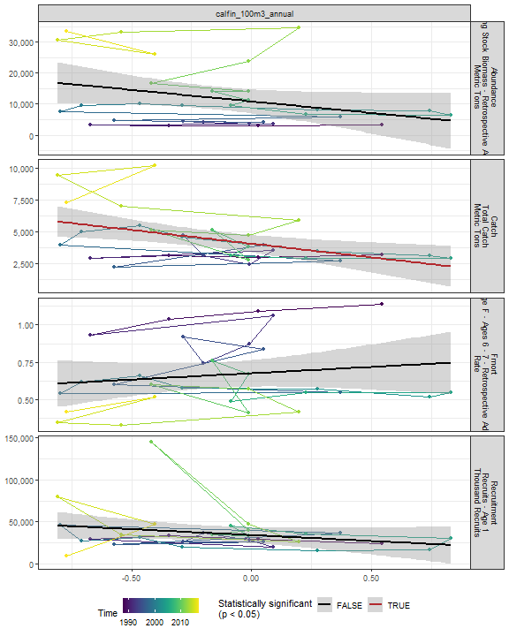

##### Regression statistics

Table 2.32: Catch vs calfin_100m3_annual

|  |  |  |  |  |
| --- | --- | --- | --- | --- |
|  | Estimate | Std. Error | t value | Pr(>|t|) |
| (Intercept) | 4073.34 | 333.98 | 12.20 | 0.00 |
| Val | -2139.28 | 734.80 | -2.91 | 0.01 |

|  |  |
| --- | --- |
| Name | Value |
| F-statistic | 8.48 |
| df | 1, 28 |
| R2 | 0.23 |
| R2-adj | 0.2 |

#### Pseudo 100m3 Annual

##### Figures

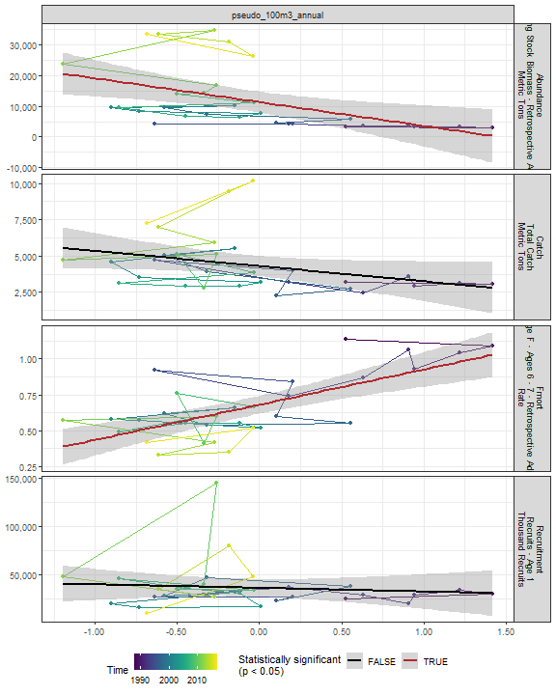

##### Regression statistics

Table 2.33: Fmort vs pseudo_100m3_annual

|  |  |  |  |  |
| --- | --- | --- | --- | --- |
|  | Estimate | Std. Error | t value | Pr(>|t|) |
| (Intercept) | 0.68 | 0.03 | 22.48 | 0 |
| Val | 0.24 | 0.05 | 5.16 | 0 |

|  |  |
| --- | --- |
| Name | Value |
| F-statistic | 26.63 |
| df | 1, 28 |
| R2 | 0.49 |
| R2-adj | 0.47 |

Table 2.33: Abundance vs pseudo_100m3_annual

|  |  |  |  |  |
| --- | --- | --- | --- | --- |
|  | Estimate | Std. Error | t value | Pr(>|t|) |
| (Intercept) | 11316.20 | 1660.25 | 6.82 | 0.00 |
| Val | -7726.88 | 2597.96 | -2.97 | 0.01 |

|  |  |
| --- | --- |
| Name | Value |
| F-statistic | 8.85 |
| df | 1, 28 |
| R2 | 0.24 |
| R2-adj | 0.21 |

#### Penilia 100m3 Annual

##### Figures

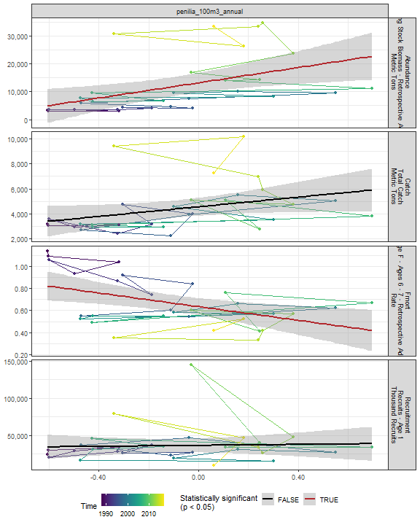

##### Regression statistics

Table 2.34: Fmort vs penilia_100m3_annual

|  |  |  |  |  |
| --- | --- | --- | --- | --- |
|  | Estimate | Std. Error | t value | Pr(>|t|) |
| (Intercept) | 0.63 | 0.04 | 16.65 | 0.00 |
| Val | -0.31 | 0.11 | -2.94 | 0.01 |

|  |  |
| --- | --- |
| Name | Value |
| F-statistic | 8.62 |
| df | 1, 28 |
| R2 | 0.24 |
| R2-adj | 0.21 |

Table 2.34: Abundance vs penilia_100m3_annual

|  |  |  |  |  |
| --- | --- | --- | --- | --- |
|  | Estimate | Std. Error | t value | Pr(>|t|) |
| (Intercept) | 13158.30 | 1725.63 | 7.63 | 0.00 |
| Val | 13623.88 | 4775.62 | 2.85 | 0.01 |

|  |  |
| --- | --- |
| Name | Value |
| F-statistic | 8.14 |
| df | 1, 28 |
| R2 | 0.23 |
| R2-adj | 0.2 |

#### Tlong 100m3 Annual

##### Figures

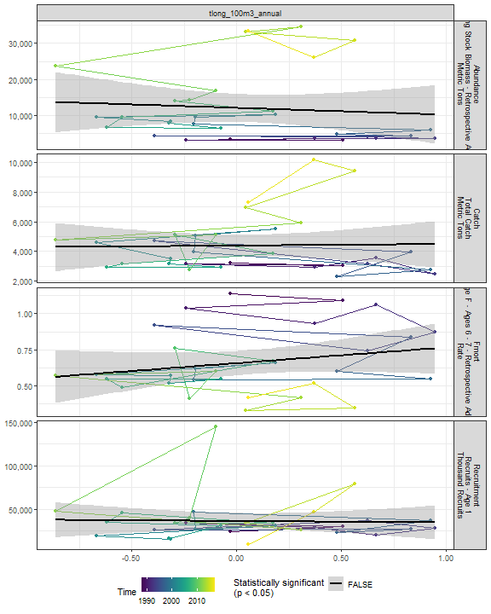

##### Regression statistics

[1] “No statistically significant data”

#### Cham 100m3 Annual

##### Figures

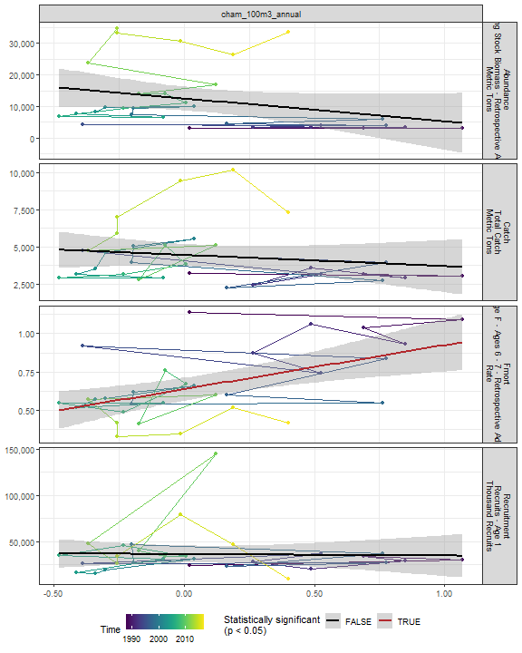

##### Regression statistics

Table 2.35: Fmort vs cham_100m3_annual

|  |  |  |  |  |
| --- | --- | --- | --- | --- |
|  | Estimate | Std. Error | t value | Pr(>|t|) |
| (Intercept) | 0.64 | 0.04 | 17.72 | 0 |
| Val | 0.29 | 0.08 | 3.41 | 0 |

|  |  |
| --- | --- |
| Name | Value |
| F-statistic | 11.66 |
| df | 1, 28 |
| R2 | 0.29 |
| R2-adj | 0.27 |

#### Echino 100m3 Annual

##### Figures

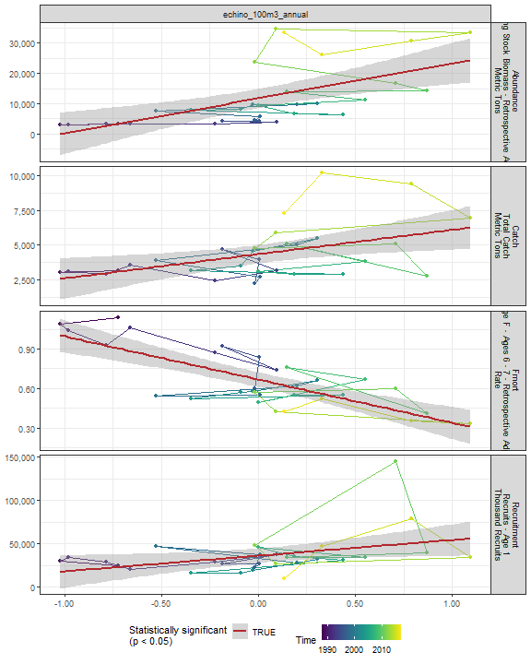

##### Regression statistics

Table 2.36: Catch vs echino_100m3_annual

|  |  |  |  |  |
| --- | --- | --- | --- | --- |
|  | Estimate | Std. Error | t value | Pr(>|t|) |
| (Intercept) | 4353.86 | 320.81 | 13.57 | 0.00 |
| Val | 1733.41 | 621.93 | 2.79 | 0.01 |

|  |  |
| --- | --- |
| Name | Value |
| F-statistic | 7.77 |
| df | 1, 28 |
| R2 | 0.22 |
| R2-adj | 0.19 |

Table 2.36: Fmort vs echino_100m3_annual

|  |  |  |  |  |
| --- | --- | --- | --- | --- |
|  | Estimate | Std. Error | t value | Pr(>|t|) |
| (Intercept) | 0.67 | 0.03 | 24.47 | 0 |
| Val | -0.33 | 0.05 | -6.21 | 0 |

|  |  |
| --- | --- |
| Name | Value |
| F-statistic | 38.59 |
| df | 1, 28 |
| R2 | 0.58 |
| R2-adj | 0.56 |

Table 2.36: Recruitment vs echino_100m3_annual

|  |  |  |  |  |
| --- | --- | --- | --- | --- |
|  | Estimate | Std. Error | t value | Pr(>|t|) |
| (Intercept) | 35916.42 | 4141.33 | 8.67 | 0.00 |
| Val | 18102.50 | 8028.35 | 2.25 | 0.03 |

|  |  |
| --- | --- |
| Name | Value |
| F-statistic | 5.08 |
| df | 1, 28 |
| R2 | 0.15 |
| R2-adj | 0.12 |

Table 2.36: Abundance vs echino_100m3_annual

|  |  |  |  |  |
| --- | --- | --- | --- | --- |
|  | Estimate | Std. Error | t value | Pr(>|t|) |
| (Intercept) | 11739.14 | 1528.31 | 7.68 | 0 |
| Val | 11456.45 | 2962.78 | 3.87 | 0 |

|  |  |
| --- | --- |
| Name | Value |
| F-statistic | 14.95 |
| df | 1, 28 |
| R2 | 0.35 |
| R2-adj | 0.32 |

#### Larvaceans 100m3 Annual

##### Figures

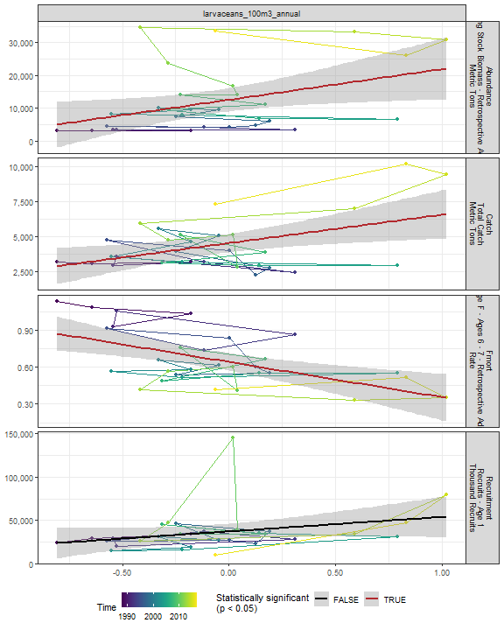

##### Regression statistics

Table 2.37: Catch vs larvaceans_100m3_annual

|  |  |  |  |  |
| --- | --- | --- | --- | --- |
|  | Estimate | Std. Error | t value | Pr(>|t|) |
| (Intercept) | 4511.25 | 324.70 | 13.89 | 0.00 |
| Val | 2036.90 | 732.85 | 2.78 | 0.01 |

|  |  |
| --- | --- |
| Name | Value |
| F-statistic | 7.73 |
| df | 1, 28 |
| R2 | 0.22 |
| R2-adj | 0.19 |

Table 2.37: Fmort vs larvaceans_100m3_annual

|  |  |  |  |  |
| --- | --- | --- | --- | --- |
|  | Estimate | Std. Error | t value | Pr(>|t|) |
| (Intercept) | 0.64 | 0.04 | 18.33 | 0 |
| Val | -0.29 | 0.08 | -3.61 | 0 |

|  |  |
| --- | --- |
| Name | Value |
| F-statistic | 13.01 |
| df | 1, 28 |
| R2 | 0.32 |
| R2-adj | 0.29 |

Table 2.37: Abundance vs larvaceans_100m3_annual

|  |  |  |  |  |
| --- | --- | --- | --- | --- |
|  | Estimate | Std. Error | t value | Pr(>|t|) |
| (Intercept) | 12502.45 | 1747.23 | 7.16 | 0.00 |
| Val | 9351.40 | 3943.57 | 2.37 | 0.02 |

|  |  |
| --- | --- |
| Name | Value |
| F-statistic | 5.62 |
| df | 1, 28 |
| R2 | 0.17 |
| R2-adj | 0.14 |

#### Para 100m3 Annual

##### Figures

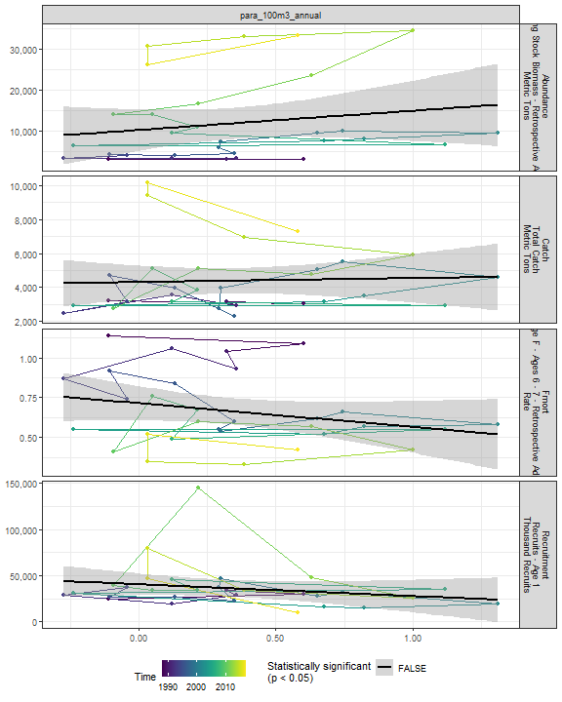

##### Regression statistics

[1] “No statistically significant data”

#### Gas 100m3 Annual

##### Figures

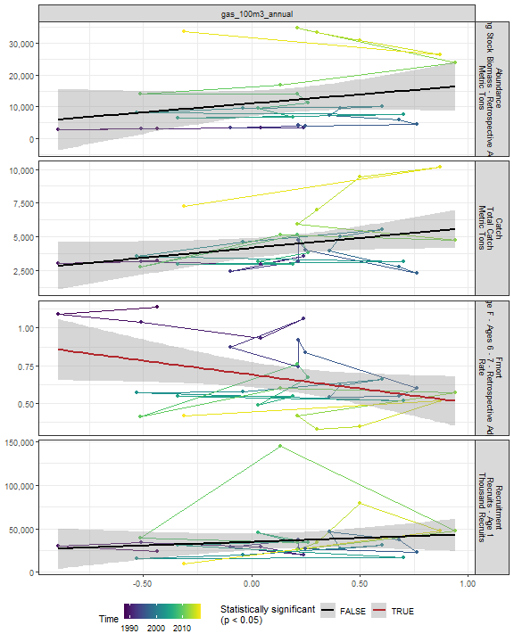

##### Regression statistics

Table 2.38: Fmort vs gas_100m3_annual

|  |  |  |  |  |
| --- | --- | --- | --- | --- |
|  | Estimate | Std. Error | t value | Pr(>|t|) |
| (Intercept) | 0.69 | 0.04 | 16.79 | 0.00 |
| Val | -0.19 | 0.09 | -2.12 | 0.04 |

|  |  |
| --- | --- |
| Name | Value |
| F-statistic | 4.48 |
| df | 1, 28 |
| R2 | 0.14 |
| R2-adj | 0.11 |

#### Acarspp 100m3 Annual

##### Figures

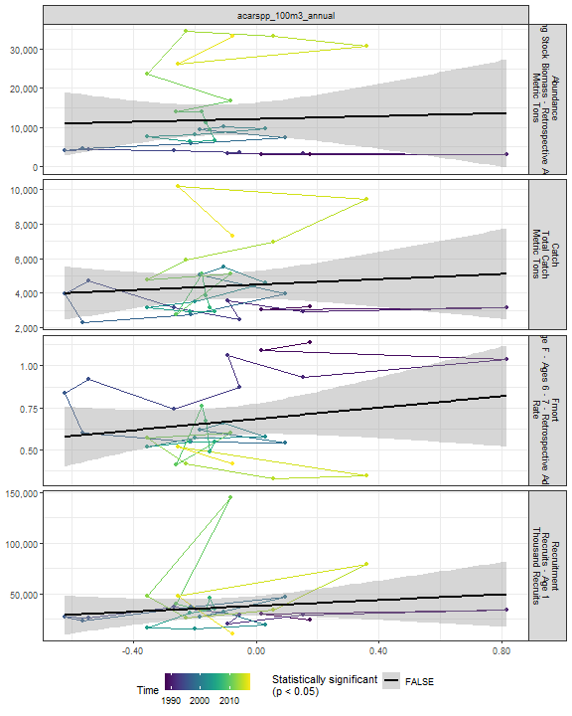

##### Regression statistics

[1] “No statistically significant data”

#### Mlucens 100m3 Annual

##### Figures

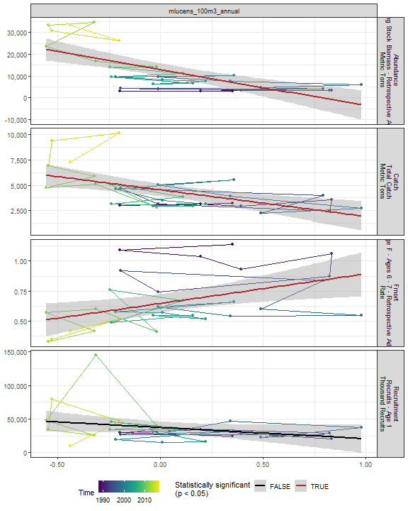

##### Regression statistics

Table 2.39: Catch vs mlucens_100m3_annual

|  |  |  |  |  |
| --- | --- | --- | --- | --- |
|  | Estimate | Std. Error | t value | Pr(>|t|) |
| (Intercept) | 4547.06 | 300.63 | 15.13 | 0 |
| Val | -2622.42 | 708.02 | -3.70 | 0 |

|  |  |
| --- | --- |
| Name | Value |
| F-statistic | 13.72 |
| df | 1, 28 |
| R2 | 0.33 |
| R2-adj | 0.3 |

Table 2.39: Fmort vs mlucens_100m3_annual

|  |  |  |  |  |
| --- | --- | --- | --- | --- |
|  | Estimate | Std. Error | t value | Pr(>|t|) |
| (Intercept) | 0.65 | 0.04 | 17.15 | 0.00 |
| Val | 0.25 | 0.09 | 2.76 | 0.01 |

|  |  |
| --- | --- |
| Name | Value |
| F-statistic | 7.62 |
| df | 1, 28 |
| R2 | 0.21 |
| R2-adj | 0.19 |

Table 2.39: Abundance vs mlucens_100m3_annual

|  |  |  |  |  |
| --- | --- | --- | --- | --- |
|  | Estimate | Std. Error | t value | Pr(>|t|) |
| (Intercept) | 12959.21 | 1386.71 | 9.35 | 0 |
| Val | -16470.99 | 3265.88 | -5.04 | 0 |

|  |  |
| --- | --- |
| Name | Value |
| F-statistic | 25.44 |
| df | 1, 28 |
| R2 | 0.48 |
| R2-adj | 0.46 |

#### Evadnespp 100m3 Annual

##### Figures

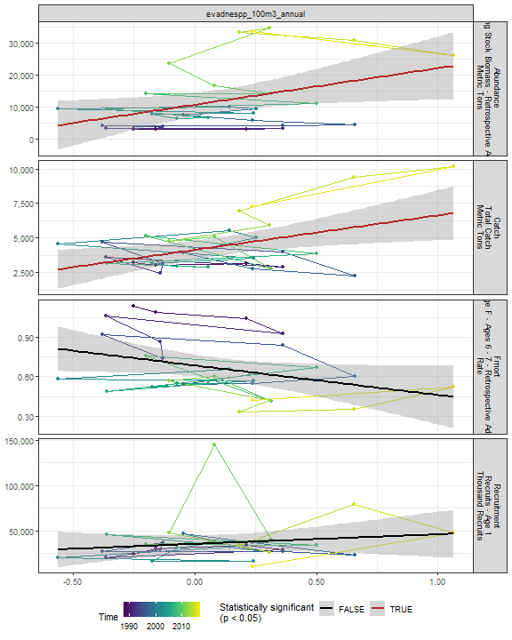

##### Regression statistics

Table 2.40: Catch vs evadnespp_100m3_annual

|  |  |  |  |  |
| --- | --- | --- | --- | --- |
|  | Estimate | Std. Error | t value | Pr(>|t|) |
| (Intercept) | 4129.14 | 334.33 | 12.35 | 0.00 |
| Val | 2507.88 | 917.77 | 2.73 | 0.01 |

|  |  |
| --- | --- |
| Name | Value |
| F-statistic | 7.47 |
| df | 1, 28 |
| R2 | 0.21 |
| R2-adj | 0.18 |

Table 2.40: Abundance vs evadnespp_100m3_annual

|  |  |  |  |  |
| --- | --- | --- | --- | --- |
|  | Estimate | Std. Error | t value | Pr(>|t|) |
| (Intercept) | 10764.82 | 1802.42 | 5.97 | 0.00 |
| Val | 11343.38 | 4947.85 | 2.29 | 0.03 |

|  |  |
| --- | --- |
| Name | Value |
| F-statistic | 5.26 |
| df | 1, 28 |
| R2 | 0.16 |
| R2-adj | 0.13 |

#### Salps 100m3 Annual

##### Figures

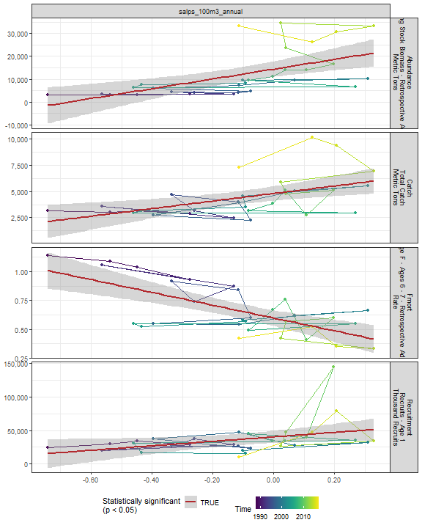

##### Regression statistics

Table 2.41: Catch vs salps_100m3_annual

|  |  |  |  |  |
| --- | --- | --- | --- | --- |
|  | Estimate | Std. Error | t value | Pr(>|t|) |
| (Intercept) | 4802.22 | 339.31 | 14.15 | 0 |
| Val | 3610.68 | 1141.48 | 3.16 | 0 |

|  |  |
| --- | --- |
| Name | Value |
| F-statistic | 10.01 |
| df | 1, 28 |
| R2 | 0.26 |
| R2-adj | 0.24 |

Table 2.41: Fmort vs salps_100m3_annual

|  |  |  |  |  |
| --- | --- | --- | --- | --- |
|  | Estimate | Std. Error | t value | Pr(>|t|) |
| (Intercept) | 0.60 | 0.03 | 17.77 | 0 |
| Val | -0.55 | 0.11 | -4.90 | 0 |

|  |  |
| --- | --- |
| Name | Value |
| F-statistic | 24.03 |
| df | 1, 28 |
| R2 | 0.46 |
| R2-adj | 0.44 |

Table 2.41: Recruitment vs salps_100m3_annual

|  |  |  |  |  |
| --- | --- | --- | --- | --- |
|  | Estimate | Std. Error | t value | Pr(>|t|) |
| (Intercept) | 40093.89 | 4533.93 | 8.84 | 0.00 |
| Val | 33449.76 | 15252.47 | 2.19 | 0.04 |

|  |  |
| --- | --- |
| Name | Value |
| F-statistic | 4.81 |
| df | 1, 28 |
| R2 | 0.15 |
| R2-adj | 0.12 |

Table 2.41: Abundance vs salps_100m3_annual

|  |  |  |  |  |
| --- | --- | --- | --- | --- |
|  | Estimate | Std. Error | t value | Pr(>|t|) |
| (Intercept) | 14409.42 | 1677.70 | 8.59 | 0 |
| Val | 21392.68 | 5643.92 | 3.79 | 0 |

|  |  |
| --- | --- |
| Name | Value |
| F-statistic | 14.37 |
| df | 1, 28 |
| R2 | 0.34 |
| R2-adj | 0.32 |

#### Oithspp 100m3 Annual

##### Figures

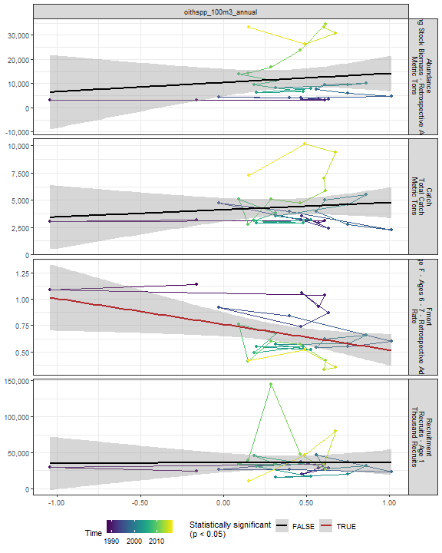

##### Regression statistics

Table 2.42: Fmort vs oithspp_100m3_annual

|  |  |  |  |  |
| --- | --- | --- | --- | --- |
|  | Estimate | Std. Error | t value | Pr(>|t|) |
| (Intercept) | 0.76 | 0.06 | 13.47 | 0.00 |
| Val | -0.24 | 0.10 | -2.35 | 0.03 |

|  |  |
| --- | --- |
| Name | Value |
| F-statistic | 5.54 |
| df | 1, 28 |
| R2 | 0.17 |
| R2-adj | 0.14 |

#### Chaeto 100m3 Annual

##### Figures

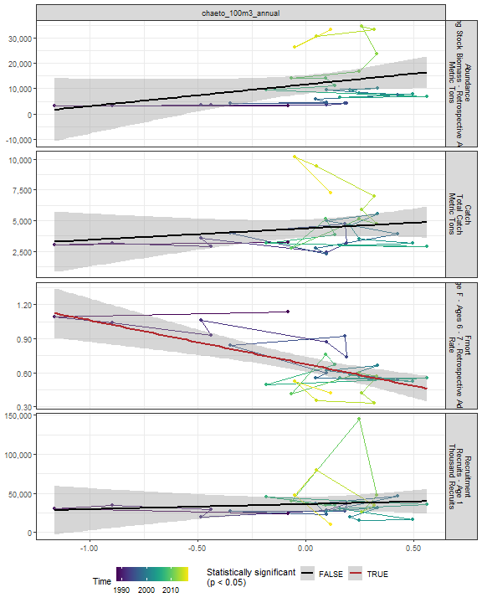

##### Regression statistics

Table 2.43: Fmort vs chaeto_100m3_annual

|  |  |  |  |  |
| --- | --- | --- | --- | --- |
|  | Estimate | Std. Error | t value | Pr(>|t|) |
| (Intercept) | 0.68 | 0.03 | 21.06 | 0 |
| Val | -0.39 | 0.09 | -4.52 | 0 |

|  |  |
| --- | --- |
| Name | Value |
| F-statistic | 20.42 |
| df | 1, 28 |
| R2 | 0.42 |
| R2-adj | 0.4 |

#### Hyper 100m3 Annual

##### Figures

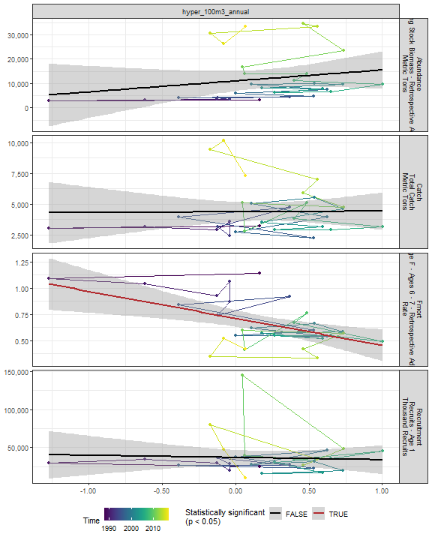

##### Regression statistics

Table 2.44: Fmort vs hyper_100m3_annual

|  |  |  |  |  |
| --- | --- | --- | --- | --- |
|  | Estimate | Std. Error | t value | Pr(>|t|) |
| (Intercept) | 0.71 | 0.04 | 18.34 | 0 |
| Val | -0.26 | 0.08 | -3.26 | 0 |

|  |  |
| --- | --- |
| Name | Value |
| F-statistic | 10.61 |
| df | 1, 28 |
| R2 | 0.27 |
| R2-adj | 0.25 |

#### Calminor 100m3 Annual

##### Figures

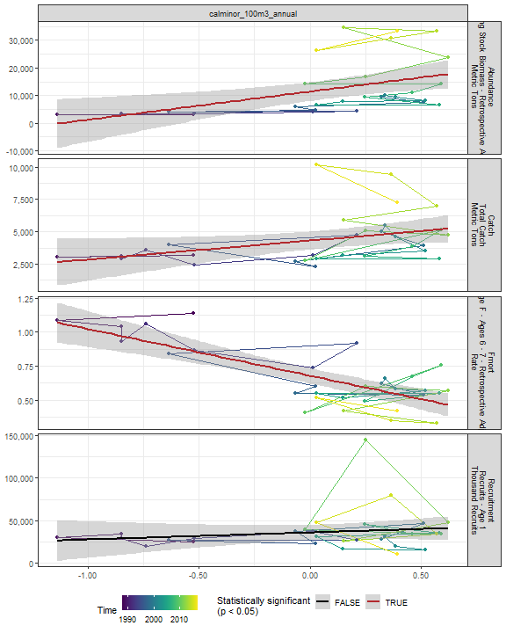

##### Regression statistics

Table 2.45: Catch vs calminor_100m3_annual

|  |  |  |  |  |
| --- | --- | --- | --- | --- |
|  | Estimate | Std. Error | t value | Pr(>|t|) |
| (Intercept) | 4304.07 | 337.81 | 12.74 | 0.00 |
| Val | 1461.15 | 684.97 | 2.13 | 0.04 |

|  |  |
| --- | --- |
| Name | Value |
| F-statistic | 4.55 |
| df | 1, 28 |
| R2 | 0.14 |
| R2-adj | 0.11 |

Table 2.45: Fmort vs calminor_100m3_annual

|  |  |  |  |  |
| --- | --- | --- | --- | --- |
|  | Estimate | Std. Error | t value | Pr(>|t|) |
| (Intercept) | 0.68 | 0.03 | 24.67 | 0 |
| Val | -0.34 | 0.06 | -6.15 | 0 |

|  |  |
| --- | --- |
| Name | Value |
| F-statistic | 37.77 |
| df | 1, 28 |
| R2 | 0.57 |
| R2-adj | 0.56 |

Table 2.45: Abundance vs calminor_100m3_annual

|  |  |  |  |  |
| --- | --- | --- | --- | --- |
|  | Estimate | Std. Error | t value | Pr(>|t|) |
| (Intercept) | 11384.67 | 1647.39 | 6.91 | 0 |
| Val | 10186.95 | 3340.40 | 3.05 | 0 |

|  |  |
| --- | --- |
| Name | Value |
| F-statistic | 9.3 |
| df | 1, 28 |
| R2 | 0.25 |
| R2-adj | 0.22 |

#### Clauso Annual

##### Figures

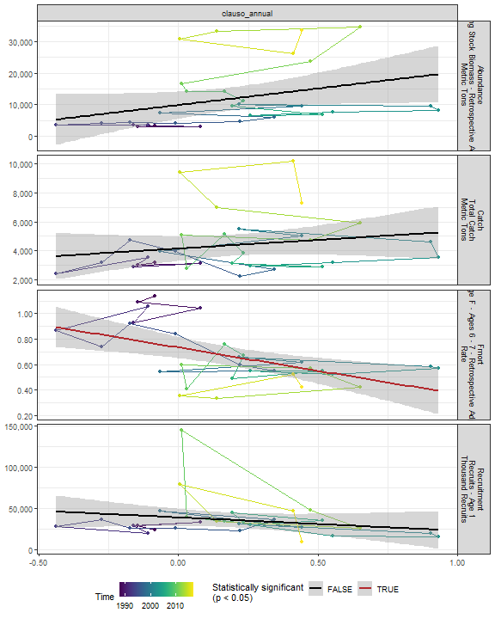

##### Regression statistics

Table 2.46: Fmort vs clauso_annual

|  |  |  |  |  |
| --- | --- | --- | --- | --- |
|  | Estimate | Std. Error | t value | Pr(>|t|) |
| (Intercept) | 0.73 | 0.04 | 17.75 | 0 |
| Val | -0.37 | 0.11 | -3.33 | 0 |

|  |  |
| --- | --- |
| Name | Value |
| F-statistic | 11.1 |
| df | 1, 28 |
| R2 | 0.28 |
| R2-adj | 0.26 |

#### Dec 100m3 Annual

##### Figures

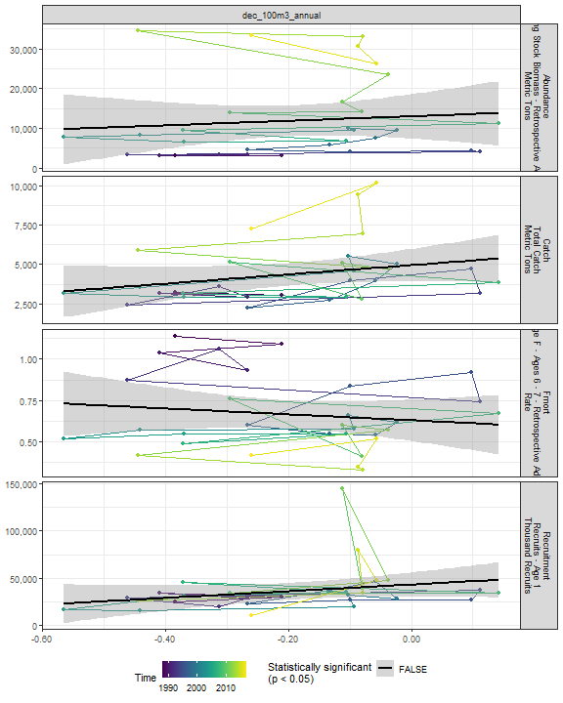

##### Regression statistics

[1] “No statistically significant data”

#### Euph 100m3 Annual

##### Figures

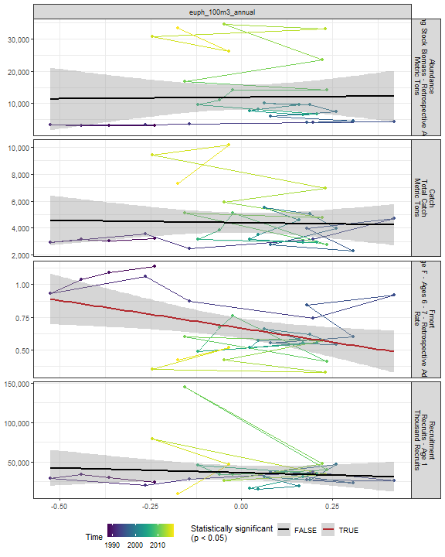

##### Regression statistics

Table 2.47: Fmort vs euph_100m3_annual

|  |  |  |  |  |
| --- | --- | --- | --- | --- |
|  | Estimate | Std. Error | t value | Pr(>|t|) |
| (Intercept) | 0.67 | 0.04 | 17.64 | 0.00 |
| Val | -0.42 | 0.16 | -2.60 | 0.01 |

|  |  |
| --- | --- |
| Name | Value |
| F-statistic | 6.77 |
| df | 1, 28 |
| R2 | 0.19 |
| R2-adj | 0.17 |

#### Prot 100m3 Annual

##### Figures

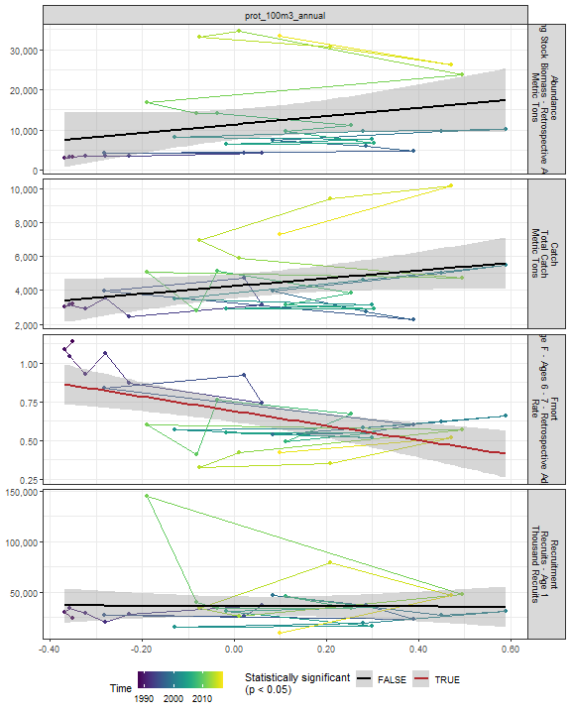

##### Regression statistics

Table 2.48: Fmort vs prot_100m3_annual

|  |  |  |  |  |
| --- | --- | --- | --- | --- |
|  | Estimate | Std. Error | t value | Pr(>|t|) |
| (Intercept) | 0.69 | 0.03 | 19.83 | 0 |
| Val | -0.47 | 0.12 | -3.82 | 0 |

|  |  |
| --- | --- |
| Name | Value |
| F-statistic | 14.59 |
| df | 1, 28 |
| R2 | 0.34 |
| R2-adj | 0.32 |

#### Poly 100m3 Annual

##### Figures

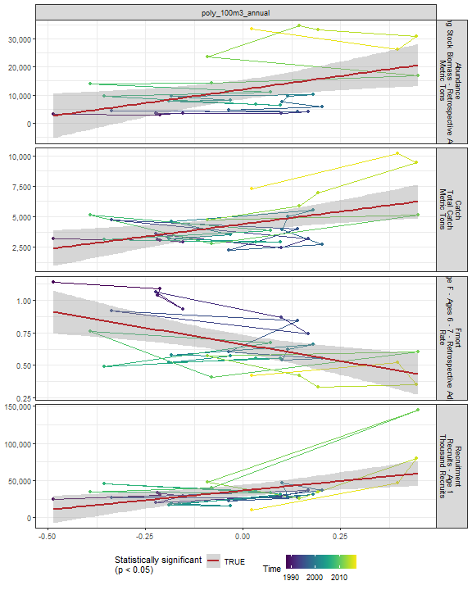

##### Regression statistics

Table 2.49: Catch vs poly_100m3_annual

|  |  |  |  |  |
| --- | --- | --- | --- | --- |
|  | Estimate | Std. Error | t value | Pr(>|t|) |
| (Intercept) | 4393.62 | 313.24 | 14.03 | 0 |
| Val | 4099.14 | 1328.93 | 3.08 | 0 |

|  |  |
| --- | --- |
| Name | Value |
| F-statistic | 9.51 |
| df | 1, 28 |
| R2 | 0.25 |
| R2-adj | 0.23 |

Table 2.49: Fmort vs poly_100m3_annual

|  |  |  |  |  |
| --- | --- | --- | --- | --- |
|  | Estimate | Std. Error | t value | Pr(>|t|) |
| (Intercept) | 0.66 | 0.04 | 18.65 | 0 |
| Val | -0.51 | 0.15 | -3.38 | 0 |

|  |  |
| --- | --- |
| Name | Value |
| F-statistic | 11.43 |
| df | 1, 28 |
| R2 | 0.29 |
| R2-adj | 0.26 |

Table 2.49: Recruitment vs poly_100m3_annual

|  |  |  |  |  |
| --- | --- | --- | --- | --- |
|  | Estimate | Std. Error | t value | Pr(>|t|) |
| (Intercept) | 36374.15 | 3867.23 | 9.41 | 0 |
| Val | 51717.57 | 16406.70 | 3.15 | 0 |

|  |  |
| --- | --- |
| Name | Value |
| F-statistic | 9.94 |
| df | 1, 28 |
| R2 | 0.26 |
| R2-adj | 0.24 |

Table 2.49: Abundance vs poly_100m3_annual

|  |  |  |  |  |
| --- | --- | --- | --- | --- |
|  | Estimate | Std. Error | t value | Pr(>|t|) |
| (Intercept) | 11964.26 | 1688.61 | 7.09 | 0.00 |
| Val | 19197.11 | 7163.95 | 2.68 | 0.01 |

|  |  |
| --- | --- |
| Name | Value |
| F-statistic | 7.18 |
| df | 1, 28 |
| R2 | 0.2 |
| R2-adj | 0.18 |

#### Fish 100m3 Annual

##### Figures

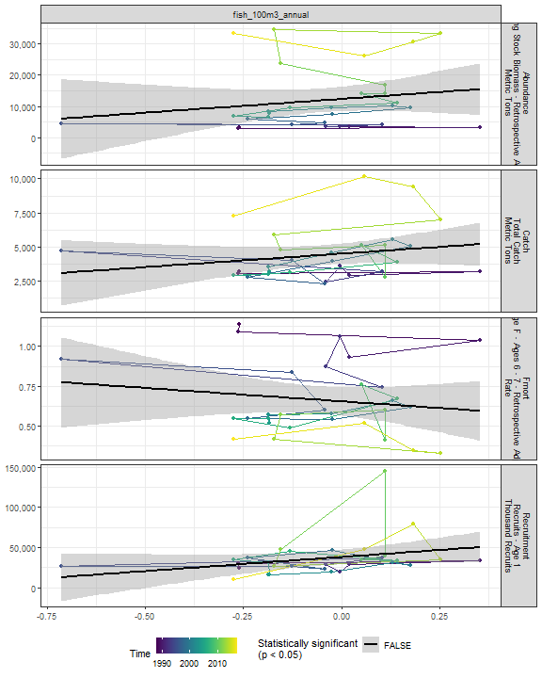

##### Regression statistics

[1] “No statistically significant data”

#### Oncaea 100m3 Annual

##### Figures

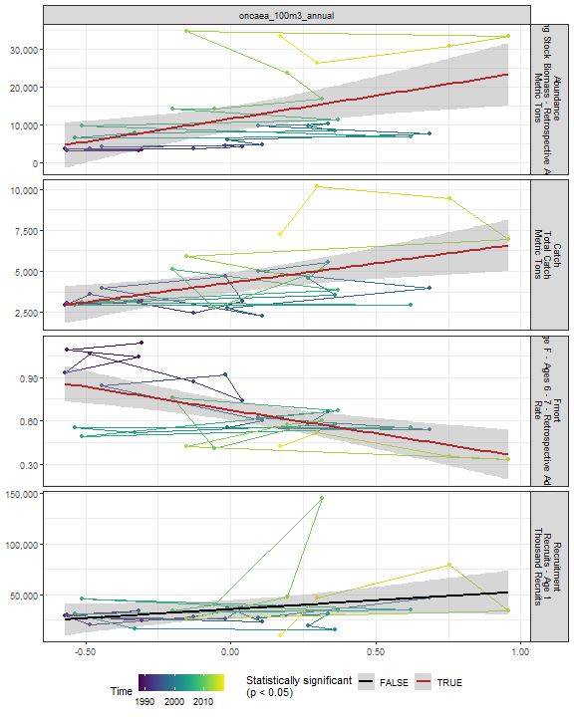

##### Regression statistics

Table 2.50: Catch vs oncaea_100m3_annual

|  |  |  |  |  |
| --- | --- | --- | --- | --- |
|  | Estimate | Std. Error | t value | Pr(>|t|) |
| (Intercept) | 4299.48 | 313.10 | 13.73 | 0 |
| Val | 2375.59 | 760.72 | 3.12 | 0 |

|  |  |
| --- | --- |
| Name | Value |
| F-statistic | 9.75 |
| df | 1, 28 |
| R2 | 0.26 |
| R2-adj | 0.23 |

Table 2.50: Fmort vs oncaea_100m3_annual

|  |  |  |  |  |
| --- | --- | --- | --- | --- |
|  | Estimate | Std. Error | t value | Pr(>|t|) |
| (Intercept) | 0.67 | 0.03 | 19.85 | 0 |
| Val | -0.32 | 0.08 | -3.90 | 0 |

|  |  |
| --- | --- |
| Name | Value |
| F-statistic | 15.23 |
| df | 1, 28 |
| R2 | 0.35 |
| R2-adj | 0.33 |

Table 2.50: Abundance vs oncaea_100m3_annual

|  |  |  |  |  |
| --- | --- | --- | --- | --- |
|  | Estimate | Std. Error | t value | Pr(>|t|) |
| (Intercept) | 11489.84 | 1643.95 | 6.99 | 0 |
| Val | 12193.92 | 3994.19 | 3.05 | 0 |

|  |  |
| --- | --- |
| Name | Value |
| F-statistic | 9.32 |
| df | 1, 28 |
| R2 | 0.25 |
| R2-adj | 0.22 |

#### Cory 100m3 Annual

##### Figures

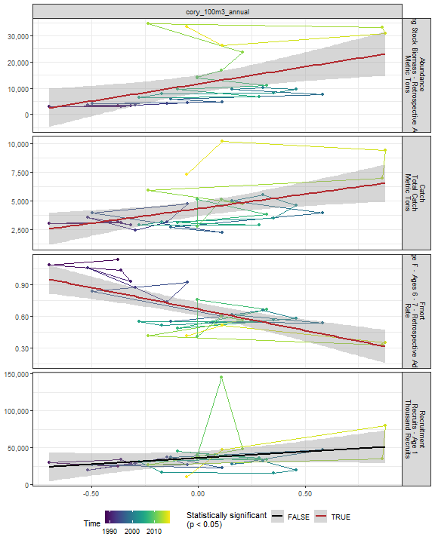

##### Regression statistics

Table 2.51: Catch vs cory_100m3_annual

|  |  |  |  |  |
| --- | --- | --- | --- | --- |
|  | Estimate | Std. Error | t value | Pr(>|t|) |
| (Intercept) | 4330.98 | 315.65 | 13.72 | 0.00 |
| Val | 2521.21 | 840.11 | 3.00 | 0.01 |

|  |  |
| --- | --- |
| Name | Value |
| F-statistic | 9.01 |
| df | 1, 28 |
| R2 | 0.24 |
| R2-adj | 0.22 |

Table 2.51: Fmort vs cory_100m3_annual

|  |  |  |  |  |
| --- | --- | --- | --- | --- |
|  | Estimate | Std. Error | t value | Pr(>|t|) |
| (Intercept) | 0.67 | 0.03 | 21.77 | 0 |
| Val | -0.40 | 0.08 | -4.93 | 0 |

|  |  |
| --- | --- |
| Name | Value |
| F-statistic | 24.31 |
| df | 1, 28 |
| R2 | 0.46 |
| R2-adj | 0.45 |

Table 2.51: Abundance vs cory_100m3_annual

|  |  |  |  |  |
| --- | --- | --- | --- | --- |
|  | Estimate | Std. Error | t value | Pr(>|t|) |
| (Intercept) | 11649.33 | 1651.51 | 7.05 | 0.00 |
| Val | 13069.23 | 4395.57 | 2.97 | 0.01 |

|  |  |
| --- | --- |
| Name | Value |
| F-statistic | 8.84 |
| df | 1, 28 |
| R2 | 0.24 |
| R2-adj | 0.21 |

#### Siph 100m3 Annual

##### Figures

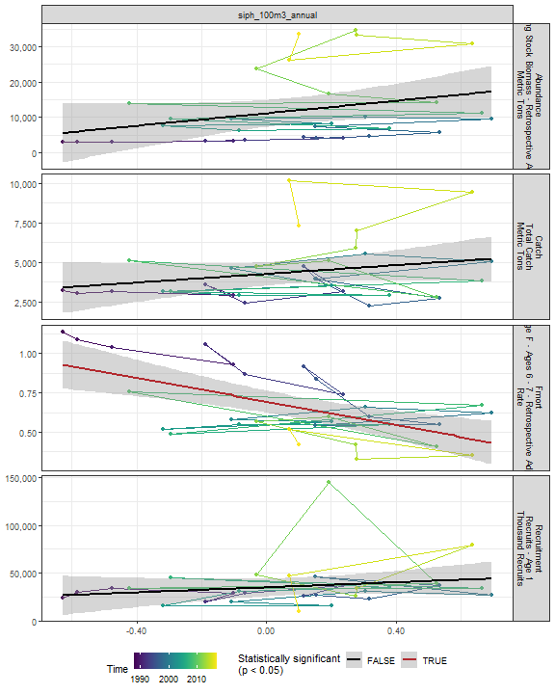

##### Regression statistics

Table 2.52: Fmort vs siph_100m3_annual

|  |  |  |  |  |
| --- | --- | --- | --- | --- |
|  | Estimate | Std. Error | t value | Pr(>|t|) |
| (Intercept) | 0.70 | 0.03 | 20.08 | 0 |
| Val | -0.38 | 0.09 | -3.96 | 0 |

|  |  |
| --- | --- |
| Name | Value |
| F-statistic | 15.65 |
| df | 1, 28 |
| R2 | 0.36 |
| R2-adj | 0.34 |

#### Coel 100m3 Annual

##### Figures

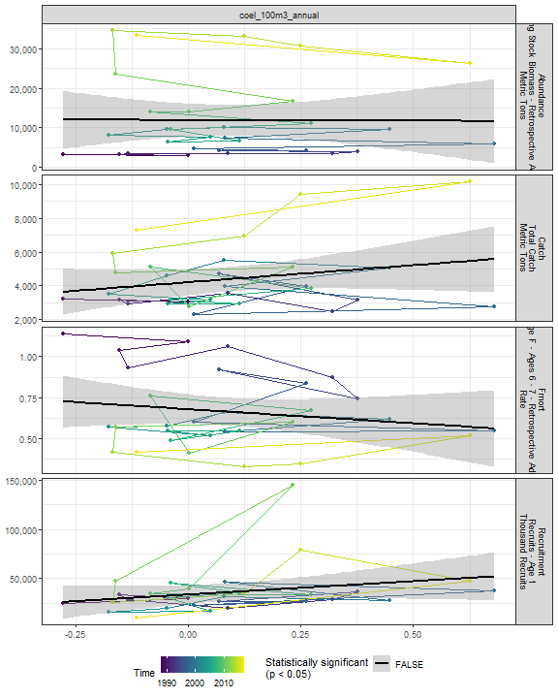

##### Regression statistics

[1] “No statistically significant data”

#### Euph1 100m3 Annual

##### Figures

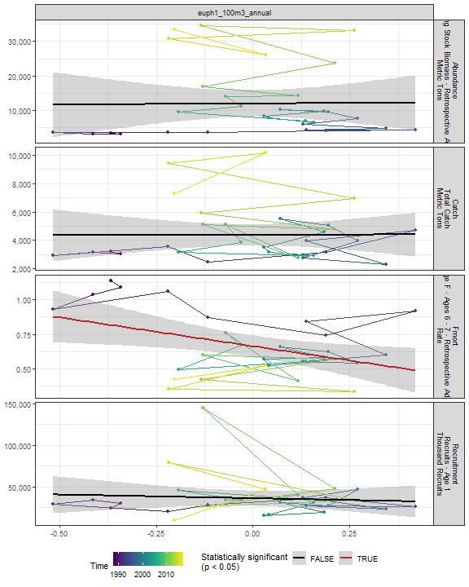

##### Regression statistics

Table 2.53: Fmort vs euph1_100m3_annual

|  |  |  |  |  |
| --- | --- | --- | --- | --- |
|  | Estimate | Std. Error | t value | Pr(>|t|) |
| (Intercept) | 0.66 | 0.04 | 17.51 | 0.00 |
| Val | -0.42 | 0.16 | -2.55 | 0.02 |

|  |  |
| --- | --- |
| Name | Value |
| F-statistic | 6.51 |
| df | 1, 28 |
| R2 | 0.19 |
| R2-adj | 0.16 |

#### Thecos 100m3 Annual

##### Figures

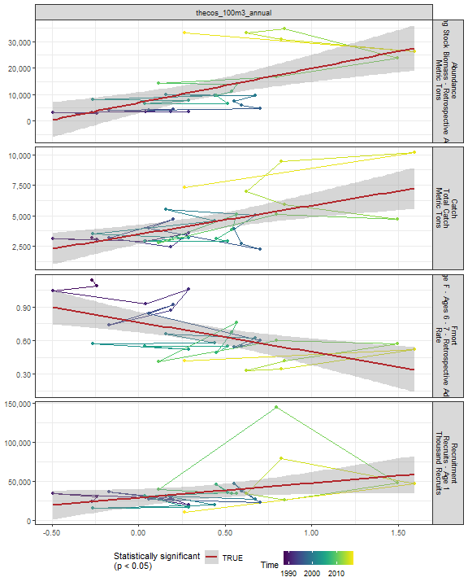

##### Regression statistics

Table 2.54: Catch vs thecos_100m3_annual

|  |  |  |  |  |
| --- | --- | --- | --- | --- |
|  | Estimate | Std. Error | t value | Pr(>|t|) |
| (Intercept) | 3474.18 | 381.80 | 9.10 | 0 |
| Val | 2365.67 | 633.44 | 3.73 | 0 |

|  |  |
| --- | --- |
| Name | Value |
| F-statistic | 13.95 |
| df | 1, 28 |
| R2 | 0.33 |
| R2-adj | 0.31 |

Table 2.54: Fmort vs thecos_100m3_annual

|  |  |  |  |  |
| --- | --- | --- | --- | --- |
|  | Estimate | Std. Error | t value | Pr(>|t|) |
| (Intercept) | 0.76 | 0.05 | 16.96 | 0 |
| Val | -0.26 | 0.07 | -3.54 | 0 |

|  |  |
| --- | --- |
| Name | Value |
| F-statistic | 12.54 |
| df | 1, 28 |
| R2 | 0.31 |
| R2-adj | 0.28 |

Table 2.54: Recruitment vs thecos_100m3_annual

|  |  |  |  |  |
| --- | --- | --- | --- | --- |
|  | Estimate | Std. Error | t value | Pr(>|t|) |
| (Intercept) | 29003.62 | 5395.44 | 5.38 | 0.00 |
| Val | 18727.27 | 8951.36 | 2.09 | 0.05 |

|  |  |
| --- | --- |
| Name | Value |
| F-statistic | 4.38 |
| df | 1, 28 |
| R2 | 0.14 |
| R2-adj | 0.1 |

Table 2.54: Abundance vs thecos_100m3_annual

|  |  |  |  |  |
| --- | --- | --- | --- | --- |
|  | Estimate | Std. Error | t value | Pr(>|t|) |
| (Intercept) | 6944.54 | 1942.66 | 3.57 | 0 |
| Val | 12955.27 | 3222.99 | 4.02 | 0 |

|  |  |
| --- | --- |
| Name | Value |
| F-statistic | 16.16 |
| df | 1, 28 |
| R2 | 0.37 |
| R2-adj | 0.34 |

#### Spirspp 100m3 Annual

##### Figures

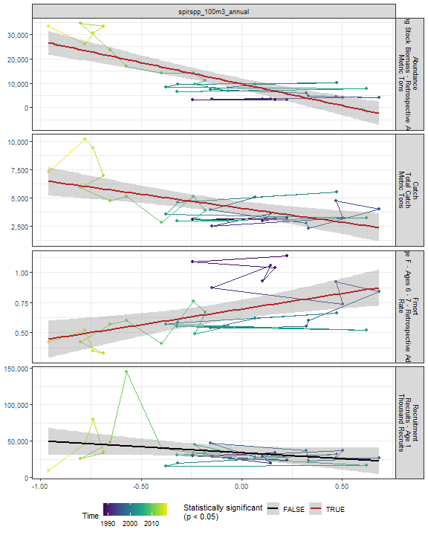

##### Regression statistics

Table 2.55: Catch vs spirspp_100m3_annual

|  |  |  |  |  |
| --- | --- | --- | --- | --- |
|  | Estimate | Std. Error | t value | Pr(>|t|) |
| (Intercept) | 4062.00 | 305.16 | 13.31 | 0 |
| Val | -2488.52 | 651.99 | -3.82 | 0 |

|  |  |
| --- | --- |
| Name | Value |
| F-statistic | 14.57 |
| df | 1, 28 |
| R2 | 0.34 |
| R2-adj | 0.32 |

Table 2.55: Fmort vs spirspp_100m3_annual

|  |  |  |  |  |
| --- | --- | --- | --- | --- |
|  | Estimate | Std. Error | t value | Pr(>|t|) |
| (Intercept) | 0.70 | 0.04 | 18.78 | 0 |
| Val | 0.26 | 0.08 | 3.29 | 0 |

|  |  |
| --- | --- |
| Name | Value |
| F-statistic | 10.8 |
| df | 1, 28 |
| R2 | 0.28 |
| R2-adj | 0.25 |

Table 2.55: Abundance vs spirspp_100m3_annual

|  |  |  |  |  |
| --- | --- | --- | --- | --- |
|  | Estimate | Std. Error | t value | Pr(>|t|) |
| (Intercept) | 9657.29 | 1190.16 | 8.11 | 0 |
| Val | -17666.19 | 2542.85 | -6.95 | 0 |

|  |  |
| --- | --- |
| Name | Value |
| F-statistic | 48.27 |
| df | 1, 28 |
| R2 | 0.63 |
| R2-adj | 0.62 |

#### Cnidar 100m3 Annual

##### Figures

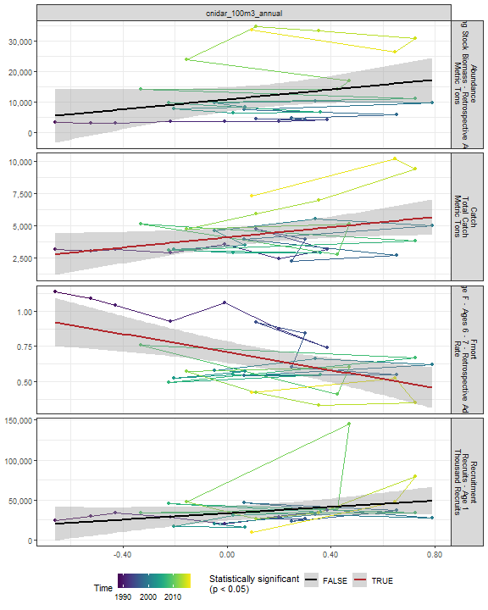

##### Regression statistics

Table 2.56: Catch vs cnidar_100m3_annual

|  |  |  |  |  |
| --- | --- | --- | --- | --- |
|  | Estimate | Std. Error | t value | Pr(>|t|) |
| (Intercept) | 4091.46 | 358.33 | 11.42 | 0.00 |
| Val | 1967.83 | 892.60 | 2.20 | 0.04 |

|  |  |
| --- | --- |
| Name | Value |
| F-statistic | 4.86 |
| df | 1, 28 |
| R2 | 0.15 |
| R2-adj | 0.12 |

Table 2.56: Fmort vs cnidar_100m3_annual

|  |  |  |  |  |
| --- | --- | --- | --- | --- |
|  | Estimate | Std. Error | t value | Pr(>|t|) |
| (Intercept) | 0.71 | 0.04 | 18.76 | 0 |
| Val | -0.32 | 0.09 | -3.42 | 0 |

|  |  |
| --- | --- |
| Name | Value |
| F-statistic | 11.67 |
| df | 1, 28 |
| R2 | 0.29 |
| R2-adj | 0.27 |

#### 2.4.3.2 Spring zooplankton abundance in the stock region

#### Ctyp 100m3 Spring

##### Figures

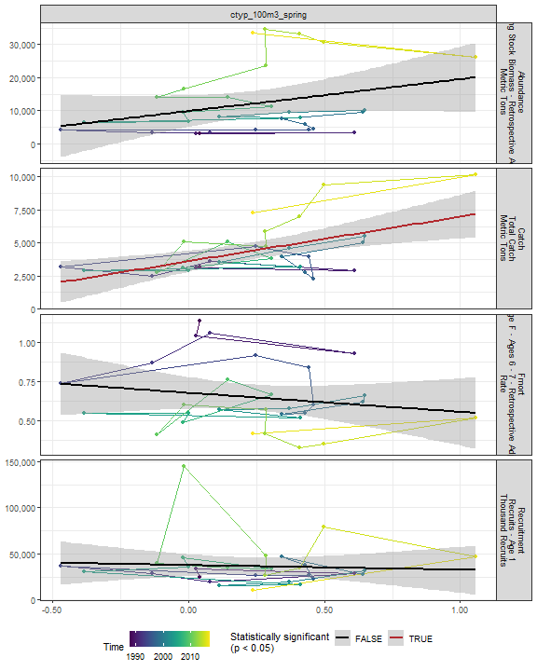

##### Regression statistics

Table 2.57: Catch vs ctyp_100m3_spring

|  |  |  |  |  |
| --- | --- | --- | --- | --- |
|  | Estimate | Std. Error | t value | Pr(>|t|) |
| (Intercept) | 3609.54 | 389.64 | 9.26 | 0 |
| Val | 3379.07 | 981.85 | 3.44 | 0 |

|  |  |
| --- | --- |
| Name | Value |
| F-statistic | 11.84 |
| df | 1, 27 |
| R2 | 0.3 |
| R2-adj | 0.28 |

#### Calfin 100m3 Spring

##### Figures

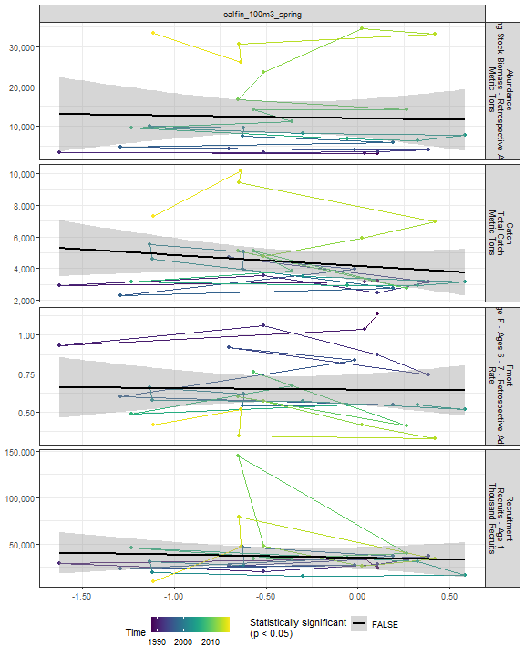

##### Regression statistics

[1] “No statistically significant data”

#### Pseudo 100m3 Spring

##### Figures

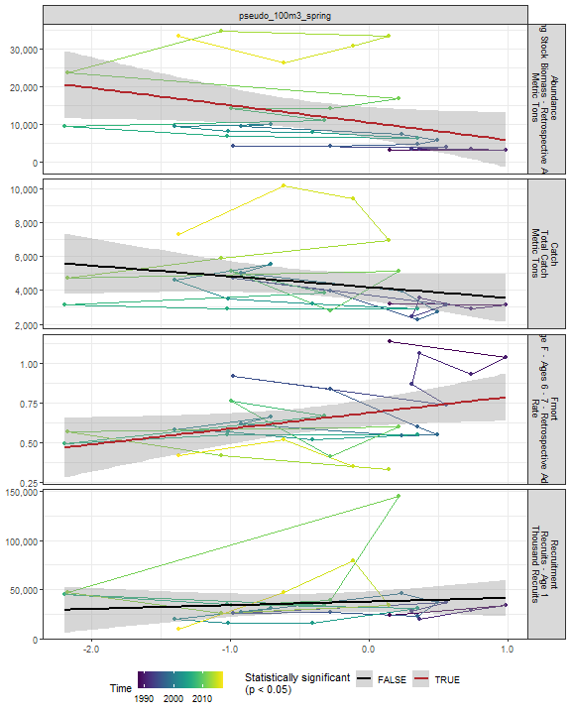

##### Regression statistics

Table 2.58: Fmort vs pseudo_100m3_spring

|  |  |  |  |  |
| --- | --- | --- | --- | --- |
|  | Estimate | Std. Error | t value | Pr(>|t|) |
| (Intercept) | 0.69 | 0.04 | 16.60 | 0.00 |
| Val | 0.10 | 0.05 | 2.17 | 0.04 |

|  |  |
| --- | --- |
| Name | Value |
| F-statistic | 4.71 |
| df | 1, 27 |
| R2 | 0.15 |
| R2-adj | 0.12 |

Table 2.58: Abundance vs pseudo_100m3_spring

|  |  |  |  |  |
| --- | --- | --- | --- | --- |
|  | Estimate | Std. Error | t value | Pr(>|t|) |
| (Intercept) | 10456.96 | 1976.31 | 5.29 | 0.00 |
| Val | -4587.14 | 2204.71 | -2.08 | 0.05 |

|  |  |
| --- | --- |
| Name | Value |
| F-statistic | 4.33 |
| df | 1, 27 |
| R2 | 0.14 |
| R2-adj | 0.11 |

#### Penilia 100m3 Spring

##### Figures

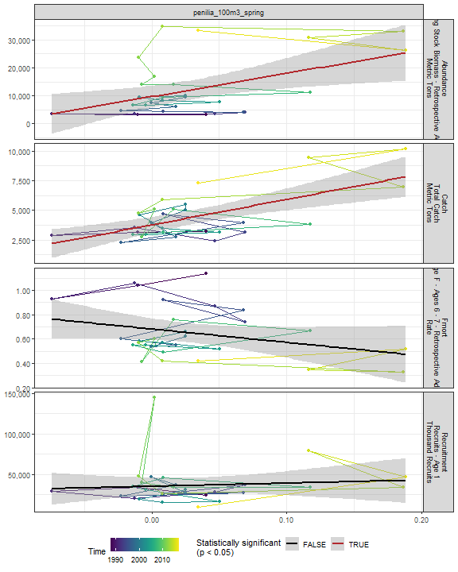

##### Regression statistics

Table 2.59: Catch vs penilia_100m3_spring

|  |  |  |  |  |
| --- | --- | --- | --- | --- |
|  | Estimate | Std. Error | t value | Pr(>|t|) |
| (Intercept) | 3776.40 | 321.09 | 11.76 | 0 |
| Val | 21442.66 | 4916.12 | 4.36 | 0 |

|  |  |
| --- | --- |
| Name | Value |
| F-statistic | 19.02 |
| df | 1, 27 |
| R2 | 0.41 |
| R2-adj | 0.39 |

Table 2.59: Abundance vs penilia_100m3_spring

|  |  |  |  |  |
| --- | --- | --- | --- | --- |
|  | Estimate | Std. Error | t value | Pr(>|t|) |
| (Intercept) | 9669.55 | 1907.27 | 5.07 | 0.00 |
| Val | 83534.40 | 29201.57 | 2.86 | 0.01 |

|  |  |
| --- | --- |
| Name | Value |
| F-statistic | 8.18 |
| df | 1, 27 |
| R2 | 0.23 |
| R2-adj | 0.2 |

#### Tlong 100m3 Spring

##### Figures

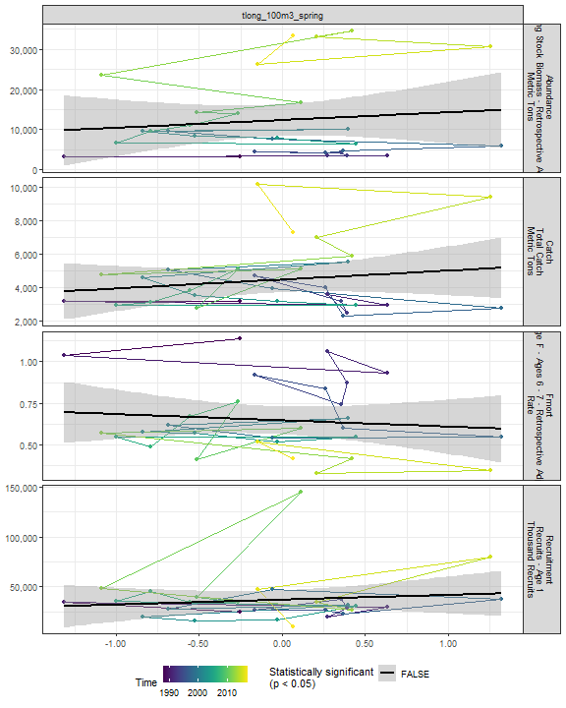

##### Regression statistics

[1] “No statistically significant data”

#### Cham 100m3 Spring

##### Figures

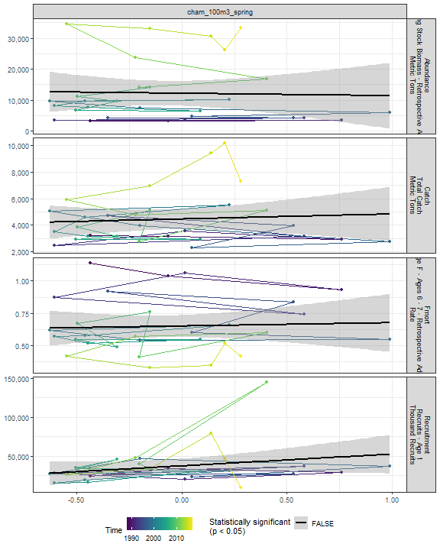

##### Regression statistics

[1] “No statistically significant data”

#### Echino 100m3 Spring

##### Figures

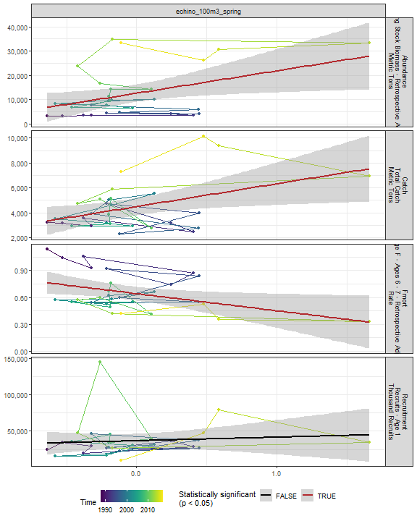

##### Regression statistics

Table 2.60: Catch vs echino_100m3_spring

|  |  |  |  |  |
| --- | --- | --- | --- | --- |
|  | Estimate | Std. Error | t value | Pr(>|t|) |
| (Intercept) | 4498.06 | 337.06 | 13.34 | 0.00 |
| Val | 1830.59 | 733.41 | 2.50 | 0.02 |

|  |  |
| --- | --- |
| Name | Value |
| F-statistic | 6.23 |
| df | 1, 27 |
| R2 | 0.19 |
| R2-adj | 0.16 |

Table 2.60: Fmort vs echino_100m3_spring

|  |  |  |  |  |
| --- | --- | --- | --- | --- |
|  | Estimate | Std. Error | t value | Pr(>|t|) |
| (Intercept) | 0.64 | 0.04 | 17.21 | 0.00 |
| Val | -0.19 | 0.08 | -2.36 | 0.03 |

|  |  |
| --- | --- |
| Name | Value |
| F-statistic | 5.56 |
| df | 1, 27 |
| R2 | 0.17 |
| R2-adj | 0.14 |

Table 2.60: Abundance vs echino_100m3_spring

|  |  |  |  |  |
| --- | --- | --- | --- | --- |
|  | Estimate | Std. Error | t value | Pr(>|t|) |
| (Intercept) | 12571.42 | 1761.06 | 7.14 | 0.00 |
| Val | 9254.65 | 3831.87 | 2.42 | 0.02 |

|  |  |
| --- | --- |
| Name | Value |
| F-statistic | 5.83 |
| df | 1, 27 |
| R2 | 0.18 |
| R2-adj | 0.15 |

#### Larvaceans 100m3 Spring

##### Figures

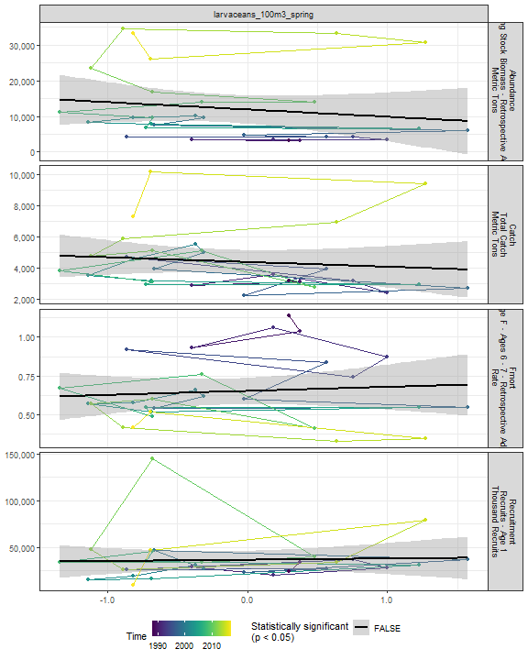

##### Regression statistics

[1] “No statistically significant data”

#### Para 100m3 Spring

##### Figures

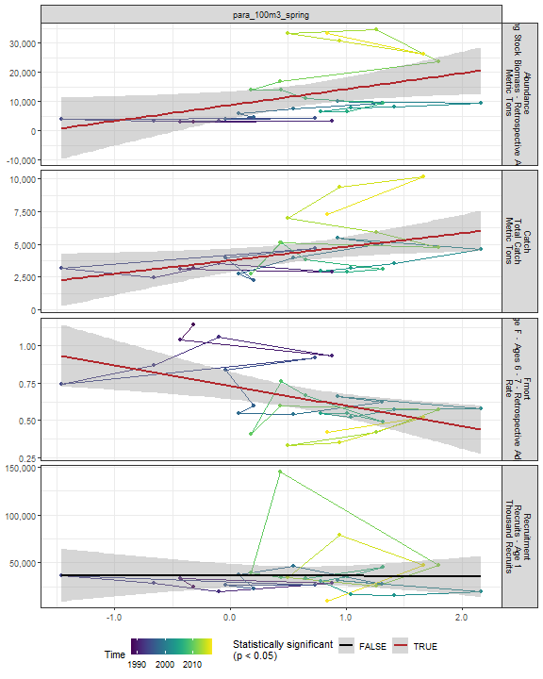

##### Regression statistics

Table 2.61: Catch vs para_100m3_spring

|  |  |  |  |  |
| --- | --- | --- | --- | --- |
|  | Estimate | Std. Error | t value | Pr(>|t|) |
| (Intercept) | 3774.63 | 436.75 | 8.64 | 0.00 |
| Val | 1034.21 | 440.63 | 2.35 | 0.03 |

|  |  |
| --- | --- |
| Name | Value |
| F-statistic | 5.51 |
| df | 1, 27 |
| R2 | 0.17 |
| R2-adj | 0.14 |

Table 2.61: Fmort vs para_100m3_spring

|  |  |  |  |  |
| --- | --- | --- | --- | --- |
|  | Estimate | Std. Error | t value | Pr(>|t|) |
| (Intercept) | 0.73 | 0.05 | 16.21 | 0.00 |
| Val | -0.14 | 0.05 | -3.01 | 0.01 |

|  |  |
| --- | --- |
| Name | Value |
| F-statistic | 9.06 |
| df | 1, 27 |
| R2 | 0.25 |
| R2-adj | 0.22 |

Table 2.61: Abundance vs para_100m3_spring

|  |  |  |  |  |
| --- | --- | --- | --- | --- |
|  | Estimate | Std. Error | t value | Pr(>|t|) |
| (Intercept) | 8790.84 | 2263.51 | 3.88 | 0.00 |
| Val | 5425.96 | 2283.62 | 2.38 | 0.02 |

|  |  |
| --- | --- |
| Name | Value |
| F-statistic | 5.65 |
| df | 1, 27 |
| R2 | 0.17 |
| R2-adj | 0.14 |

#### Gas 100m3 Spring

##### Figures

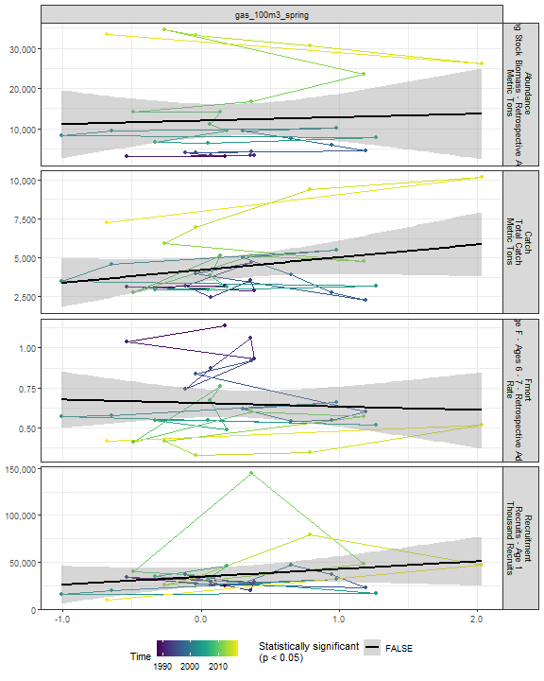

##### Regression statistics

[1] “No statistically significant data”

#### Acarspp 100m3 Spring

##### Figures

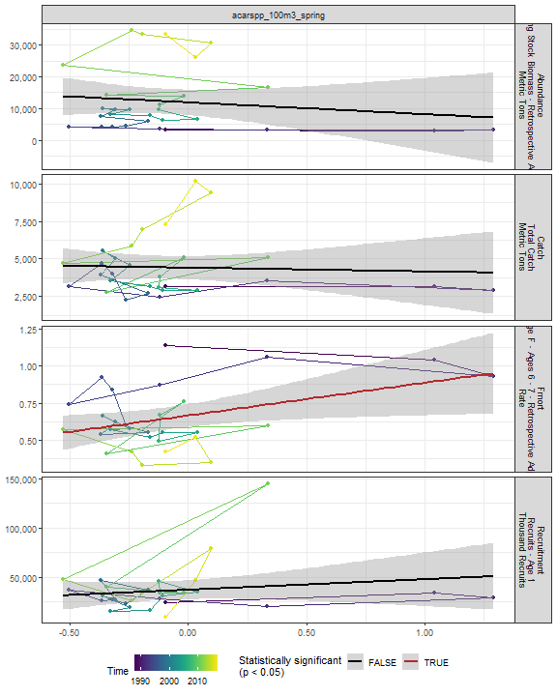

##### Regression statistics

Table 2.62: Fmort vs acarspp_100m3_spring

|  |  |  |  |  |
| --- | --- | --- | --- | --- |
|  | Estimate | Std. Error | t value | Pr(>|t|) |
| (Intercept) | 0.67 | 0.04 | 17.63 | 0.00 |
| Val | 0.22 | 0.09 | 2.35 | 0.03 |

|  |  |
| --- | --- |
| Name | Value |
| F-statistic | 5.53 |
| df | 1, 27 |
| R2 | 0.17 |
| R2-adj | 0.14 |

#### Mlucens 100m3 Spring

##### Figures

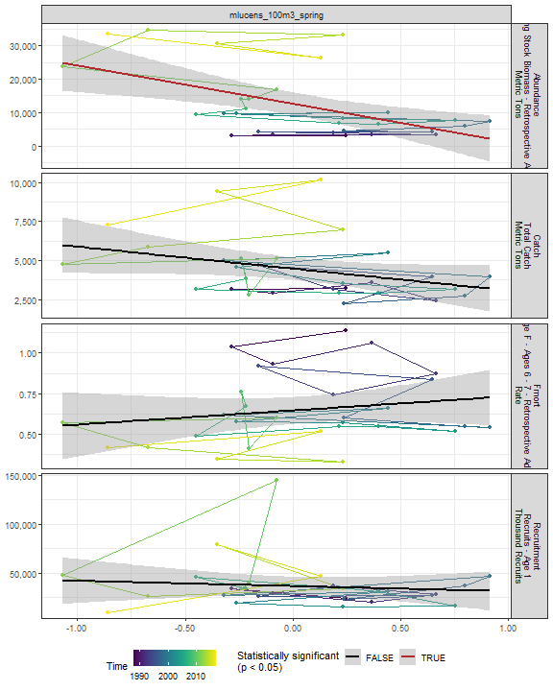

##### Regression statistics

Table 2.63: Abundance vs mlucens_100m3_spring

|  |  |  |  |  |
| --- | --- | --- | --- | --- |
|  | Estimate | Std. Error | t value | Pr(>|t|) |
| (Intercept) | 12656.38 | 1627.02 | 7.78 | 0 |
| Val | -11355.43 | 3359.20 | -3.38 | 0 |

|  |  |
| --- | --- |
| Name | Value |
| F-statistic | 11.43 |
| df | 1, 27 |
| R2 | 0.3 |
| R2-adj | 0.27 |

#### Evadnespp 100m3 Spring

##### Figures

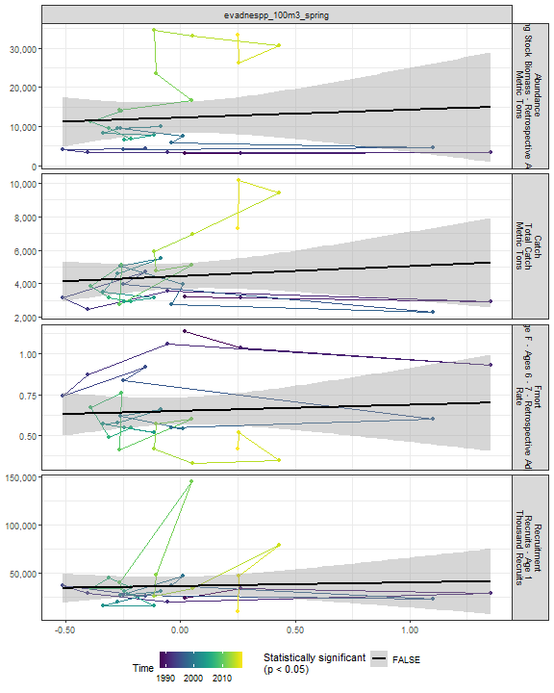

##### Regression statistics

[1] “No statistically significant data”

#### Salps 100m3 Spring

##### Figures

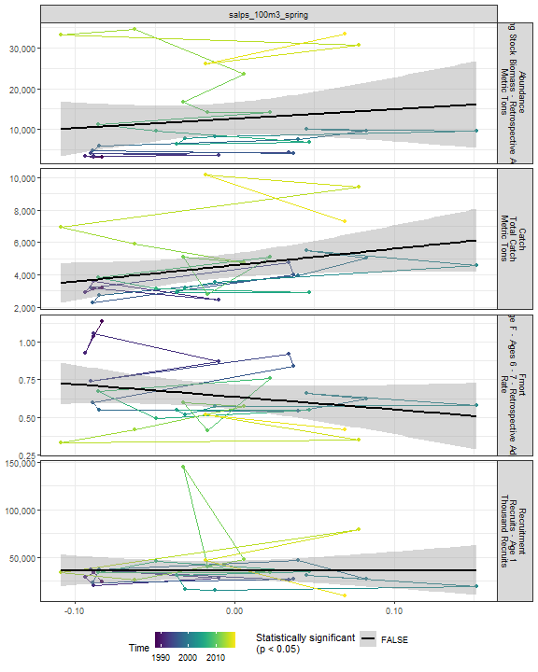

##### Regression statistics

[1] “No statistically significant data”

#### Oithspp 100m3 Spring

##### Figures

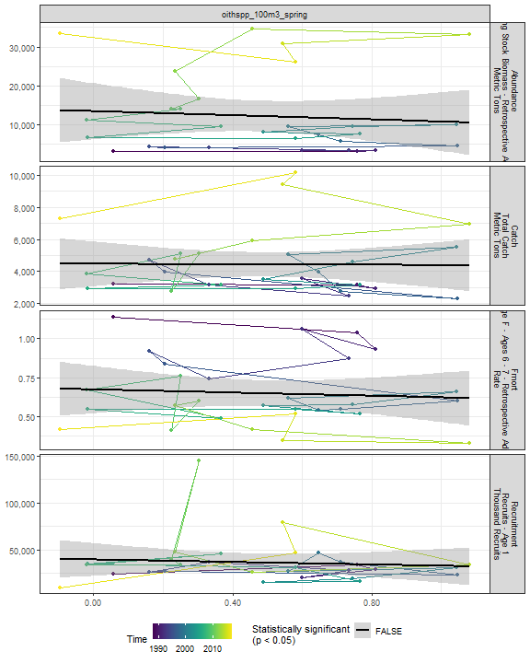

##### Regression statistics

[1] “No statistically significant data”

#### Chaeto 100m3 Spring

##### Figures

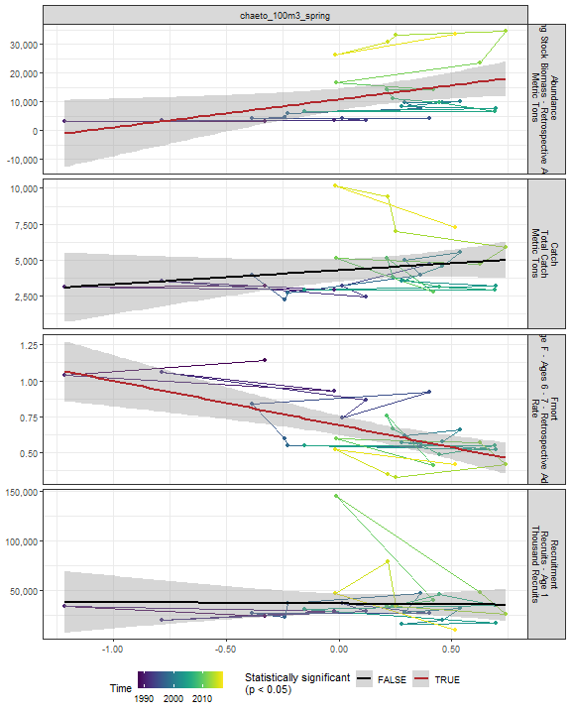

##### Regression statistics

Table 2.64: Fmort vs chaeto_100m3_spring

|  |  |  |  |  |
| --- | --- | --- | --- | --- |
|  | Estimate | Std. Error | t value | Pr(>|t|) |
| (Intercept) | 0.69 | 0.03 | 21.07 | 0 |
| Val | -0.31 | 0.07 | -4.33 | 0 |

|  |  |
| --- | --- |
| Name | Value |
| F-statistic | 18.74 |
| df | 1, 27 |
| R2 | 0.41 |
| R2-adj | 0.39 |

Table 2.64: Abundance vs chaeto_100m3_spring

|  |  |  |  |  |
| --- | --- | --- | --- | --- |
|  | Estimate | Std. Error | t value | Pr(>|t|) |
| (Intercept) | 10786.27 | 1836.77 | 5.87 | 0.00 |
| Val | 9772.71 | 3972.04 | 2.46 | 0.02 |

|  |  |
| --- | --- |
| Name | Value |
| F-statistic | 6.05 |
| df | 1, 27 |
| R2 | 0.18 |
| R2-adj | 0.15 |

#### Hyper 100m3 Spring

##### Figures

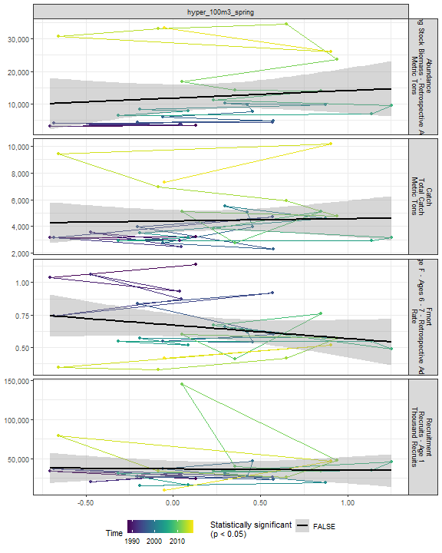

##### Regression statistics

[1] “No statistically significant data”

#### Calminor 100m3 Spring

##### Figures

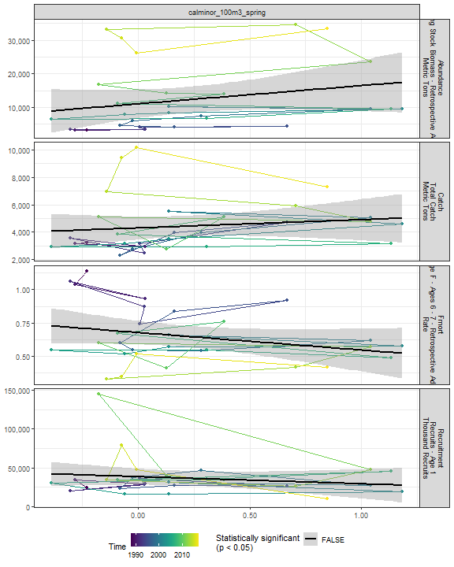

##### Regression statistics

[1] “No statistically significant data”

#### Clauso Spring

##### Figures

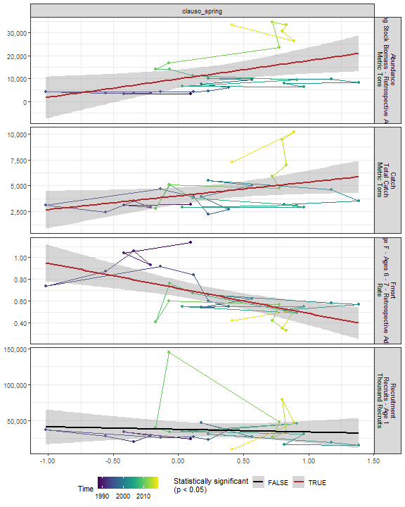

##### Regression statistics

Table 2.65: Catch vs clauso_spring

|  |  |  |  |  |
| --- | --- | --- | --- | --- |
|  | Estimate | Std. Error | t value | Pr(>|t|) |
| (Intercept) | 4029.32 | 390.46 | 10.32 | 0.00 |
| Val | 1318.68 | 619.89 | 2.13 | 0.04 |

|  |  |
| --- | --- |
| Name | Value |
| F-statistic | 4.53 |
| df | 1, 27 |
| R2 | 0.14 |
| R2-adj | 0.11 |

Table 2.65: Fmort vs clauso_spring

|  |  |  |  |  |
| --- | --- | --- | --- | --- |
|  | Estimate | Std. Error | t value | Pr(>|t|) |
| (Intercept) | 0.72 | 0.04 | 19.57 | 0 |
| Val | -0.23 | 0.06 | -3.97 | 0 |

|  |  |
| --- | --- |
| Name | Value |
| F-statistic | 15.75 |
| df | 1, 27 |
| R2 | 0.37 |
| R2-adj | 0.35 |

Table 2.65: Abundance vs clauso_spring

|  |  |  |  |  |
| --- | --- | --- | --- | --- |
|  | Estimate | Std. Error | t value | Pr(>|t|) |
| (Intercept) | 9804.73 | 1964.56 | 4.99 | 0.00 |
| Val | 8006.28 | 3118.86 | 2.57 | 0.02 |

|  |  |
| --- | --- |
| Name | Value |
| F-statistic | 6.59 |
| df | 1, 27 |
| R2 | 0.2 |
| R2-adj | 0.17 |

#### Dec 100m3 Spring

##### Figures

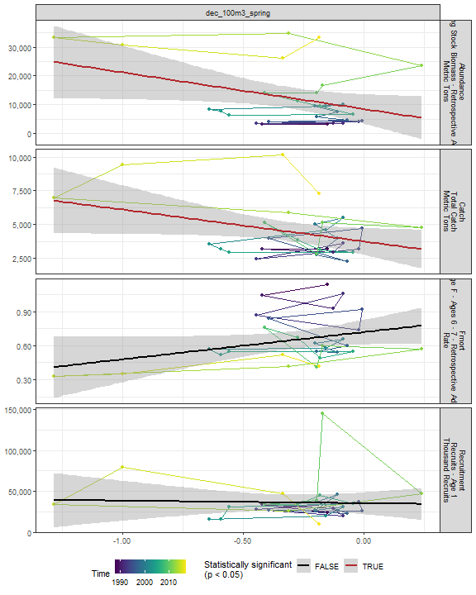

##### Regression statistics

Table 2.66: Catch vs dec_100m3_spring

|  |  |  |  |  |
| --- | --- | --- | --- | --- |
|  | Estimate | Std. Error | t value | Pr(>|t|) |
| (Intercept) | 3734.58 | 479.9 | 7.78 | 0.00 |
| Val | -2365.90 | 1147.5 | -2.06 | 0.05 |

|  |  |
| --- | --- |
| Name | Value |
| F-statistic | 4.25 |
| df | 1, 27 |
| R2 | 0.14 |
| R2-adj | 0.1 |

Table 2.66: Abundance vs dec_100m3_spring

|  |  |  |  |  |
| --- | --- | --- | --- | --- |
|  | Estimate | Std. Error | t value | Pr(>|t|) |
| (Intercept) | 8497.78 | 2478.93 | 3.43 | 0.00 |
| Val | -12698.95 | 5927.45 | -2.14 | 0.04 |

|  |  |
| --- | --- |
| Name | Value |
| F-statistic | 4.59 |
| df | 1, 27 |
| R2 | 0.15 |
| R2-adj | 0.11 |

#### Euph 100m3 Spring

##### Figures

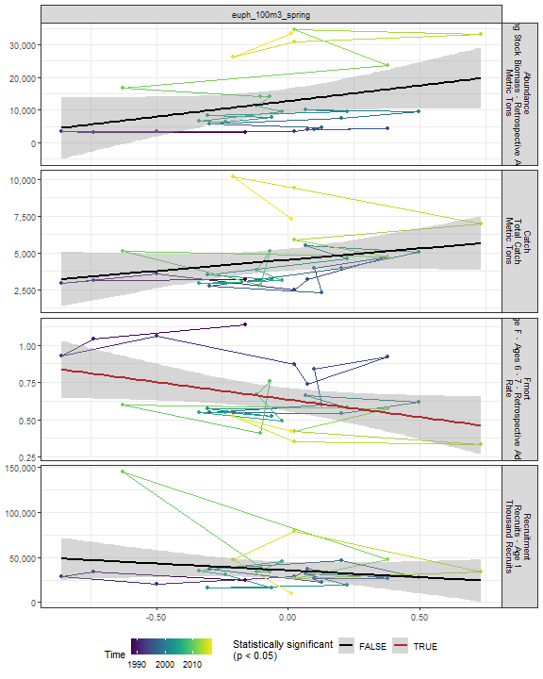

##### Regression statistics

Table 2.67: Fmort vs euph_100m3_spring

|  |  |  |  |  |
| --- | --- | --- | --- | --- |
|  | Estimate | Std. Error | t value | Pr(>|t|) |
| (Intercept) | 0.63 | 0.04 | 16.64 | 0.00 |
| Val | -0.24 | 0.11 | -2.18 | 0.04 |

|  |  |
| --- | --- |
| Name | Value |
| F-statistic | 4.76 |
| df | 1, 27 |
| R2 | 0.15 |
| R2-adj | 0.12 |

#### Prot 100m3 Spring

##### Figures

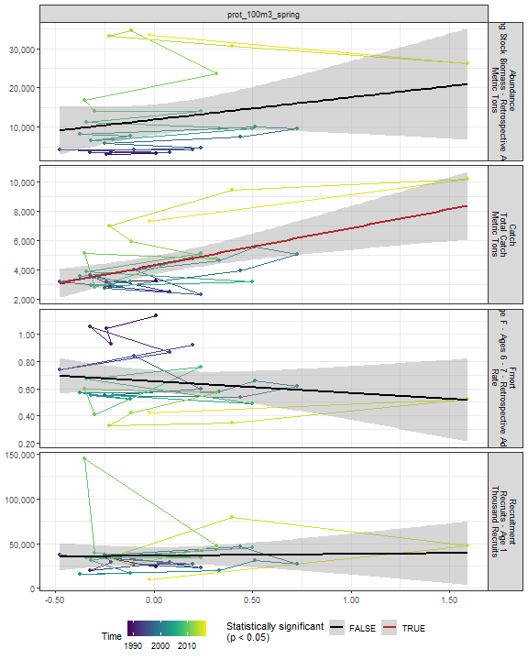

##### Regression statistics

Table 2.68: Catch vs prot_100m3_spring

|  |  |  |  |  |
| --- | --- | --- | --- | --- |
|  | Estimate | Std. Error | t value | Pr(>|t|) |
| (Intercept) | 4279.20 | 307.94 | 13.90 | 0 |
| Val | 2558.08 | 706.52 | 3.62 | 0 |

|  |  |
| --- | --- |
| Name | Value |
| F-statistic | 13.11 |
| df | 1, 27 |
| R2 | 0.33 |
| R2-adj | 0.3 |

#### Poly 100m3 Spring

##### Figures

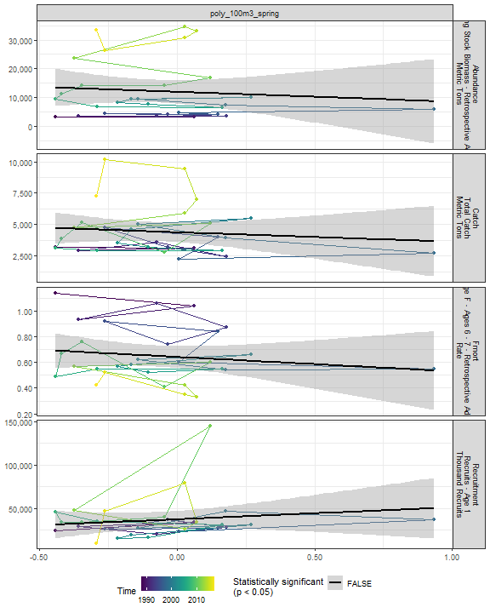

##### Regression statistics

[1] “No statistically significant data”

#### Fish 100m3 Spring

##### Figures

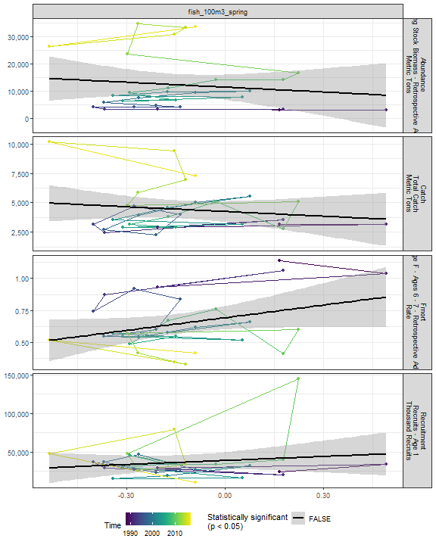

##### Regression statistics

[1] “No statistically significant data”

#### Oncaea 100m3 Spring

##### Figures

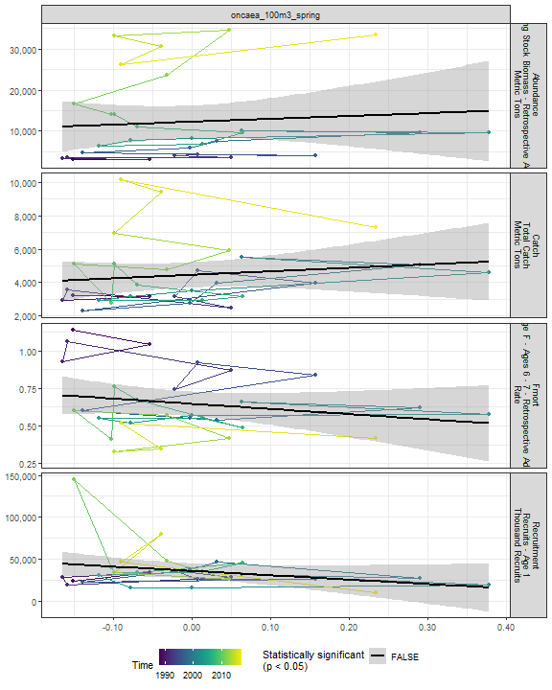

##### Regression statistics

[1] “No statistically significant data”

#### Cory 100m3 Spring

##### Figures

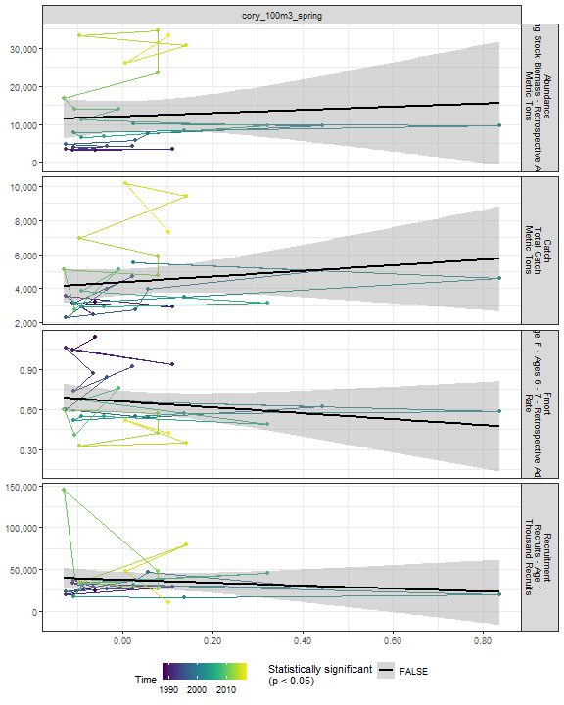

##### Regression statistics

[1] “No statistically significant data”

#### Siph 100m3 Spring

##### Figures

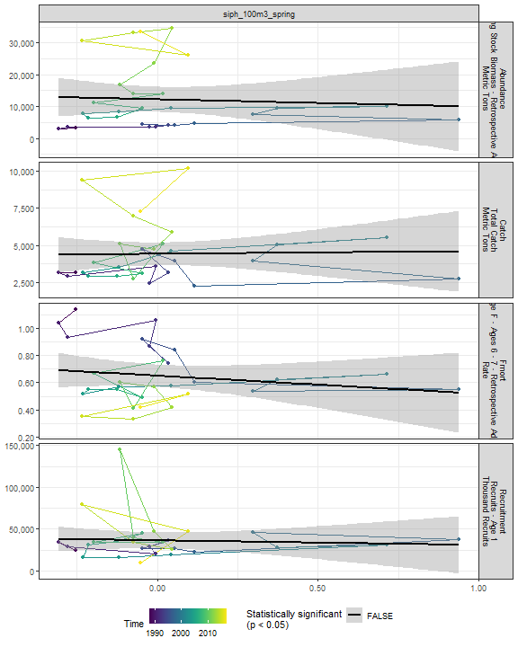

##### Regression statistics

[1] “No statistically significant data”

#### Coel 100m3 Spring

##### Figures

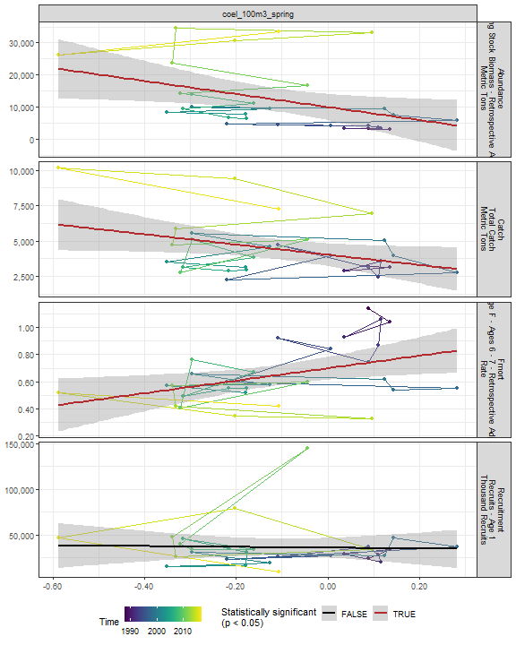

##### Regression statistics

Table 2.69: Catch vs coel_100m3_spring

|  |  |  |  |  |
| --- | --- | --- | --- | --- |
|  | Estimate | Std. Error | t value | Pr(>|t|) |
| (Intercept) | 4028.24 | 391.69 | 10.28 | 0.00 |
| Val | -3601.91 | 1705.96 | -2.11 | 0.04 |

|  |  |
| --- | --- |
| Name | Value |
| F-statistic | 4.46 |
| df | 1, 27 |
| R2 | 0.14 |
| R2-adj | 0.11 |

Table 2.69: Fmort vs coel_100m3_spring

|  |  |  |  |  |
| --- | --- | --- | --- | --- |
|  | Estimate | Std. Error | t value | Pr(>|t|) |
| (Intercept) | 0.70 | 0.04 | 16.82 | 0.00 |
| Val | 0.46 | 0.18 | 2.53 | 0.02 |

|  |  |
| --- | --- |
| Name | Value |
| F-statistic | 6.41 |
| df | 1, 27 |
| R2 | 0.19 |
| R2-adj | 0.16 |

Table 2.69: Abundance vs coel_100m3_spring

|  |  |  |  |  |
| --- | --- | --- | --- | --- |
|  | Estimate | Std. Error | t value | Pr(>|t|) |
| (Intercept) | 9972.59 | 2004.83 | 4.97 | 0.00 |
| Val | -20265.37 | 8731.90 | -2.32 | 0.03 |

|  |  |
| --- | --- |
| Name | Value |
| F-statistic | 5.39 |
| df | 1, 27 |
| R2 | 0.17 |
| R2-adj | 0.14 |

#### Euph1 100m3 Spring

##### Figures

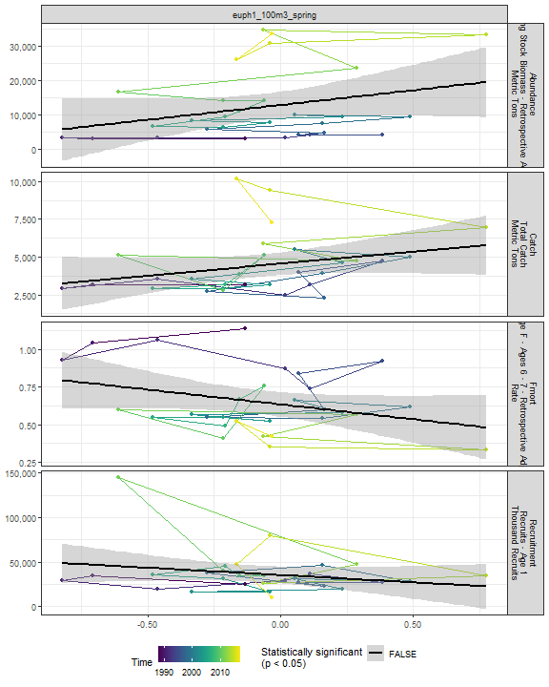

##### Regression statistics

[1] “No statistically significant data”

#### Thecos 100m3 Spring

##### Figures

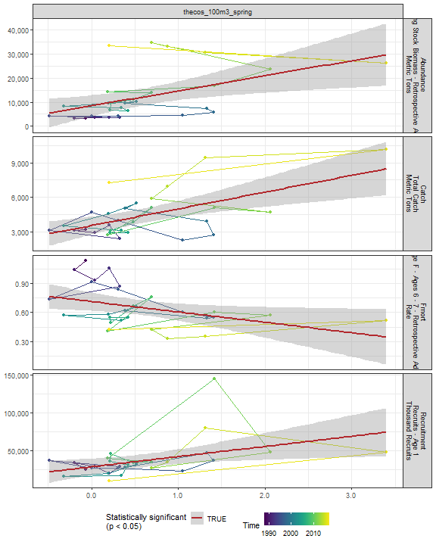

##### Regression statistics

Table 2.70: Catch vs thecos_100m3_spring

|  |  |  |  |  |
| --- | --- | --- | --- | --- |
|  | Estimate | Std. Error | t value | Pr(>|t|) |
| (Intercept) | 3559.80 | 380.00 | 9.37 | 0 |
| Val | 1447.28 | 387.37 | 3.74 | 0 |

|  |  |
| --- | --- |
| Name | Value |
| F-statistic | 13.96 |
| df | 1, 27 |
| R2 | 0.34 |
| R2-adj | 0.32 |

Table 2.70: Fmort vs thecos_100m3_spring

|  |  |  |  |  |
| --- | --- | --- | --- | --- |
|  | Estimate | Std. Error | t value | Pr(>|t|) |
| (Intercept) | 0.71 | 0.05 | 15.18 | 0.00 |
| Val | -0.11 | 0.05 | -2.25 | 0.03 |

|  |  |
| --- | --- |
| Name | Value |
| F-statistic | 5.06 |
| df | 1, 27 |
| R2 | 0.16 |
| R2-adj | 0.13 |

Table 2.70: Recruitment vs thecos_100m3_spring

|  |  |  |  |  |
| --- | --- | --- | --- | --- |
|  | Estimate | Std. Error | t value | Pr(>|t|) |
| (Intercept) | 28344.62 | 5271.91 | 5.38 | 0.00 |
| Val | 13461.62 | 5374.22 | 2.50 | 0.02 |

|  |  |
| --- | --- |
| Name | Value |
| F-statistic | 6.27 |
| df | 1, 27 |
| R2 | 0.19 |
| R2-adj | 0.16 |

Table 2.70: Abundance vs thecos_100m3_spring

|  |  |  |  |  |
| --- | --- | --- | --- | --- |
|  | Estimate | Std. Error | t value | Pr(>|t|) |
| (Intercept) | 8460.99 | 2124.89 | 3.98 | 0.00 |
| Val | 6251.84 | 2166.13 | 2.89 | 0.01 |

|  |  |
| --- | --- |
| Name | Value |
| F-statistic | 8.33 |
| df | 1, 27 |
| R2 | 0.24 |
| R2-adj | 0.21 |

#### Spirspp 100m3 Spring

##### Figures

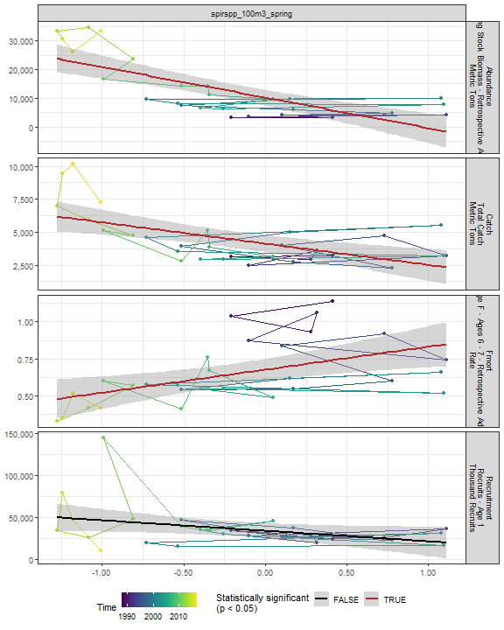

##### Regression statistics

Table 2.71: Catch vs spirspp_100m3_spring

|  |  |  |  |  |
| --- | --- | --- | --- | --- |
|  | Estimate | Std. Error | t value | Pr(>|t|) |
| (Intercept) | 4125.97 | 310.73 | 13.28 | 0 |
| Val | -1615.87 | 426.61 | -3.79 | 0 |

|  |  |
| --- | --- |
| Name | Value |
| F-statistic | 14.35 |
| df | 1, 27 |
| R2 | 0.35 |
| R2-adj | 0.32 |

Table 2.71: Fmort vs spirspp_100m3_spring

|  |  |  |  |  |
| --- | --- | --- | --- | --- |
|  | Estimate | Std. Error | t value | Pr(>|t|) |
| (Intercept) | 0.68 | 0.04 | 18.82 | 0 |
| Val | 0.16 | 0.05 | 3.14 | 0 |

|  |  |
| --- | --- |
| Name | Value |
| F-statistic | 9.86 |
| df | 1, 27 |
| R2 | 0.27 |
| R2-adj | 0.24 |

Table 2.71: Abundance vs spirspp_100m3_spring

|  |  |  |  |  |
| --- | --- | --- | --- | --- |
|  | Estimate | Std. Error | t value | Pr(>|t|) |
| (Intercept) | 10241.49 | 1328.77 | 7.71 | 0 |
| Val | -10634.89 | 1824.31 | -5.83 | 0 |

|  |  |
| --- | --- |
| Name | Value |
| F-statistic | 33.98 |
| df | 1, 27 |
| R2 | 0.56 |
| R2-adj | 0.54 |

#### Cnidar 100m3 Spring

##### Figures

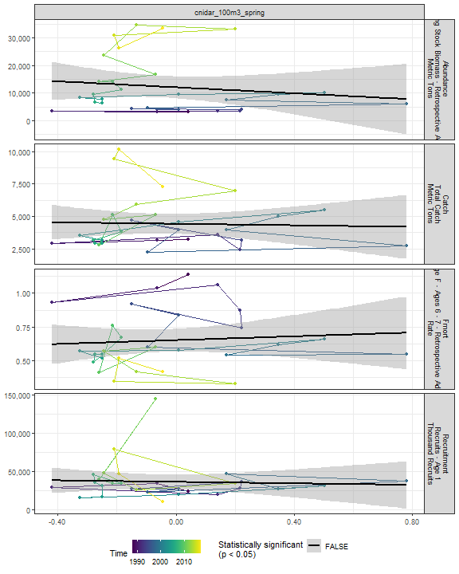

##### Regression statistics

[1] “No statistically significant data”

#### 2.4.3.3 Fall zooplankton abundance in the stock region

#### Ctyp 100m3 Fall

##### Figures

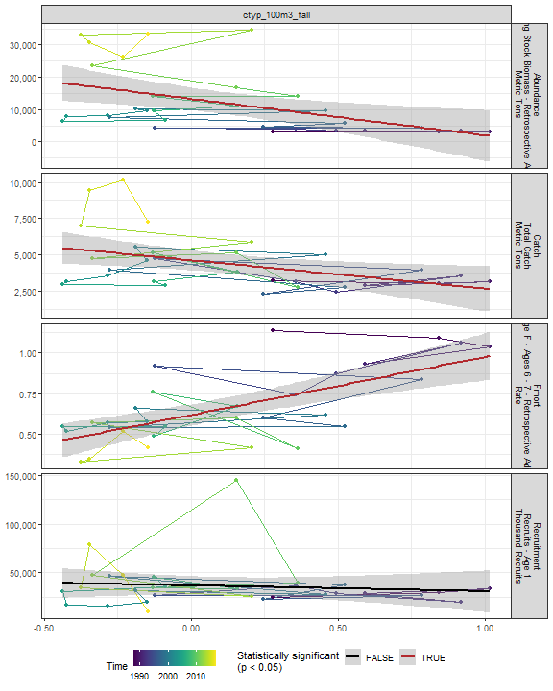

##### Regression statistics

Table 2.72: Catch vs ctyp_100m3_fall

|  |  |  |  |  |
| --- | --- | --- | --- | --- |
|  | Estimate | Std. Error | t value | Pr(>|t|) |
| (Intercept) | 4617.40 | 340.85 | 13.55 | 0.00 |
| Val | -1951.68 | 770.99 | -2.53 | 0.02 |

|  |  |
| --- | --- |
| Name | Value |
| F-statistic | 6.41 |
| df | 1, 28 |
| R2 | 0.19 |
| R2-adj | 0.16 |

Table 2.72: Fmort vs ctyp_100m3_fall

|  |  |  |  |  |
| --- | --- | --- | --- | --- |
|  | Estimate | Std. Error | t value | Pr(>|t|) |
| (Intercept) | 0.62 | 0.03 | 19.26 | 0 |
| Val | 0.36 | 0.07 | 4.90 | 0 |

|  |  |
| --- | --- |
| Name | Value |
| F-statistic | 24.03 |
| df | 1, 28 |
| R2 | 0.46 |
| R2-adj | 0.44 |

Table 2.72: Abundance vs ctyp_100m3_fall

|  |  |  |  |  |
| --- | --- | --- | --- | --- |
|  | Estimate | Std. Error | t value | Pr(>|t|) |
| (Intercept) | 13278.63 | 1732.93 | 7.66 | 0.00 |
| Val | -11276.79 | 3919.89 | -2.88 | 0.01 |

|  |  |
| --- | --- |
| Name | Value |
| F-statistic | 8.28 |
| df | 1, 28 |
| R2 | 0.23 |
| R2-adj | 0.2 |

#### Calfin 100m3 Fall

##### Figures

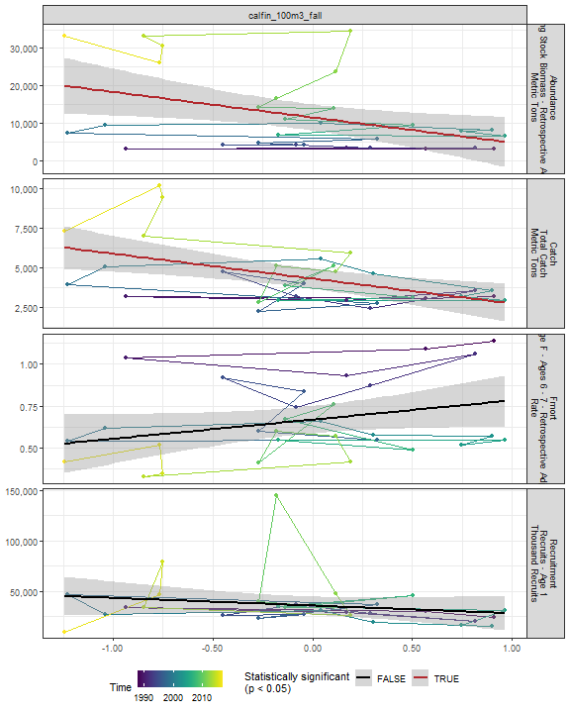

##### Regression statistics

Table 2.73: Catch vs calfin_100m3_fall

|  |  |  |  |  |
| --- | --- | --- | --- | --- |
|  | Estimate | Std. Error | t value | Pr(>|t|) |
| (Intercept) | 4297.49 | 311.02 | 13.82 | 0 |
| Val | -1571.53 | 490.58 | -3.20 | 0 |

|  |  |
| --- | --- |
| Name | Value |
| F-statistic | 10.26 |
| df | 1, 28 |
| R2 | 0.27 |
| R2-adj | 0.24 |

Table 2.73: Abundance vs calfin_100m3_fall

|  |  |  |  |  |
| --- | --- | --- | --- | --- |
|  | Estimate | Std. Error | t value | Pr(>|t|) |
| (Intercept) | 11542.23 | 1715.33 | 6.73 | 0.00 |
| Val | -6781.30 | 2705.61 | -2.51 | 0.02 |

|  |  |
| --- | --- |
| Name | Value |
| F-statistic | 6.28 |
| df | 1, 28 |
| R2 | 0.18 |
| R2-adj | 0.15 |

#### Pseudo 100m3 Fall

##### Figures

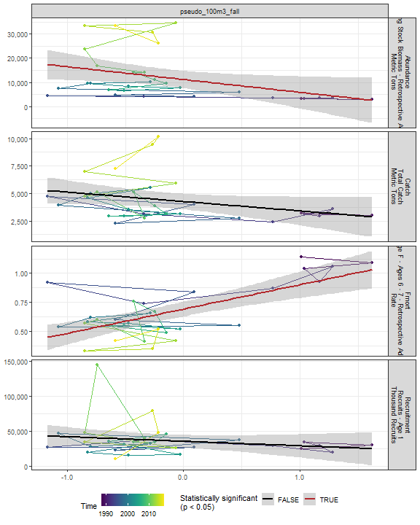

##### Regression statistics

Table 2.74: Fmort vs pseudo_100m3_fall

|  |  |  |  |  |
| --- | --- | --- | --- | --- |
|  | Estimate | Std. Error | t value | Pr(>|t|) |
| (Intercept) | 0.69 | 0.03 | 22.38 | 0 |
| Val | 0.21 | 0.04 | 5.06 | 0 |

|  |  |
| --- | --- |
| Name | Value |
| F-statistic | 25.55 |
| df | 1, 28 |
| R2 | 0.48 |
| R2-adj | 0.46 |

Table 2.74: Abundance vs pseudo_100m3_fall

|  |  |  |  |  |
| --- | --- | --- | --- | --- |
|  | Estimate | Std. Error | t value | Pr(>|t|) |
| (Intercept) | 11165.60 | 1773.58 | 6.30 | 0.00 |
| Val | -5284.48 | 2378.12 | -2.22 | 0.03 |

|  |  |
| --- | --- |
| Name | Value |
| F-statistic | 4.94 |
| df | 1, 28 |
| R2 | 0.15 |
| R2-adj | 0.12 |

#### Penilia 100m3 Fall

##### Figures

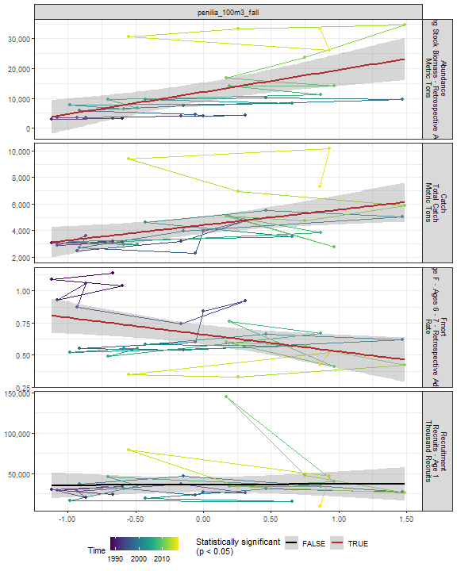

##### Regression statistics

Table 2.75: Catch vs penilia_100m3_fall

|  |  |  |  |  |
| --- | --- | --- | --- | --- |
|  | Estimate | Std. Error | t value | Pr(>|t|) |
| (Intercept) | 4409.46 | 322.36 | 13.68 | 0.00 |
| Val | 1157.60 | 423.66 | 2.73 | 0.01 |

|  |  |
| --- | --- |
| Name | Value |
| F-statistic | 7.47 |
| df | 1, 28 |
| R2 | 0.21 |
| R2-adj | 0.18 |

Table 2.75: Fmort vs penilia_100m3_fall

|  |  |  |  |  |
| --- | --- | --- | --- | --- |
|  | Estimate | Std. Error | t value | Pr(>|t|) |
| (Intercept) | 0.66 | 0.04 | 17.54 | 0.00 |
| Val | -0.13 | 0.05 | -2.66 | 0.01 |

|  |  |
| --- | --- |
| Name | Value |
| F-statistic | 7.07 |
| df | 1, 28 |
| R2 | 0.2 |
| R2-adj | 0.17 |

Table 2.75: Abundance vs penilia_100m3_fall

|  |  |  |  |  |
| --- | --- | --- | --- | --- |
|  | Estimate | Std. Error | t value | Pr(>|t|) |
| (Intercept) | 12099.83 | 1563.76 | 7.74 | 0 |
| Val | 7430.73 | 2055.19 | 3.62 | 0 |

|  |  |
| --- | --- |
| Name | Value |
| F-statistic | 13.07 |
| df | 1, 28 |
| R2 | 0.32 |
| R2-adj | 0.29 |

#### Tlong 100m3 Fall

##### Figures

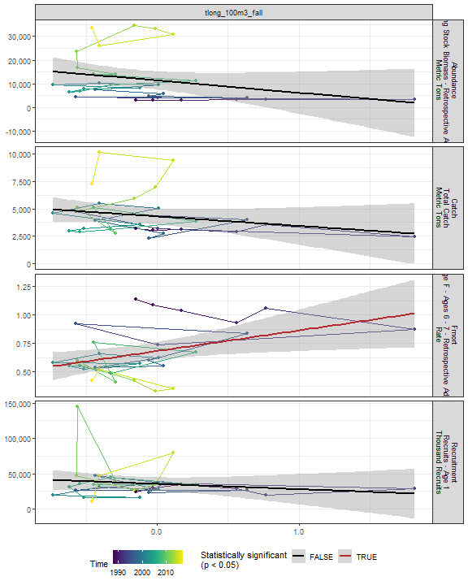

##### Regression statistics

Table 2.76: Fmort vs tlong_100m3_fall

|  |  |  |  |  |
| --- | --- | --- | --- | --- |
|  | Estimate | Std. Error | t value | Pr(>|t|) |
| (Intercept) | 0.68 | 0.04 | 17.57 | 0.00 |
| Val | 0.18 | 0.07 | 2.47 | 0.02 |

|  |  |
| --- | --- |
| Name | Value |
| F-statistic | 6.1 |
| df | 1, 28 |
| R2 | 0.18 |
| R2-adj | 0.15 |

#### Cham 100m3 Fall

##### Figures

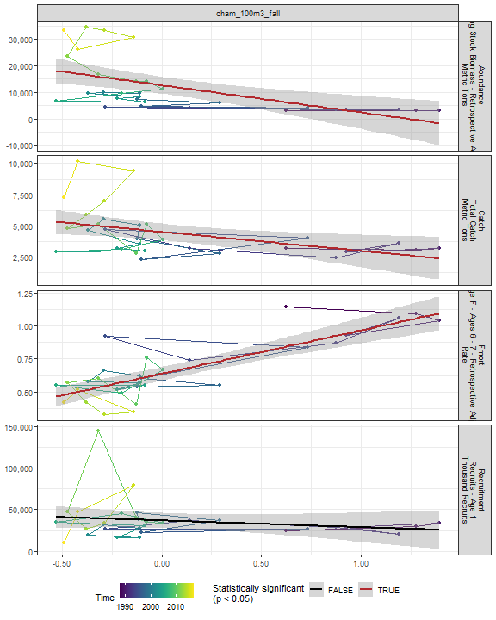

##### Regression statistics

Table 2.77: Catch vs cham_100m3_fall

|  |  |  |  |  |
| --- | --- | --- | --- | --- |
|  | Estimate | Std. Error | t value | Pr(>|t|) |
| (Intercept) | 4491.31 | 328.49 | 13.67 | 0.00 |
| Val | -1525.62 | 587.01 | -2.60 | 0.01 |

|  |  |
| --- | --- |
| Name | Value |
| F-statistic | 6.75 |
| df | 1, 28 |
| R2 | 0.19 |
| R2-adj | 0.17 |

Table 2.77: Fmort vs cham_100m3_fall

|  |  |  |  |  |
| --- | --- | --- | --- | --- |
|  | Estimate | Std. Error | t value | Pr(>|t|) |
| (Intercept) | 0.64 | 0.02 | 25.82 | 0 |
| Val | 0.33 | 0.04 | 7.39 | 0 |

|  |  |
| --- | --- |
| Name | Value |
| F-statistic | 54.55 |
| df | 1, 28 |
| R2 | 0.66 |
| R2-adj | 0.65 |

Table 2.77: Abundance vs cham_100m3_fall

|  |  |  |  |  |
| --- | --- | --- | --- | --- |
|  | Estimate | Std. Error | t value | Pr(>|t|) |
| (Intercept) | 12658.49 | 1575.01 | 8.04 | 0 |
| Val | -10225.50 | 2814.54 | -3.63 | 0 |

|  |  |
| --- | --- |
| Name | Value |
| F-statistic | 13.2 |
| df | 1, 28 |
| R2 | 0.32 |
| R2-adj | 0.3 |

#### Echino 100m3 Fall

##### Figures

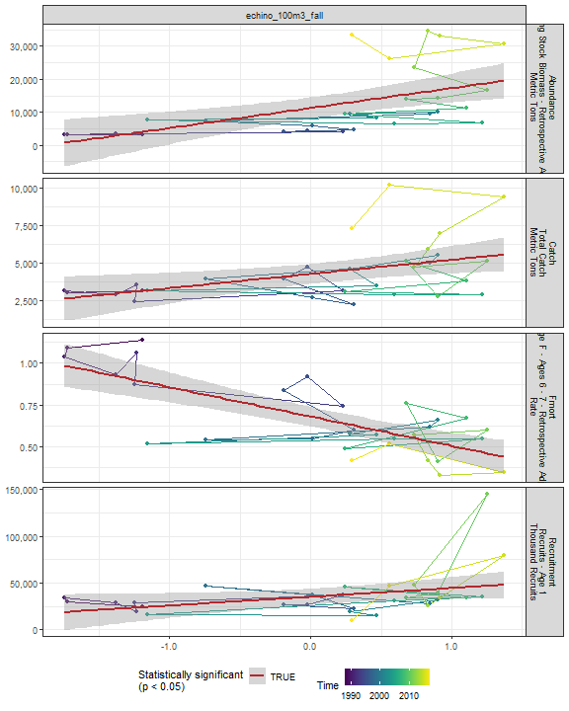

##### Regression statistics

Table 2.78: Catch vs echino_100m3_fall

|  |  |  |  |  |
| --- | --- | --- | --- | --- |
|  | Estimate | Std. Error | t value | Pr(>|t|) |
| (Intercept) | 4276.35 | 324.20 | 13.19 | 0.00 |
| Val | 937.92 | 343.87 | 2.73 | 0.01 |

|  |  |
| --- | --- |
| Name | Value |
| F-statistic | 7.44 |
| df | 1, 28 |
| R2 | 0.21 |
| R2-adj | 0.18 |

Table 2.78: Fmort vs echino_100m3_fall

|  |  |  |  |  |
| --- | --- | --- | --- | --- |
|  | Estimate | Std. Error | t value | Pr(>|t|) |
| (Intercept) | 0.68 | 0.03 | 23.84 | 0 |
| Val | -0.17 | 0.03 | -5.77 | 0 |

|  |  |
| --- | --- |
| Name | Value |
| F-statistic | 33.26 |
| df | 1, 28 |
| R2 | 0.54 |
| R2-adj | 0.53 |

Table 2.78: Recruitment vs echino_100m3_fall

|  |  |  |  |  |
| --- | --- | --- | --- | --- |
|  | Estimate | Std. Error | t value | Pr(>|t|) |
| (Intercept) | 35156.45 | 4212.78 | 8.35 | 0.00 |
| Val | 9319.66 | 4468.38 | 2.09 | 0.05 |

|  |  |
| --- | --- |
| Name | Value |
| F-statistic | 4.35 |
| df | 1, 28 |
| R2 | 0.13 |
| R2-adj | 0.1 |

Table 2.78: Abundance vs echino_100m3_fall

|  |  |  |  |  |
| --- | --- | --- | --- | --- |
|  | Estimate | Std. Error | t value | Pr(>|t|) |
| (Intercept) | 11243.31 | 1570.67 | 7.16 | 0 |
| Val | 6040.90 | 1665.97 | 3.63 | 0 |

|  |  |
| --- | --- |
| Name | Value |
| F-statistic | 13.15 |
| df | 1, 28 |
| R2 | 0.32 |
| R2-adj | 0.3 |

#### Larvaceans 100m3 Fall

##### Figures

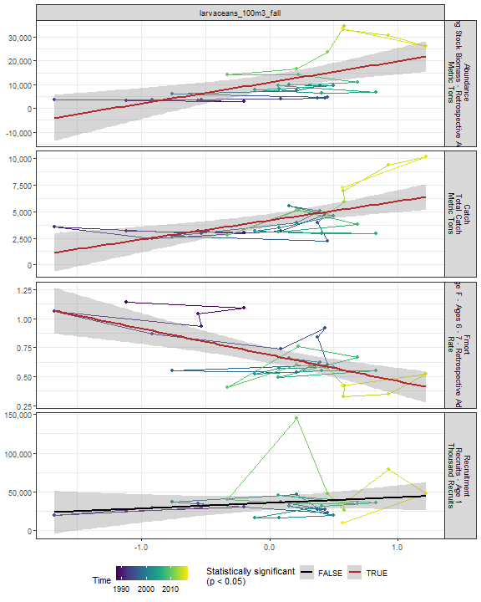

##### Regression statistics

Table 2.79: Catch vs larvaceans_100m3_fall

|  |  |  |  |  |
| --- | --- | --- | --- | --- |
|  | Estimate | Std. Error | t value | Pr(>|t|) |
| (Intercept) | 4178.68 | 296.72 | 14.08 | 0 |
| Val | 1798.34 | 463.84 | 3.88 | 0 |

|  |  |
| --- | --- |
| Name | Value |
| F-statistic | 15.03 |
| df | 1, 28 |
| R2 | 0.35 |
| R2-adj | 0.33 |

Table 2.79: Fmort vs larvaceans_100m3_fall

|  |  |  |  |  |
| --- | --- | --- | --- | --- |
|  | Estimate | Std. Error | t value | Pr(>|t|) |
| (Intercept) | 0.69 | 0.03 | 21.03 | 0 |
| Val | -0.23 | 0.05 | -4.43 | 0 |

|  |  |
| --- | --- |
| Name | Value |
| F-statistic | 19.61 |
| df | 1, 28 |
| R2 | 0.41 |
| R2-adj | 0.39 |

Table 2.79: Abundance vs larvaceans_100m3_fall

|  |  |  |  |  |
| --- | --- | --- | --- | --- |
|  | Estimate | Std. Error | t value | Pr(>|t|) |
| (Intercept) | 10906.85 | 1591.43 | 6.85 | 0 |
| Val | 8889.47 | 2487.73 | 3.57 | 0 |

|  |  |
| --- | --- |
| Name | Value |
| F-statistic | 12.77 |
| df | 1, 28 |
| R2 | 0.31 |
| R2-adj | 0.29 |

#### Para 100m3 Fall

##### Figures

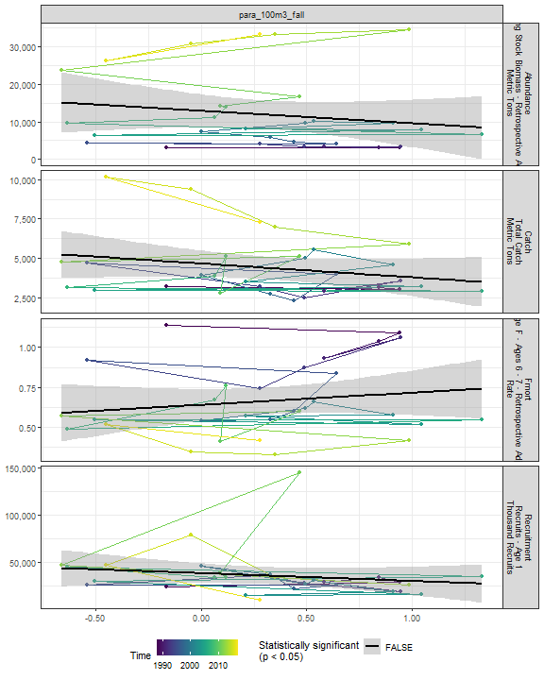

##### Regression statistics

[1] “No statistically significant data”

#### Gas 100m3 Fall

##### Figures

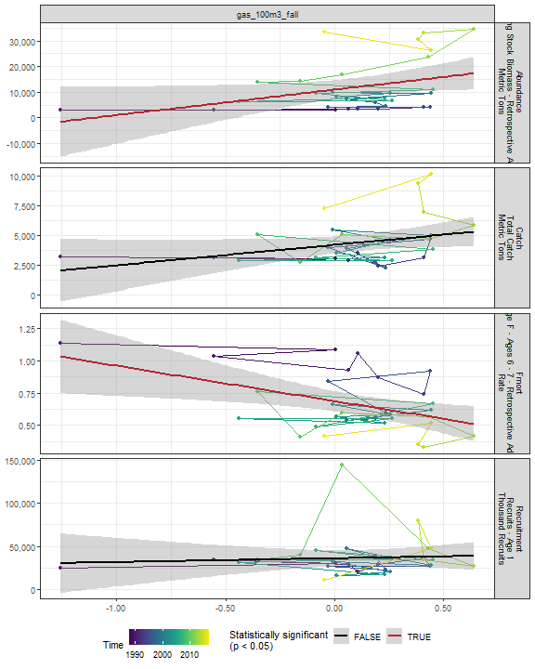

##### Regression statistics

Table 2.80: Fmort vs gas_100m3_fall

|  |  |  |  |  |
| --- | --- | --- | --- | --- |
|  | Estimate | Std. Error | t value | Pr(>|t|) |
| (Intercept) | 0.69 | 0.04 | 17.92 | 0.00 |
| Val | -0.27 | 0.10 | -2.74 | 0.01 |

|  |  |
| --- | --- |
| Name | Value |
| F-statistic | 7.53 |
| df | 1, 28 |
| R2 | 0.21 |
| R2-adj | 0.18 |

Table 2.80: Abundance vs gas_100m3_fall

|  |  |  |  |  |
| --- | --- | --- | --- | --- |
|  | Estimate | Std. Error | t value | Pr(>|t|) |
| (Intercept) | 10957.86 | 1809.95 | 6.05 | 0.00 |
| Val | 9956.49 | 4711.17 | 2.11 | 0.04 |

|  |  |
| --- | --- |
| Name | Value |
| F-statistic | 4.47 |
| df | 1, 28 |
| R2 | 0.14 |
| R2-adj | 0.11 |

#### Acarspp 100m3 Fall

##### Figures

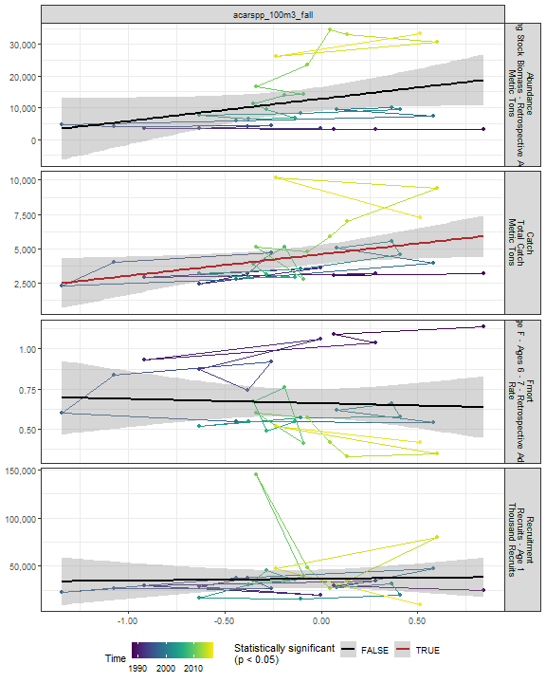

##### Regression statistics

Table 2.81: Catch vs acarspp_100m3_fall

|  |  |  |  |  |
| --- | --- | --- | --- | --- |
|  | Estimate | Std. Error | t value | Pr(>|t|) |
| (Intercept) | 4579.66 | 343.89 | 13.32 | 0.00 |
| Val | 1572.37 | 680.20 | 2.31 | 0.03 |

|  |  |
| --- | --- |
| Name | Value |
| F-statistic | 5.34 |
| df | 1, 28 |
| R2 | 0.16 |
| R2-adj | 0.13 |

#### Mlucens 100m3 Fall

##### Figures

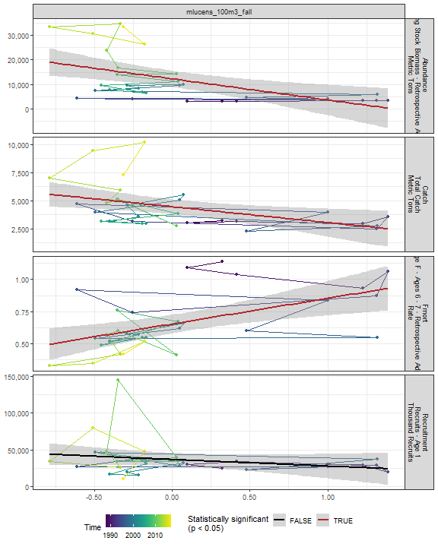

##### Regression statistics

Table 2.82: Catch vs mlucens_100m3_fall

|  |  |  |  |  |
| --- | --- | --- | --- | --- |
|  | Estimate | Std. Error | t value | Pr(>|t|) |
| (Intercept) | 4442.02 | 325.10 | 13.66 | 0.00 |
| Val | -1410.00 | 531.78 | -2.65 | 0.01 |

|  |  |
| --- | --- |
| Name | Value |
| F-statistic | 7.03 |
| df | 1, 28 |
| R2 | 0.2 |
| R2-adj | 0.17 |

Table 2.82: Fmort vs mlucens_100m3_fall

|  |  |  |  |  |
| --- | --- | --- | --- | --- |
|  | Estimate | Std. Error | t value | Pr(>|t|) |
| (Intercept) | 0.65 | 0.04 | 18.51 | 0 |
| Val | 0.20 | 0.06 | 3.45 | 0 |

|  |  |
| --- | --- |
| Name | Value |
| F-statistic | 11.93 |
| df | 1, 28 |
| R2 | 0.3 |
| R2-adj | 0.27 |

Table 2.82: Abundance vs mlucens_100m3_fall

|  |  |  |  |  |
| --- | --- | --- | --- | --- |
|  | Estimate | Std. Error | t value | Pr(>|t|) |
| (Intercept) | 12286.20 | 1618.92 | 7.59 | 0 |
| Val | -8580.31 | 2648.11 | -3.24 | 0 |

|  |  |
| --- | --- |
| Name | Value |
| F-statistic | 10.5 |
| df | 1, 28 |
| R2 | 0.27 |
| R2-adj | 0.25 |

#### Evadnespp 100m3 Fall

##### Figures

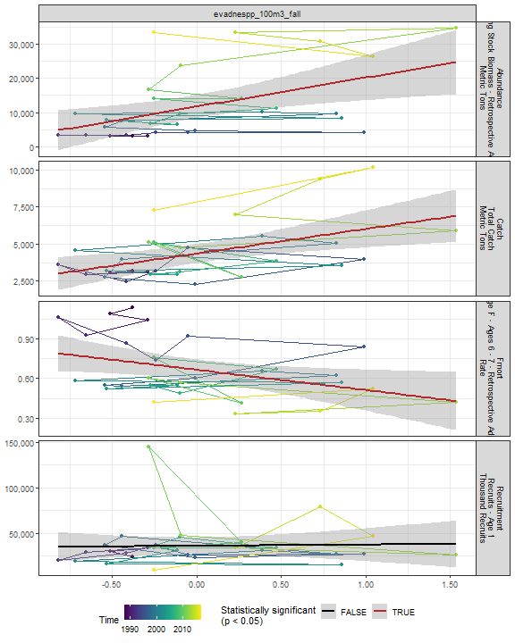

##### Regression statistics

Table 2.83: Catch vs evadnespp_100m3_fall

|  |  |  |  |  |
| --- | --- | --- | --- | --- |
|  | Estimate | Std. Error | t value | Pr(>|t|) |
| (Intercept) | 4355.81 | 312.55 | 13.94 | 0 |
| Val | 1658.43 | 533.11 | 3.11 | 0 |

|  |  |
| --- | --- |
| Name | Value |
| F-statistic | 9.68 |
| df | 1, 28 |
| R2 | 0.26 |
| R2-adj | 0.23 |

Table 2.83: Fmort vs evadnespp_100m3_fall

|  |  |  |  |  |
| --- | --- | --- | --- | --- |
|  | Estimate | Std. Error | t value | Pr(>|t|) |
| (Intercept) | 0.67 | 0.04 | 17.30 | 0.00 |
| Val | -0.15 | 0.07 | -2.34 | 0.03 |

|  |  |
| --- | --- |
| Name | Value |
| F-statistic | 5.47 |
| df | 1, 28 |
| R2 | 0.16 |
| R2-adj | 0.13 |

Table 2.83: Abundance vs evadnespp_100m3_fall

|  |  |  |  |  |
| --- | --- | --- | --- | --- |
|  | Estimate | Std. Error | t value | Pr(>|t|) |
| (Intercept) | 11779.89 | 1646.44 | 7.15 | 0.00 |
| Val | 8426.59 | 2808.26 | 3.00 | 0.01 |

|  |  |
| --- | --- |
| Name | Value |
| F-statistic | 9 |
| df | 1, 28 |
| R2 | 0.24 |
| R2-adj | 0.22 |

#### Salps 100m3 Fall

##### Figures

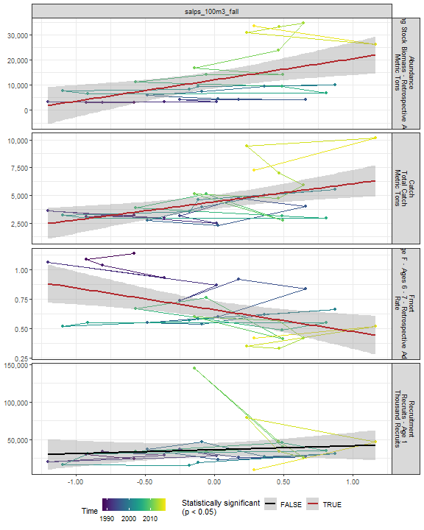

##### Regression statistics

Table 2.84: Catch vs salps_100m3_fall

|  |  |  |  |  |
| --- | --- | --- | --- | --- |
|  | Estimate | Std. Error | t value | Pr(>|t|) |
| (Intercept) | 4408.82 | 310.92 | 14.18 | 0 |
| Val | 1632.91 | 513.61 | 3.18 | 0 |

|  |  |
| --- | --- |
| Name | Value |
| F-statistic | 10.11 |
| df | 1, 28 |
| R2 | 0.27 |
| R2-adj | 0.24 |

Table 2.84: Fmort vs salps_100m3_fall

|  |  |  |  |  |
| --- | --- | --- | --- | --- |
|  | Estimate | Std. Error | t value | Pr(>|t|) |
| (Intercept) | 0.66 | 0.04 | 18.15 | 0 |
| Val | -0.19 | 0.06 | -3.09 | 0 |

|  |  |
| --- | --- |
| Name | Value |
| F-statistic | 9.54 |
| df | 1, 28 |
| R2 | 0.25 |
| R2-adj | 0.23 |

Table 2.84: Abundance vs salps_100m3_fall

|  |  |  |  |  |
| --- | --- | --- | --- | --- |
|  | Estimate | Std. Error | t value | Pr(>|t|) |
| (Intercept) | 12052.24 | 1629.05 | 7.40 | 0 |
| Val | 8437.78 | 2691.00 | 3.14 | 0 |

|  |  |
| --- | --- |
| Name | Value |
| F-statistic | 9.83 |
| df | 1, 28 |
| R2 | 0.26 |
| R2-adj | 0.23 |

#### Oithspp 100m3 Fall

##### Figures

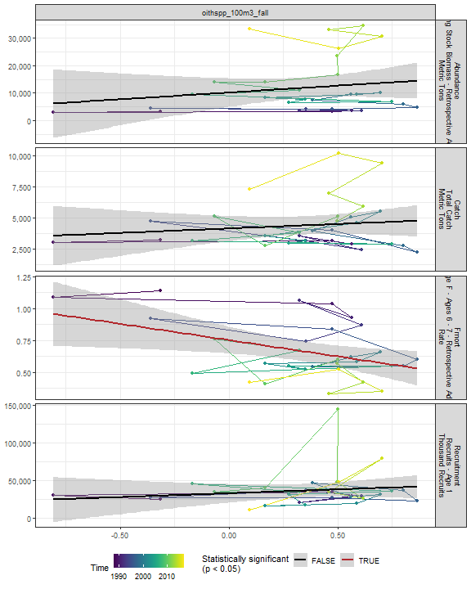

##### Regression statistics

Table 2.85: Fmort vs oithspp_100m3_fall

|  |  |  |  |  |
| --- | --- | --- | --- | --- |
|  | Estimate | Std. Error | t value | Pr(>|t|) |
| (Intercept) | 0.75 | 0.05 | 14.48 | 0.00 |
| Val | -0.26 | 0.10 | -2.51 | 0.02 |

|  |  |
| --- | --- |
| Name | Value |
| F-statistic | 6.28 |
| df | 1, 28 |
| R2 | 0.18 |
| R2-adj | 0.15 |

#### Chaeto 100m3 Fall

##### Figures

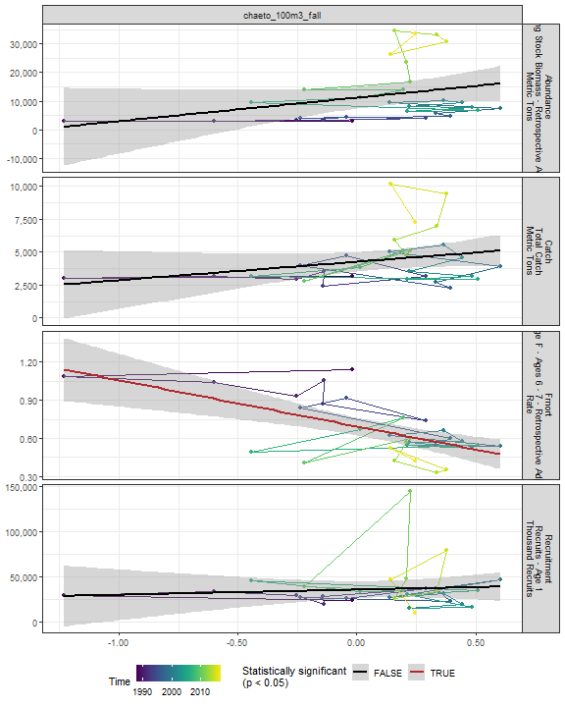

##### Regression statistics

Table 2.86: Fmort vs chaeto_100m3_fall

|  |  |  |  |  |
| --- | --- | --- | --- | --- |
|  | Estimate | Std. Error | t value | Pr(>|t|) |
| (Intercept) | 0.70 | 0.03 | 20.36 | 0 |
| Val | -0.36 | 0.09 | -4.09 | 0 |

|  |  |
| --- | --- |
| Name | Value |
| F-statistic | 16.75 |
| df | 1, 28 |
| R2 | 0.37 |
| R2-adj | 0.35 |

#### Hyper 100m3 Fall

##### Figures

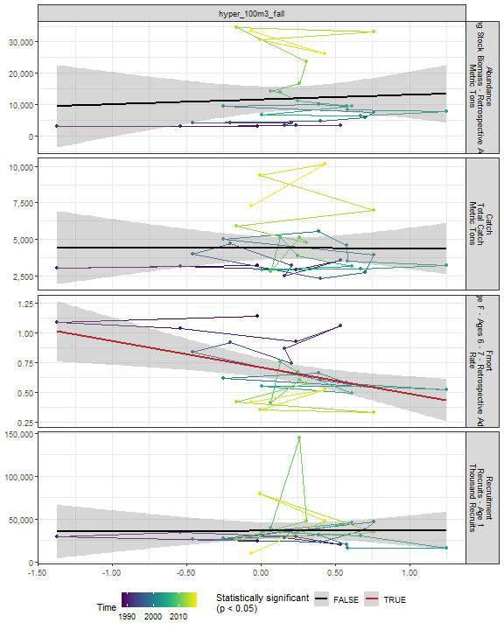

##### Regression statistics

Table 2.87: Fmort vs hyper_100m3_fall

|  |  |  |  |  |
| --- | --- | --- | --- | --- |
|  | Estimate | Std. Error | t value | Pr(>|t|) |
| (Intercept) | 0.71 | 0.04 | 17.73 | 0.00 |
| Val | -0.22 | 0.08 | -2.92 | 0.01 |

|  |  |
| --- | --- |
| Name | Value |
| F-statistic | 8.53 |
| df | 1, 28 |
| R2 | 0.23 |
| R2-adj | 0.21 |

#### Calminor 100m3 Fall

##### Figures

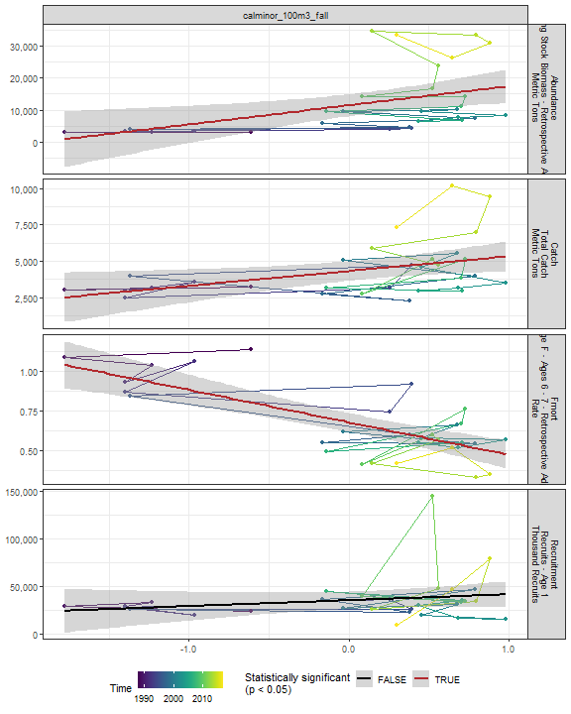

##### Regression statistics

Table 2.88: Catch vs calminor_100m3_fall

|  |  |  |  |  |
| --- | --- | --- | --- | --- |
|  | Estimate | Std. Error | t value | Pr(>|t|) |
| (Intercept) | 4305.27 | 329.86 | 13.05 | 0.00 |
| Val | 1016.58 | 412.98 | 2.46 | 0.02 |

|  |  |
| --- | --- |
| Name | Value |
| F-statistic | 6.06 |
| df | 1, 28 |
| R2 | 0.18 |
| R2-adj | 0.15 |

Table 2.88: Fmort vs calminor_100m3_fall

|  |  |  |  |  |
| --- | --- | --- | --- | --- |
|  | Estimate | Std. Error | t value | Pr(>|t|) |
| (Intercept) | 0.68 | 0.03 | 23.55 | 0 |
| Val | -0.20 | 0.04 | -5.68 | 0 |

|  |  |
| --- | --- |
| Name | Value |
| F-statistic | 32.25 |
| df | 1, 28 |
| R2 | 0.54 |
| R2-adj | 0.52 |

Table 2.88: Abundance vs calminor_100m3_fall

|  |  |  |  |  |
| --- | --- | --- | --- | --- |
|  | Estimate | Std. Error | t value | Pr(>|t|) |
| (Intercept) | 11471.31 | 1674.99 | 6.85 | 0.00 |
| Val | 5930.97 | 2097.04 | 2.83 | 0.01 |

|  |  |
| --- | --- |
| Name | Value |
| F-statistic | 8 |
| df | 1, 28 |
| R2 | 0.22 |
| R2-adj | 0.19 |

#### Clauso Fall

##### Figures

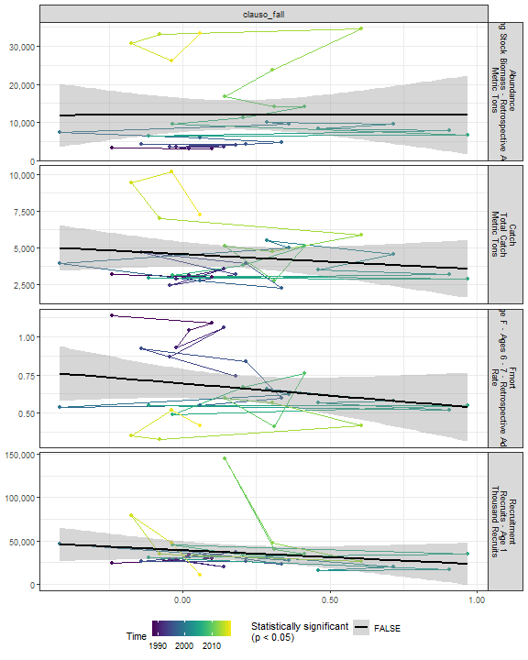

##### Regression statistics

[1] “No statistically significant data”

#### Dec 100m3 Fall

##### Figures

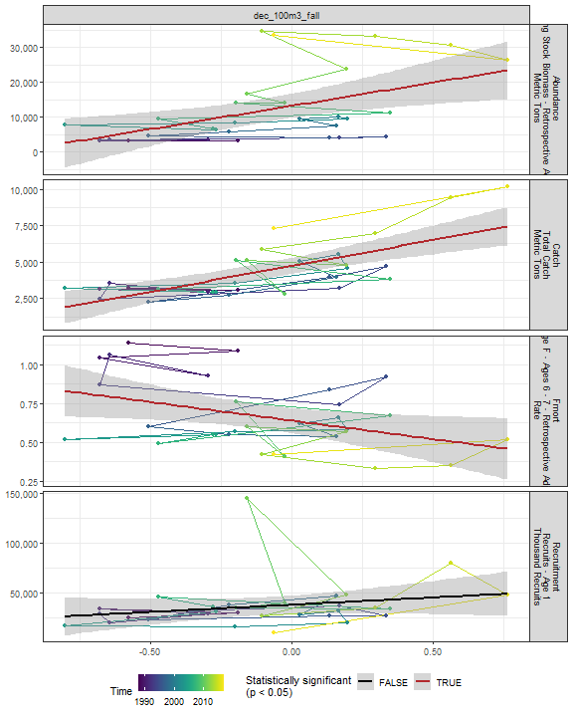

##### Regression statistics

Table 2.89: Catch vs dec_100m3_fall

|  |  |  |  |  |
| --- | --- | --- | --- | --- |
|  | Estimate | Std. Error | t value | Pr(>|t|) |
| (Intercept) | 4729.69 | 266.64 | 17.74 | 0 |
| Val | 3546.57 | 678.11 | 5.23 | 0 |

|  |  |
| --- | --- |
| Name | Value |
| F-statistic | 27.35 |
| df | 1, 28 |
| R2 | 0.49 |
| R2-adj | 0.48 |

Table 2.89: Fmort vs dec_100m3_fall

|  |  |  |  |  |
| --- | --- | --- | --- | --- |
|  | Estimate | Std. Error | t value | Pr(>|t|) |
| (Intercept) | 0.64 | 0.04 | 16.09 | 0.00 |
| Val | -0.24 | 0.10 | -2.35 | 0.03 |

|  |  |
| --- | --- |
| Name | Value |
| F-statistic | 5.51 |
| df | 1, 28 |
| R2 | 0.16 |
| R2-adj | 0.13 |

Table 2.89: Abundance vs dec_100m3_fall

|  |  |  |  |  |
| --- | --- | --- | --- | --- |
|  | Estimate | Std. Error | t value | Pr(>|t|) |
| (Intercept) | 13209.19 | 1687.99 | 7.83 | 0 |
| Val | 13328.94 | 4292.92 | 3.10 | 0 |

|  |  |
| --- | --- |
| Name | Value |
| F-statistic | 9.64 |
| df | 1, 28 |
| R2 | 0.26 |
| R2-adj | 0.23 |

#### Euph 100m3 Fall

##### Figures

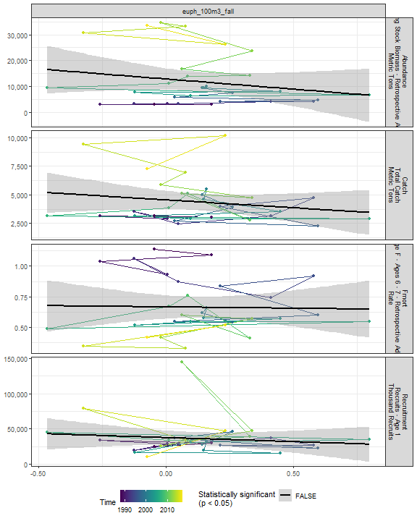

##### Regression statistics

[1] “No statistically significant data”

#### Prot 100m3 Fall

##### Figures

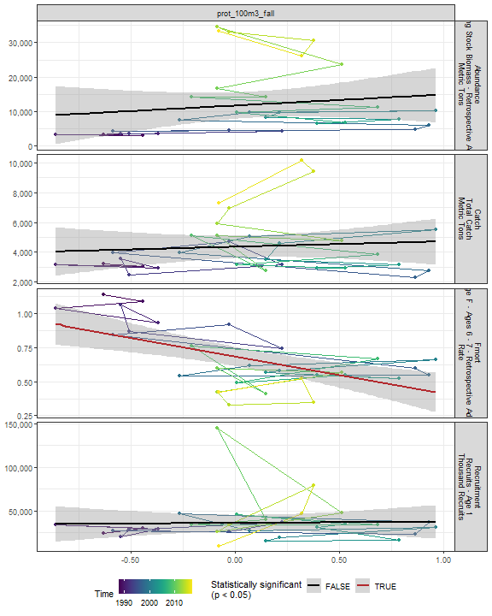

##### Regression statistics

Table 2.90: Fmort vs prot_100m3_fall

|  |  |  |  |  |
| --- | --- | --- | --- | --- |
|  | Estimate | Std. Error | t value | Pr(>|t|) |
| (Intercept) | 0.69 | 0.03 | 20.02 | 0 |
| Val | -0.27 | 0.07 | -3.92 | 0 |

|  |  |
| --- | --- |
| Name | Value |
| F-statistic | 15.37 |
| df | 1, 28 |
| R2 | 0.35 |
| R2-adj | 0.33 |

#### Poly 100m3 Fall

##### Figures

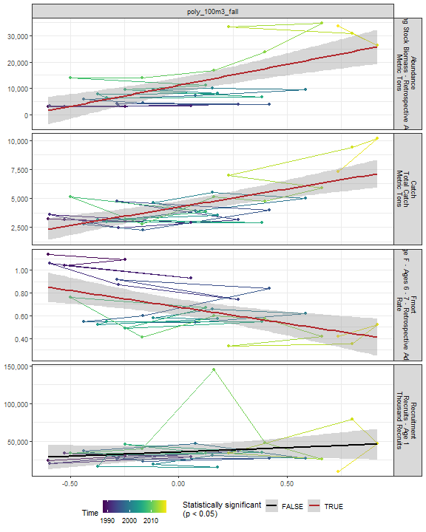

##### Regression statistics

Table 2.91: Catch vs poly_100m3_fall

|  |  |  |  |  |
| --- | --- | --- | --- | --- |
|  | Estimate | Std. Error | t value | Pr(>|t|) |
| (Intercept) | 4239.19 | 259.59 | 16.33 | 0 |
| Val | 3142.57 | 603.14 | 5.21 | 0 |

|  |  |
| --- | --- |
| Name | Value |
| F-statistic | 27.15 |
| df | 1, 28 |
| R2 | 0.49 |
| R2-adj | 0.47 |

Table 2.91: Fmort vs poly_100m3_fall

|  |  |  |  |  |
| --- | --- | --- | --- | --- |
|  | Estimate | Std. Error | t value | Pr(>|t|) |
| (Intercept) | 0.68 | 0.04 | 19.25 | 0 |
| Val | -0.29 | 0.08 | -3.54 | 0 |

|  |  |
| --- | --- |
| Name | Value |
| F-statistic | 12.54 |
| df | 1, 28 |
| R2 | 0.31 |
| R2-adj | 0.28 |

Table 2.91: Abundance vs poly_100m3_fall

|  |  |  |  |  |
| --- | --- | --- | --- | --- |
|  | Estimate | Std. Error | t value | Pr(>|t|) |
| (Intercept) | 11193.54 | 1400.21 | 7.99 | 0 |
| Val | 15823.70 | 3253.22 | 4.86 | 0 |

|  |  |
| --- | --- |
| Name | Value |
| F-statistic | 23.66 |
| df | 1, 28 |
| R2 | 0.46 |
| R2-adj | 0.44 |

#### Fish 100m3 Fall

##### Figures

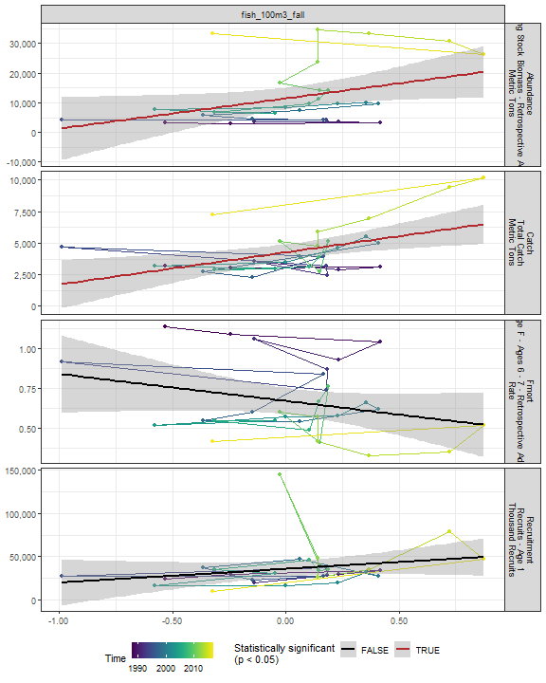

##### Regression statistics

Table 2.92: Catch vs fish_100m3_fall

|  |  |  |  |  |
| --- | --- | --- | --- | --- |
|  | Estimate | Std. Error | t value | Pr(>|t|) |
| (Intercept) | 4258.17 | 316.89 | 13.44 | 0.00 |
| Val | 2549.24 | 841.25 | 3.03 | 0.01 |

|  |  |
| --- | --- |
| Name | Value |
| F-statistic | 9.18 |
| df | 1, 28 |
| R2 | 0.25 |
| R2-adj | 0.22 |

Table 2.92: Abundance vs fish_100m3_fall

|  |  |  |  |  |
| --- | --- | --- | --- | --- |
|  | Estimate | Std. Error | t value | Pr(>|t|) |
| (Intercept) | 11408.78 | 1762.53 | 6.47 | 0.00 |
| Val | 10203.73 | 4679.03 | 2.18 | 0.04 |

|  |  |
| --- | --- |
| Name | Value |
| F-statistic | 4.76 |
| df | 1, 28 |
| R2 | 0.15 |
| R2-adj | 0.11 |

#### Oncaea 100m3 Fall

##### Figures

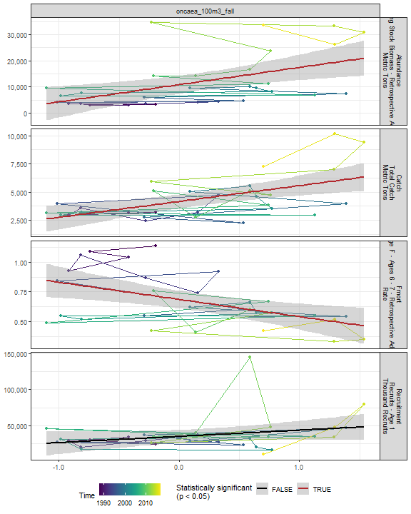

##### Regression statistics

Table 2.93: Catch vs oncaea_100m3_fall

|  |  |  |  |  |
| --- | --- | --- | --- | --- |
|  | Estimate | Std. Error | t value | Pr(>|t|) |
| (Intercept) | 4155.57 | 302.33 | 13.75 | 0 |
| Val | 1409.17 | 378.87 | 3.72 | 0 |

|  |  |
| --- | --- |
| Name | Value |
| F-statistic | 13.83 |
| df | 1, 28 |
| R2 | 0.33 |
| R2-adj | 0.31 |

Table 2.93: Fmort vs oncaea_100m3_fall

|  |  |  |  |  |
| --- | --- | --- | --- | --- |
|  | Estimate | Std. Error | t value | Pr(>|t|) |
| (Intercept) | 0.69 | 0.04 | 18.60 | 0 |
| Val | -0.14 | 0.05 | -3.13 | 0 |

|  |  |
| --- | --- |
| Name | Value |
| F-statistic | 9.82 |
| df | 1, 28 |
| R2 | 0.26 |
| R2-adj | 0.23 |

Table 2.93: Abundance vs oncaea_100m3_fall

|  |  |  |  |  |
| --- | --- | --- | --- | --- |
|  | Estimate | Std. Error | t value | Pr(>|t|) |
| (Intercept) | 10853.94 | 1655.31 | 6.56 | 0 |
| Val | 6570.12 | 2074.39 | 3.17 | 0 |

|  |  |
| --- | --- |
| Name | Value |
| F-statistic | 10.03 |
| df | 1, 28 |
| R2 | 0.26 |
| R2-adj | 0.24 |

#### Cory 100m3 Fall

##### Figures

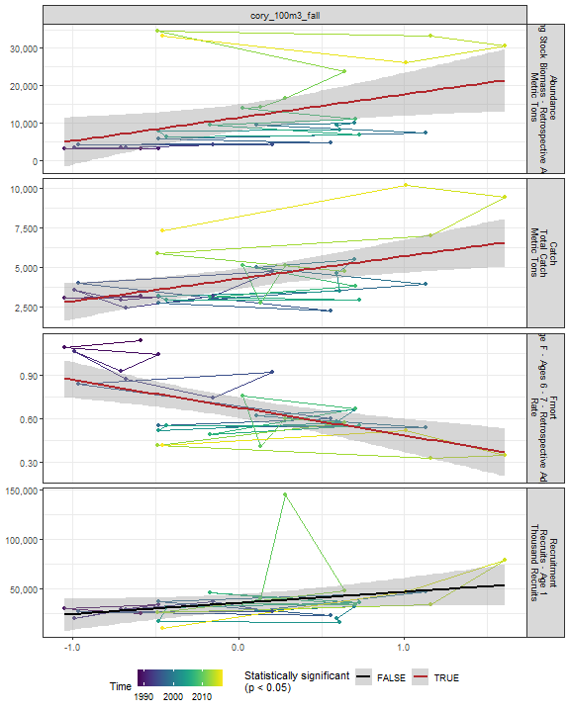

##### Regression statistics

Table 2.94: Catch vs cory_100m3_fall

|  |  |  |  |  |
| --- | --- | --- | --- | --- |
|  | Estimate | Std. Error | t value | Pr(>|t|) |
| (Intercept) | 4278.47 | 310.42 | 13.78 | 0 |
| Val | 1421.95 | 438.18 | 3.25 | 0 |

|  |  |
| --- | --- |
| Name | Value |
| F-statistic | 10.53 |
| df | 1, 28 |
| R2 | 0.27 |
| R2-adj | 0.25 |

Table 2.94: Fmort vs cory_100m3_fall

|  |  |  |  |  |
| --- | --- | --- | --- | --- |
|  | Estimate | Std. Error | t value | Pr(>|t|) |
| (Intercept) | 0.68 | 0.03 | 20.07 | 0 |
| Val | -0.19 | 0.05 | -4.00 | 0 |

|  |  |
| --- | --- |
| Name | Value |
| F-statistic | 16 |
| df | 1, 28 |
| R2 | 0.36 |
| R2-adj | 0.34 |

Table 2.94: Abundance vs cory_100m3_fall

|  |  |  |  |  |
| --- | --- | --- | --- | --- |
|  | Estimate | Std. Error | t value | Pr(>|t|) |
| (Intercept) | 11454.36 | 1708.75 | 6.70 | 0.00 |
| Val | 6222.18 | 2412.04 | 2.58 | 0.02 |

|  |  |
| --- | --- |
| Name | Value |
| F-statistic | 6.65 |
| df | 1, 28 |
| R2 | 0.19 |
| R2-adj | 0.16 |

#### Siph 100m3 Fall

##### Figures

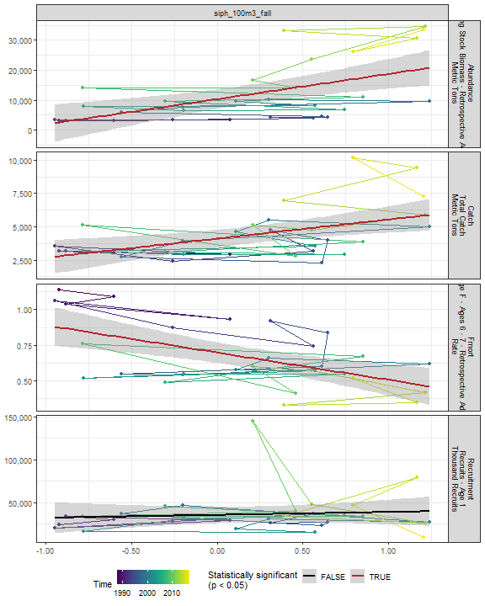

##### Regression statistics

Table 2.95: Catch vs siph_100m3_fall

|  |  |  |  |  |
| --- | --- | --- | --- | --- |
|  | Estimate | Std. Error | t value | Pr(>|t|) |
| (Intercept) | 4107.26 | 324.67 | 12.65 | 0 |
| Val | 1430.98 | 462.84 | 3.09 | 0 |

|  |  |
| --- | --- |
| Name | Value |
| F-statistic | 9.56 |
| df | 1, 28 |
| R2 | 0.25 |
| R2-adj | 0.23 |

Table 2.95: Fmort vs siph_100m3_fall

|  |  |  |  |  |
| --- | --- | --- | --- | --- |
|  | Estimate | Std. Error | t value | Pr(>|t|) |
| (Intercept) | 0.70 | 0.04 | 19.67 | 0 |
| Val | -0.19 | 0.05 | -3.77 | 0 |

|  |  |
| --- | --- |
| Name | Value |
| F-statistic | 14.19 |
| df | 1, 28 |
| R2 | 0.34 |
| R2-adj | 0.31 |

Table 2.95: Abundance vs siph_100m3_fall

|  |  |  |  |  |
| --- | --- | --- | --- | --- |
|  | Estimate | Std. Error | t value | Pr(>|t|) |
| (Intercept) | 10300.97 | 1613.92 | 6.38 | 0 |
| Val | 8429.47 | 2300.75 | 3.66 | 0 |

|  |  |
| --- | --- |
| Name | Value |
| F-statistic | 13.42 |
| df | 1, 28 |
| R2 | 0.32 |
| R2-adj | 0.3 |

#### Coel 100m3 Fall

##### Figures

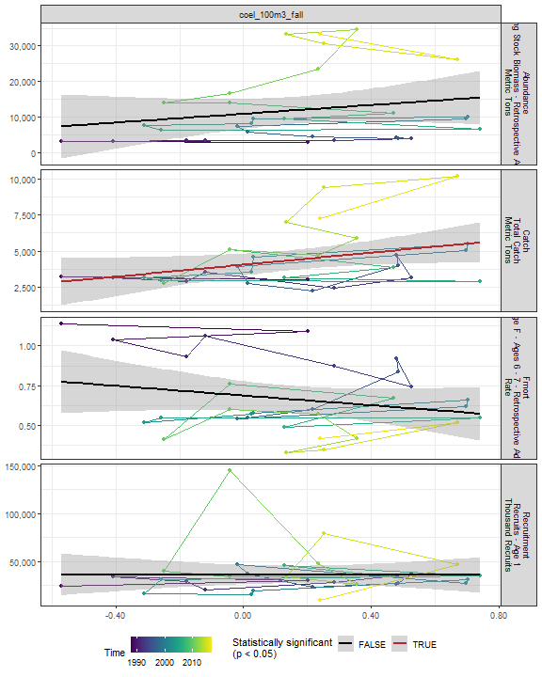

##### Regression statistics

Table 2.96: Catch vs coel_100m3_fall

|  |  |  |  |  |
| --- | --- | --- | --- | --- |
|  | Estimate | Std. Error | t value | Pr(>|t|) |
| (Intercept) | 4048.93 | 370.66 | 10.92 | 0.00 |
| Val | 2079.56 | 988.91 | 2.10 | 0.04 |

|  |  |
| --- | --- |
| Name | Value |
| F-statistic | 4.42 |
| df | 1, 28 |
| R2 | 0.14 |
| R2-adj | 0.11 |

#### Euph1 100m3 Fall

##### Figures

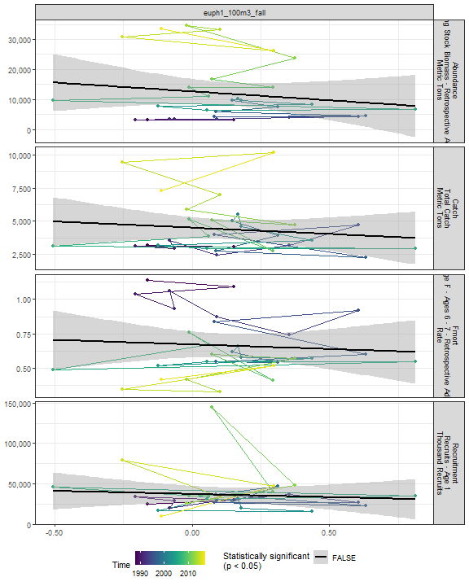

##### Regression statistics

[1] “No statistically significant data”

#### Thecos 100m3 Fall

##### Figures

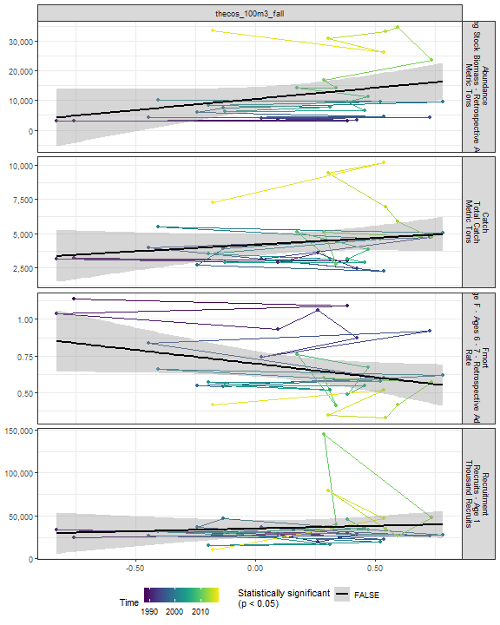

##### Regression statistics

[1] “No statistically significant data”

#### Spirspp 100m3 Fall

##### Figures

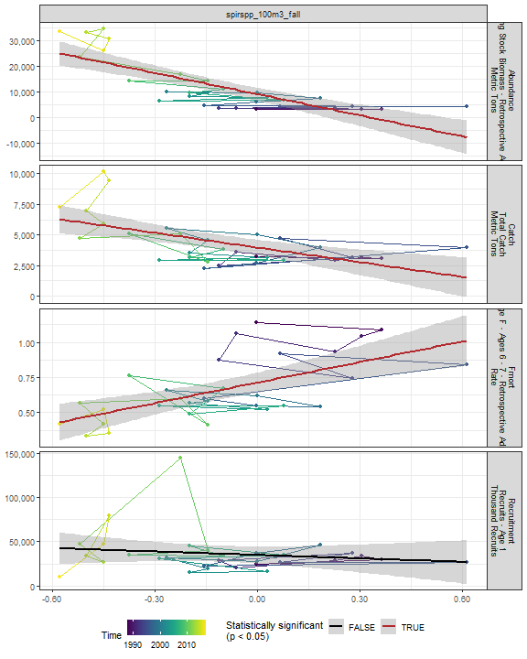

##### Regression statistics

Table 2.97: Catch vs spirspp_100m3_fall

|  |  |  |  |  |
| --- | --- | --- | --- | --- |
|  | Estimate | Std. Error | t value | Pr(>|t|) |
| (Intercept) | 3967.07 | 310.47 | 12.78 | 0 |
| Val | -3984.93 | 1026.12 | -3.88 | 0 |

|  |  |
| --- | --- |
| Name | Value |
| F-statistic | 15.08 |
| df | 1, 28 |
| R2 | 0.35 |
| R2-adj | 0.33 |

Table 2.97: Fmort vs spirspp_100m3_fall

|  |  |  |  |  |
| --- | --- | --- | --- | --- |
|  | Estimate | Std. Error | t value | Pr(>|t|) |
| (Intercept) | 0.71 | 0.03 | 20.40 | 0 |
| Val | 0.49 | 0.12 | 4.21 | 0 |

|  |  |
| --- | --- |
| Name | Value |
| F-statistic | 17.7 |
| df | 1, 28 |
| R2 | 0.39 |
| R2-adj | 0.37 |

Table 2.97: Abundance vs spirspp_100m3_fall

|  |  |  |  |  |
| --- | --- | --- | --- | --- |
|  | Estimate | Std. Error | t value | Pr(>|t|) |
| (Intercept) | 9068.60 | 1255.93 | 7.22 | 0 |
| Val | -27454.82 | 4150.95 | -6.61 | 0 |

|  |  |
| --- | --- |
| Name | Value |
| F-statistic | 43.75 |
| df | 1, 28 |
| R2 | 0.61 |
| R2-adj | 0.6 |

#### Cnidar 100m3 Fall

##### Figures

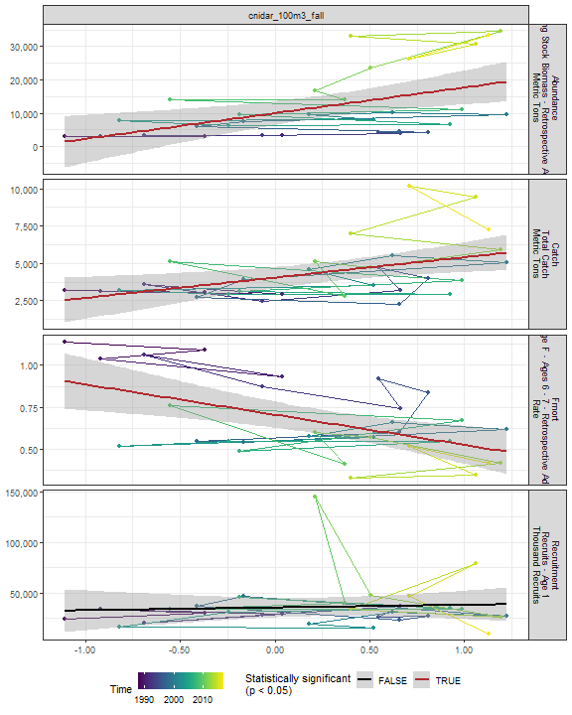

##### Regression statistics

Table 2.98: Catch vs cnidar_100m3_fall

|  |  |  |  |  |
| --- | --- | --- | --- | --- |
|  | Estimate | Std. Error | t value | Pr(>|t|) |
| (Intercept) | 4045.74 | 341.31 | 11.85 | 0.00 |
| Val | 1363.63 | 487.56 | 2.80 | 0.01 |

|  |  |
| --- | --- |
| Name | Value |
| F-statistic | 7.82 |
| df | 1, 28 |
| R2 | 0.22 |
| R2-adj | 0.19 |

Table 2.98: Fmort vs cnidar_100m3_fall

|  |  |  |  |  |
| --- | --- | --- | --- | --- |
|  | Estimate | Std. Error | t value | Pr(>|t|) |
| (Intercept) | 0.71 | 0.04 | 18.62 | 0 |
| Val | -0.18 | 0.05 | -3.31 | 0 |

|  |  |
| --- | --- |
| Name | Value |
| F-statistic | 10.98 |
| df | 1, 28 |
| R2 | 0.28 |
| R2-adj | 0.26 |

Table 2.98: Abundance vs cnidar_100m3_fall

|  |  |  |  |  |
| --- | --- | --- | --- | --- |
|  | Estimate | Std. Error | t value | Pr(>|t|) |
| (Intercept) | 10017.45 | 1738.56 | 5.76 | 0 |
| Val | 7705.16 | 2483.50 | 3.10 | 0 |

|  |  |
| --- | --- |
| Name | Value |
| F-statistic | 9.63 |
| df | 1, 28 |
| R2 | 0.26 |
| R2-adj | 0.23 |

## 2.5 Larvae and YOY indicators

### 2.5.1 Recruitment

##### Figures

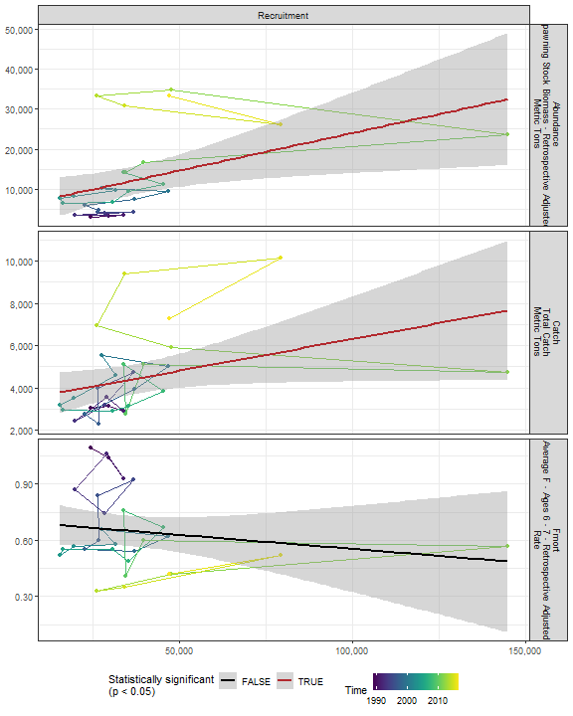

##### Regression statistics

Table 2.99: Catch vs Recruitment

|  |  |  |  |  |
| --- | --- | --- | --- | --- |
|  | Estimate | Std. Error | t value | Pr(>|t|) |
| (Intercept) | 3298.04 | 642.76 | 5.13 | 0.00 |
| Val | 0.03 | 0.01 | 2.06 | 0.05 |

|  |  |
| --- | --- |
| Name | Value |
| F-statistic | 4.26 |
| df | 1, 27 |
| R2 | 0.14 |
| R2-adj | 0.1 |

Table 2.99: Abundance vs Recruitment

|  |  |  |  |  |
| --- | --- | --- | --- | --- |
|  | Estimate | Std. Error | t value | Pr(>|t|) |
| (Intercept) | 5196.06 | 3212.70 | 1.62 | 0.12 |
| Val | 0.19 | 0.07 | 2.58 | 0.02 |

|  |  |
| --- | --- |
| Name | Value |
| F-statistic | 6.65 |
| df | 1, 27 |
| R2 | 0.2 |
| R2-adj | 0.17 |

### 2.5.2 Larval growth

## 2.6 Juvenile indicators

### 2.6.1 Length-age curves

### 2.6.2 Condition

### 2.6.3 CPUE

## 2.7 Adult indicators

### 2.7.1 Abundance

##### Figures

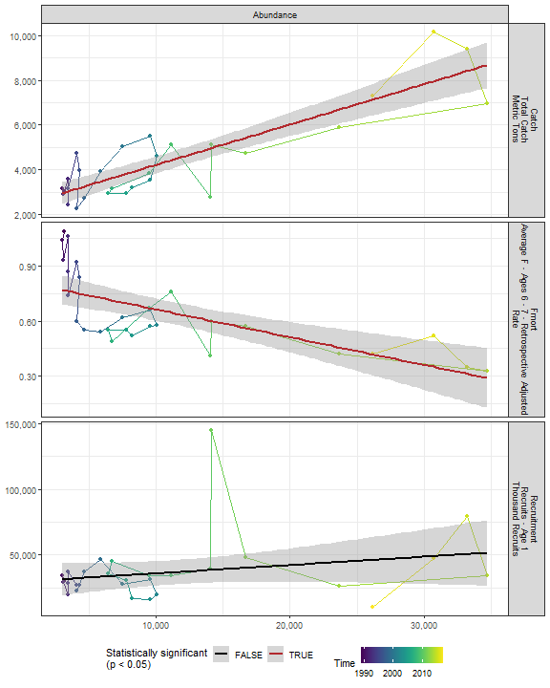

##### Regression statistics

Table 2.100: Catch vs Abundance

|  |  |  |  |  |
| --- | --- | --- | --- | --- |
|  | Estimate | Std. Error | t value | Pr(>|t|) |
| (Intercept) | 2402.56 | 285.15 | 8.43 | 0 |
| Val | 0.18 | 0.02 | 9.21 | 0 |

|  |  |
| --- | --- |
| Name | Value |
| F-statistic | 84.85 |
| df | 1, 27 |
| R2 | 0.76 |
| R2-adj | 0.75 |

Table 2.100: Fmort vs Abundance

|  |  |  |  |  |
| --- | --- | --- | --- | --- |
|  | Estimate | Std. Error | t value | Pr(>|t|) |
| (Intercept) | 0.82 | 0.05 | 17.90 | 0 |
| Val | 0.00 | 0.00 | -4.83 | 0 |

|  |  |
| --- | --- |
| Name | Value |
| F-statistic | 23.29 |
| df | 1, 27 |
| R2 | 0.46 |
| R2-adj | 0.44 |

### 2.7.2 Mean age of spawning stock

### 2.7.3 Age distribution

### 2.7.4 Length-age curves

### 2.7.5 Condition

##### Figures

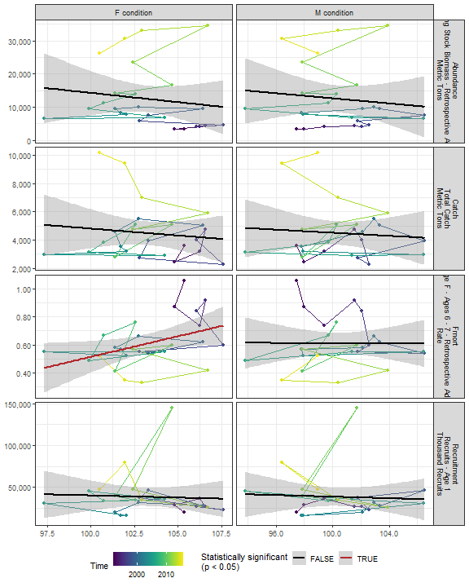

##### Regression statistics

Table 2.101: Fmort vs F condition

|  |  |  |  |  |
| --- | --- | --- | --- | --- |
|  | Estimate | Std. Error | t value | Pr(>|t|) |
| (Intercept) | -2.43 | 1.36 | -1.79 | 0.09 |
| Val | 0.03 | 0.01 | 2.24 | 0.04 |

|  |  |
| --- | --- |
| Name | Value |
| F-statistic | 5.01 |
| df | 1, 23 |
| R2 | 0.18 |
| R2-adj | 0.14 |

### 2.7.6 Stomach fullness

##### Figures

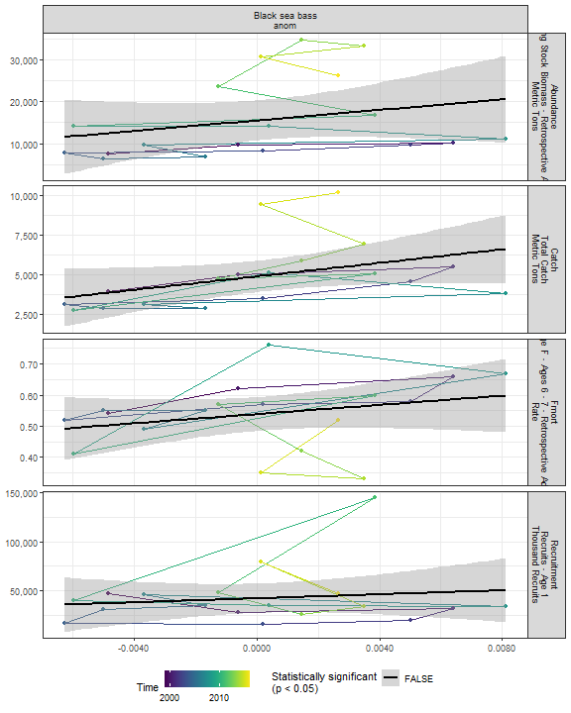

##### Regression statistics

[1] “No statistically significant data”

### 2.7.7 Center of gravity and area occupied

## 2.8 Socioeconomic indicators

### 2.8.1 CPUE by catch strategy

### 2.8.2 Recreational CPUE

##### Figures

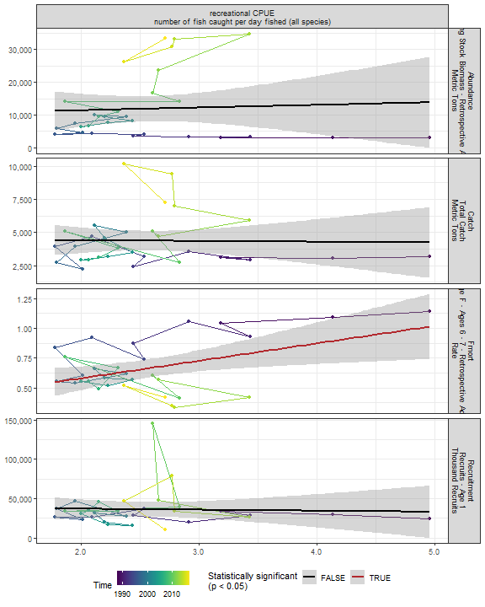

##### Regression statistics

Table 2.102: Fmort vs recreational CPUE number of fish caught per day fished (all species)

|  |  |  |  |  |
| --- | --- | --- | --- | --- |
|  | Estimate | Std. Error | t value | Pr(>|t|) |
| (Intercept) | 0.29 | 0.14 | 1.98 | 0.06 |
| Val | 0.15 | 0.05 | 2.72 | 0.01 |

|  |  |
| --- | --- |
| Name | Value |
| F-statistic | 7.4 |
| df | 1, 28 |
| R2 | 0.21 |
| R2-adj | 0.18 |

# 3 Summary of statistically significant indicators

## 3.1 Abundance

|  |  |  |  |  |
| --- | --- | --- | --- | --- |
| Indicator | Number of data points | Slope | P-value | R2_adj |
| Time | 29 | 1000 | 1.3e-09 | 0.74 |
| cumulative intensity |  |  |  |  |

degrees C (annual mean) |25 |51 |0.0017 |0.33 | |cumulative intensity Black sea bass north spring degrees C (annual mean) |25 |51 |4e-04 |0.4 | |cumulative intensity Black sea bass spring degrees C (annual mean) |26 |50 |0.0019 |0.31 | |maximum intensity Black sea bass north spring degrees C (annual mean) |25 |8300 |0.041 |0.13 | |maximum intensity Black sea bass spring degrees C (annual mean) |26 |17000 |0.0034 |0.28 | |GLORYS bottom temp anomaly degreesC |25 |6400 |0.002 |0.32 | |long-term sst degreesC |30 |11000 |3e-06 |0.53 | |spring OI SST Anomaly degreesC |30 |6500 |0.0045 |0.23 | |summer OI SST Anomaly degreesC |30 |8100 |0.00037 |0.35 | |fall OI SST Anomaly degreesC |30 |9000 |6.6e-05 |0.42 | |winter OI SST Anomaly Black sea bass north spring degreesC |30 |6000 |0.0033 |0.24 | |spring OI SST Anomaly Black sea bass north spring degreesC |30 |7800 |0.0026 |0.26 | |summer OI SST Anomaly Black sea bass north spring degreesC |30 |7600 |3e-04 |0.36 | |fall OI SST Anomaly Black sea bass north spring degreesC |30 |8100 |6.1e-06 |0.51 | |winter OI SST Anomaly Black sea bass spring degreesC |30 |4700 |0.024 |0.14 | |summer OI SST Anomaly Black sea bass spring degreesC |30 |8100 |0.00051 |0.33 | |fall OI SST Anomaly Black sea bass spring degreesC |30 |8600 |3e-05 |0.45 | |summer OI SST Anomaly Black sea bass south spring degreesC |30 |7100 |0.0046 |0.23 | |fall OI SST Anomaly Black sea bass south spring degreesC |30 |7500 |0.0016 |0.28 | |spring OI SST Anomaly Black sea bass spring degreesC |30 |6000 |0.015 |0.16 | |tke winter J/kg |30 |57000 |0.015 |0.17 | |hcly summer m2/sec2 |30 |-660 |0.0095 |0.19 | |Latitude degreesN |30 |45000 |8.8e-07 |0.57 | |Longitude degreesW |30 |38000 |2.2e-06 |0.54 | |along-shelf distance km |30 |320 |3.3e-07 |0.6 | |depth m |30 |890 |0.011 |0.18 | |distance to coast km |30 |730 |0.043 |0.11 | |northern_latitude |30 |11000 |0.00045 |0.34 | |MONTHLY CHLOR A MEDIAN month 02 mg m^-3 |20 |38000 |0.03 |0.19 | |WEEKLY CHLOR A MEDIAN week 06 mg m^-3 |20 |20000 |0.017 |0.24 | |WEEKLY CHLOR A MEDIAN week 07 mg m^-3 |20 |22000 |0.01 |0.28 | |WEEKLY CHLOR A RATIO ANOMALY week 07 |20 |30000 |0.044 |0.16 | |WEEKLY CHLOR A MEDIAN week 05 mg m^-3 |20 |30000 |0.012 |0.27 | |MONTHLY PPD MEDIAN month 05 gCarbon/m^2/Day |20 |40000 |0.02 |0.22 | |MONTHLY PPD MEDIAN month 06 gCarbon/m^2/Day |20 |26000 |0.044 |0.16 | |MONTHLY PPD MEDIAN month 07 gCarbon/m^2/Day |20 |21000 |0.027 |0.2 | |WEEKLY PPD MEDIAN week 11 gCarbon/m^2/Day |20 |50000 |0.0063 |0.31 | |WEEKLY PPD MEDIAN week 20 gCarbon/m^2/Day |20 |57000 |0.00015 |0.53 | |WEEKLY PPD RATIO ANOMALY week 20 |20 |50000 |4.8e-05 |0.59 | |WEEKLY PPD RATIO ANOMALY week 19 |20 |28000 |0.039 |0.17 | |WEEKLY PPD MEDIAN week 21 gCarbon/m^2/Day |20 |32000 |0.0068 |0.31 | |WEEKLY PPD MEDIAN week 22 gCarbon/m^2/Day |20 |25000 |0.033 |0.19 | |WEEKLY PPD MEDIAN week 25 gCarbon/m^2/Day |20 |23000 |0.031 |0.19 | |WEEKLY PPD MEDIAN week 26 gCarbon/m^2/Day |20 |21000 |0.037 |0.18 | |WEEKLY PPD MEDIAN week 27 gCarbon/m^2/Day |20 |22000 |0.012 |0.26 | |WEEKLY PPD MEDIAN week 28 gCarbon/m^2/Day |20 |23000 |0.013 |0.26 | |WEEKLY PPD MEDIAN week 29 gCarbon/m^2/Day |20 |17000 |0.046 |0.16 | |WEEKLY PPD RATIO ANOMALY week 21 |20 |29000 |0.0083 |0.29 | |WEEKLY PPD RATIO ANOMALY week 22 |20 |22000 |0.047 |0.16 | |WEEKLY PPD RATIO ANOMALY week 25 |20 |23000 |0.048 |0.16 | |WEEKLY PPD RATIO ANOMALY week 26 |20 |26000 |0.025 |0.21 | |WEEKLY PPD RATIO ANOMALY week 27 |20 |30000 |0.012 |0.26 | |WEEKLY PPD RATIO ANOMALY week 28 |20 |28000 |0.013 |0.26 | |WEEKLY PPD RATIO ANOMALY week 29 |20 |22000 |0.027 |0.2 | |WEEKLY PPD RATIO ANOMALY week 30 |20 |25000 |0.038 |0.17 | |WEEKLY PPD RATIO ANOMALY week 48 |20 |-29000 |0.03 |0.19 | |pseudocalanus zoo spring log N m^-3 |25 |-4700 |0.043 |0.13 | |SmallCalanoida Absolute Number of Individuals |30 |-7.3e-06 |0.04 |0.11 | |Calanus CV and adult Summer |26 |-1.3 |0.018 |0.18 | |spring Black sea bass north spring gC m-2 d-1 |20 |50000 |0.03 |0.19 | |spring Black sea bass spring gC m-2 d-1 |20 |50000 |0.016 |0.24 | |spring Black sea bass south spring gC m-2 d-1 |20 |44000 |0.012 |0.26 | |pseudo_100m3_annual |30 |-7700 |0.006 |0.21 | |penilia_100m3_annual |30 |14000 |0.0081 |0.2 | |echino_100m3_annual |30 |11000 |6e-04 |0.32 | |larvaceans_100m3_annual |30 |9400 |0.025 |0.14 | |mlucens_100m3_annual |30 |-16000 |2.5e-05 |0.46 | |evadnespp_100m3_annual |30 |11000 |0.03 |0.13 | |salps_100m3_annual |30 |21000 |0.00073 |0.32 | |calminor_100m3_annual |30 |10000 |0.005 |0.22 | |poly_100m3_annual |30 |19000 |0.012 |0.18 | |oncaea_100m3_annual |30 |12000 |0.0049 |0.22 | |cory_100m3_annual |30 |13000 |0.006 |0.21 | |thecos_100m3_annual |30 |13000 |4e-04 |0.34 | |spirspp_100m3_annual |30 |-18000 |1.5e-07 |0.62 | |pseudo_100m3_spring |29 |-4600 |0.047 |0.11 | |penilia_100m3_spring |29 |84000 |0.0081 |0.2 | |echino_100m3_spring |29 |9300 |0.023 |0.15 | |para_100m3_spring |29 |5400 |0.025 |0.14 | |mlucens_100m3_spring |29 |-11000 |0.0022 |0.27 | |chaeto_100m3_spring |29 |9800 |0.021 |0.15 | |clauso_spring |29 |8000 |0.016 |0.17 | |dec_100m3_spring |29 |-13000 |0.041 |0.11 | |coel_100m3_spring |29 |-20000 |0.028 |0.14 | |thecos_100m3_spring |29 |6300 |0.0076 |0.21 | |spirspp_100m3_spring |29 |-11000 |3.3e-06 |0.54 | |ctyp_100m3_fall |30 |-11000 |0.0076 |0.2 | |calfin_100m3_fall |30 |-6800 |0.018 |0.15 | |pseudo_100m3_fall |30 |-5300 |0.035 |0.12 | |penilia_100m3_fall |30 |7400 |0.0012 |0.29 | |cham_100m3_fall |30 |-10000 |0.0011 |0.3 | |echino_100m3_fall |30 |6000 |0.0011 |0.3 | |larvaceans_100m3_fall |30 |8900 |0.0013 |0.29 | |gas_100m3_fall |30 |10000 |0.044 |0.11 | |mlucens_100m3_fall |30 |-8600 |0.0031 |0.25 | |evadnespp_100m3_fall |30 |8400 |0.0056 |0.22 | |salps_100m3_fall |30 |8400 |0.004 |0.23 | |calminor_100m3_fall |30 |5900 |0.0086 |0.19 | |dec_100m3_fall |30 |13000 |0.0043 |0.23 | |poly_100m3_fall |30 |16000 |4e-05 |0.44 | |fish_100m3_fall |30 |10000 |0.038 |0.11 | |oncaea_100m3_fall |30 |6600 |0.0037 |0.24 | |cory_100m3_fall |30 |6200 |0.015 |0.16 | |siph_100m3_fall |30 |8400 |0.001 |0.3 | |spirspp_100m3_fall |30 |-27000 |3.6e-07 |0.6 | |cnidar_100m3_fall |30 |7700 |0.0044 |0.23 | |Recruitment |29 |0.19 |0.016 |0.17 |

### 3.1.1 Generalized linear model

This is an exploratory fit of a poisson GLM. Initial covariates were included based on statistical significance at a Bonferroni-corrected alpha in the linear correlations shown in this report. Final covariates were chosen by forward stepwise AIC selection of additive GLMs.

|  |  |  |  |  |
| --- | --- | --- | --- | --- |
| rnames | Estimate | Std. Error | z value | Pr(>|z|) |
| (Intercept) | 772 | 22.3 | 34.7 | 1.78e-263 |
| spirspp 100m3 fall | -1.03 | 0.0389 | -26.6 | 1.02e-155 |
| WEEKLY PPD RATIOANOMALY week 20 | 1.78 | 0.0225 | 79 | 0 |
| spirspp 100m3 annual | -1.06 | 0.037 | -28.8 | 3.1e-182 |
| Latitude degreesN | 48.3 | 1.4 | 34.5 | 6.81e-261 |
| mlucens 100m3 annual | 0.773 | 0.0184 | 42.1 | 0 |
| long term sstdegreesC | -0.123 | 0.011 | -11.2 | 2.54e-29 |
| Longitude degreesW | 31.9 | 0.916 | 34.8 | 2.37e-265 |
| along shelf distancekm | -0.561 | 0.0164 | -34.3 | 4.12e-257 |
| fall OI SST AnomalyBlack sea bass northspring degreesC | -0.195 | 0.0219 | -8.91 | 4.96e-19 |
| spirspp 100m3 spring | 0.34 | 0.0188 | 18.1 | 2.52e-73 |
| fall OI SST AnomalyBlack sea bassspring degreesC | 1.36 | 0.0738 | 18.5 | 4.83e-76 |
| fall OI SST AnomalydegreesC | -0.964 | 0.0544 | -17.7 | 2.27e-70 |

Dropped coefficients: poly_100m3_fall

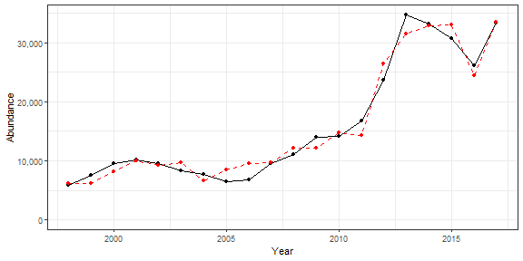

## 3.2 Recruitment

|  |  |  |  |  |
| --- | --- | --- | --- | --- |
| Indicator | Number of data points | Slope | P-value | R2_adj |
| cumulative intensity |  |  |  |  |

degrees C (annual mean) |25 |90 |0.033 |0.15 | |cumulative intensity Black sea bass north spring degrees C (annual mean) |25 |140 |8.8e-06 |0.57 | |cumulative intensity Black sea bass spring degrees C (annual mean) |26 |86 |0.04 |0.13 | |maximum intensity Black sea bass north spring degrees C (annual mean) |25 |38000 |3.6e-06 |0.6 | |cumulative intensity Black sea bass south spring degrees C (annual mean) |26 |120 |0.015 |0.19 | |spring OI SST Anomaly degreesC |30 |14000 |0.0098 |0.19 | |summer OI SST Anomaly degreesC |30 |14000 |0.014 |0.17 | |fall OI SST Anomaly degreesC |30 |14000 |0.02 |0.15 | |spring OI SST Anomaly Black sea bass north spring degreesC |30 |14000 |0.029 |0.13 | |summer OI SST Anomaly Black sea bass north spring degreesC |30 |11000 |0.045 |0.11 | |fall OI SST Anomaly Black sea bass north spring degreesC |30 |11000 |0.019 |0.15 | |summer OI SST Anomaly Black sea bass spring degreesC |30 |14000 |0.021 |0.15 | |fall OI SST Anomaly Black sea bass spring degreesC |30 |12000 |0.022 |0.14 | |summer OI SST Anomaly Black sea bass south spring degreesC |30 |15000 |0.011 |0.18 | |spring OI SST Anomaly Black sea bass spring degreesC |30 |14000 |0.017 |0.16 | |spring OI SST Anomaly Black sea bass south spring degreesC |30 |11000 |0.022 |0.14 | |MONTHLY CHLOR A MEDIAN month 01 mg m^-3 |20 |80000 |0.032 |0.19 | |MONTHLY CHLOR A MEDIAN month 09 mg m^-3 |20 |130000 |0.036 |0.18 | |MONTHLY CHLOR A MEDIAN month 10 mg m^-3 |20 |120000 |0.028 |0.2 | |MONTHLY CHLOR A MEDIAN month 12 mg m^-3 |20 |59000 |0.036 |0.18 | |MONTHLY CHLOR A RATIO ANOMALY month 01 |20 |120000 |0.018 |0.23 | |MONTHLY CHLOR A RATIO ANOMALY month 06 |20 |-63000 |0.045 |0.16 | |MONTHLY CHLOR A RATIO ANOMALY month 07 |20 |-56000 |0.048 |0.16 | |MONTHLY CHLOR A RATIO ANOMALY month 09 |20 |65000 |0.00029 |0.5 | |MONTHLY CHLOR A RATIO ANOMALY month 10 |20 |110000 |0.011 |0.27 | |MONTHLY CHLOR A RATIO ANOMALY month 12 |20 |88000 |0.017 |0.24 | |WEEKLY CHLOR A MEDIAN week 07 mg m^-3 |20 |54000 |0.027 |0.2 | |WEEKLY CHLOR A RATIO ANOMALY week 07 |20 |93000 |0.024 |0.21 | |WEEKLY CHLOR A MEDIAN week 02 mg m^-3 |20 |56000 |0.0056 |0.32 | |WEEKLY CHLOR A MEDIAN week 25 mg m^-3 |20 |-92000 |0.049 |0.15 | |WEEKLY CHLOR A MEDIAN week 35 mg m^-3 |20 |77000 |0.0087 |0.29 | |WEEKLY CHLOR A MEDIAN week 48 mg m^-3 |20 |40000 |0.017 |0.24 | |WEEKLY CHLOR A MEDIAN week 52 mg m^-3 |20 |46000 |0.044 |0.16 | |WEEKLY CHLOR A RATIO ANOMALY week 01 |20 |88000 |0.018 |0.23 | |WEEKLY CHLOR A RATIO ANOMALY week 02 |20 |86000 |0.034 |0.18 | |WEEKLY CHLOR A RATIO ANOMALY week 08 |20 |97000 |0.039 |0.17 | |WEEKLY CHLOR A RATIO ANOMALY week 13 |20 |52000 |0.043 |0.17 | |WEEKLY CHLOR A RATIO ANOMALY week 14 |20 |76000 |0.018 |0.23 | |WEEKLY CHLOR A RATIO ANOMALY week 24 |20 |-58000 |0.024 |0.21 | |WEEKLY CHLOR A RATIO ANOMALY week 27 |20 |-42000 |0.047 |0.16 | |WEEKLY CHLOR A RATIO ANOMALY week 29 |20 |-54000 |0.034 |0.18 | |WEEKLY CHLOR A RATIO ANOMALY week 35 |20 |37000 |0.0011 |0.42 | |WEEKLY CHLOR A RATIO ANOMALY week 36 |20 |44000 |0.0015 |0.41 | |WEEKLY CHLOR A RATIO ANOMALY week 37 |20 |44000 |0.0094 |0.28 | |WEEKLY CHLOR A RATIO ANOMALY week 38 |20 |53000 |0.044 |0.16 | |WEEKLY CHLOR A RATIO ANOMALY week 48 |20 |44000 |0.041 |0.17 | |WEEKLY CHLOR A RATIO ANOMALY week 50 |20 |89000 |0.029 |0.2 | |MONTHLY PPD MEDIAN month 10 gCarbon/m^2/Day |20 |130000 |0.035 |0.18 | |WEEKLY PPD MEDIAN week 18 gCarbon/m^2/Day |20 |120000 |0.033 |0.19 | |WEEKLY PPD MEDIAN week 19 gCarbon/m^2/Day |20 |130000 |0.0015 |0.4 | |WEEKLY PPD MEDIAN week 42 gCarbon/m^2/Day |20 |150000 |0.04 |0.17 | |WEEKLY PPD MEDIAN week 50 gCarbon/m^2/Day |20 |130000 |0.021 |0.22 | |WEEKLY PPD RATIO ANOMALY week 18 |20 |99000 |0.012 |0.26 | |WEEKLY PPD RATIO ANOMALY week 19 |20 |1e+05 |0.0046 |0.33 | |WEEKLY PPD RATIO ANOMALY week 39 |20 |57000 |0.047 |0.16 | |WEEKLY PPD RATIO ANOMALY week 41 |20 |74000 |0.033 |0.19 | |WEEKLY PPD RATIO ANOMALY week 42 |20 |99000 |0.0024 |0.38 | |WEEKLY PPD RATIO ANOMALY week 50 |20 |65000 |0.029 |0.2 | |winter Black sea bass north spring mg m^-3 |20 |170000 |0.048 |0.16 | |summer Black sea bass spring mg m^-3 |20 |110000 |0.04 |0.17 | |fall Black sea bass north spring gC m-2 d-1 |20 |280000 |0.01 |0.28 | |fall Black sea bass spring gC m-2 d-1 |20 |250000 |0.012 |0.27 | |fall Black sea bass south spring gC m-2 d-1 |20 |170000 |0.033 |0.19 | |echino_100m3_annual |30 |18000 |0.032 |0.12 | |salps_100m3_annual |30 |33000 |0.037 |0.12 | |poly_100m3_annual |30 |52000 |0.0038 |0.24 | |thecos_100m3_annual |30 |19000 |0.046 |0.1 | |thecos_100m3_spring |29 |13000 |0.019 |0.16 | |echino_100m3_fall |30 |9300 |0.046 |0.1 |

### 3.2.1 Generalized linear model

This is an exploratory fit of a poisson GLM. Initial covariates were included based on statistical significance at a Bonferroni-corrected alpha in the linear correlations shown in this report. Final covariates were chosen by forward stepwise AIC selection of additive GLMs.

|  |  |  |  |  |
| --- | --- | --- | --- | --- |
| rnames | Estimate | Std. Error | z value | Pr(>|z|) |
| (Intercept) | 9.31 | 0.00583 | 1600 | 0 |
| maximum intensityBlack sea bass northspring degrees Cannual mean | 0.415 | 0.00295 | 141 | 0 |
| cumulative intensityBlack sea bass northspring degrees Cannual mean | 0.00141 | 1.18e-05 | 119 | 0 |

Dropped coefficients: none

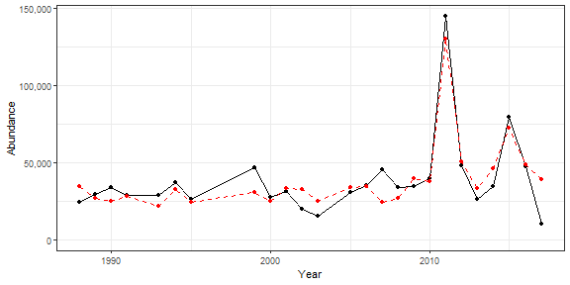

## 3.3 Catch

|  |  |  |  |  |
| --- | --- | --- | --- | --- |
| Indicator | Number of data points | Slope | P-value | R2_adj |
| Time | 29 | 160 | 6.7e-05 | 0.43 |
| V_max | 25 | -29000 | 0.038 | 0.14 |
| cumulative intensity |  |  |  |  |

degrees C (annual mean) |25 |9.3 |0.0031 |0.29 | |cumulative intensity Black sea bass north spring degrees C (annual mean) |25 |9.4 |0.00076 |0.37 | |cumulative intensity Black sea bass spring degrees C (annual mean) |26 |9.2 |0.0033 |0.28 | |maximum intensity Black sea bass north spring degrees C (annual mean) |25 |1600 |0.045 |0.13 | |maximum intensity Black sea bass spring degrees C (annual mean) |26 |2700 |0.016 |0.19 | |cumulative intensity Black sea bass south spring degrees C (annual mean) |26 |8.1 |0.038 |0.13 | |GLORYS bottom temp anomaly degreesC |25 |1400 |0.00086 |0.36 | |long-term sst degreesC |30 |1800 |0.00013 |0.39 | |spring OI SST Anomaly degreesC |30 |920 |0.042 |0.11 | |summer OI SST Anomaly degreesC |30 |1300 |0.003 |0.25 | |fall OI SST Anomaly degreesC |30 |1800 |3.9e-05 |0.44 | |winter OI SST Anomaly Black sea bass north spring degreesC |30 |1000 |0.013 |0.17 | |spring OI SST Anomaly Black sea bass north spring degreesC |30 |1100 |0.036 |0.12 | |summer OI SST Anomaly Black sea bass north spring degreesC |30 |1200 |0.0033 |0.24 | |fall OI SST Anomaly Black sea bass north spring degreesC |30 |1500 |2.2e-05 |0.46 | |winter OI SST Anomaly Black sea bass spring degreesC |30 |810 |0.045 |0.11 | |summer OI SST Anomaly Black sea bass spring degreesC |30 |1300 |0.0037 |0.24 | |fall OI SST Anomaly Black sea bass spring degreesC |30 |1600 |3.5e-05 |0.44 | |summer OI SST Anomaly Black sea bass south spring degreesC |30 |1200 |0.012 |0.18 | |fall OI SST Anomaly Black sea bass south spring degreesC |30 |1600 |0.00055 |0.33 | |stratification (0-50 m) kg m^-3 |27 |-160000 |0.01 |0.21 | |total wind speed spring J/kg |30 |-1900 |0.043 |0.11 | |hcly summer m2/sec2 |30 |-130 |0.0093 |0.19 | |vwnd summer J/kg |30 |-1700 |0.05 |0.1 | |gulf stream index latitude anomaly (annual mean) |25 |1300 |0.038 |0.14 | |Latitude degreesN |30 |8000 |1.5e-05 |0.48 | |Longitude degreesW |30 |6500 |6.5e-05 |0.42 | |along-shelf distance km |30 |55 |1.2e-05 |0.48 | |northern_latitude |30 |1900 |0.0027 |0.25 | |WEEKLY CHLOR A MEDIAN week 06 mg m^-3 |20 |3900 |0.023 |0.21 | |WEEKLY CHLOR A MEDIAN week 07 mg m^-3 |20 |5000 |0.0036 |0.35 | |WEEKLY CHLOR A MEDIAN week 41 mg m^-3 |20 |5400 |0.042 |0.17 | |WEEKLY CHLOR A RATIO ANOMALY week 04 |20 |8200 |0.033 |0.19 | |WEEKLY CHLOR A RATIO ANOMALY week 07 |20 |6200 |0.044 |0.16 | |WEEKLY PPD MEDIAN week 11 gCarbon/m^2/Day |20 |13000 |0.00017 |0.53 | |WEEKLY PPD MEDIAN week 20 gCarbon/m^2/Day |20 |8100 |0.021 |0.22 | |WEEKLY PPD RATIO ANOMALY week 11 |20 |7400 |0.023 |0.21 | |WEEKLY PPD RATIO ANOMALY week 20 |20 |7000 |0.017 |0.24 | |Calanus CV and adult Summer |26 |-0.27 |0.012 |0.21 | |large Anomaly |30 |-2000 |0.0097 |0.19 | |calfin_100m3_annual |30 |-2100 |0.007 |0.2 | |echino_100m3_annual |30 |1700 |0.0094 |0.19 | |larvaceans_100m3_annual |30 |2000 |0.0096 |0.19 | |mlucens_100m3_annual |30 |-2600 |0.00092 |0.3 | |evadnespp_100m3_annual |30 |2500 |0.011 |0.18 | |salps_100m3_annual |30 |3600 |0.0037 |0.24 | |calminor_100m3_annual |30 |1500 |0.042 |0.11 | |poly_100m3_annual |30 |4100 |0.0046 |0.23 | |oncaea_100m3_annual |30 |2400 |0.0041 |0.23 | |cory_100m3_annual |30 |2500 |0.0056 |0.22 | |thecos_100m3_annual |30 |2400 |0.00085 |0.31 | |spirspp_100m3_annual |30 |-2500 |0.00069 |0.32 | |cnidar_100m3_annual |30 |2000 |0.036 |0.12 | |ctyp_100m3_spring |29 |3400 |0.0019 |0.28 | |penilia_100m3_spring |29 |21000 |0.00017 |0.39 | |echino_100m3_spring |29 |1800 |0.019 |0.16 | |para_100m3_spring |29 |1000 |0.027 |0.14 | |clauso_spring |29 |1300 |0.043 |0.11 | |dec_100m3_spring |29 |-2400 |0.049 |0.1 | |prot_100m3_spring |29 |2600 |0.0012 |0.3 | |coel_100m3_spring |29 |-3600 |0.044 |0.11 | |thecos_100m3_spring |29 |1400 |0.00089 |0.32 | |spirspp_100m3_spring |29 |-1600 |0.00077 |0.32 | |ctyp_100m3_fall |30 |-2000 |0.017 |0.16 | |calfin_100m3_fall |30 |-1600 |0.0034 |0.24 | |penilia_100m3_fall |30 |1200 |0.011 |0.18 | |cham_100m3_fall |30 |-1500 |0.015 |0.17 | |echino_100m3_fall |30 |940 |0.011 |0.18 | |larvaceans_100m3_fall |30 |1800 |0.00058 |0.33 | |acarspp_100m3_fall |30 |1600 |0.028 |0.13 | |mlucens_100m3_fall |30 |-1400 |0.013 |0.17 | |evadnespp_100m3_fall |30 |1700 |0.0043 |0.23 | |salps_100m3_fall |30 |1600 |0.0036 |0.24 | |calminor_100m3_fall |30 |1000 |0.02 |0.15 | |dec_100m3_fall |30 |3500 |1.5e-05 |0.48 | |poly_100m3_fall |30 |3100 |1.6e-05 |0.47 | |fish_100m3_fall |30 |2500 |0.0052 |0.22 | |oncaea_100m3_fall |30 |1400 |0.00089 |0.31 | |cory_100m3_fall |30 |1400 |0.003 |0.25 | |siph_100m3_fall |30 |1400 |0.0045 |0.23 | |coel_100m3_fall |30 |2100 |0.045 |0.11 | |spirspp_100m3_fall |30 |-4000 |0.00057 |0.33 | |cnidar_100m3_fall |30 |1400 |0.0092 |0.19 | |Recruitment |29 |0.03 |0.049 |0.1 | |Abundance |29 |0.18 |8e-10 |0.75 |

## 3.4 Fmort

|  |  |  |  |  |
| --- | --- | --- | --- | --- |
| Indicator | Number of data points | Slope | P-value | R2_adj |
| Time | 29 | -0.021 | 2.5e-08 | 0.68 |
| Warm Core Rings |  |  |  |  |
| n | 30 | -0.016 | 0.00055 | 0.33 |
| cumulative intensity |  |  |  |  |

degrees C (annual mean) |25 |-0.00078 |0.021 |0.18 | |maximum intensity degrees C (annual mean) |25 |-0.26 |0.017 |0.19 | |cumulative intensity Black sea bass north spring degrees C (annual mean) |25 |-0.00085 |0.01 |0.22 | |cumulative intensity Black sea bass spring degrees C (annual mean) |26 |-0.00083 |0.023 |0.16 | |maximum intensity Black sea bass spring degrees C (annual mean) |26 |-0.29 |0.022 |0.17 | |long-term sst degreesC |30 |-0.19 |5e-04 |0.33 | |summer OI SST Anomaly degreesC |30 |-0.17 |0.0011 |0.3 | |fall OI SST Anomaly degreesC |30 |-0.17 |0.0017 |0.27 | |spring OI SST Anomaly Black sea bass north spring degreesC |30 |-0.12 |0.042 |0.11 | |summer OI SST Anomaly Black sea bass north spring degreesC |30 |-0.15 |0.002 |0.27 | |fall OI SST Anomaly Black sea bass north spring degreesC |30 |-0.13 |0.0033 |0.24 | |summer OI SST Anomaly Black sea bass spring degreesC |30 |-0.17 |0.0016 |0.28 | |fall OI SST Anomaly Black sea bass spring degreesC |30 |-0.15 |0.0022 |0.26 | |summer OI SST Anomaly Black sea bass south spring degreesC |30 |-0.16 |0.0039 |0.23 | |fall OI SST Anomaly Black sea bass south spring degreesC |30 |-0.16 |0.0034 |0.24 | |tke winter J/kg |30 |-2 |2.4e-05 |0.46 | |total wind speed winter J/kg |30 |-0.2 |0.0078 |0.2 | |tke spring J/kg |30 |-2.4 |0.045 |0.11 | |hcly summer m2/sec2 |30 |0.015 |0.0087 |0.19 | |Latitude degreesN |30 |-0.83 |2e-04 |0.37 | |Longitude degreesW |30 |-0.85 |2.8e-06 |0.53 | |along-shelf distance km |30 |-0.0063 |1.5e-05 |0.48 | |depth m |30 |-0.023 |0.0025 |0.26 | |distance to coast km |30 |-0.02 |0.012 |0.18 | |northern_latitude |30 |-0.17 |0.024 |0.14 | |southern_latitude |30 |-0.25 |0.047 |0.1 | |WEEKLY CHLOR A MEDIAN week 06 mg m^-3 |20 |-0.22 |0.0088 |0.29 | |WEEKLY CHLOR A MEDIAN week 07 mg m^-3 |20 |-0.21 |0.023 |0.21 | |WEEKLY CHLOR A MEDIAN week 05 mg m^-3 |20 |-0.29 |0.022 |0.22 | |WEEKLY CHLOR A RATIO ANOMALY week 06 |20 |-0.36 |0.036 |0.18 | |WEEKLY PPD MEDIAN week 20 gCarbon/m^2/Day |20 |-0.37 |0.044 |0.16 | |WEEKLY PPD RATIO ANOMALY week 20 |20 |-0.32 |0.032 |0.19 | |WEEKLY PPD MEDIAN week 07 gCarbon/m^2/Day |20 |0.76 |0.025 |0.21 | |pseudocalanus zoo fall log N m^-3 |27 |0.11 |0.032 |0.14 | |SmallCalanoida Absolute Number of Individuals |30 |2.4e-10 |0.001 |0.3 | |Zoo_Shannon-Wiener_Diversity_index Unitless |30 |-0.47 |0.00032 |0.35 | |small Anomaly |30 |0.35 |0.0015 |0.28 | |Forage_SE |18 |-0.89 |0.015 |0.28 | |ctyp_100m3_annual |30 |0.34 |0.0086 |0.19 | |pseudo_100m3_annual |30 |0.24 |1.8e-05 |0.47 | |penilia_100m3_annual |30 |-0.31 |0.0066 |0.21 | |cham_100m3_annual |30 |0.29 |0.002 |0.27 | |echino_100m3_annual |30 |-0.33 |1e-06 |0.56 | |larvaceans_100m3_annual |30 |-0.29 |0.0012 |0.29 | |gas_100m3_annual |30 |-0.19 |0.043 |0.11 | |mlucens_100m3_annual |30 |0.25 |0.01 |0.19 | |salps_100m3_annual |30 |-0.55 |3.6e-05 |0.44 | |oithspp_100m3_annual |30 |-0.24 |0.026 |0.14 | |chaeto_100m3_annual |30 |-0.39 |1e-04 |0.4 | |hyper_100m3_annual |30 |-0.26 |0.0029 |0.25 | |calminor_100m3_annual |30 |-0.34 |1.2e-06 |0.56 | |clauso_annual |30 |-0.37 |0.0024 |0.26 | |euph_100m3_annual |30 |-0.42 |0.015 |0.17 | |prot_100m3_annual |30 |-0.47 |0.00068 |0.32 | |poly_100m3_annual |30 |-0.51 |0.0021 |0.26 | |oncaea_100m3_annual |30 |-0.32 |0.00054 |0.33 | |cory_100m3_annual |30 |-0.4 |3.4e-05 |0.45 | |siph_100m3_annual |30 |-0.38 |0.00047 |0.34 | |euph1_100m3_annual |30 |-0.42 |0.016 |0.16 | |thecos_100m3_annual |30 |-0.26 |0.0014 |0.28 | |spirspp_100m3_annual |30 |0.26 |0.0027 |0.25 | |cnidar_100m3_annual |30 |-0.32 |0.002 |0.27 | |pseudo_100m3_spring |29 |0.1 |0.039 |0.12 | |echino_100m3_spring |29 |-0.19 |0.026 |0.14 | |para_100m3_spring |29 |-0.14 |0.0056 |0.22 | |acarspp_100m3_spring |29 |0.22 |0.026 |0.14 | |chaeto_100m3_spring |29 |-0.31 |0.00018 |0.39 | |clauso_spring |29 |-0.23 |0.00048 |0.35 | |euph_100m3_spring |29 |-0.24 |0.038 |0.12 | |coel_100m3_spring |29 |0.46 |0.017 |0.16 | |thecos_100m3_spring |29 |-0.11 |0.033 |0.13 | |spirspp_100m3_spring |29 |0.16 |0.0041 |0.24 | |ctyp_100m3_fall |30 |0.36 |3.6e-05 |0.44 | |pseudo_100m3_fall |30 |0.21 |2.4e-05 |0.46 | |penilia_100m3_fall |30 |-0.13 |0.013 |0.17 | |tlong_100m3_fall |30 |0.18 |0.02 |0.15 | |cham_100m3_fall |30 |0.33 |4.8e-08 |0.65 | |echino_100m3_fall |30 |-0.17 |3.4e-06 |0.53 | |larvaceans_100m3_fall |30 |-0.23 |0.00013 |0.39 | |gas_100m3_fall |30 |-0.27 |0.01 |0.18 | |mlucens_100m3_fall |30 |0.2 |0.0018 |0.27 | |evadnespp_100m3_fall |30 |-0.15 |0.027 |0.13 | |salps_100m3_fall |30 |-0.19 |0.0045 |0.23 | |oithspp_100m3_fall |30 |-0.26 |0.018 |0.15 | |chaeto_100m3_fall |30 |-0.36 |0.00033 |0.35 | |hyper_100m3_fall |30 |-0.22 |0.0068 |0.21 | |calminor_100m3_fall |30 |-0.2 |4.4e-06 |0.52 | |dec_100m3_fall |30 |-0.24 |0.026 |0.13 | |prot_100m3_fall |30 |-0.27 |0.00052 |0.33 | |poly_100m3_fall |30 |-0.29 |0.0014 |0.28 | |oncaea_100m3_fall |30 |-0.14 |0.004 |0.23 | |cory_100m3_fall |30 |-0.19 |0.00042 |0.34 | |siph_100m3_fall |30 |-0.19 |0.00078 |0.31 | |spirspp_100m3_fall |30 |0.49 |0.00024 |0.37 | |cnidar_100m3_fall |30 |-0.18 |0.0026 |0.26 | |Abundance |29 |-1.5e-05 |4.9e-05 |0.44 | |F condition |25 |0.029 |0.035 |0.14 | |recreational CPUE number of fish caught per day fished (all species) |30 |0.15 |0.011 |0.18 |

# 4 Appendix

## 4.1 R session information

## R version 4.0.3 (2020-10-10)  
## Platform: x86_64-w64-mingw32/x64 (64-bit)  
## Running under: Windows 10 x64 (build 19042)  
##   
## Matrix products: default  
##   
## locale:  
## [1] LC_COLLATE=English_United States.1252 LC_CTYPE=English_United States.1252 LC_MONETARY=English_United States.1252 LC_NUMERIC=C   
## [5] LC_TIME=English_United States.1252   
##   
## attached base packages:  
## [1] stats graphics grDevices utils datasets methods base   
##   
## other attached packages:  
## [1] NEespShiny_0.1.1 shiny_1.6.0   
##   
## loaded via a namespace (and not attached):  
## [1] nlme_3.1-149 fs_1.5.0 assessmentdata_0.0.0.9000 ecodata_0.1.0 xts_0.12.1 usethis_2.0.1   
## [7] lubridate_1.7.10 devtools_2.3.2 httr_1.4.2 rprojroot_2.0.2 tools_4.0.3 bslib_0.2.4   
## [13] utf8_1.1.4 R6_2.5.0 DT_0.17 mgcv_1.8-33 DBI_1.1.1 colorspace_2.0-0   
## [19] withr_2.4.1 tidyselect_1.1.0 gridExtra_2.3 prettyunits_1.1.1 processx_3.4.5 curl_4.3   
## [25] compiler_4.0.3 cli_2.3.1 priceR_0.1.5 desc_1.3.0 labeling_0.4.2 bookdown_0.21   
## [31] sass_0.3.1 scales_1.1.1 tidyquant_1.0.3 quadprog_1.5-8 callr_3.5.1 stringr_1.4.0   
## [37] digest_0.6.27 rmarkdown_2.7 pkgconfig_2.0.3 htmltools_0.5.1.1 sessioninfo_1.1.1 highr_0.8   
## [43] fastmap_1.1.0 NEesp_0.1.1 htmlwidgets_1.5.3 rlang_0.4.10 TTR_0.24.2 rstudioapi_0.13   
## [49] quantmod_0.4.18 farver_2.1.0 jquerylib_0.1.3 generics_0.1.0 zoo_1.8-9 jsonlite_1.7.2   
## [55] crosstalk_1.1.1 dplyr_1.0.5 magrittr_2.0.1 Matrix_1.2-18 Rcpp_1.0.6 Quandl_2.10.0   
## [61] munsell_0.5.0 fansi_0.4.1 ggnewscale_0.4.5 proto_1.0.0 viridis_0.5.1 lifecycle_1.0.0   
## [67] stringi_1.5.3 yaml_2.2.1 MASS_7.3-53 PerformanceAnalytics_2.0.4 pkgbuild_1.2.0 grid_4.0.3   
## [73] promises_1.2.0.1 crayon_1.4.1 lattice_0.20-41 splines_4.0.3 knitr_1.31.6 ps_1.5.0   
## [79] pillar_1.5.1 pkgload_1.2.0 glue_1.4.2 evaluate_0.14 remotes_2.2.0 vctrs_0.3.6   
## [85] httpuv_1.5.5 testthat_3.0.2 gtable_0.3.0 purrr_0.3.4 tidyr_1.1.3 assertthat_0.2.1   
## [91] gsubfn_0.7 cachem_1.0.4 ggplot2_3.3.3 xfun_0.19 mime_0.10 xtable_1.8-4   
## [97] later_1.1.0.1 viridisLite_0.3.0 tibble_3.0.4 memoise_2.0.0 ellipsis_0.3.1

## 4.2 NEesp information

## Package: NEesp  
## Title: Generate Preliminary ESP Reports for the Northeast  
## Version: 0.1.1  
## Description: Generates preliminary Ecosystem and Socioeconomic Profiles for Northeast and Mid-Atlantic USA fishery stocks.  
## License: file LICENSE  
## Authors@R: c(person("Abigail", "Tyrell", email = "abigail.tyrell@noaa.gov", role = c("aut", "cre"), comment = c(ORCID = "0000-0002-6656-8470")),  
## person("Ricky", "Tabandera", email = "ricky.tabandera@noaa.gov", role = "aut"))  
## Maintainer: Abigail Tyrell <abigail.tyrell@noaa.gov>  
## URL: https://noaa-edab.github.io/NEesp/  
## BugReports: https://github.com/NOAA-EDAB/NEesp/issues  
## Imports: assessmentdata, bookdown, DT, ecodata, FSA, ggpubr, ggrepel, ggridges, ggthemes, here, nmfspalette, papeR, priceR, rgeos, rnaturalearth,  
## rnaturalearthhires, tidyquant, viridis  
## Remotes: ropensci/rnaturalearthhires, nmfs-general-modeling-tools/nmfspalette, NOAA-EDAB/ecodata, NOAA-EDAB/assessmentdata  
## Encoding: UTF-8  
## LazyData: true  
## Roxygen: list(markdown = TRUE)  
## RoxygenNote: 7.1.1  
## Depends: R (>= 3.5.0)  
## Suggests: testthat (>= 3.0.0)  
## Config/testthat/edition: 3  
## RemoteType: github  
## RemoteHost: api.github.com  
## RemoteRepo: NEesp  
## RemoteUsername: NOAA-EDAB  
## RemoteRef: dev  
## RemoteSha: b97a213df4b12e9eb34559612778edd93d0d02dc  
## GithubRepo: NEesp  
## GithubUsername: NOAA-EDAB  
## GithubRef: dev  
## GithubSHA1: b97a213df4b12e9eb34559612778edd93d0d02dc  
## NeedsCompilation: no  
## Packaged: 2021-07-13 20:45:00 UTC; abigail.tyrell  
## Author: Abigail Tyrell [aut, cre] (<https://orcid.org/0000-0002-6656-8470>), Ricky Tabandera [aut]  
## Built: R 4.0.3; ; 2021-07-13 20:45:08 UTC; windows  
##   
## -- File: C:/Users/abigail.tyrell/Documents/R/win-library/4.0/NEesp/Meta/package.rds